**Course: ICS 370-01 Final Exam**

**Date: 12/09/2020**

**Total Marks: 60 Marks**

Answer all the questions. You will be given a problem description and asked to identify and draw different objects/classes using UML diagrams. You will be graded on each question for correctness, completeness and thoughtfulness. Do not copy or plagiarize. Submit the answer script through D2L submission folder.

**YOUR NAME: Bradley Taylor**

**Problems**

* 1. The students of Metropolitan State University consist of full time and part time students. Each student belongs to a department. The departments offer different programs and each program has many courses. Students can enroll for a program. The students can register for three courses in each semester and a course might have zero or one pre-requisite course. Finally, the system admin Mr. XYZ will approve the courses registered by the students. Based on this problem description answer the following questions:

List all the actors of the proposed system(5 points)

1. Student
2. Admin
3. department

Draw a use case diagram for the proposed system (10 Points).

Draw a domain Model for the proposed system (10 Points).

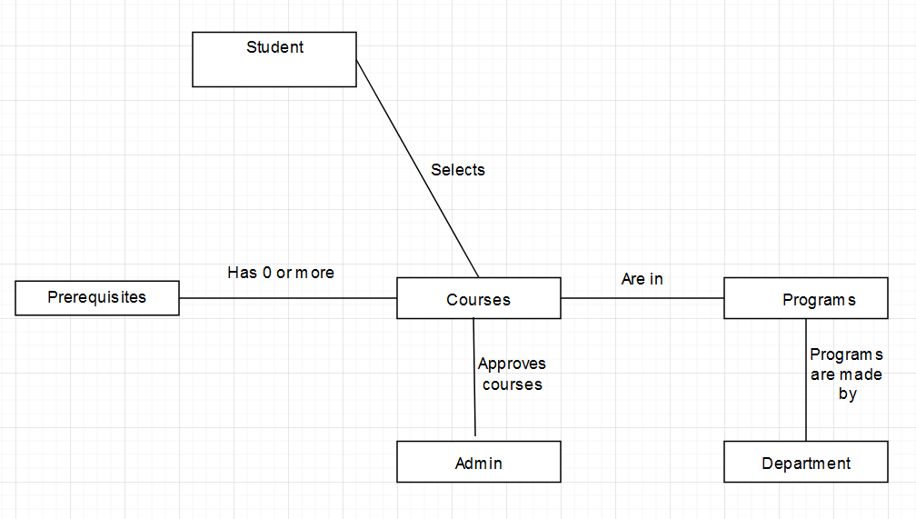

Draw a Design Class Diagram for the proposed system (10 Points).

Draw a Sequence Diagram for one actor (10 Points).

1. Draw a Design Class Diagram based on the following database requirements as provided by a book publisher
   * + 1. For each author, the book publisher would like to keep track of the author’s IC number, name and contact number(5 Points)
          1. IC number is unique for each author
          2. First Name
          3. Last Name
          4. email
       2. For each book, the book publisher would like to keep track of the book’s ISBN (International Standard Book Number) and name(5 Points)
          1. ISBN is unique for each book
       3. Authors write books(5 Points)
          1. An author writes zero or more books
          2. A book is written by one or more authors

