COMP3204 Lecture #0 03-10-16

Introduction to Computer Vision
Coursework was set
COMP3204 Lecture #1 04-10-16

Eye and Human Vision

Physical Model
- The eye
- Evolved for defence/survival
- The eye forms an image on the fovea by shaping the lens
- There are many image sensors (Rods and Cones)
- Rods
- Form black and white images (Monochrome)
- A.K.A Photopic vision
- 10⁸
- Off the fovea
- Cones
- Form colour images (Scotpic)
- Rember them because cones, colour and scotopic contain co
- 10⁷
- On the fovea (The eye rotates in light/dark on/off the fovea to suit)
- Different types based on wavelength:
- S(hort) = blue (UV)
- M(edium) = green/yellow
- L(ong) = red (IR)
- Most cones are just next to the fovea
- Eye is bad at seeing blue so it compensates by being more sensitive to blue
- Lack of bandwith in the Optic Nerve suggests coding
- Subject to mach bands (When your eyes change from one grey to another you perceive lines inbetween from the way the eye moves but the lines do not exist)

Neural Model
- Found by experiments
- You combine the signals
- Use mathematical models
- Justify with experiments
- LGN = Lateral Genicular Nucleus (new find)

Processing – Psychology

Occipital Cortex Associative Cortex
- texture - links
- needs training
- easily deceived

COMP3204 Lecture #2 06-10-16
Pg 37-45

Image Formation
Images are stored as 8-bit bytes.
6dB per bit => 48dB ~ video bandwidth
Human vision is roughly 5 bits.

Resolution
- Stored in 2^{n} x 2^{n} for efficiency
- Depends on task for resolution, you use the smalles image you can get away with
- But how can we know the correct resolution?

Fourier Transform
- Guides resolution
- New way to understand the image
- Spacial Image + Fourier Transform = frequency (like a music graphic equaliser with frequecy levels)
- The inverse can reverse the process
- ω = frequency t = time
- For sound signals
- Given a simple pulse as shown in the first diagram of the handout, if we count the center of the pulse as T we can cancel the above equation down to
- A fourier transform has both magnitude and phase.
- The magnitude is how much and the phase is when
COMP3204 Lecture #3 10-10-16
Pg 49-71

Image Sampling and 2D Transforms

Sampling
Very fast = high resolution
Very slow = low resolution (may also experience aliasing)
Nyquist-Shannon sampling theory states:
“Sample at twice the maximum frequency”
e.g. speech maximum = 6kHz so you sample at 12kHz
Video is 2 dimensional so there is no sampling theorem.
The guidline is to sample at 2 points per feature of interest.

Discrete Fourier Transform
Where u^i is the discrete set of points
This is implemented by the fast fourier transform.
Sampled points + sampled frequencies

Applications
- Texture – understand image
- Coding – via frequency content
- Representation
- Speed up algorithms
COMP3204 Lecture #4 11-10-16
Pg 83-95

Point Operators
An image can be described by a histogram.
It uses a point operators map:
New point = some function on the old point
N_{x,y} = f(O_{x,y})
Such as = - O_{x,y}
= g(ain) * O_{x,y} + b(rightness)
= log( O_{x,y})
We need an automatic way to find the right combination of funtions instead of guessing until we like the outcome.

Intensity Normalisation
Omin
Omax

The original image doesn’t use the entire grey scale, so we want to modify it to expand it’s range.
Given the old minimum and maximum (O_{min} and O_{max}).
Range = O_{min} – O_{max}
We need to scale it, using the maximum number of levels in the grey scale (255), we get

This give a linear strech occupying all possible grey levels.

Histogram Equalisation
The aim of equalisation is to suit an image for human vision.
You want to aim for a flat histogram. It is a non-linear process and is applied to an NxN image.
Number of points in the new = Number of points in the old
Number of points in new upto q brightness level = Number of points in old upto p brightness level
Where l is the level and N(l)/O(l) is the number of points in the new/old at that level:
Assuming we have a perfect uniform flat histogram:
q

This give a mapping function into an equalised image.
N_{x,y} = E(q, O) where E mean equalised.
Equalising does all it can do in one go, if you were to equalise and equalised image it wouldn’t change any more. It is only meant for display because it is non-linear.

Thresholding
N_{x,y} = |
The formatting doesn’t work too well for this but that is the notation for a conditional operation, so the new point would be 1 if the old point was above some threshold or a 0 otherwise.
Imagine it looks more like this without the right hand line
There are many variants of this e.g. “optimal” thresholding. Mark Nixon doesn’t believe they are truly optimal but they advertise it.
COMP3204 L5 13-10-16
Pg 98-114

Group Operators
Form an image by combining points in regions. It is implemented by template convolution.
Where w is the weighting.
What about the edges? You can use fourier assumptions with wrap-around or use a smaller region at the border but this can be complex, it might be acceptable to just set the edge to black.

Averaging
W_{i} = 1/window size e.g. in a 3x3 w_{i} = 1/9

Guassian Averaging
This is better at averaging but at a time cost.
Calculate w_{i} from a guassian distribution:
w_{i} depends on the window size and σ(standard deviation)
At a large σ it’s similar to a direct average.
At a small σ it’s the same as no averaging.
If there is guassian noise then obviously guassian averaging is great for fixing it, the majority of noise is guassian so this is a good method for most means of removing noise.

Median Averaging
Median averaging can retain edges and can remove random salt and pepper noise very well.
It lists the pixel values in the region, sorts them and then takes the median value. This means that any extreme white or black noisy pixels from salt and pepper noise are removed. It is optimal.

Mode Averaging
Great for rally noise (like in medical imaging), but is more complicated to code and takes much more time.
COMP3204 L8 25-10-16
Pg 222-235 & 243-249

Finding Shapes
Occlusion is just organised noise (image blocking part of your vision).
To find shapes we group (edge) points. We shouldn’t use thresholding because this is too simple and we need shapes. Template matching is the basic procedure.
Template Matching
We tak an image and the template we are searching for.
In an accumultor you add how many points match the template at each point of the image.
The darkest point is the best match.
It is a lot like template convolution.
It is optimal for noise and occlusion but it is slow :(
It can be sped up with Fourier! :)
Template Matching = inverse_fourier(Fourier(template)*Fourier(image))
Hough Transform – for lines
y=mx+c points(x,y) gradient(m) intercept(c)
c=-xm+y points(m,c) gradient(-c) intercept(y)
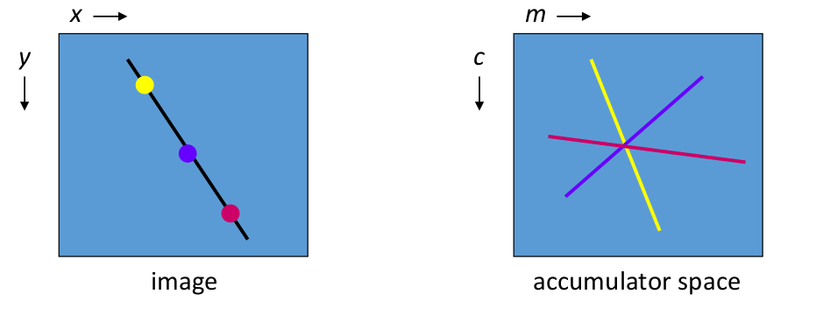
so the argmax(accumulator) is the peak!
Procedure:
forall x,y !search image
if image(x,y) >= threshold !find point
forall m in m_{min},m_{max} !all values of m
c=-xm+y
accumulator(m,c) += 1 !vote
Afterwards argmax(accumulator) gives values of best m,c.
Same result as template matchin but it’s faster! It is impractical though due to the maximum m (vertical line) is infinity! This causes an infinite loop.
We overcome this problem with a different equation that we can apply that does the same thing. This is the polar equation.
Xcosθ + ysinθ = ρ
You can prove the foot from the normal.
-90<θ<90
0<ρ<root(2)N where N is the picture size
So parameters are now constrained unlike the cartesian version.
COMP3204 L9 26-10-16
Pg 250-258,271-279

Finding More Shapes
Hough Transform for Circles

forall x,y in image !all points in the image
if edge(x,y) >= threshold !significant points
forall r in r_{min},r_{max} !all values of r
forall %theta in 1,360 !go around the circle
x₀ = x+rcos(%theta)
y₀ = y+rsin(%theta)
accumulator(x₀,y₀) += 1
Afterwards you search for the peak/maximum in the accumulator.
Ellipses

This is a 4D accumulator x₀,y₀, a, b.
If you were to add rotation you would get a 5th dimension
If each parameter has 100 values (10²) then our 5D accumulator would have 10¹⁰.
This will get very slow so it needs some special implementations.
Arbitrary Shapes
We use a generalised Hough Transform:
1. We form a template
2. Use the template for voting
3. Search for peak
The image below is from the slides and it describes how you define each point in the image based on it’s position relative to the centre. We can form a template for this which is then stored in an R-Table. This contains the distance and angle to the centre point.
It uses the edge direction or Ф(phi) as the index/address in the table.
Multiple points may have the same edge direction and thus be under the same index, this will produce noise but for every noise element you have a correct one so it does not compromise the result.
In order to rotate the image you add a constant to alpha or phi, for scaling, multiply r.
