# Observable Trends

In analyzing the data, several trends become apparent. The first is the indisputable success of Capomulin and Ramicane in reducing tumor volume over the course of the experiment, as illustrated by this figure:

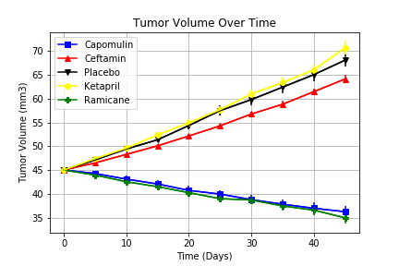

Compared to other drugs such as Ceftamin which offers only marginal improvement over a placebo vs Ketapril, which does worse than the placebo in controlling tumor growth, Ramicane and Capomulin show the greatest reduction by day 45. Indeed, they are the only two drugs in the experiment that reduce tumor volume by a statistically significant amount.

Capomulin and Ramicane also show an observable and significant reduction in metastatic site spread as opposed to Ceftamin and Ketapril as well as the Placebo.

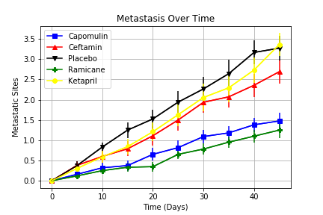

As can be seen in the graph of the data, Ramicane and Capomulin keep new metastatic sites below 1.5 on average, though not within the margin of error for capomulin. Considering this data, I recommend that Ramicane be pursued for Stage 2 drug trials over Capomulin, despite the promise of both as cancer treatment vectors.

Survival of the subjects is not significantly different between Capomulin and Ramicane, but it is significant when compared to the contenders. The difference between Capomulin and Ramicane is most likely due to chance.

