Brad Mosier

D277 - Front End Web Development

Task 2

Sept 17 2025

F:

I felt the way I had designed the original layout was too busy on the eyes. I also realized my original wireframes really didn't account for the elements the rubric was asking for so I needed to rework it quite a bit. Instead, I want a more vertical approach which seems to be more of an industry standard anyway. I dropped the images and city information between the main section and the “contact us” aside and I replaced them with things the rubric was requiring as I was having a hard time deciding where to put the lists and table, with the already very busy design I previously had. I created a contact page which is not depicted here after seeing it was needed by the rubric.

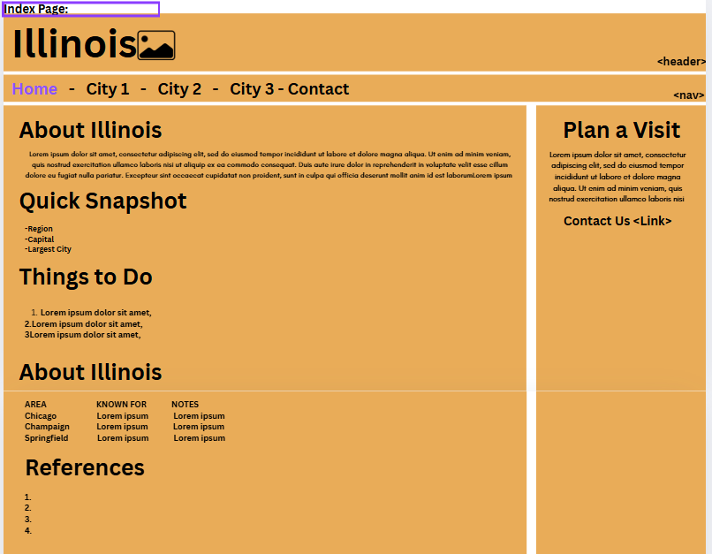

For the city pages, I once again took a vertical approach to make it less busy on the eyes. I decided to put the fun facts in an unordered list in the aside with the picture. Under that, I included a link to each city’s wiki page. I put what people can look forward to doing in an ordered list at the bottom of the page. I put the key facts in an unordered list under the city overview. This makes everything they need to know visible at a glance. I kept the header and nav the same across all pages.

