Proposal for a future lab assignment

By Branden Lee

**Problem:**

You want to turn in a project for Professor Larkins class, but realized you separated your project into separate files and he had specifically requested that you TURN IN JUST ONE FILE. You would like to continue separating your header (.h) and implementation (.cpp) in separate files so you want to make a utility that can combine them into an amalgamated (combined) file.

You also happen to prefer writing code before designing your application so you want to programmatically generate UML diagrams for the UMLet.

**Implementation:**

Because the <filesystem> header is still not implemented on certain compilers, we will hard code each file path for this lab. You are given a set of header and implementation files and must create an amalgamated file from these that will successfully compile.

Remember that you must remove header includes in each file and pay attention to the order.

To speed up the amalgamation process, you want to use threads to combine two files into one, concurrently, then join that pair with another until the final amalgamated file is created.

**File to turn in:**

A single c++ file that will take the input files in the **src** directory attached:

Must the following when run output:

* program.cpp
* programUML.uxf

Grading:

myProgram.cpp must compile on visual studio 2017

myProgramUML.uxf must display properly in UMLet

The UMLet uses XML sheets, so you must use regex to grab class methods and variables, then generate an XML sheet.

For example:

The XML shown in the image below:

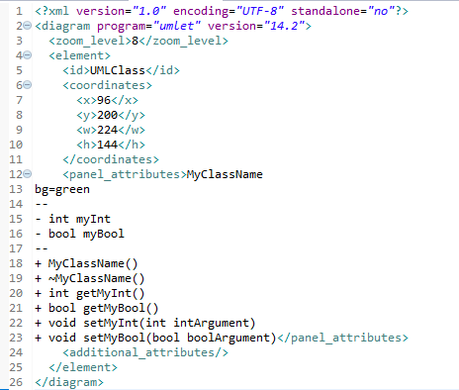

Will generate:

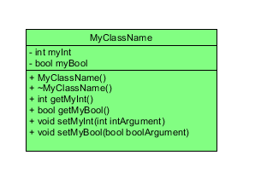

**Possible STL templates to use:**

|  |  |
| --- | --- |
| STL Template | Use |
| Regex | Find and remove #include “…” |
| Threads | Concurrently combine files |
| Queue | A queue of files to amalgamate |
| String | Handle file data |

**note:**

**the src/ folder is what is given to the student**

**the myProgram.cpp is a possible output from the program written by the student**

**THE CODE CONTAINED IN /SRC DIRECTORY IS NOT MY OWN. IT IS AN OPEN SOURCE PROJECT MADE BY TENCENT.**

**the souce program could be any mid-size project that will be difficult to combine into an amalgamated file.**

**I used this one as an example.**