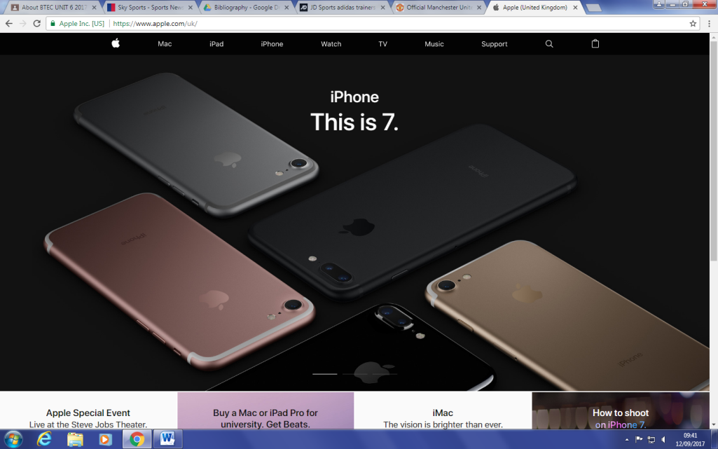

Easy navigation allows users to search through all their different types of products and learn more about them.

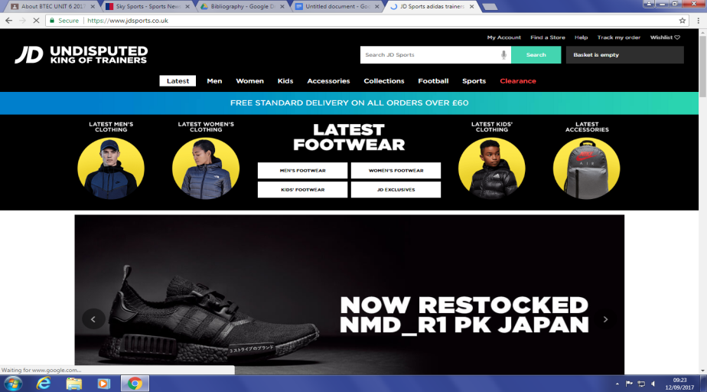

The purpose of JD is for a customer to navigate and purchase items of clothing that they like.

The website is aimed at the teenage and young adult and is displayed through the pictures on the home screen.

JD’s colour scheme is black throughout each page with a simple design and easy navigation.

Images of their latest products, as well as information about them excite customers who may want to buy them.

Simplistic design and basic colour scheme reflects their products simple design.

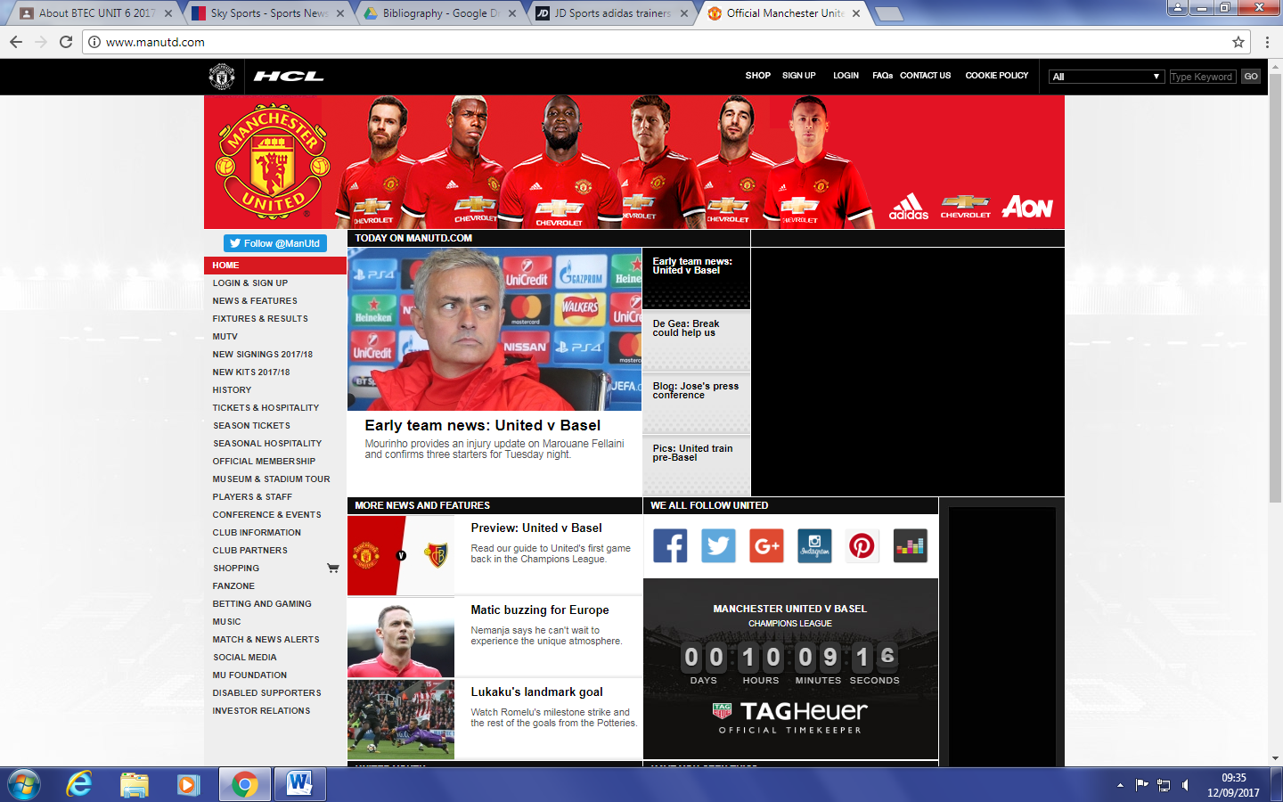

Photographs of new signings and club players with the new kit incise customers that want to purchase kits and other clothing.

The purpose of Manchester United’s website is to inform fans with frequent updates and information, but also inform non fans and neutrals of upcoming games and news.

Red colour scheme and club badge on each page means there is a consistent flow from page to page.