Driven ESAC: Motor Controller

Purpose:
Off the shelf motor controllers limit us as a team to how we can drive the motor. Typical controllers such as the PORTER-10 are designed to handle short current bursts but stabilise around 10/20amps. Our aim was to design a motor controller that would provide stable power at 40amps as well as have a peak current draw of 120amps. This will allow the car to accelerate off the line quicker but also maintain faster speeds. Additionally, designing a motor controller to our requirements allows us to be more efficient in how we drive the motor, but also add future functionality such as regenerative braking.

Outcome:
After many conversations, we came up with a list of requirements and ultimately a specification to build the motor controller to. Some of the aims were:
- 120A peak current draw.
- ~40A continuous draw.
- Works with a 24v system.
- PWM input to control the motor.
- On-board voltage regulation.
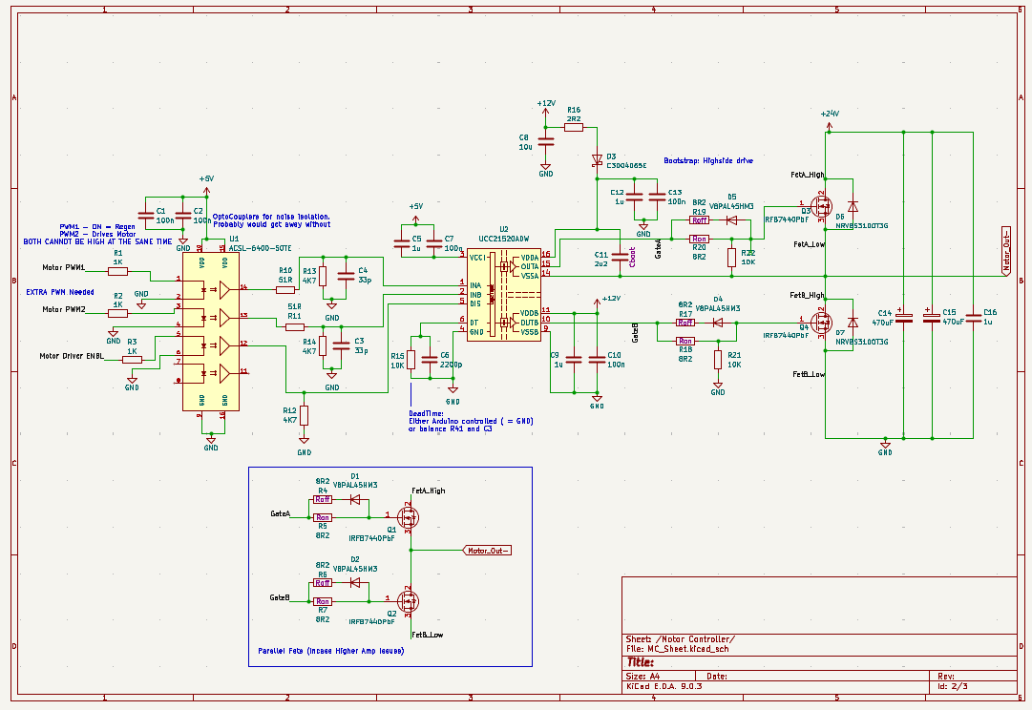
With these requirements, we build the following schematic.

Key Components:
- UCC12520 Dual-Channel Gate Driver.
- ACSL-6400-50TE OptoCoupler.
- IRFB7440PbF 120A Mosfets

How it works:
This motor controller circuit is designed to drive the motor in the driven race car, utilising the UCC21520 isolated gate driver and IFBN7440PbF N-channel MOSFETs. The UCC21520 receives PWM and control signals from a microcontroller and provides reinforced isolation between the low-voltage logic and high-voltage power stages, ensuring robust protection against the electrical transients, which are common in motor control environments. Its high current drive capability (4A source, 6A sink) enables fast and efficient switching of the IFBN7440PbF, which is optimized for low RDS and rapid response. This is critical for delivering precise torque and speed control when under dynamic racing conditions. The gate driver's programmable dead-time feature prevents shoot-through during switching, while its fast propagation delay supports high-frequency PWM for precise motor control. The signals required to drive this motor controller are:
- PWM 1 (INPUT A)
- PWM 2 (INPUT B)
- ENABLE (LOGIC HIGH)

IO:

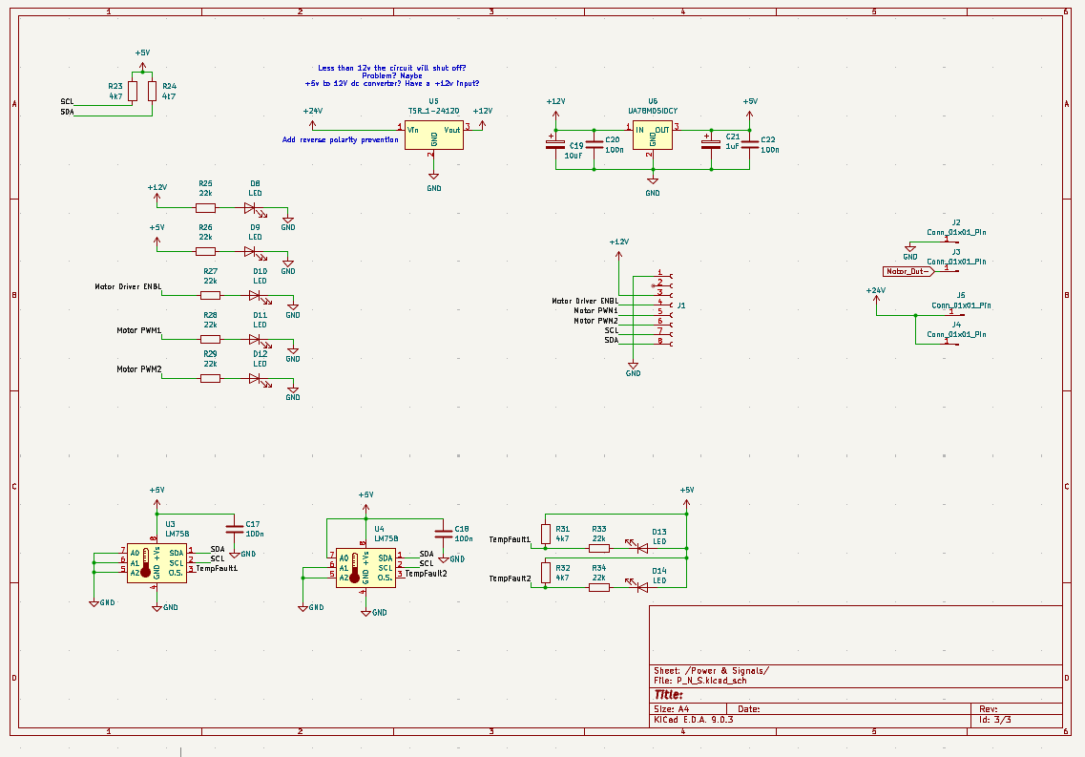
Connectors:
MOLEX 43045-0806: 8 pin socket, this is where all the main inputs are provided to the board.
Wurth 7461098: M8 metal lug connections, allow the high-current connections from the battery and output to the motor. These can handle up to 250A.

I2C:
The 8 pin socket (J1)has two inputs for the I2C signals, SCL (7) and SDA (8). These signals allow the two LM75 temperature sensors to be connected to the Arduino. The purpose of these is to provide a precise temperature of how hot the high and low side MOSFETs are. The LM75 can be programmed to have a threshold temperature in which an LED will illuminate.

Voltage Regulation:
The board is designed to have an onboard TSR-1-24120 voltage regulator to step down the +24v to +12v. However, this IC only regulates when the input voltage is greater than +15v. From race data, it can be seen that the battery voltages drop well below this, I propose that there is an external voltage step up that can always provide +12v to the motor controller. Pin 3 on Connector J1 has a +12v input.
The +5v will always be regulated as long as there is a +12v rail present. The 5v regulator is a UA78M05.

PCB:
The PCB has a four layer stack up:
- Power & Signals.
- Continuous Ground (Noise Isolation)
- Ground and I2C.
- Power and Signals.
The board MUST be manufactured with a 2Oz copper outer layers. This will help with thermal dissipation and is what the board has been designed to handle. The PCB has been designed to be as thermally efficient as possible, with many thermal vias. The MOSFETS face away from the PCB, so that they can be mounted to an external heatsink and keep the board cooler. See the PORTER-10 for an example. A sufficient heatsink will need to be manufactured.
THIS PCB HAS NO REVERSE POLARITY PROTECTION. From discussions with the ESAC Team we felt that the necessary complexity of protecting this device from reverse polarity was not required. Please take caution when powering this device and ensure that is has been wired correctly. There is BAT+ and BAT- labels as well as big ‘+’ and ‘-‘ idents on the silkscreen.

Layer Stackup:
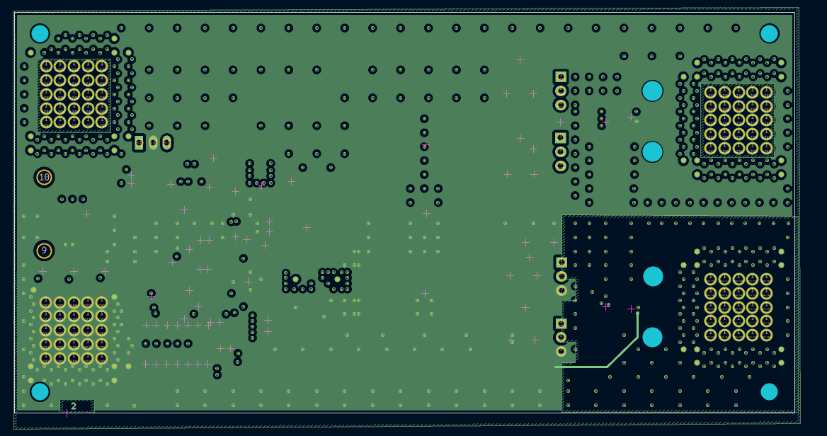
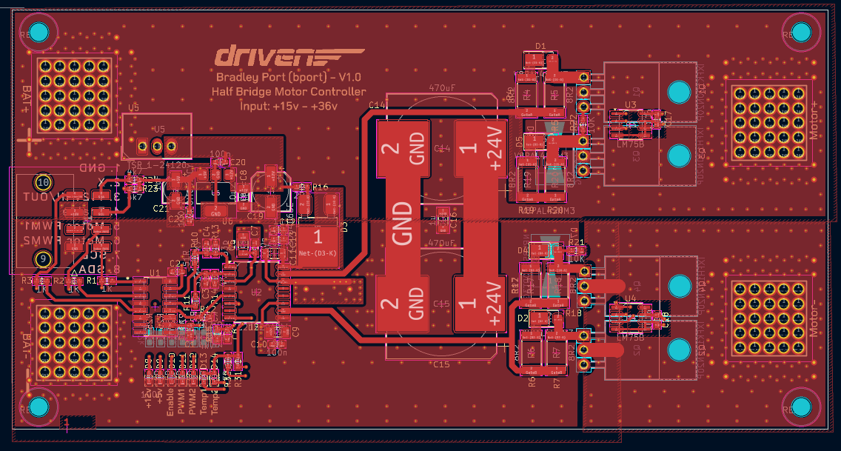
Layer 1:
Layer 2:
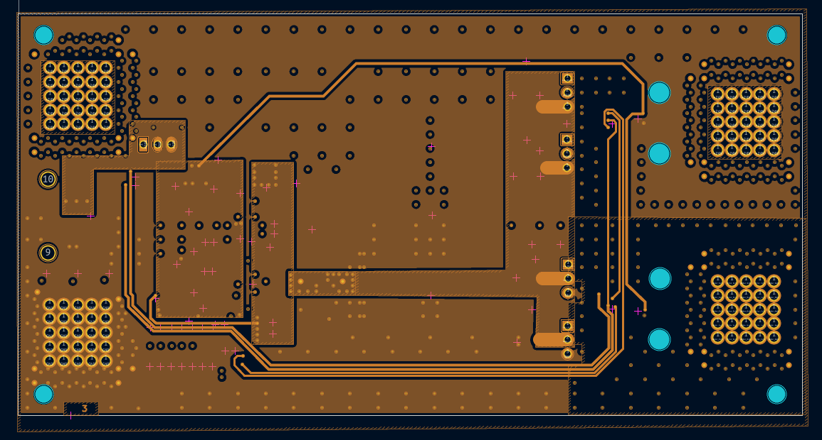
Layer 3:
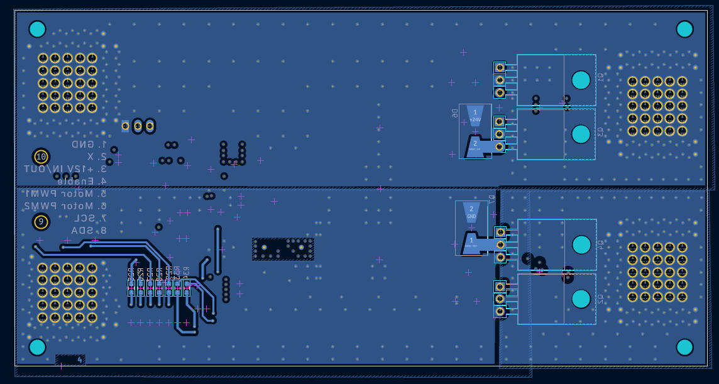
Layer 4:

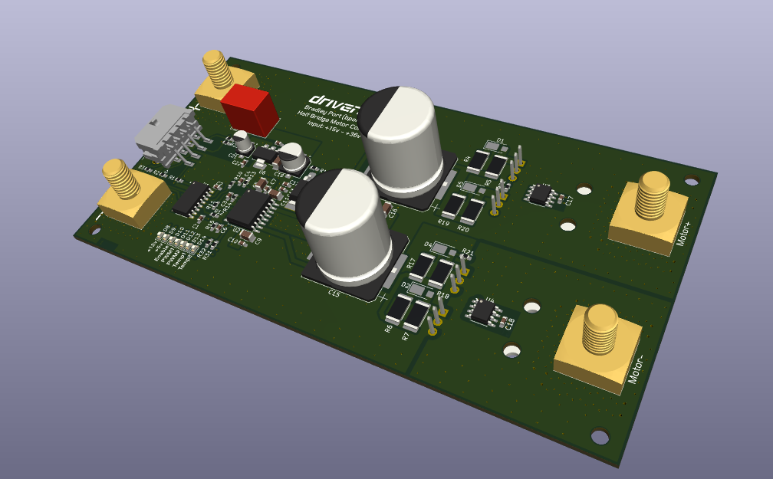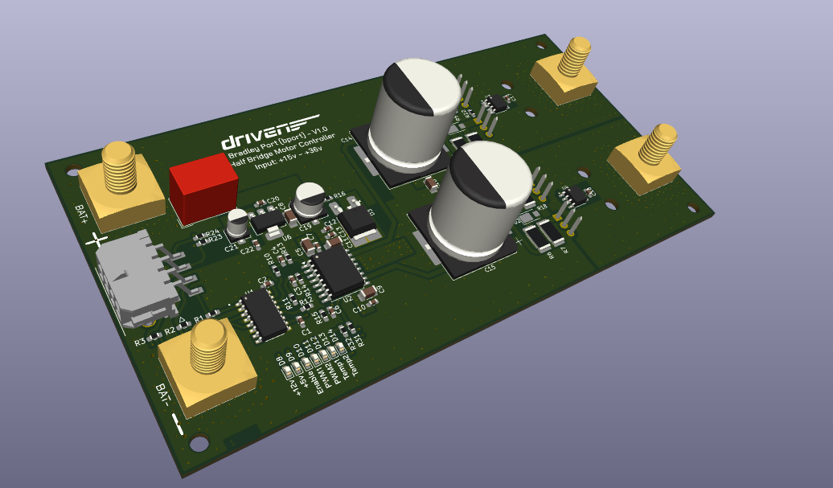
In the bottom left corner of the PCB there is a bank of LEDs that detail all of the signal status. When the LEDs are illuminated, it means that the signals are present. The TEMP1 and TEMP2 LEDS will illuminate when the temperature read by the LM75 is above the programmed value.

Overview:
This board was designed in KiCAD. There are two schematic sheets, ‘Motor Controller’ and ‘Power & Signals’. Each section is split into these two sheets to make it easier to navigate.
The motor controller is a good addition to the Driven Race Car as it will allow the ESAC team to provide precise motor control as well as a future proof device if regenerative braking is added in the future.
The BOM outlines a rough production cost of £90. This consists of £45 in components and £45 to manufacture the PCB with JLR PCB. Please refer to the BOM excel sheet for more precise details.

