CVS Client Setup Guide

Brad Touesnard

Table of Contents

Table of Contents i
Table of Figures ii
1.0 Introduction 1
2.0 Requirements 1
2.1 Client-Side Requirements 1
2.2 Server-Side Requirements 1
3.0 Configuring OpenSSH 1
3.1 Connecting to the Server via SSH 1
3.2 Setting-Up Public-Key Authentication 2
3.2.1 Generating and Installing Keys 2
3.2.2 Connecting with Private-Key Authentication 4
4.0 Configuring WinCVS 4
Sources 8

Table of Figures

Figure 2.1: Required Software Packages 1
Figure 3.1: WinSCP Login Information Screen 3
Figure 3.2: WinSCP Main Screen 3
Figure 4.1: WinCVS Preferences Dialog 5
Figure 4.2: WinCVS SSH Options Dialog 6
Figure 4.3: WinCVS Globals Preferences Dialog 6
Figure 4.4: WinCVS CVS Preferences Dialog 7

Introduction

The Concurrrent Versioning System (CVS) has become an integral tool in the development of many software applications. Although CVS clients are often setup on Unix and used as a command line application, there are several popular Windows GUI applications in use as well. This document details how to setup the CVS client known as WinCVS (http://www.wincvs.org) with SSH access to the CVS server.

Requirements

Client-Side Requirements

Table 2.1 lists the software packages required to successfully install WinCVS. If you do not have the packages installed, you should install them now.

Package | Download
OpenSSH (client only) | http://lexa.mckenna.edu/sshwindows/download/releases/
WinSCP | http://winscp.sourceforge.net/eng/download.php
Python | http://www.python.org/download/
WinCVS | http://www.wincvs.org/download.html#WINCVS
Figure 2.1: Required Software Packages

Server-Side Requirements

On the server, you must have a valid user setup with SSH access in order to access CVS via SSH. Please refer to the CVS Server Setup Guide for further details.

Configuring OpenSSH

Connecting to the Server via SSH

The OpenSSH for Windows client allows you to run SSH as a command line utility in Windows much like the utility bundled with Linux. To test it, do the following:

- In Windows, click “Start” then “Run…”
- Type “cmd” and click “Ok”
- At the command prompt type “ssh <username>@<hostname>”

You should see something similar to the following:

The authenticity of host '<hostname>' can't be established.
RSA key fingerprint is ...
Are you sure you want to continue connecting (yes/no)?

- Type “yes” after this prompt. You should see a warning message and a password prompt like the following:

Warning: Permanently added '<hostname>' (RSA) to the list of known hosts.
<username>@<hostname>'s password:

- Enter your SSH password. You should now be logged into the server via SSH.

Setting-Up Public-Key Authentication

Since every action on the CVS server will require authentication, we will use public key authentication to give us the convenience of not having to enter a password while maintaining security in the authentication and data exchange process.

Generating and Installing Keys

While still logged-in to the server via SSH, generate public and private SSH keys for your user:

$ ssh-keygen –t rsa -b 1024

The program will respond with some information and ask for which file to save the key. Simply press ‘Enter’ for the default.

Generating public/private rsa key pair.
Enter file in which to save the key (~/.ssh/id_rsa):

It will then ask for your passphrase, but since we want CVS to operate seamlessly through SSH, press the ‘Enter’ key twice to use no passphrase.

Enter passphrase (empty for no passphrase):
Enter same passphrase again:

Your identification has been saved in ~/.ssh/id_rsa.
Your public key has been saved in ~/.ssh/id_rsa.pub.
The key fingerprint is:
... <username>@<hostname>

You should notice a new directory in your /home/username directory called “.ssh” and some files within it. The file “id_rsa” is the private key and the file “id_rsa.pub” is the public key. The public key is used on the server and the private key is used on the client. The next step is to install the keys on both the client and server.

Installing the public key on the server is easy:

$ cat ~/.ssh/id_rsa.pub >> ~/.ssh/authorized_keys
$ chmod 400 ~/.ssh/authorized_keys

Now to install the private key, you must copy it to your client machine. The best way to do this is by using an SCP client program to connect to the server via SSH and transfer the file. It is recommended to use WinSCP mentioned in Section 2.1 of this document.

To login with WinSCP, simply enter the same login credentials as you used to login with SSH. That is, the <hostname>, <username> and password for which you were prompted (Figure 3.1). The remaining options should be fine. Click the “Login” button.

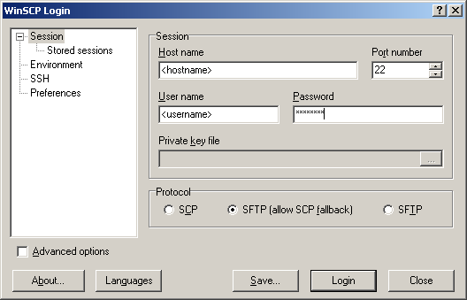
Figure 3.1: WinSCP Login Information Screen

Once you are connected with WinSCP, you should see a display much like an FTP program (Figure 3.2). The right pane contains a list of the files in your home directory on the server and the left pane contains a local folder on your machine.

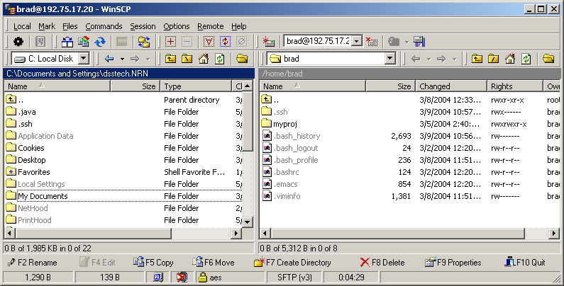
Figure 3.2: WinSCP Main Screen

Now you must open the “.ssh” directory in the right pane (server) and copy the “id_rsa” file to the “.ssh” directory in your home directory on your machine. The home directory differs between versions of Windows:

For Windows 2000:
C:\Documents and Settings\<username>

For Windows NT 4.0
C:\WINNT\Profiles\<username>

For Windows 9x
C:\WINDOWS\Profiles\<username>

So in WinSCP on Windows 2000, you would change the directory in the left pane to “C:\Documents and Settings\<username>\.ssh” (creating the “.ssh” directory if it doesn’t exist), then drag the “id_rsa” file from the right pane and drop it in the left pane.

Connecting with Private-Key Authentication

Now we can test to see if the Private and Public Keys are setup properly by establishing a new SSH connection.

- In Windows, click “Start” then “Run…”
- Type “cmd” and click “Ok”
- At the command prompt, type “ssh <username>@<hostname>”

If you are not prompted for your password, then the authentication is working properly. You can now remove the “~/.ssh/id_rsa” file from the server to ensure no one else can use it to login to your account. Do not remove the “id_rsa” file from your local machine.

If you are prompted for your password, you should review the process to ensure you didn’t miss anything or try again from the beginning. To ensure that your “id_rsa” file is being located by OpenSSH, run the ssh command with the path to the “id_rsa” file explicitly defined:

ssh –i C:\<home_dir>\.ssh\<private-key file> <username>@<hostname>

Configuring WinCVS

Now we must configure our WinCVS client to connect to the CVS server via SSH.

- In Windows, start WinCVS from the “Start” menu or Desktop
- Click “Admin” -> “Preferences” from the menu
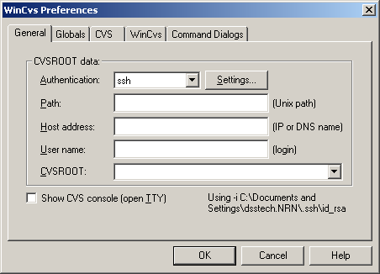
Figure 4.1: WinCVS Preferences Dialog

- Fill out the form (Figure 4.1) with the following values:

Authentication: | ssh
Path: | Path to the CVS repository root  (e.g. /home/cvs/cvsroot)
Host address: | Address of the CVS server  (Same as <hostname> used when setting up SSH)
User name: | SSH username to access the server  (Same as <username> used when setting up SSH)

- Click the “Settings…” button. A dialog will appear (Figure 4.2).
- Select the “RSA private key file (identity)” checkbox
- In the textbox, enter the path to you’re the “id_rsa” file you copied from the server with WinSCP in the section Generating and Installing Keys.
- Click “Ok”.
- Click the “Globals” tab
- Adjust settings as shown in Figure 4.3
- Click the “CVS” tab (Figure 4.4)
- Enter the home directory of your local machine. You used this in the section Generating and Installing Keys.
- Click “Ok”

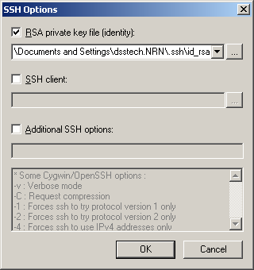
Figure 4.2: WinCVS SSH Options Dialog

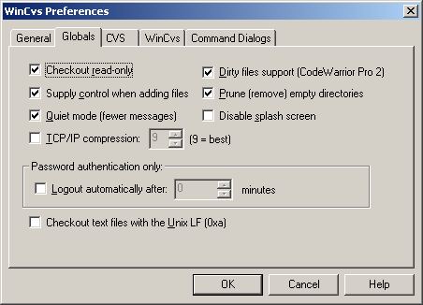
Figure 4.3: WinCVS Globals Preferences Dialog

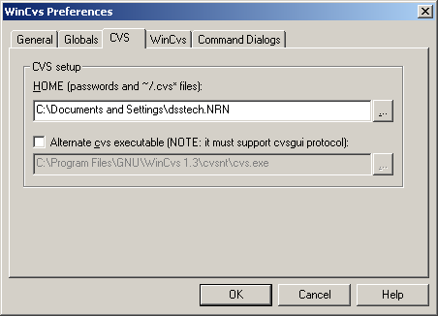
Figure 4.4: WinCVS CVS Preferences Dialog

Now WinCVS should be ready to go!

Sources

Reagan, Patrick. “A Practical Guide to WinCVS and SSH”. http://www.wincvs.org/ssh.html. [Accessed 2004-03-09]

