# Creating a Micrometer File

First, take images with a micrometer. For each image, mark the objective used and the zoom. If you are not using a motorized zoom, use the value 1 for zoom.

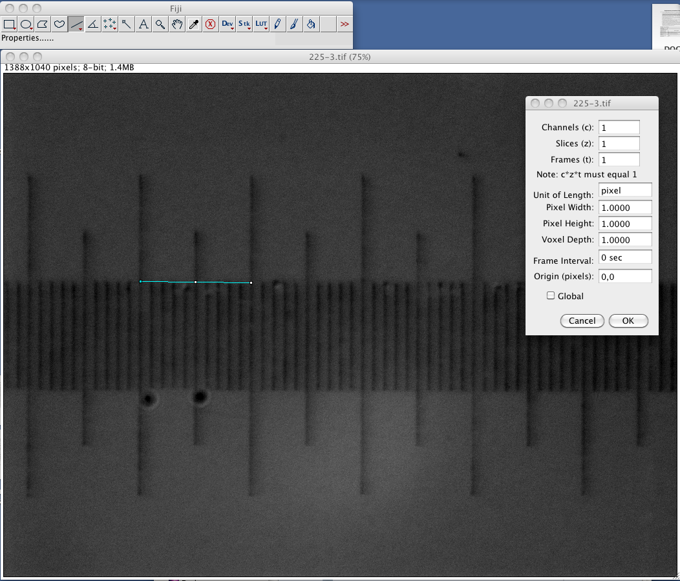Open Fiji. Open the image file that contains a picture of the micrometer at a specified zoom and objective. Make sure the scale of the image is set to unit 1 by going to Image -> Properties… and setting the pixel width and height fields to 1.

Use the Line tool. Click and drag a line along the micrometer in the image to a known distance (e.g. along 1 major tick in the micrometer). Hit ctrl-m (or mac button-m), a table containing measurement will pop up. Record the length of the line. The microns per pixel for the zoom and objective is: length of micrometer ticks/length of line. For our example, if the length between the major ticks in 50 microns, we would have microns per pixel = 50/228.016 = .219.

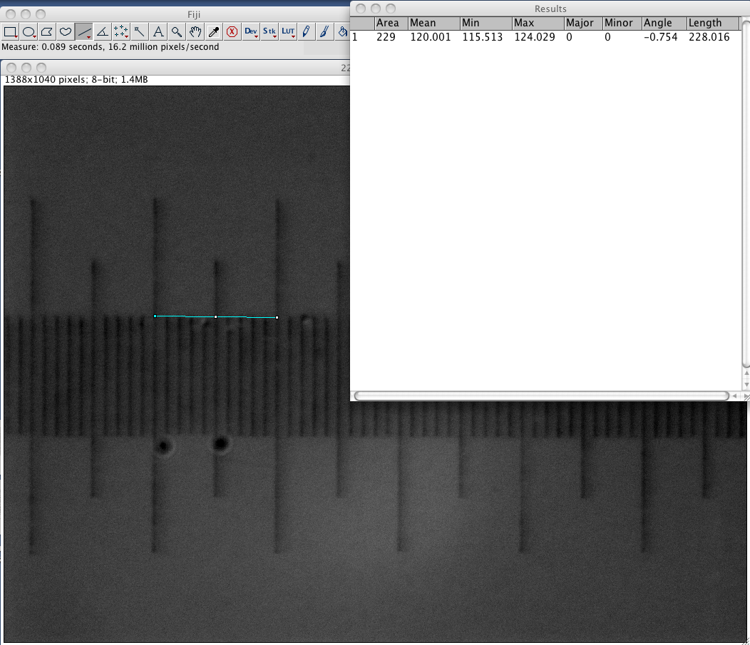

The micrometer CSV file is a comma-delimited file with no header (i.e. no column names, just data). It has three columns:

* Objective – a text string identifying the objective
* Zoom – a decimal number representing the zoom level (if you don’t have a zoom on your microscope, just put 1.0 in here)
* Microns Per Pixel – the microns per pixel as calculated above

You can add as many rows as you like. Missing zoom values will be interpolated automatically by WormSizer. The CSV file can be loaded at runtime in WormSizer.