## Installation

To install WormSizer, open Fiji, goto Plugins -> Install PlugIn and open the WormSize-fiji_.jar file. The plugin should now appear in your Fiji plugins menu.

There are two plugins under Fiji -> Plugins -> WormSizer. The WormSizer GUI is used for typical use. The WormSizer Batch is for use with CellProfiler or for use within an existing Fiji Macro.

## WormSizer GUI

In Fiji, goto Plugins -> WormSizer -> WormSizer GUI.

The main window has two buttons for the the two primary functions of WormSizer:

1. Analyzing directories of images and measuring nematode size and shape
2. Manually reviewing segmentation results from previously analyzed images

Press the play icon to begin analyzing images; press the magnifying glass icon to review previously analyzed images.

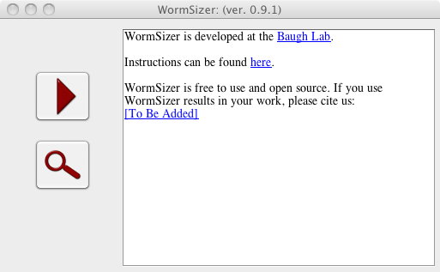

### Analyzing Images

In order to analyze images, there are three primary steps:

1. Choose directories for input and output,
2. Set the scale (microns per pixel),
3. Set the image processing settings.

### Choose Directories

WormSizer analyzes images by directory. Each directory is considered its own experiment or replicate. The directory must contain images, and the allowed image types are: TIFF, JPEG, PNG, and BMP. These images must be 8-bit (byte) grayscale images. If the "Include Subdirectories" option is checked, then WormSizer will process each subdirectory in the chosen directory, and each subdirectory will be treated like a separate experiment or replicate. The name of the directory containing images will be used as the name for output files.

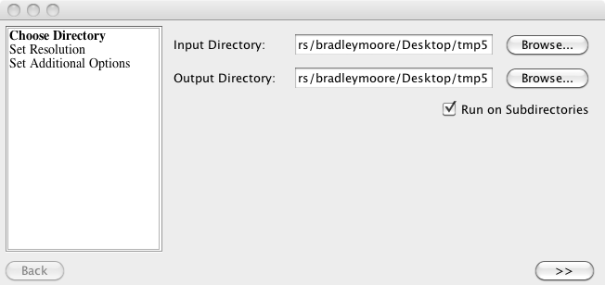

WormSizer produces three files per experiment:

1. EXPERIMENT-settings.csv - a comma-delimited file containing the settings used when analyzing the experiment. The columns are:
   * experimentId - the name of the directory containing images, this is used as a unique id for the experiment and groups images together
   * micronsPerPixel - the number of microns per pixel in each image
   * rollingBallRadius - the parameter for the background subtraction algorithm
   * thresholdMethod - the automatic threshold method used
   * closeRadius - the amount of morphological closing applied after thresholding
   * minWormArea - a lower bound on the size of an identified nematode (in pixels)
   * maxWormArea - an upper bound on the size of an identified nematode (in pixels)
   * minTubeness - a lower bound on the ratio of pruned segments to total segments in an identified nematode's skeleton
2. EXPERIMENT-results.csv - a comma-delimited file containing the measurements for each nematode in each image of an experiment. The columns are:
   * experimentId – the name of the directory containing images, this is used as a unique id and a key for referencing settings information
   * imageFile – the relative path from the output directory (which contains this file) to the image containing this nematode
   * id – a unique number (per image) identifying the nematode
   * pass – the outcome of manual review of this nematode, values are: true, false, NA (NA means it has not been reviewed)
   * volume – the volume of this nematode in (1000 x μm3 ) which is equivalent to (10-15 x m3)
   * length – the length of this nematode in microns
   * middleWidth – the width sampled at the middle of this nematode in microns
   * meanWidth – the mean width (100 sampled points along the skeleton) of this nematode in microns
3. EXERIMENT.xml – an XML file containing the above information as well as enough information to draw the outline of the nematode

### Set Resolution

WormSizer requires that you specify the resolution or number of microns per pixel for the images in an experiment. There are two ways to do this:

1. Set it manually – simply type the actual microns per pixel in the microns per pixel field and **press enter**.
2. Set it via objective and zoom settings – first, a micrometer file must be chosen.
   1. A micrometer file is a CSV file with the following fields, **no header row in the file**:
      * Objective - text describing the objective being used
      * Zoom – a decimal number representing the level of zoom associated with the objective
      * Microns per pixel – the number of microns per pixel for that objective and zoom
   2. Selective the objective from the drop-down menu
   3. Type the zoom and **press enter**
   4. The microns per pixel field will be updated with the calculated resolution.

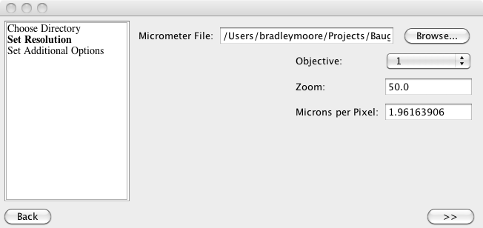

### Set Additional Options

WormSizer allows you to set additional options for the image processing algorithms. If you check the “Preview” box, you will see an image from the input set automatically analyzed. Each time you select a new drop down button or press enter in a field will update the preview image. The options are:

* Rolling Ball Radius - the parameter for the background subtraction algorithm
* Threshold Method - the automatic threshold method used
* Close Radius - the amount of morphological closing applied after thresholding
* Worm Area Filter - a bound on the size of an identified nematode (in pixels)
* Minimum Tubeness Filter - a lower bound on the ratio of pruned segments to total segments in an identified nematode's skeleton

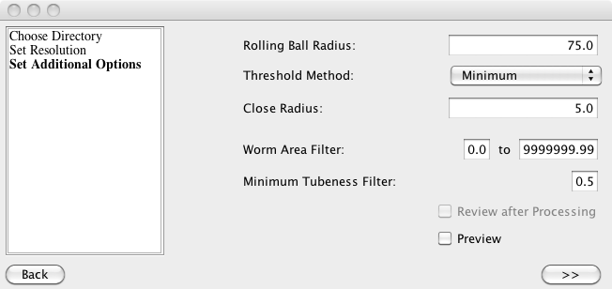

## Manual Review of Output

By pressing the magnifying glass on the introductory screen, you can review output generated by WormSizer. A file open dialogue will appear; simply point to the EXPERIMENT.xml file from a prior execution of WormSizer. The review process will begin by displaying an image an highlighting an identified nematode. The contour of the nematode is in yellow, the skeleton in dark blue, and the sample radii in cyan. The id of the nematode (also listed in the results file) is in red. The user may pass/fail the nematode by pressing [p] for pass or [f] for fail, or by pressing the green checkbox for pass or pressing the red X for fail. After pressing pass/fail, the next nematode in the image (or the next image if no other nematodes exist) will be shown. Each time a pass/fail is entered, the EXPERIMENT.xml and the EXPERIMENT-results.csv files will be updated in the “pass” column.

The user doesn’t have to pass/fail images, and can simply browse images and nematodes by using the arrows icons in the toolbar. The single-arrows icon will either select the previous or next nematode, the double-arrow icons will select the previous or next image. A pass/fail designation can be changed back to the default value of NA by toggling the green check or red X icons.

The overlay can be removed from the image (in order to get a better look at the image) by either pressing [w] or by toggling the worm icon. Users can also use Fiji’s zoom and image movement operations while reviewing an image to get a better look.

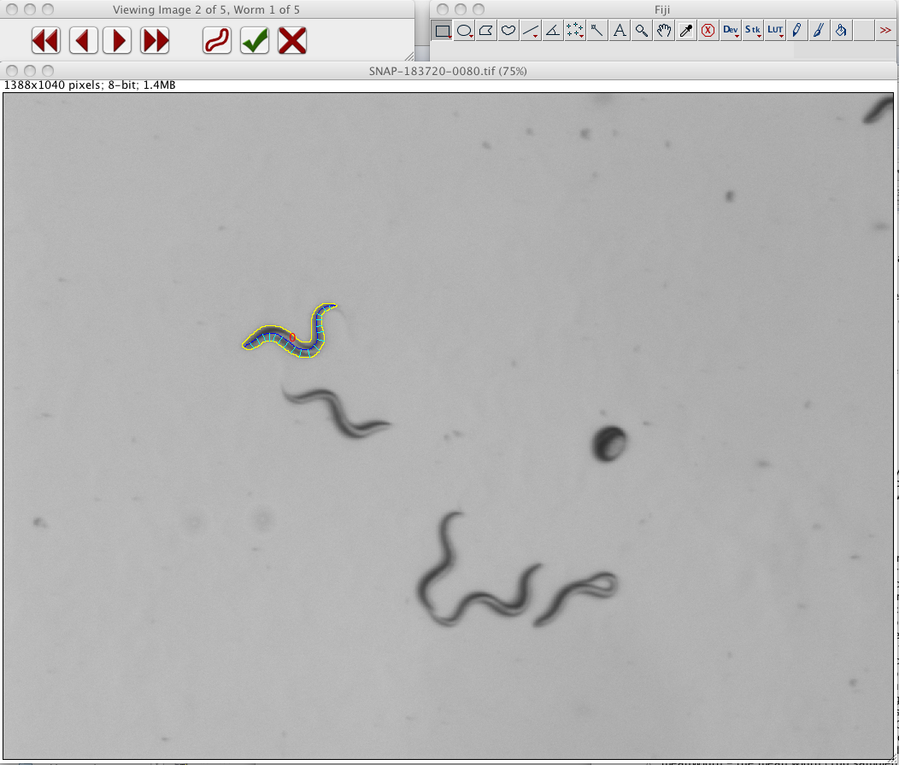

## WormSizer Batch

WormSizer Batch is a barebones plugin for use in CellProfiler or within a Fiji macro. Due to a limitation in the current version of CellProfiler, this will only work in **Windows (no Mac support)**.In order to use WormSizer in CellProfiler

1. Open CellProfiler -> Preferences and change the ImageJ plugin directory to your Fiji plugin directory (i.e. where the WormSizer-fiji_.jar exists).
2. Restart CellProfiler.
3. Download and load the example CellProfiler pipeline off of the WormSizer website.
4. Examine the RunImageJ pipeline step. WormSizer should be selected as the ImageJ command. The arguments to WormSizer can be (and should be) modified. Note, if using this within a Fiji macro, the plugin expects a black-white segmented image.
   1. xmlfile – this is where the output file from WormSizer will be written
   2. csvfile – this is where the CSV output file will be written
   3. micronsperpixel – the microns per pixel in the images
   4. minarea – the minimum area, in pixels, that a worm should have
   5. maxarea – the maximum area, in pixels, that a worm should have
   6. minscore – the minimum skeleton score (see WormSizer GUI instructions)
5. Run the pipeline
6. Note, any errors that occur should either appear in CellProfiler or in a file USER_HOME/wormsizer-error.txt