Brad Wagoner

[bradwagoner1@gmail.com](mailto:bradwagoner1@gmail.com)

CSC-E57 Assignment-1.1:

This project builds and runs with the following commands executed from within this directory:

mvn clean install

mvn exec:java -Dexec.mainClass="wagoner.brad.harvard.app.App" -Dexec.cleanupDaemonThreads=false

I began this assignment from the org.apache.maven.archetypes:maven-archetype-quickstart archetype. I then created the additional structure as shown below:

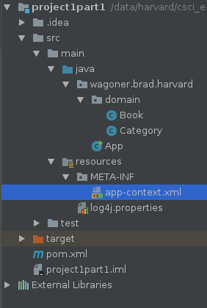

In the app-context file I first create the beans for the categories and the books, then I populated the collection beans that will be referenced from the App.java with the appropriate books.

Some of the books are populated using ref notation and others are created inline.

Following is the output of each of the category from App.java:

