Brad Wagoner

[bradwagoner1@gmail.com](mailto:bradwagoner1@gmail.com)

CSC-E57 Assignment-1.2: Spring JDBC

This project builds and runs with the following commands executed from within this directory:

mvn clean install

mvn exec:java -Dexec.mainClass="wagoner.brad.harvard.app.App" -Dexec.cleanupDaemonThreads=false

I began this assignment from the org.apache.maven.archetypes:maven-archetype-quickstart archetype. I then created the additional structure as shown below:

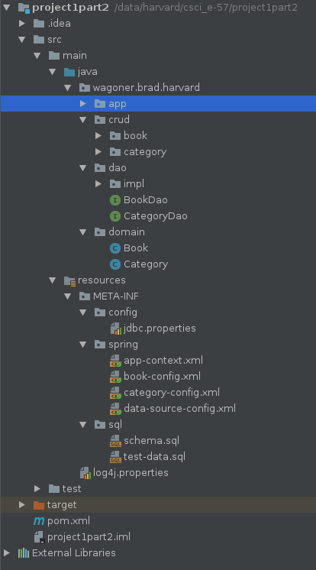

I then created the database described in src/main/resources/META-INF/sql/schema.sql and test-data.sql.

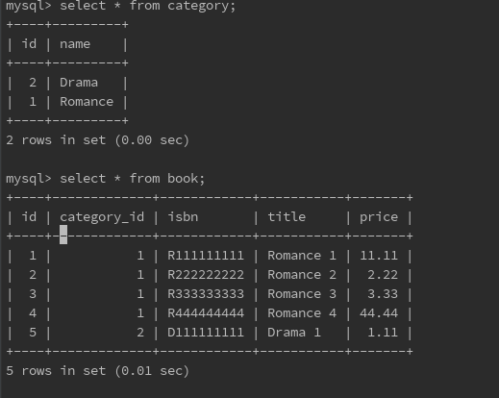

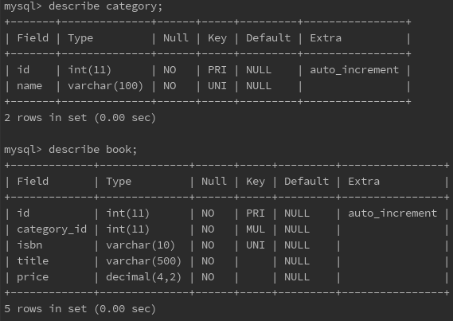

Then I began building and executing the different problems presented in the assignment.

* Find all books by category name

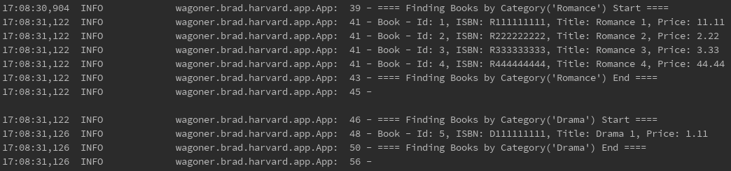

* Find all categories

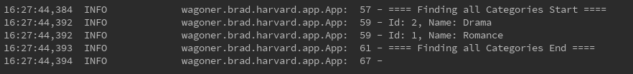

* Find all books

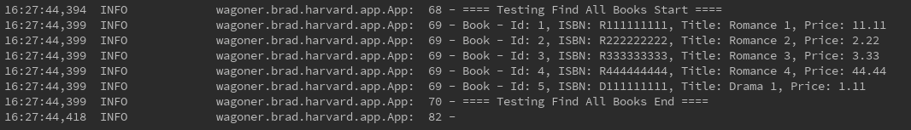

* Insert one book



* Update some data describing this book



* Delete this book



I also create CRUD methods for categories and exercise those methods in the App.java main class, they can also be debugged in you tune the log4j.properties – log4j.category.wagoner.brad.harvard.app entry to 'DEBUG'.