Cascading detection model for apnea-hypopnea events based on nasal flow and arterial blood oxygen saturation

**Abstract**

*Purpose*

Sleep apnea and hypopnea syndrome (SAHS) seriously affects sleep quality. In recent years, much research has focused on the detection of SAHS using various physiological signals and algorithms. However, there are still some limitations such as low detection resolution.

*Methods*

We proposed a cascading detection model for precise detection of apnea-hypopnea (AH) events based on morphological features extracted from nasal flow and arterial blood oxygen saturation (SpO2).

*Results*

For the more than 280,000 10-s segments in the database, the cascading detection model reached an accuracy of 89.0%. For more than 1800 AH events, it achieved a sensitivity of 82.8%, while the Pearson’s correlation coefficient between estimated AH index (AHI) and reference AHI was 0.98. In the diagnosis of SAHS severity, the proposed method exhibited a performance with a Cohen’s kappa coefficient of 0.83.

*Conclusions*

The cascading detection model is able to predict AH events and provide an estimate of AHI. The results indicate that it has the potential to be a useful tool for SAHS diagnosis.

**Keywords**

Sleep apnea and hypopnea syndrome, Apnea-hypopnea index, Polysomnography, Cascading detection model, Apnea-hypopnea events

**Introduction**

Sleep apnea and hypopnea syndrome (SAHS) is a prevalent sleep breathing disorder in middle-aged people. The gold standard for diagnosis of SAHS is to perform polysomnography (PSG) in a laboratory. However, PSG requires patients to sleep with many sensors for at least one night, the scoring of apnea-hypopnea (AH) events can take a long time. Therefore, many researchers hope to simplify or replace PSG by using a limited number of physiological signals. Electrocardiogram (ECG) was first studied for this purpose. McNames et al. [1] found that heart rate, S-pulse amplitude, and pulse energy were correlated with SAHS. Bsoul et al. [2] cut the ECG into 60 s segments and used a support vector machine (SVM) for real-time detection of SAHS. However, ECG is also correlated with many other diseases; hence, nasal flow (NF) [3-6], arterial blood oxygen saturation (SpO2) [7], snoring [8], or a combination of these signals [9, 10] have been adopted more recently. Gutierrez et al. [4] used the overall features of single-channel NF for the diagnosis of SAHS severity. Xie et al. [10] utilized a combination of classifiers to achieve real-time detection of SAHS based on ECG and SpO2. All the above studies can be roughly divided into two categories: those that predict the AH index (AHI) based on the detection of AH events [2, 3, 5, 7, 9-11], and those that predict it based on the overall signal features [1, 4, 6, 8, 12, 13]. The latter approach cannot provide time information for each AH event, whereas most studies in the former category [2, 7, 10, 11] only involve 60 s segment identification, which may lead to errors in the estimation of AHI. On the other hand, the methods mentioned above include threshold [5, 7, 9], SVM [2, 10, 11], and neural network [3, 11] approaches, which require a large number of hyperparameters to be set by experience. Therefore, we utilized random forests composed of CART decision trees based on morphological features extracted from NF and SpO2 for the real-time detection of SAHS. A 60 s detector and a 10 s detector were cascaded to improve the resolution of detection for AH events.

**Materials and Methods**

**Subjects**

The database used in this work was the St. Vincent University Hospital/Dublin University College Sleep Apnea Syndrome Database (UCDDB) [14] public on Physionet [15]. The database contains 25 subjects’ PSG data, including EEG, electrooculogram, submental electromyography, NF, ribcage and abdomen movements, SpO2, snoring, and body position. All signals were obtained using a Jaeger–Toennies system. The annotation files consisted of onset time and duration of respiratory events provided by an experienced specialist. The cutoff value for AHI is commonly set to 5, 15, or 30 events/h [3, 4, 7, 16, 17]. There were data for two non-SAHS subjects, 12 mild-SAHS subjects, five moderate-SAHS subjects, and six severe-SAHS subjects in the database. To balance the number of subjects in each class, we randomly selected two, four, four, and five subjects from each category, respectively, for training and testing. The sleep-related parameters of the subjects are summarized in Table 1.

Table 1. Summary of sleep-related parameters (mean ± standard deviation)

|  |  |  |  |  |
| --- | --- | --- | --- | --- |
|  | Non-SAHS | Mild SAHS | Moderate SAHS | Severe SAHS |
| Age (years) | 52.0±15.6 | 49.0±1.6 | 57.5±7.2 | 46.6±5.5 |
| AHI (events/h) | 4.1±5.7 | 12.4±1.8 | 25.6±3.6 | 43.8±16.3 |
| Epworth Sleepiness Score | 7.0±8.5 | 14.5±3.9 | 9.3±6.2 | 12.4±7.9 |

According to the American Academy of Sleep Medicine (AASM) manual [16], apnea should be scored when there is a more than 90% drop in the peak signal of the pre-event baseline for NF with a duration longer than 10 s. Hypopnea is scored by the following rules: 1) there is a more than 30% drop in the peak signal of the pre-event baseline for nasal pressure with a duration longer than 10 s, accompanied by 2) more than 3% arterial oxygen desaturation or an arousal. As a result, we selected NF and SpO2 for SAHS detection.

**Study design**

The cascading detection model based on AH event detection is shown in Fig. 1. It comprises the following main steps. 1) Removal of invalid data, filtering, segmentation with a sliding window, and SpO2 alignment. 2) Extraction of a specific feature set from each segment. 3) The cascading detection model predicts each segment and outputs a sequence of results. 4) The event detector corrects the invalid results in the sequence and calculates the AHI.

**Fig. 1** Design of cascading detection model based on AH event detection

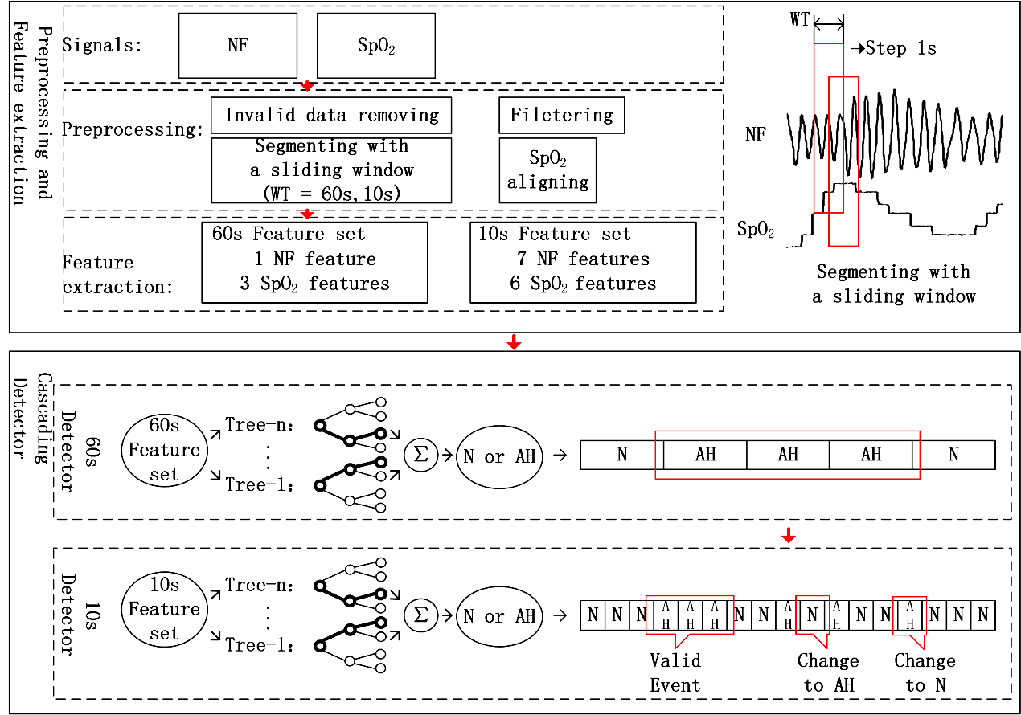

**Signal preprocessing**

Signal preprocessing comprises the following four steps. 1) Removal of invalid data. Normal people’s SpO2 tends to stay around 98%; therefore, any SpO2 values lower than 80% were considered to be artifacts and removed from the analysis (5.8% of the data). 2) Filtering: a four-point sliding average filter and a third-order Butterworth high-pass filter with a cut-off frequency of 0.05 Hz were used to prevent baseline drift and high-frequency noise caused by artifacts. 3) Segmentation: the original signals were segmented using a 60 s window and a 10 s window, respectively. In both cases, the step was set to 1 s. Segments were categorized into two classes: AH and N (normal). The segments containing more than 5 s SAHS were labeled as AH. Other cases were labeled as N. 4) SpO2 alignment. As SpO2 responds slowly to AH events [18], we moved SpO2 forward τ s (0<τ<30). The results showed that the model performed best with τ set to 23 s. After preprocessing, we obtained a total of 35,309 AH segments and 249,977 N segments.

**Feature extraction**

**NF feature set**

According to the AASM definition of AH events, the amplitude of the NF provides important information. Therefore, we first extracted the maximum () and minimum points from the NF data. Then the tidal volume per breath was calculated as the difference between two adjacent extreme points. The mean, standard deviation, and range of the tidal volume were extracted for each segment. We calculated the baseline of the tidal volume every 30 s using equation (1):

（1）

where represents the segment. The number of breaths with tidal volume reductions of more than 30% (and 70% (, and the number of normal breaths were calculated using equations (2)–(4).

（2）

（3）

（4）

Besides, owing to the cessation of breathing, there will be fluctuations in the breathing rate during AH events. One normal breath lasts for 3–5 s, energy will be concentrated with a peak in the corresponding frequency. As a result, we took the kurtosis in 0.2–0.4 Hz of NF’s FFT as another feature.

**SpO2 feature set**

There are always fluctuations in SpO2 during AH events; hence, we first calculated the standard deviation and range coefficients of SpO2 in each segment. The slope of SpO2 in each segment (was also calculated. Two other commonly used features were calculated: the times that SpO2 stays below 92% and 91% [19, 20] in each segment, respectively. We took the maximum ( and average SpO2 value every 30 s as the baseline. The duration and level of oxygen desaturation were calculated for each segment using equations (5)–(8).

（5）

（6）

（7）

（8）

All the above features were extracted from each segment; the total feature set is given in Table 2.

Table 2. Features and their definitions

|  |  |  |
| --- | --- | --- |
| Index | Name | Definition |
| 1 | , , | Average, standard deviation, and range of tidal volume |
| 2 |  | Number of breaths with a reduction more than 30% in tidal volume and its ratio to total number of breaths |
| 3 |  | Number of breaths with a reduction more than 70% in tidal volume and its ratio to total number of breaths |
| 4 |  | Number of normal breaths and its ratio to total number of breaths |
| 5 |  | Kurtosis in 0.2–0.4 Hz of NF’s FFT |
| 6 | , | Standard deviation and range of SpO2 |
| 7 |  | Slope of SpO2 |
| 8 |  | Duration of SpO2 desaturation |
| 9 |  | Level of SpO2 desaturation |
| 10 |  | Duration of SpO2 staying below 92% and 91% |

**Design of cascading detector**

The cascading detector contained two parts. The first was a random forest consisting of 10 CART decision trees for the prediction of 60 s segments. This could screen out most of the N segments while retaining the AH segments. The second part was a random forest consisting of 20 CART decision trees for the prediction of 10 s segments. Based on the results of the 60 s detector, the 10 s detector was able to locate the start and end times of AH events.

Note that the 60 s detector was trained using a feature set composed of features 2, 6, and 8, in order to improve the training speed; the results indicated that there was almost no effect on the performance. Owing to the imbalance in the number of AH and N segments, the weights for the two classes in CART trees were set to inverse ratio of their numbers.

A twofold cross-validation was used in the tests. Each time, half of the segments were used for training with the remaining half used for testing. The cascading detector output the sequence composed by the prediction results of the 10 s segments. The detector was trained on a computer with an i5-7600k CPU and 8 G RAM.

**Design of event detector**

The sequence predicted by the cascading detector was then fed into the event detector to correct invalid results using the following two rules. 1) Only an event lasting longer than 10 consecutive AH segments was considered to be a valid AH event. As the original data were segmented by a 10 s window, and one AH event lasts at least 10 s, one AH event corresponded to at least 10 consecutive AH segments. Any AH segment which did not meet the above rule was modified to N. 2) The N segments between two adjacent AH segments were required to be longer than five. This was also determined by the nature of the data segmentation. Any segment that did not meet the rule was reset to AH. The total number of AH sequences after event detection was considered to be the number of AH events, while the first and last segment of each AH sequence were considered to indicate the start and end times of the AH event.

**Results**

The cascading detection model was able to estimate AHI and provide a diagnosis of SAHS severity based on AH event detection. We analyzed its performance with respect to two aspects: segments and AHI.

**Segment analysis**

Table 3. Results for segments and events

|  |  |  |  |  |  |  |  |  |  |  |  |
| --- | --- | --- | --- | --- | --- | --- | --- | --- | --- | --- | --- |
| Segments |  | | | Reference | | | | ACC (%) | | SEN (%) | SPE (%) |
| AH | | N | |
| Estimated | | AH | 25942 | | 21898 | | 89.0 | | 73.5 | 91.2 |
| N | 9367 | | 228079 | |  | |  |  |
| AH events | | Wrong events | | | Right events | | Total events | | PPV (%) | | SEN (%) |
| 593 | | | 1513 | | 1828 | | 71.8 | | 82.8 |

The test set contained data for 15 subjects and more than 100 h, a total of 285,286 10-s segments. The prediction results for the above data are shown in Table 3. The cascading detection model achieved an accuracy (ACC) of 89.0%, a sensitivity (SEN) of 73.5%, and a specificity (SPE) of 91.2%. Table 3 also summarizes the prediction results for AH events. The cascading detection model detected 1513 of 1828 AH events, achieving a sensitivity of 82.8% with a positive predictive value (PPV) of 71.8%.

**AHI analysis**

Fig. 2(a) shows a scatter plot of the AHI estimated (AHIest) by the model and the AHI marked (AHIref) by PSG. The solid line fitted shows a high correlation (Pearson’s correlation coefficient 0.98) between AHIest and AHIref. Fig. 2(b) shows the Bland–Altman plot of AHIest and AHIref. The average error of AHIest and AHIref was -1.7 events/h, and the error range was -5.7 to 2.3 events/h with a 95% confidential coefficient.

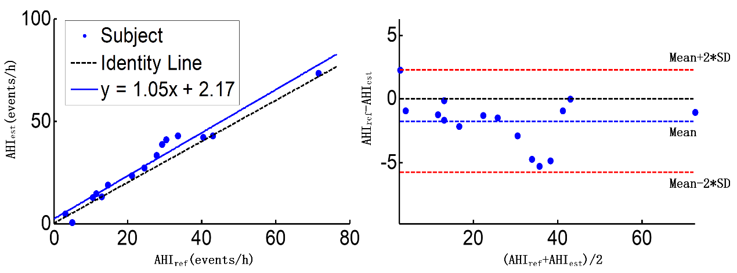

(a)

(b)

**Fig. 2** (a) Scatter plot of AHIest and AHIref; (b) Bland–Altman plot of AHIest and AHIref

Table 4 summarizes the classification results for SAHS severity. The mean values for sensitivity, specificity, PPV, and accuracy were 100.0%, 87.8%, 87.1%, and 93.3%, respectively, for AHI thresholds of 5, 15, and 30 events/h.

Table 4. SAHS severity classification and diagnostic performance

|  |  |  |  |  |  |  |  |  |  |  |
| --- | --- | --- | --- | --- | --- | --- | --- | --- | --- | --- |
|  |  | Determined from PSG | | | |  | AHI cutoff (events/h) | | | |
|  |  | Non | Mild | Moderate | Severe |  | ≥5 | ≥15 | ≥30 | AVE |
| Estimated | Non | 2 | 0 | 0 | 0 | SEN(%) | 100.0 | 100.0 | 100.0 | 100.0 |
| Mild | 0 | 3 | 0 | 0 | SPE(%) | 100.0 | 83.3 | 80.0 | 87.8 |
| Moderate | 0 | 1 | 2 | 0 | PPV(%) | 100.0 | 90.0 | 71.4 | 87.1 |
| Severe | 0 | 0 | 2 | 5 | ACC(%) | 100.0 | 93.3 | 86.6 | 93.3 |

**Discussion**

Here, we proposed a cascading detection model that could predict AHI based on AH event detection. Compared with PSG, only NF and SpO2 were used. Previously, the original signals were commonly cut into 60 s segments for AH event detection [2, 7, 10, 11]; however, this approach had two limitations. First, the detection resolution was not high enough. Detection by non-overlapping windows can only determine whether there was AH in the segment; it cannot predict the start and end time of the event. Furthermore, in some cases it cannot distinguish between two AH events with a short interval, which may lead to an error in AHI estimation. Therefore, some researchers [7, 9] cut the signals into shorter segments for detection. However, it is difficult to extract effective features from a segment shorter than 10 s, because there will be no more than five complete breaths in one segment in most cases. As a result, we proposed a cascading detection model composed of a 60 s detector and a 10 s detector to predict AH events precisely. Table 3 shows the classification results for the segments. Notably, the model tended to make false positive errors. Of these errors, around 10.3% actually met the rules recommended by AASM in 2012 (Fig. 3(a)), but the annotations in the database did not annotate. In the case of false negative errors, approximately 85.2% did not meet the rules in the AASM manual (Fig. 3(b)). These segments might have been annotated based on signals from other channels, such as ribcage or abdomen movements. The cascading detection model achieved a sensitivity of 94.9% and a specificity of 92.1% without these controversial segments.

**Fig. 3** (a) False positives in the prediction results; (b) False negatives in the prediction results

(a)

(b)

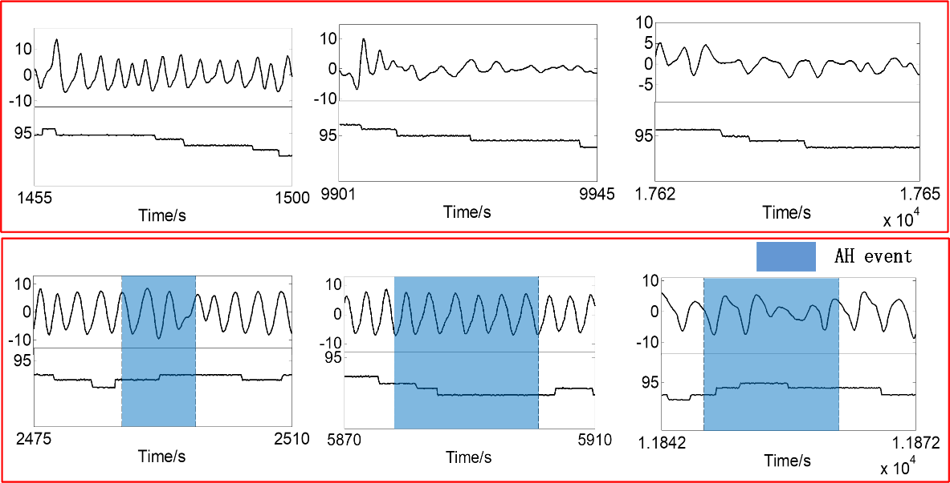

As illustrated in Fig. 2, AHIest showed high correlation with AHIref (Pearson correlation coefficient 0.98). The performance of the model also showed good consistency among different subjects. On the other hand, AHIest was slightly higher than AHIref. Consequently, SAHS severity was overestimated for three subjects; for the remaining 12 subjects, the model gave the correct prediction (Table 4). The average kappa coefficient of the cascading detection model for diagnosis of SAHS severity was 0.83, indicating that this method represents a powerful screening tool for SAHS.

We also tested the speed of the cascading detection model. Training required 13.9 s, while only 9.1 s was needed to provide results for all segments and to predict SAHS severity for all 15 subjects. It took 37 ms to predict one segment and 0.6 s to diagnose one subject on average. This implies that the model could be used for real-time SAHS detection.

Compared with the results of other studies, our method exhibited a good sensitivity but not very good specificity. We aim to improve the specificity in future work. More importantly, the model could not only predict the severity of SAHS but could also provide time information for each AH event. Furthermore, compared with other methods such as convolutional neural networks, a smaller number of hyperparameters and less computation were required by our random forest-based approach, and the CART trees provided better interpretability for clinical detection.

Table 5. Comparison with other studies

|  |  |  |  |  |  |  |
| --- | --- | --- | --- | --- | --- | --- |
| Related work | Method | Signal | AHI cutoff | ACC (%) | SEN (%) | SPE (%) |
| Choi et al. [3] | Convolutional neural networks | Nasal pressure | 5 | 96.2 | 100.0 | 84.6 |
| 15 | 92.3 | 98.1 | 86.5 |
| 30 | 96.2 | 96.2 | 96.2 |
| Gonzalo et al. [4] | AdaBoost-Linear discriminant analysis | Nasal flow | 5 | 86.5 | 87.1 | 80.0 |
| 15 | 81.0 | 85.9 | 72.9 |
| 30 | 82.5 | 74.2 | 90.6 |
| Current study | Cascade of random forests | Nasal flow and SpO2 | 5 | 100.0 | 100.0 | 100.0 |
| 15 | 93.3 | 100.0 | 83.3 |
| 30 | 86.7 | 100.0 | 80.0 |

However, there were some limitations to this study. First, we did not further classify AH events into apnea events and hypopnea events. Second, the model was not tested in an online environment. We hope to confirm the usability of our method online in the future.

**Conclusion**

The purpose of this study was to propose a model for real-time detection of SAHS. Based on the morphological features of NF and SpO2, the cascade of a 60 s detector and 10 s detector could not only predict AHI and SAHS severity, but could also provide time information for each AH event. Compared with previous research, the cascading detection model based on random forests provides better interpretation with reduced computational complexity. Therefore, it is expected to be an effective tool for SAHS diagnosis.