Cascading detection model for SAHS events based on ora-nasal flow and arterial blood oxygen saturation

**Abstract**

*Background*

Sleep apnea and hypopnea syndrome (SAHS) seriously affects people’s sleep quality and may lead to a series of cardiovascular diseases. In recent years, many researches have been made for the detection of SAHS using various physiological signals and algorithms. However, there are still some limitations such as low detection time resolution.

*Method*

We proposed a cascading detection model for precise detection of SAHS events based on morphological features extracted from ora-nasal flow (NF) and arterial blood oxygen saturation (SpO2).

*Results*

For the more than 280,000 ten-second segments in the database, the cascading detection model reached an accuracy of 89.0%. As for more than 1800 SAHS events, it achieved a sensitivity of 82.8%, while the Pearson’s correlation coefficient between estimated apnea-hypopnea index (AHI) and reference AHI was 0.98. Besides, for the diagnosis of SAHS severity, the proposed method exhibited performance results with a Cohen’s Kappa coefficient of 0.83.

*Conclusions*

The cascading detection model is able to predict SAHS events and provide an estimation of AHI which indicates that it can be used for diagnosis of SAHS before PSG.

**Keywords**

Sleep apnea and hypopnea syndrome, Apnea-hypopnea index, Polysomnography, Cascading detection model

**Introduction**

Sleep apnea and hypopnea syndrome (SAHS) is a prevalent sleep breathing disorder. Patients with SAHS experience repeated oxygen saturation and arousals due to complete (apnea) or partial (hypopnea) cessation of breathing during sleep. What’s more serious, SAHS is also a risk factor for cardiovascular disease, metabolic abnormalities and neurocognitive disorders[1]. It is estimated that 2% of the middle-aged women and 4% of middle-aged men are affected by SAHS[2].

The gold standard for diagnosis of SAHS is to perform Polysomnography (PSG) in laboratory. The specialist needs to score every sleep apnea and hypopnea event based on PSG and finally diagnose the severity of SAHS according to apnea-hypopnea index (AHI). However, on the one hand PSG requires patients to sleep in laboratory with many sensors for at least one night, on the other hand too much time are required for the score of SAHS events. Therefore, in recent years many researchers hope to simplify or replace PSG by using a limited number of physiological signals. Electrocardiogram (ECG) was firstly taken into study, McNames et al.[3] found that heart rate, S-pulse amplitude and pulse energy are correlated with SAHS. Oguzhan et al.[4] used K-Near-Neighbor (KNN) to predict whether a suspect is with SAHS based on heart rate variability. Bsoul et al. [5] cut the ECG into one-minute segments and utilize Support Vector Machine (SVM) to realize real-time detection of SAHS. However because ECG is a complex physiological signal that is also correlated with many other kinds of diseases, lately ora-nasal flow (NF)[6-9], arterial blood oxygen saturation (SpO2)[10], snoring[11] or a combination of these signals[12, 13] have been used for the detection. Gutierrez et al.[7] used the overall features of single-channel NF for the diagnosis of SAHS severity. B.Xie et al. [13] utilized a combination of classifiers to achieve real-time detection of SAHS based on ECG and SpO2. All the above studies can be roughly divided into two categories. One is to predict AHI based on the detection of SAHS events[5, 6, 8, 10, 12-14], one is to predict AHI based on the overall signal features[3, 4, 7, 9, 11, 15]. The latter cannot provide time information of each SAHS event, while most studies in the former[5, 10, 13, 14] are only for one-minute segment identification which may lead to error in the estimation of AHI. On the other side, the methods used in above studies include threshold[8, 10, 12], SVM[5, 13, 14], neural networks[6, 14], KNN[4]. Which acquire a large number of hyperparameters to be set by experience or test. Therefore, we utilized random forest consisted of CART decision trees based on morphological features extracted from NF and SpO2 for the real-time detection of SAHS. A long-time detector and a short-time detector are cascaded to improve the detection time resolution for SAHS events.

The structure of this paper is divided into the following four parts: the first part summarized the research progress of SAHS detection; the second part introduces the details of the cascading detection model; the third part quantitatively analyzes the performance of cascading detection model for SAHS events and AHI; the fourth part discusses the advantages of cascading detection model, the two types of error in prediction results and the comparison with other similar researches.

**Materials and Methods**

**Subjects**

The database utilized in this paper is St. Vincent University Hospital/Dublin University College Sleep Apnea Syndrome Database (UCDDB)[16] public on Physionet[17]. The database contains 25 subjects’ PSG which includes electroencephalogram (EEG), electrooculogram (EOG), submental electromyography (EMG), NF measured by thermistor, ribcage and abdomen movements, SpO2 measured by finger pulse oximeter, snoring and body position. All signals were obtained by Jaeger-Toennies system. The annotation file consisted of onset time and duration of respiratory events provided by an experienced specialist. The cutoff value of AHI is commonly set to 5, 15, 30 events/h[6, 7, 10, 18, 19], while AHI = 5 events/h is usually used to determine a SAHS-positive patient[20]. There are 2 non-SAHS subjects, 12 mild-SAHS subjects, 5 moderate-SAHS subjects and 6 severe-SAHS subjects in the database. To balance the number of subjects in each class, we randomly select 2, 4, 4, 5 subjects in each category for the following training and testing. The sleep-related parameters of the subjects are summarized in Table 1.

Table 1. Summary of sleep-related parameters (Mean ± Standard deviation）

|  |  |  |  |  |
| --- | --- | --- | --- | --- |
|  | Non-SAHS | Mild SAHS | Moderate SAHS | Severe SAHS |
| Age(years) | 52.0±15.6 | 49.0±1.6 | 57.5±7.2 | 46.6±5.5 |
| BMI(kg/m2) | 31.0±3.7 | 28.5±2.7 | 31.5±2.3 | 34.4±6.2 |
| AHI(events/h) | 4.1±5.7 | 12.4±1.8 | 25.6±3.6 | 43.8±16.3 |
| Study Duration(hours) | 7.0±0.9 | 7.0±0.2 | 6.6±0.4 | 6.8±0.8 |
| Epworth Sleepiness Score | 7.0±8.5 | 14.5±3.9 | 9.3±6.2 | 12.4±7.9 |

According to American Academy of Sleep Medicine (AASM) manual[18], apnea is scored when there is a more than 90% drop in the peak signal of pre-event baseline with a duration longer than 10s in the oro-nasal thermal sensor signal; hypopnea is scored by the following rules: 1) there is a more than 30% drop in the peak signal of pre-event baseline with a duration longer than 10s in the nasal pressure signal, accompanied by 2) more than 3% arterial oxygen desaturation or an arousal. As a result, we selected NF and SpO2 for SAHS detection.

**Study design**

The cascading detection model based on SAHS event detection is shown in Fig.1. It mainly includes the following four steps: 1) Invalid data removing, filtering, segmenting with a sliding window and SpO2 aligning. 2) Specific feature set extracted from each segment. 3) Cascading detection model predicts every segment and outputs a sequence of results. 4) Event detector corrects the invalid results in the sequence and calculates the AHI.

Figure 1. Design of cascading detection model based on SAHS event detection

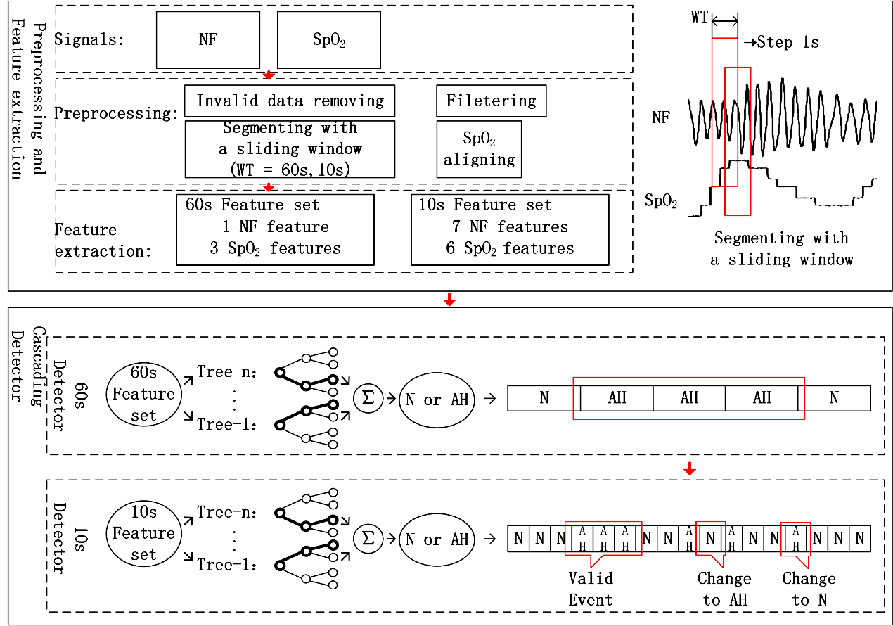

**Signal preprocessing**

Signal preprocessing includes the following four steps: 1) Invalid data removing. Normal people’s SpO2 tends to stay around 98%, therefore any SpO2 values less than 80% were considered as artifacts and removed from analysis (5.8% of data). 2) Filtering. In order to avoid the baseline drift and high-frequency noise caused artifacts, a 4-point sliding average filter and a third-order Butterworth high-pass filter were adopted. The cut-off frequency of the high pass filter was set at 0.05Hz. 3) Segmenting. The original signals were segmented by a 60-second window and a 10-second window respectively.

The step of both windows was set to 1 second. Segments were categorized into two classes: AH (apnea or hypopnea) and N (normal). The segments containing more than five seconds’ SAHS were labeled as AH. Other cases were labeled as N. 4) SpO2 aligning. Considering oxygen desaturation is typically delayed by ten or more seconds after SAHS events [21], we moved SpO2 forward τ seconds (0<τ<30) to avoid the influence of the delay. It was shown in test results that the cascading detection model performed best when τ was set to 23s. After preprocessing, we totally obtained 35,309 AH segments and 249,977 N segments.

**Feature extraction**

**NF Feature set**

According to AASM’s definition of SAHS events, there is important information in the NF’s amplitude. Therefore, we firstly extracted the extreme points in NF. Then the tidal volume of per breath was calculated by the difference between adjacent two extreme points (Fig. 2 (a)). The mean, standard deviation and range coefficients of tidal volume were extracted from each segment. Meanwhile we calculated the baseline of tidal volume every thirty seconds following equation (1).

（1）

In the equation, represents the segment. Then the number of breaths with a tidal volume reduction more than 30% (and 70% (and the number of normal breaths were calculated following the equations (2) ~ (4).

（2）

（3）

（4）

Besides, due to the cessation of breathing, there will be fluctuations in the breathing rate during the period of SAHS events. While one breath will last for three to five seconds in normal period. As a result, the energy of NF will be distributed mainly in the corresponding frequency (Fig. 2(b)). Hence, we took the kurtosis in 0.2-0.4 Hz of NF’s FFT as another feature.

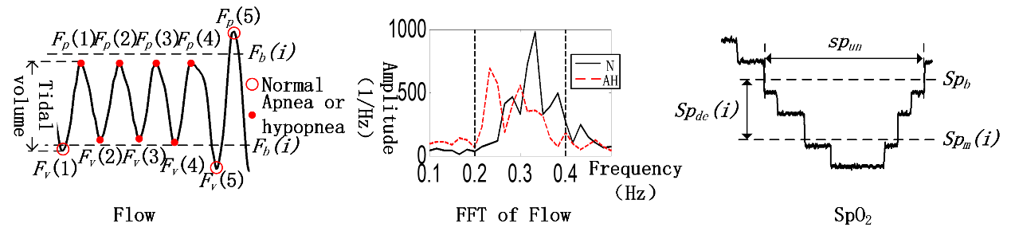

（a）

（b）

（c）

Figure 2. (a) NF features in time domain; (b) NF features in frequency domain; (c) SpO2 features in time domain

**SpO2 Feature set**

There are always fluctuations in SpO2 during the SAHS events’ period, hence we firstly calculated the standard deviation and range (coefficients of SpO2 in each segment. Meanwhile the slope of SpO2 in each segment (was also calculated. At the same time the commonly used features: the time of SpO2 stays below 92% and 91% [22, 23] in each segment were calculated as another two features. In order to capture the features of oxygen desaturation, we took the maximum ( and average SpO2 value in every thirty seconds as the baseline. Then the duration and level of oxygen desaturation were calculated in each segment following equations (5) – (8).

（5）

（6）

（7）

（8）

The total feature set is shown in table 2.

Table 2. Features and their definitions

|  |  |  |
| --- | --- | --- |
| Index | Name | Definition |
| 1 |  | Average tidal volume |
| 2 |  | Standard deviation of tidal volume |
| 3 |  | Range of tidal volume |
| 4 |  | The number of breaths with a reduction more than 30% in tidal volume and the ratio of it to the total number of breaths in the segment |
| 5 |  | The number of breaths with a reduction more than 70% in tidal volume and the ratio of it to the total number of breaths in the segment |
| 6 |  | The number of normal breaths and the ratio of it to the total number of breaths in the segment |
| 7 |  | The kurtosis in 0.2-0.4Hz of NF’s FFT |
| 8 |  | Standard deviation of SpO2 |
| 9 |  | Range of SpO2 |
| 10 |  | Slope of SpO2 in the segment |
| 11 |  | Duration of SpO2 desaturation |
| 12 |  | Level of SpO2 desaturation |
| 13 |  | Duration of SpO2 stays below 92% and 91% |

**Design of Cascading Detection Model**

The cascading detection model contains two parts. The first is a random forest consisted of ten CART decision trees for the prediction of 60-second segments. It can screen out most of the N segments while maintain most of AH segments; The second is a random forest consisted of twenty CART decision trees for the prediction of 10-second segments. Based on the results of 60s-detector, the 10s-detector is able to locate the onset and duration of SAHS events precisely.

The 10s-detector was trained using the feature set composed of feature 4, 8, 9 and 11. This reduced the computational complexity and improved the training speed of the detector. While the results illustrated that there was almost no effect on the performance. Besides, in order to overcome the imbalance of the number of samples in two classes, the weights for the two classes in CART trees were set to the inverse ratio of their numbers. Finally, in order to ensure that every CART tree in the random forest can be fully trained, the terminal condition for the growth of the tree was set as follows: 1) every leaf node contains at least fifty samples; 2) the maximum depth of the tree does not exceed thirty.

A two-fold-cross validation was used in the test. Each time, half of the segments were used for training while the remaining half were for test. The cascading detector will output the sequence composed by the prediction results of all 10-second segments. The cascading detection model was trained on a computer with an i5-7600k CPU and 8G RAM.

**Design of Event Detector**

The sequence predicted by cascading detector will then be fed into event detector to correct the invalid results following the two rules: 1) At least ten consecutive AH segments was considered to be a valid SAHS event. Since the original data was segmented by a 10-second window while one SAHS event lasts at least ten second, which determines that one SAHS event corresponds to at least ten consecutive AH segments while the segments do not meet the above were modified to N. 2) The interval between two adjacent AH segments should be longer than five. This is also determined by the way of data segmentation. Any segment does not meet the rule was reset to AH. The total number of AH sequence after the event detector was considered to be the number of SAHS events, while the first and last segment in each AH sequence was considered to be the start and end time of SAHS event.

**Results**

The cascading detection model is able to detect each event and its start and end time, then calculate the AHI and provide a diagnosis of the SAHS severity. We analyzed the performance of cascading detection model in two aspects: segments analysis and AHI analysis.

**Segments analysis**

Table 3. Results for segments and events

|  |  |  |  |  |  |  |  |  |  |  |  |
| --- | --- | --- | --- | --- | --- | --- | --- | --- | --- | --- | --- |
| Segments |  | | | Reference | | | | Acc(%) | | Sen(%) | Spe(%) |
| AH | | N | |
| Estimated | | AH | 25942 | | 21898 | | 89.0 | | 73.5 | 91.2 |
| N | 9367 | | 228079 | |  | |  |  |
| SAHS events | | Wrong events | | | Right events | | Total events | | Acc(%) | | Sen(%) |
| 593 | | | 1513 | | 1828 | | 71.8 | | 82.8 |

The test set contains fifteen subjects’ over one hundred hours of data, totally 285,286 ten-second segments. The prediction results for the above data are shown in Table 3. The cascading detection model achieved an accuracy of 89.0%, a sensitivity of 73.5%, and a specificity of 91.2%. Table 3 also summarizes the predicition results for SAHS events. The cascading detection model detected 1513 events from 1828 SAHS events, achieved a sensitivity of 82.8% accompanied by a positive predictive value (PPV) of 71.8%.

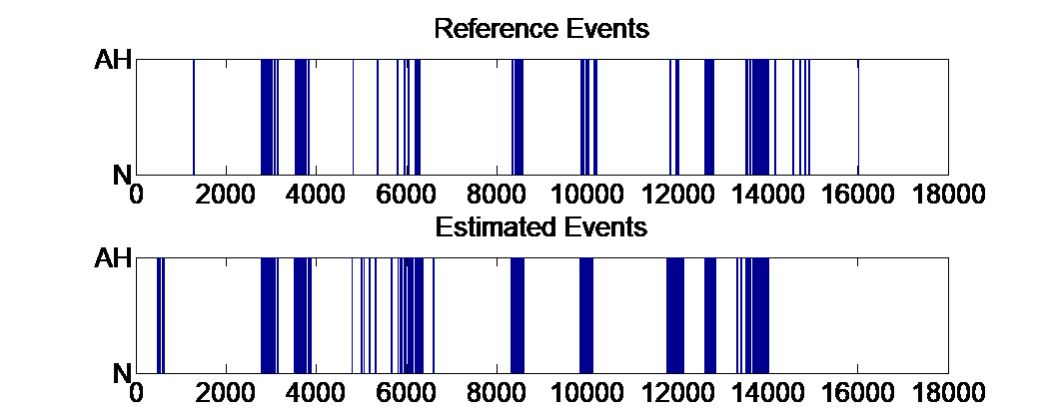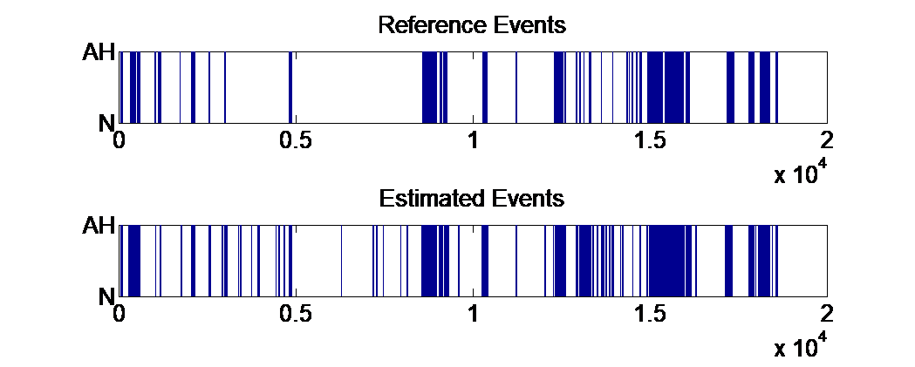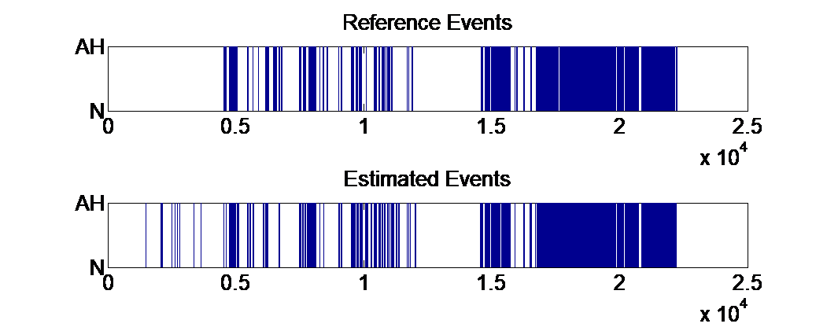

Reference Events

Estimated Events

Reference Events

Estimated Events

Reference Events

Estimated Events

N

N

AH

AH

N

N

AH

AH

N

N

AH

AH

(b)

(c)

(a)

Figure 3. (a) Best estimation result in mild-SAHS group; (b) Best estimation result in moderate-SAHS group; (c) Best estimation result in severe-SAHS group

Fig.3 displays the SAHS event estimation results for a mild, moderate and severe SAHS subject. For the mild-SAHS subject, the sensitivity and PPV were 76.7%, 78.0% respectively; While the corresponding values were 89.8% and 80.3% for the moderate-SAHS subject and 89.3%, 86.8% for the severe-SAHS subject.

**AHI analysis**

Fig. 4(a) shows a scatter plot of the AHI estimated (AHIest) by cascading detection model and the AHI marked (AHIref) by PSG. The solid line fitted shows a significant correlation (Pearson’s correlation coefficient = 0.98) between AHIest and AHIref. Fig. 4(b) shows the Bland-Altman plot of AHIest and AHIref. The average error of AHIest and AHIref is -1.7 events/h, and the error range is -5.7to 2.3 events/h with a 95% confidential coefficient.

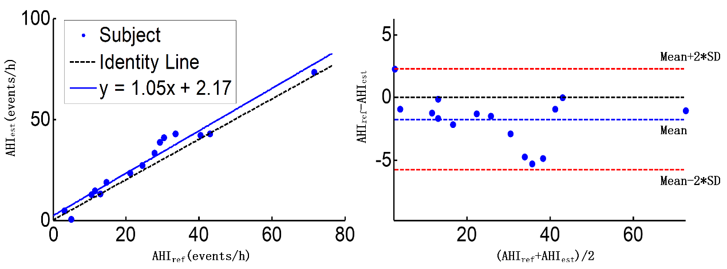

(a)

(b)

Figure 4. (a) Scatter plot of AHIest and AHIref; (b) Bland-Altman plot of AHIest and AHIref

Table 4 summarizes the classification results for SAHS severity. The mean values for sensitivity, specificity, PPV, accuracy were 100.0%, 87.8%, 87.1%, 93.3% respectively for AHI thresholds of 5, 15 and 30 events/h.

Table 4. SAHS severity classification and diagnostic performance

|  |  |  |  |  |  |  |  |  |  |  |
| --- | --- | --- | --- | --- | --- | --- | --- | --- | --- | --- |
|  | SAHS severity determined from PSG | | | | |  | AHI cutoff(events/h) | | | |
|  | Non | Mild | Moderate | Severe | Total |  | ≥5 | ≥15 | ≥30 | ave |
| Non | 2 | 0 | 0 | 0 | 2 | sen(%) | 100.0 | 100.0 | 100.0 | 100.0 |
| Mild | 0 | 3 | 0 | 0 | 3 | spe(%) | 100.0 | 83.3 | 80.0 | 87.8 |
| Moderate | 0 | 1 | 2 | 0 | 3 | pre(%) | 100.0 | 90.0 | 71.4 | 87.1 |
| Severe | 0 | 0 | 2 | 5 | 7 | acu(%) | 100.0 | 93.3 | 86.6 | 93.3 |
| Total | 2 | 4 | 4 | 5 | 15 |  |  |  |  |  |

**Discussion**

This paper proposed a cascading detection model that can predict SAHS event precisely. Compared with PSG, only NF and SpO2 were adopted in the model meantime based on the events’ prediction, the AHI can also be calculated. In the past, 60-second segments were commonly adopted for the event-based SAHS detection[5, 10, 13, 14], however there are two limitations. One is the detection resolution is not enough. The detection by non-overlapping window can only determine whether there is a SAHS event in the segment but cannot predict the start and end time of the SAHS event. Meanwhile in some cases it cannot distinguish the two SAHS events with a short interval (Fig 5(a)). However, if a 10-second window is adopted, there are no more than five complete breaths in one segment in most cases which improves the difficulty extracting effective features (Fig 5(b)). While on one hand, the cascade of 60s detector and 10s detector is able to capture the variation in signals caused by SAHS events in one minute. On the other hand, it can predict the SAHS events precisely.

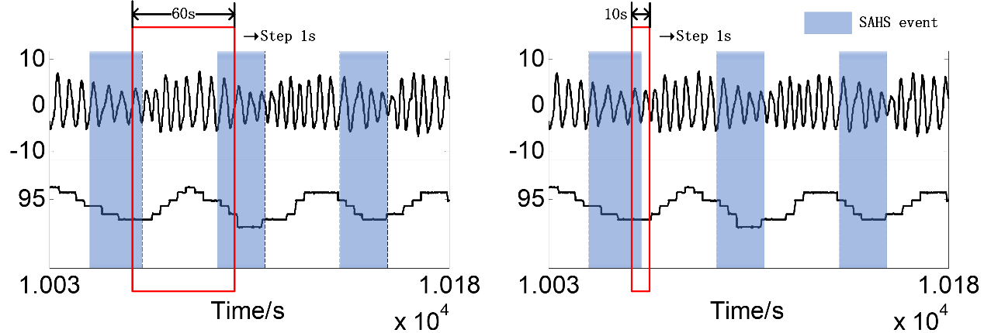

（a）

（b）

Figure 5. (a) Segmented by a 60-second window; (b) Segmented by a 10-second window

Table 3 shows the classification results of segments. The model achieved a sensitivity of 73.5% and a specificity of 91.2%. it should be noted that the model tended to make false positive errors. Around 10.3% of these errors actually met the rules recommended by AASM in 2012 (Fig. 6(a)), but the annotations in the database did not annotate these segments. Another part of these errors mainly appeared before or after AH segments which represents that the SAHS event estimated by the model tends to be longer than the reference. As for the false negative errors in the results, approximately 85.2% of these errors actually didn’t meet the rules in AASM’s manual (Fig. 6(b)), however the specialist may annotate these segments according to ribcage and abdomen movements. The cascading detection model achieved a sensitivity of 94.9% and a specificity of 92.1% without these controversial segments.

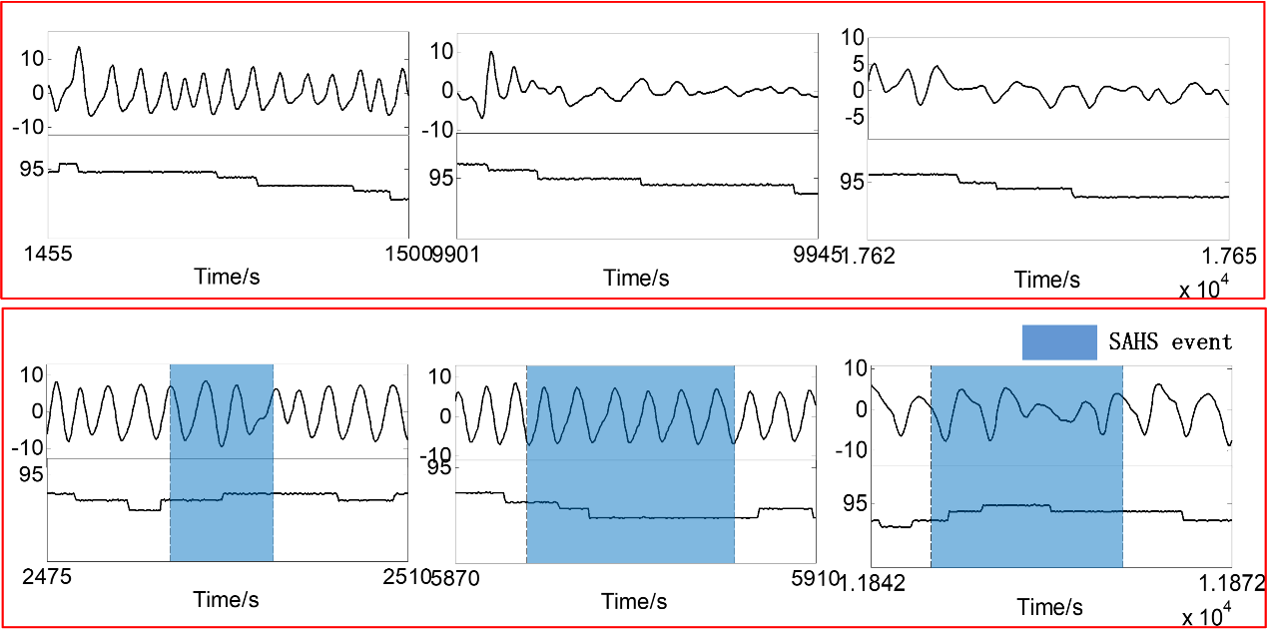

(a)

(b)

Figure 6. (a)False positives in the prediction results. (b)False negatives in the prediction results.

It is illustrated in Fig. 4 that the AHIest shows a high correlation with AHIref (Pearson correlation coefficient = 0.98). Meanwhile the model performed a good consistency among different subjects. Table 5 shows the comparison of AHIest and AHIref, the AHI estimated by the model is slightly higher than AHIref. Consequently, there were three subjects’ SAHS severity overestimated, as for the rest twelve subjects the model gave the correct prediction (Table 4). The average KAPPA coefficient of the cascading detection model for diagnosis of SAHS severity was 0.83, which means this method can be used as a powerful tool for screening SAHS.

Table 5. Comparison of the number of SAHS events and AHI from the proposed model and PSG

|  |  |  |  |  |
| --- | --- | --- | --- | --- |
| Group | No. of SAHS events | | AHI (events/h) | |
| Reference | Estimated | Reference | Estimated |
| Non-SAHS | 21.0±7.1 | 13.5±16.3 | 4.1±1.3 | 2.6±3.2 |
| Mild SAHS | 73.5±17.1 | 89.5±27.5 | 12.4±1.8 | 14.9±2.7 |
| Moderate SAHS | 133.2±23.3 | 160.0±38.3 | 23.0±3.6 | 27.6±6.6 |
| Severe SAHS | 191.8±70.5 | 216.2±71.0 | 43.8±16.3 | 40.7±14.0 |

We also tested the training and prediction speed of the cascading detection model. It cost the model 13.9s to get trained while only 9.1s to provide the results of all segments with every subject’s AHI and SAHS severity. 37ms were cost for predicting one segment on average and 0.6s was cost for predicting all SAHS events and AHI for one subject on average. Which implies that the model meets the needs of real-time detection for SAHS.

Table 6 shows the comparison with other studies. It can be seen that our method illustrates a good sensitivity but not very good specificity. This is where we want to improve in the future. More importantly, the model not only can predict the severity of SAHS but also can provide the time information for each SAHS event. Meanwhile compared with other methods such as convolutional neural networks, a smaller number of hyperparameters and less computation are required in random forest. And the CART trees in the random forest can provide a better interpretability in clinical detection.

Table 6. Comparison with other studies

|  |  |  |  |  |  |  |
| --- | --- | --- | --- | --- | --- | --- |
| Related work | Method | Signal | AHI cutoff | acc(%) | sen(%) | spe(%) |
| San Ho Choi et al.[6] | Convolutional neural networks | Nasal pressure | 5 | 96.2 | 100.0 | 84.6 |
| 15 | 92.3 | 98.1 | 86.5 |
| 30 | 96.2 | 96.2 | 96.2 |
| Da Woon Jung et al.[10] | Regression Model | SpO2 | 5 | 97.8 | 98.6 | 94.4 |
| 10 | 96.7 | 98.4 | 92.9 |
| 15 | 95.7 | 96.4 | 94.6 |
| 30 | 96.7 | 97.1 | 96.5 |
| Gonzalo C et al.[7] | AdaBoost-Linear discriminant analysis | Nasal flow | 5 | 86.5 | 87.1 | 80.0 |
| 15 | 81.0 | 85.9 | 72.9 |
| 30 | 82.5 | 74.2 | 90.6 |
| Our study | Cascade of random forests | Nasal flow and SpO2 | 5 | 100.0 | 100.0 | 100.0 |
| 15 | 93.3 | 100.0 | 83.3 |
| 30 | 86.7 | 100.0 | 80.0 |

At the same time, there are still some limitations in our research. First, we have no further classified SAHS events into apnea events and hypopnea events which may provide more information in clinical diagnosis. In addition, the model has not been tested in an online environment. We hope to confirm the usability of our method in the future.

**Conclusion**

The purpose of this study is to propose a model for real-time detection of SAHS. Based on the morphological features of NF and SpO2, the cascade of 60-second detector and 10-second detector can not only predict the AHI and SAHS severity, but can also provide the start and end time information of each SAHS event. Compared with previous research, the cascading detection model based on random forest is able to provide better interpretation and effectively reduces the computational complexity. Therefore, it is expected to be an effective tool for SAHS diagnosis.

[1] A. S. Jordan, D. G. McSharry, and A. Malhotra, "Adult obstructive sleep apnoea," *Lancet,* vol. 383, no. 9918, pp. 736-747, Feb 22 2014.

[2] T. Young, M. Palta, J. Dempsey, J. Skatrud, S. Weber, and S. Badr, "The occurrence of sleep-disordered breathing among middle-aged adults," *The New England journal of medicine,* vol. 328, no. 17, pp. 1230-5, 1993-Apr-29 1993.

[3] J. N. McNames, A. M. Fraser, and I. Ieee, "Obstructive sleep apnea classification based on spectrogram patterns in the electrocardiogram," in *Computers in Cardiology 2000, Vol 27*, vol. 27(Computers in Cardiology, 2000, pp. 749-752.

[4] O. Timus and E. Dogru Bolat, "k-NN-based classification of sleep apnea types using ECG," *Turkish Journal of Electrical Engineering and Computer Sciences,* vol. 25, no. 4, pp. 3008-3023, 2017 2017.

[5] M. Bsoul, H. Minn, and L. Tamil, "Apnea MedAssist: Real-time Sleep Apnea Monitor Using Single-Lead ECG," *Ieee Transactions on Information Technology in Biomedicine,* vol. 15, no. 3, pp. 416-427, May 2011.

[6] S. H. Choi *et al.*, "Real-time apnea-hypopnea event detection during sleep by convolutional neural networks," *Computers in Biology and Medicine,* vol. 100, pp. 123-131, 2018/09/01/ 2018.

[7] G. C. Gutierrez-Tobal, D. Alvarez, F. del Campo, and R. Hornero, "Utility of AdaBoost to Detect Sleep Apnea-Hypopnea Syndrome From Single-Channel Airflow," (in English), *Ieee Transactions on Biomedical Engineering,* Article vol. 63, no. 3, pp. 636-646, Mar 2016.

[8] H. Lee, J. Park, H. Kim, and K.-J. Lee, "New Rule-Based Algorithm for Real-Time Detecting Sleep Apnea and Hypopnea Events Using a Nasal Pressure Signal," *Journal of Medical Systems,* vol. 40, no. 12, Dec 2016, Art. no. 282.

[9] H. Nakano, T. Tanigawao, T. Furukawa, and S. Nishima, "Automatic detection of sleep-disordered breathing from a single-channel airflow record," *European Respiratory Journal,* vol. 29, no. 4, pp. 728-736, Apr 2007.

[10] D. W. Jung *et al.*, "Real-Time Automatic Apneic Event Detection Using Nocturnal Pulse Oximetry," (in English), *Ieee Transactions on Biomedical Engineering,* Article vol. 65, no. 3, pp. 706-712, Mar 2018.

[11] J. Sola-Soler, J. Antonio Fiz, J. Morera, and R. Jane, "Multiclass classification of subjects with sleep apnoea-hypopnoea syndrome through snoring analysis," *Medical Engineering & Physics,* vol. 34, no. 9, pp. 1213-1220, Nov 2012.

[12] W. Huang, B. Guo, Y. Shen, and X. Tang, "A novel method to precisely detect apnea and hypopnea events by airflow and oximetry signals," *Computers in Biology and Medicine,* vol. 88, pp. 32-40, Sep 1 2017.

[13] B. Xie and H. Minn, "Real-Time Sleep Apnea Detection by Classifier Combination," *IEEE Transactions on Information Technology in Biomedicine,* vol. 16, no. 3, pp. 469-477, 2012.

[14] N. Hoa Dinh, B. A. Wilkins, Q. Cheng, and B. A. Benjamin, "An Online Sleep Apnea Detection Method Based on Recurrence Quantification Analysis," *Ieee Journal of Biomedical and Health Informatics,* vol. 18, no. 4, pp. 1285-1293, Jul 2014.

[15] D. W. Jung, S. H. Hwang, Y. J. Lee, D.-U. Jeong, and K. S. Park, "Apnea-Hypopnea Index Prediction Using Electrocardiogram Acquired During the Sleep-Onset Period," *Ieee Transactions on Biomedical Engineering,* vol. 64, no. 2, pp. 295-301, Feb 2017.

[16] "St. Vincent's University Hospital University College Dublin Sleep Apnea Database," 2008. <http://physionet.org/pn3/ucddb/>

[17] A. L. Goldberger *et al.*, "PhysioBank, PhysioToolkit, and PhysioNet - Components of a new research resource for complex physiologic signals," *Circulation,* vol. 101, no. 23, pp. E215-E220, Jun 13 2000.

[18] R. Berry *et al.*, "Rules for scoring respiratory events in sleep: update of the 2007 AASM Manual for the Scoring of Sleep and Associated Events. Deliberations of the Sleep Apnea Definitions Task Force of the American Academy of Sleep Medicine," (in eng), *J Clin Sleep Med,* vol. 8, no. 5, pp. 597-619, 2012.

[19] A. Qureshi, R. D. Ballard, and H. S. Nelson, "Obstructive sleep apnea," *Journal of Allergy and Clinical Immunology,* vol. 112, no. 4, pp. 643-651, 2003/10/01/ 2003.

[20] f. American academy of sleep medicine task, "Sleep-related breathing disorders in adults : recommendations for syndrome definition and measurement techniques in clinical research," *Sleep,* vol. 22, pp. 667-689, 1999 1999.

[21] N. Selvaraj, R. Narasimhan, and Ieee, "Detection of Sleep Apnea on a Per-Second Basis Using Respiratory Signals," in *2013 35th Annual International Conference of the Ieee Engineering in Medicine and Biology Society*(IEEE Engineering in Medicine and Biology Society Conference Proceedings, 2013, pp. 2124-2127.

[22] L. G. Olson, A. Ambrogetti, and S. G. Gyulay, "Prediction of sleep-disordered breathing by unattended overnight oximetry," (in English), *Journal of Sleep Research,* Article vol. 8, no. 1, pp. 51-55, Mar 1999.

[23] U. J. Magalang *et al.*, "Prediction of the apnea-hypopnea index from overnight pulse oximetry," *Chest,* vol. 124, no. 5, pp. 1694-1701, Nov 2003.