Image Compression using Singular Value Decomposition (SVD)

by Brady Mathews

12 December 2014

The University of Utah

# (1) What is the Singular Value Decomposition?

Linear Algebra is a study that works mostly with math on matrices. A matrix is just a table that holds data, storing numbers in columns and rows. Linear Algebra then takes these matrices and tries to manipulate them which allows for us to analyze large portions of data. This paper will be discussing one of these large portions of data as we talk about image compression later on where each pixel can be represented as a number, and the columns and rows of the matrix hold the position of that value relative to where it is on the image.

First however, let us talk about what the Singular Value Decomposition, or SVD for short, is. When given a matrix, there are several important values that mathematicians can derive from them that help explain what the data represents, classify the data into families, and they can also manipulate matrices by pulling them apart into values that are easier to work with, then stitching those values back together at the end of the computation to obtain some type of result. The SVD is one such computation which mathematicians find extremely useful.

What the SVD does is split a matrix into three important sub matrices to represent the data. Given the matrix A, where the size of a is where represents the number of rows in the matrix, and represents the number of columns, A can be broken down into three sub matrices where is of size , is of size and is diagonal, and is of size . It is required for matrix multiplication that the size of the columns of the first matrix must match up with the size of the rows of the second matrix. When you multiply a matrix of size and a matrix of size , the resulting matrix will yield a matrix of size .

So, abstracting the matrices into their size components, we can see that this multiplication will yield a matrix of the same size:

Now, the interesting part of these matrices “” are that the data is arrange in such a way that the most important data is stored on the top. is a matrix that holds important information about the rows of the matrix, and the most important information about the matrix is stored on the first column. is a matrix that holds important information about the columns of each matrix, and the most important information about the matrix is stored on the first row. is a diagonal matrix which will only have at most “” important values, the rest of the matrix being zero. Because the important numbers of this matrix are only stored on the diagonal, we will ignore this for size comparison.

Key point: The reason why the SVD is computed is because you can use the first components of these matrices to give you a close approximation of what the actual matrix looked like. Going back to our size example, if the most important information of is stored on its first column, then ’s important information can be written as an matrix. If the most important information of is stored on its first row, then ’s important information can be written as a ( matrix. We will also say that the important information of is stored on the first row, first column of that matrix, yielding a matrix. By multiplying these matrices together:

We can see that the resulting computation is the same size as the original matrix. This resulting matrix, which we will call , is a good approximation of the original matrix . For an even closer approximation, you include the next column of and the next row of . But where do these magic matrices come from? Linear algebra holds the mystery.

# (2) Computing the SVD

Now we will get into the math and theory behind what I just described above. We will go through an example to solve the equation .

Given find the SVD:

The first thing we need to find in this computation is finding the matrix . The superscript T stands for “transpose” which to put nicely, you flip the matrix on its side, row one becoming column one.

If you’re not a mathematician, matrix multiplication works likes so. To get the first row, first column of the resulting matrix, you need to take the first row of the first matrix, and the first column of the second matrix. Then you multiply the corresponding first values together, and the corresponding second values together etc., and then sum those values.

Therefore, first row first column: will yield

Once you find , you will need to find its eigenvalues and eigenvectors. To find the eigenvalues of the matrix, you need to compute the determinate of and solving for , where I is the identity matrix. First let’s find :

Now what we need to do is compute the determinate of this matrix. The determinate is more complicated to find. The determinate of a matrix is defined as the following:

For a matrix, you can pick one column in the matrix. You go down that column, and write down the number. You then multiply that number with the determinate of the remaining matrix that appears when you cancel out the whole row and column that the corresponding number belongs to. Example:

Given the matrix:

We can pick to iterate down the first column in the matrix and choose the first value to be . We then cross off the column and row that belongs to, and multiply by the determinate of the resulting matrix.

We can continue to iterate down the row to get the other two values for the determinate:

Therefore, the resulting determinate looks like:

You do sum the result, but we have the subtraction in the second term because there is really an invisible multiplied to each term, where *“x”* is the row number and *“y”* is the column number. Going back to our definition of how to solve the determinate of a matrix, we get:

Now in our example matrix, we have a lot of zeros in column 3, so instead let’s iterate down colum3 to compute our result.

Since zero multiplied by anything is zero, we can drop the first two terms:

Computing the matrix we get:

Now we can solve to find when to find our eigenvalues:

Therefore or eigenvalues are 8, 2, and 0. You will want to keep these numbers in descending order.

With this information, we can find an important value which is the square root of the eigenvalues. We ignore zero for the term. Therefore:

**and**

These values are the important values along the diagonal of matrix .

Next we need to find the normalized version of the corresponding eigenvectors to each of the eigenvalues. To find an eigenvalue, replace with the corresponding eigenvalue in the equation . Then find the *nullspace* of that resulting matrix:

When , the resulting matrix yields:

To find the nullspace of this matrix, we need to find some vector *“”* that when multiplied by the matrix, will yield the zero vector. The vector though cannot be the zero vector itself. There are complicated methods to solve for the nullspace, however in this example, you might be able to just see it.

As you can see, when we multiply this vector by the matrix, it will yield the zero vector:

Now that we found *“”*, we need to compute the normalized version, and then solve for the remaining eigenvectors in a similar fashion. To find the normalized version, you multiply the vector by the reciprocal of the square root of the sum of the squared rows. So for this example, and the sum of the squared rows is 2. Therefore the normalized version is:

Now we need to find the normalized eigenvectors for when and when .

When , the resulting matrix yields:

When , the resulting matrix yields:

Now that we have found or eigenvalues denoted by *“”* we need to find this term *“u”* which can be found using the equation **or** .

Calculating the next term:

Since there are no more terms, we can stop there. Now with all of the values we have found, we can complete the three matrices in the equation .

First is the matrix *U* which can be found by making the first column in the matrix the first term and the second column the second term. Therefore:

Next is the matrix which is the same size as the matrix *A* and can be found by placing the terms along the diagonal of a matrix of that size, and then filling in the rest of the matrix with zeros.

Lastly is the matrix which can be found by first computing and then transposing it, by turning the columns into the corresponding rows. is found similar to *U* in the fact that the columns of are the corresponding terms. Remember to multiply the constant used to scale the vector through the entire term before adding it to the matrix.

So now we have the finished equation yields:

You can also multiply the terms together to show that the equation holds true. Now to move onto the point of this paper, why do we care, and what are the real world applications.

# (3) Compressing an Image

The monitor on your computer is a truly magical device. When you look at the color white on your screen, you’re not actually looking at white, and the same thing for the color yellow. There is actually no white or yellow pigment in your screen. What you are looking at is a mixture of the colors red, green, and blue displayed by extremely small pixels on your screen. These pixels are displayed in a grid like pattern, and the saturation of each pixel tricks your brain into thinking it’s a different color entirely when looked at from a distance.

These red, green, and blue pixels range in saturation on a scale of 0 to 255; 0 being completely off, and 255 being completely on. They can also be written in hexadecimal format like #F5C78A for example. In hexadecimal, A is the value 10, and F is the value 15, therefore 0F = 15 and A0 = 16. The first two numbers in this string of numbers represents the red value, the next two representing the green value, and the final two representing the blue value. To put reference into what these are doing, here are some easy color examples:

#000000 = Black

#FFFFFF = White

#A0A0A0 = Gray

#FF0000 = Red

#00FF00 = Green

#0000FF = Blue

Because of a pixel’s grid like nature on your monitor, a picture can actually be represented as data in a matrix. Let’s stick with a grayscale image for right now. To make an image gray, the values for red, green, and blue need to be the same. Therefore you can represent a pixel as having a value of 0 through 255 (in hexadecimal 00 through FF), and then repeating that value across the red, green, and blue saturation to get the corresponding shade of gray.

Let’s say that you have a grayscale image that is pixels in dimension. Each of those pixels can be represented in a matrix that is also , where the values in the matrix range from 0 to 255. Now, if you wanted to store that image, you would have to keep track of exactly numbers or 10,000 different pixel values. That may not seem like a lot, but you can also think if the image as your desktop background which is probably and image in which you would have to store 1,310,720 different pixel values! And that’s if it was a grayscale image, if it was colored, it would be triple that, having to keep track of 3,932,160 different numbers, which if you think about one of those numbers equating to a byte on your computer, that equals 1.25MB for a grayscale image or 3.75MB for a colored image. Just imagine how quickly a movie would increase in size if it was updating at the rate of 30-60 frames per second.

What we can actually do to save memory on our image is to compute the SVD and then calculate some level of precision. You would find that in an image that is pixels would look really quite good with only 10 *modes* of precision using the SVD computation.

Going back to our example in section 1, “The reason why the SVD is computed is because you can use the first components of these matrices to give you a close approximation of what the actual matrix looked like.”

Then we calculated the first components of these matrices by taking the first column of *U* and multiplying it by the first row of . We saw that this resulted in a matrix with the dimensions of the original matrix *A.*

Modes are how many columns of the matrix *U* you want to use and how many rows of the matrix you wanted to use to calculate your specified level of precision.

Therefore if we have a matrix , and we use a level of precision of 10 modes, we will find that our matrices are:

So now we are only keeping track of 2,100 different numbers instead of 10,000 which greatly increases the storage of memory. Also, if you remember how we computed , it is a diagonal matrix with values along the diagonal and zeros everywhere else. Therefore, we can represent as only being the first ten values of , and saving only those values in memory, reconstructing the matrix when opening the file, and goes from size 100 to size 10. However, there may not be as many in the computation as the size of the matrix, in a matrix, you can have at most five ’s, but you can also have as little as one, the rest of the values on the diagonal also being zero. So really # modes, which is going to be so little anyway, we are going to negate it from our computation.

That’s great in theory, but when you compute these new matrices using your specified modes of precision, what do they actually look like? Well, using a program called “MatLab”, we can write a program that will load in image file, turn the pixel values of the grayscale image into a matrix, compute the SVD for us, and then convert our new matrix back into an image for our viewing pleasure.

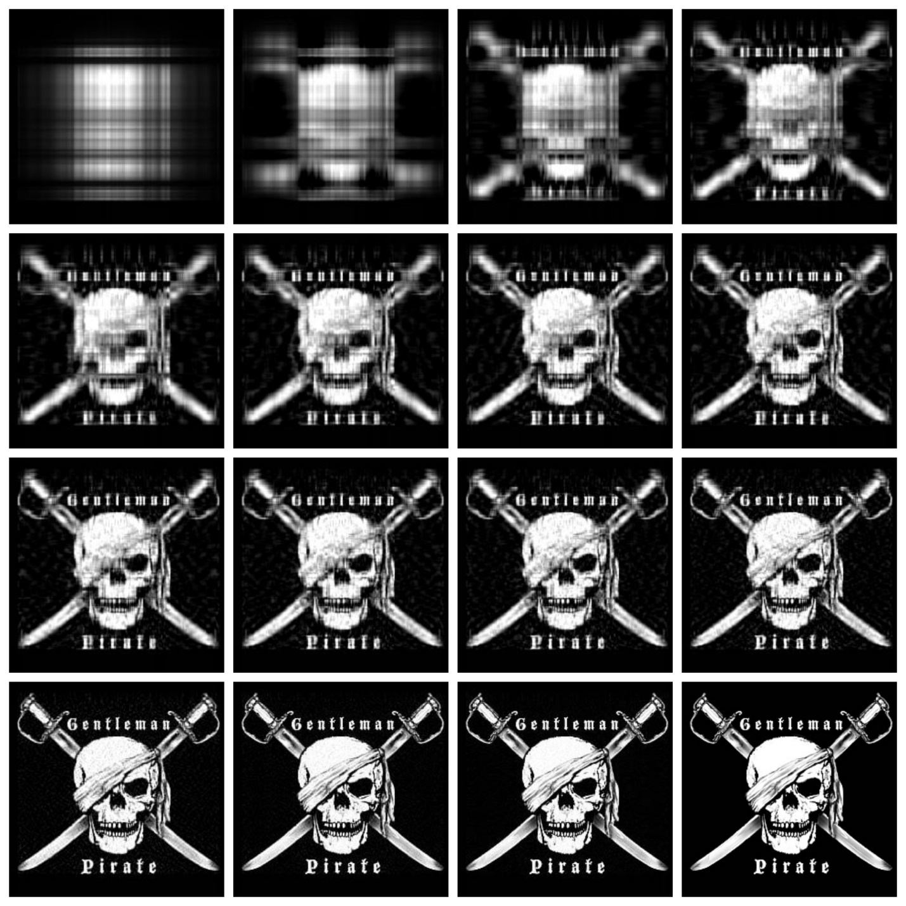

Figure 3.1: Image size 250x236 – modes used {{1,2,4,6},{8,10,12,14},{16,18,20,25},{50,75,100,original image}}

In figure 3.1 we see that the image size is 250x236 pixels. By storing the image in its entirety, we can calculate that we would need to store 59,000 different pixel values. The image starts to look very decent along the bottom row, the last images using modes 50, 75, and 100. By negating the size of since it is so miniscule, we can calculate:

Original Image: 59,000 bytes

Mode 100: 48,600 bytes

Mode 75: 36,450 bytes

Mode 50: 24,300 bytes

So, these modes actually do save on memory quite a bit, more than halving the amount of memory used at mode 50, which is represented by the bottom left image in figure 3.1.

We can even graph the error involved in the image compression, or how badly the image differs from the original image. We can gather the data by measuring the error as the difference in our new image by the differences in our original image and plot it on a graph.

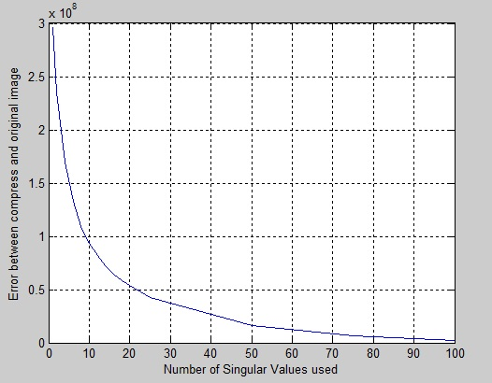

Graph 3.1: Shows the difference in the new image to the original image of Figure 3.1 by calculating the error rate between the two.

The graph starts to show a heavy turn at about 15 modes in, and starts to show a decent image approximately 30 modes in, 50 modes having an extremely low number or error, and 100 modes having a miniscule amount.

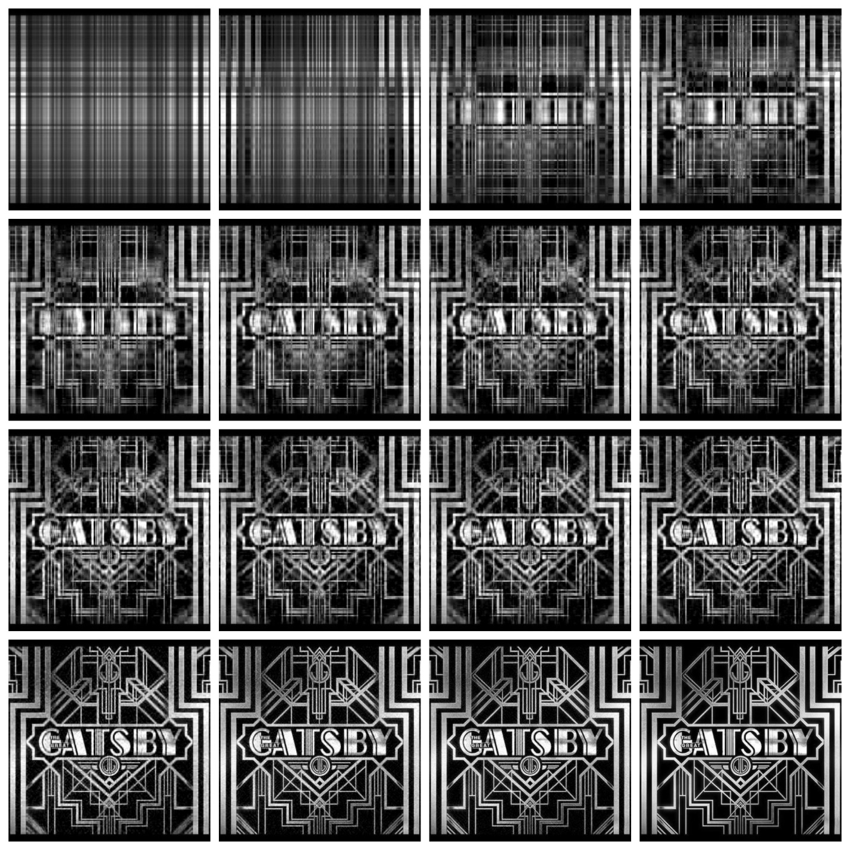

Figure 3.2: Image size 600x387, same modes used as in Figure 3.1

A second example, the image shown by figure 3.2, we use the exact same modes, and the image is even bigger. For this we can calculate the estimated file sizes again:

Original Image: 232,200 bytes

Mode 100: 98,700 bytes

Mode 75: 74,025 bytes

Mode 50: 49,350 bytes

And we can also show the error rates from the new image to the original image as well, and by halving the memory on mode 100, you could keep increasing the number of modes and still get save on memory.

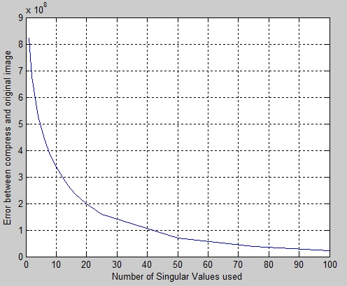

Graph 3.2: Shows the difference in the new image to the original image of Figure 3.2 by calculating the error rate between the two.

Now we can see that this works for a grayscale image, but what about a colored image? Would this still have the same application for image compression? The answer is a surprising yes, but it does require a few more calculations.

The difference between a grayscale image and a colored image is that you are now storing 3 bytes of information per pixel rather than 1 byte per pixel. This is because the red, green, and blue pixel values are now different rather than the same, so we have to represent each individually.

First, we need to take a colored image, and split it into three new images, a red-scale, green-scale, and blue-scale image.

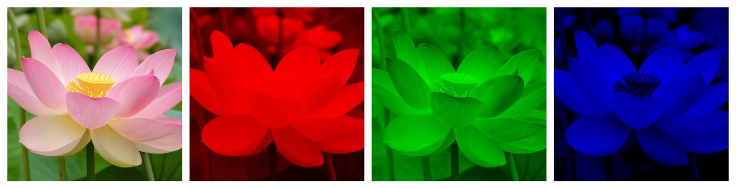

We can treat the red-scale, green-scale, and blue-scale images just like we did with the grayscale image. This time the values 0 through 255 on our table represent only the saturation of that particular color. We can compute the SVD computation on each of these images separately, and then combine them back together to create our colored image.

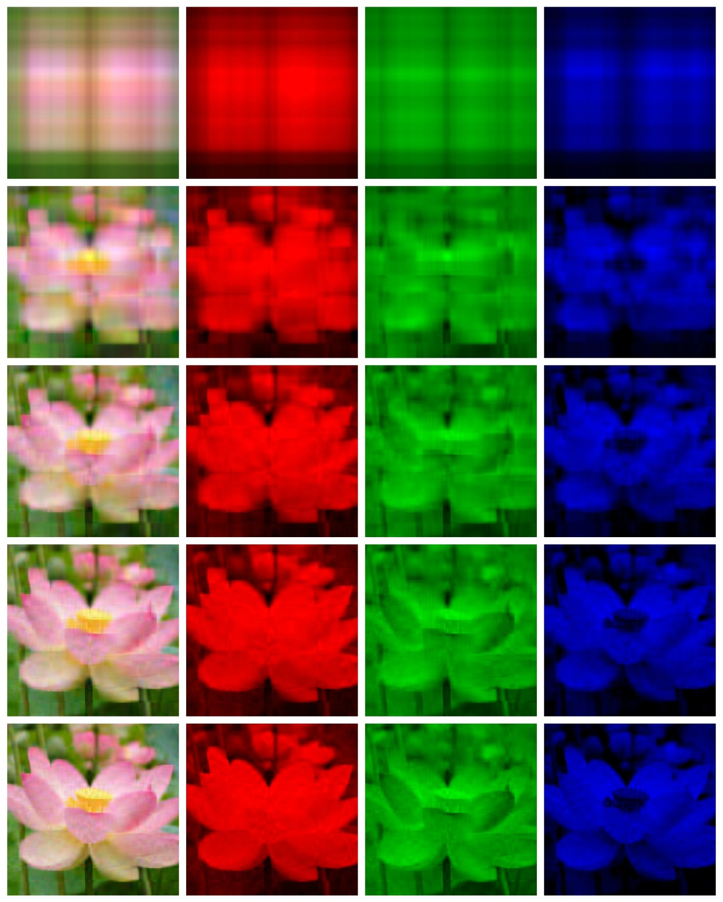

Figure 3.3 shows an image of size 2800x2052 being split into three scaled images representing red, green, and blue pixel values, and then performs the SVD computation using modes {{1, 5, 10, 15, 20}}

This image is pretty big, and as you can see, even just by 20 modes of precision, you have a very good idea of what you’re looking at.

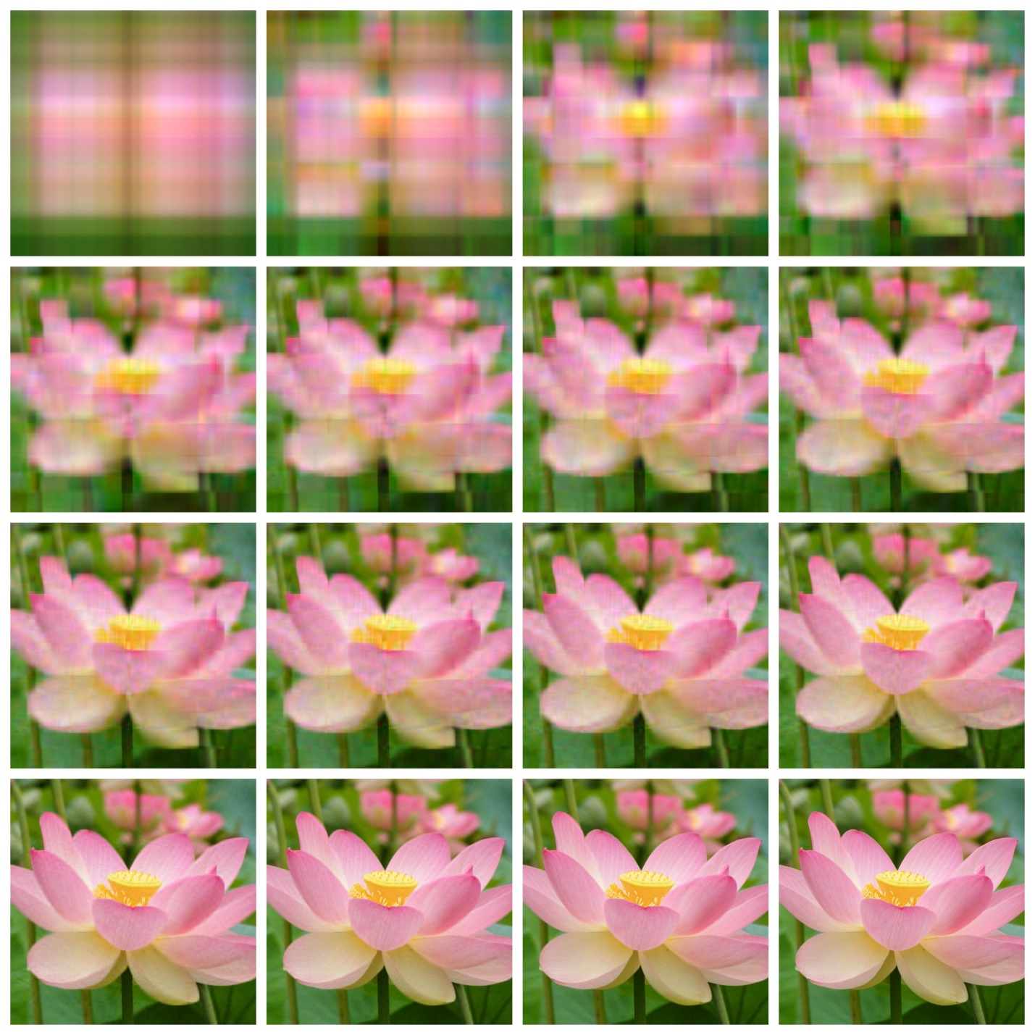

Figure 3.4: Image size 2800x2052 with modes used {{1, 2, 4, 6}, {8, 10, 12, 14}, {16, 18, 20, 25}, {50, 75, 100, original image}}

As you can see, the image still looks very good at 50 modes even with such a large image. It is very hard to tell, but by squinting at the difference of the picture derived from mode 100 to the original image, the pink lines on the petals appear to be a little stronger, giving the image more contrast. But to the average person, most people will think that modes 50-100 look relatively the same. The reason for the sharper contrast is because the SVD is very pattern oriented, so those natural patters in the image may show up a little stronger than in the original image.

Let’s compute the sizes of the image again. Remember, now instead of a grayscale image, we have color, so we have to add the matrix three times instead of just the once. So for an image that is 2800x2052 we have:

Original Image: 17,236,800 bytes (16.4MB)

Mode 100: 1,455,600 bytes (1.4MB)

Mode 75: 1,091,700 bytes (1.0MB)

Mode 50: 727,800 bytes (0.7MB)

The error is a little more difficult to plot, as the graph would be three dimensional, since the image has three layers. But you can still see that once you hit that certain point of precision, you ultimately can’t tell the difference between the compressed and the original image as the error rate becomes so minute, that in the large picture it really doesn’t matter.

Conclusion: All an image is, is data represented on a matrix being visually displayed to you through pixels of red, green and blue on your computer. This data can be manipulated through the use of the SVD theorem to calculate a level of precision close to the original without storing as much data. The SVD allows us to store information instead of information where the size of the image is , or when the image is in color instead of 3.

If you would like to try this out for yourself, the following pages will have an attached reference to the MatLab code used to create the above images and graphs.

MatLab Code for GrayScale Images

% Brady Mathews - The University of Utah December 2014

% This document contains instructions for Matlab which will Open an image

% file, turn the image into a grayscale format Grab the image data and

% build a matrix representing each pixel value as 0-255 as data on the

% matrix. It will then compute the SVD on the matrix, and display varying

% different modes and levels of pressision based on the image compression,

% as well as an error graph at the end on how accurate the image got based

% on the difference from the original image. It will also save these

% resulting images on your computer. To upload an image, replace the

% "image.jpg" with the filepath, name, and data type of the image you wish

% to use. If you would not like the program to save the image to your

% computer, comment out or eleminate the lines that say

% "imwrite(unit8(...), '%d...')"

% The following will give you modes 1, then (2,4,6,8,10,12,14,16,18,20)

% then it will give you modes (25,50.75.100). To edit these, change the

% value of N in the loops.

close all

clear all

clc

%reading and converting the image

inImage=imread('image.jpg');

inImage=rgb2gray(inImage);

inImageD=double(inImage);

imwrite(uint8(inImageD), 'original.jpg');

% decomposing the image using singular value decomposition

[U,S,V]=svd(inImageD);

% Using different number of singular values (diagonal of S) to compress and

% reconstruct the image

dispEr = [];

numSVals = [];

N = 1

% store the singular values in a temporary var

C = S;

% discard the diagonal values not required for compression

C(N+1:end,:)=0;

C(:,N+1:end)=0;

% Construct an Image using the selected singular values

D=U*C*V';

% display and compute error

figure;

buffer = sprintf('Image output using %d singular values', N)

imshow(uint8(D));

imwrite(uint8(D), sprintf('%dbw.jpg', N));

title(buffer);

error=sum(sum((inImageD-D).^2));

% store vals for display

dispEr = [dispEr; error];

numSVals = [numSVals; N];

for N=2:2:20

% store the singular values in a temporary var

C = S;

% discard the diagonal values not required for compression

C(N+1:end,:)=0;

C(:,N+1:end)=0;

% Construct an Image using the selected singular values

D=U*C*V';

% display and compute error

figure;

buffer = sprintf('Image output using %d singular values', N)

imshow(uint8(D));

imwrite(uint8(D), sprintf('%dbw.jpg', N));

title(buffer);

error=sum(sum((inImageD-D).^2));

% store vals for display

dispEr = [dispEr; error];

numSVals = [numSVals; N];

end

for N=25:25:100

% store the singular values in a temporary var

C = S;

% discard the diagonal values not required for compression

C(N+1:end,:)=0;

C(:,N+1:end)=0;

% Construct an Image using the selected singular values

D=U*C*V';

% display and compute error

figure;

buffer = sprintf('Image output using %d singular values', N)

imshow(uint8(D));

imwrite(uint8(D), sprintf('%dbw.jpg', N));

title(buffer);

error=sum(sum((inImageD-D).^2));

% store vals for display

dispEr = [dispEr; error];

numSVals = [numSVals; N];

end

% dislay the error graph

figure;

title('Error in compression');

plot(numSVals, dispEr);

grid on

xlabel('Number of Singular Values used');

ylabel('Error between compress and original image');

MatLab Code for Colored Images

% Brady Mathews - The University of Utah December 2014

% This document contains instructions for Matlab which will Open an image

% file, and then split the image into three separate images; a red-scale,

% a green-scale, and a blue-scale image. It will then plot the pixel data

% from these images into a matrix, representing values 0-255 based on the

% pixel saturation. It will then compute the SVD on each of these scaled

% images, save them on the computer, display the corresponding scaled

% images, and then it will also merge these images back together to form a

% colored image, also displaying and saving the image as well. You can

% prevent the program from saving images to your computer by commenting out

% or eliminating the lines that say imwrite(uint8(...),

% sprintf('%d....jpg', N));

% The following will give you modes 1, then (2,4,6,8,10,12,14,16,18,20)

% then it will give you modes (25,50.75.100). To edit these, change the

% value of N in the loops.

close all

clear all

clc

filename = 'image.jpg';

[X, map] = imread(filename);

figure('Name','ORIGINAL component of the imported image');

imshow(X);

imwrite(X, '!original.jpg');

R = X(:,:,1);

G = X(:,:,2);

B = X(:,:,3);

Rimg = cat(3, R, zeros(size(R)), zeros(size(R)));

Gimg = cat(3, zeros(size(G)), G, zeros(size(G)));

Bimg = cat(3, zeros(size(B)), zeros(size(B)), B);

figure('Name','RED component of the imported image');

imshow(Rimg);

imwrite(Rimg, '!red.jpg');

figure('Name','GREEN component of the imported image');

imshow(Gimg);

imwrite(Gimg, '!green.jpg');

figure('Name','BLUE component of the imported image');

imshow(Bimg);

imwrite(Bimg, '!blue.jpg');

Red =double(R);

Green = double(G);

Blue = double(B);

N = 1;

% Compute values for the red image

[U,S,V]=svd(Red);

C = S;

C(N+1:end,:)=0;

C(:,N+1:end)=0;

Dr=U*C*V';

% Rebuild the data back into a displayable image and show it

figure;

buffer = sprintf('Red image output using %d singular values', N);

Rimg = cat(3, Dr, zeros(size(Dr)), zeros(size(Dr)));

imshow(uint8(Rimg));

imwrite(uint8(Rimg), sprintf('%dred.jpg', N));

title(buffer);

% Compute values for the green image

[U2, S2, V2]=svd(Green);

C = S2;

C(N+1:end,:)=0;

C(:,N+1:end)=0;

Dg=U2*C*V2';

% Rebuild the data back into a displayable image and show it

figure;

buffer = sprintf('Green image output using %d singular values', N);

Gimg = cat(3, zeros(size(Dg)), Dg, zeros(size(Dg)));

imshow(uint8(Gimg));

imwrite(uint8(Gimg), sprintf('%dgreen.jpg', N));

title(buffer);

% Compute values for the blue image

[U3, S3, V3]=svd(Blue);

C = S3;

C(N+1:end,:)=0;

C(:,N+1:end)=0;

Db=U3*C*V3';

% Rebuild the data back into a displayable image and show it

figure;

buffer = sprintf('Blue image output using %d singular values', N);

Bimg = cat(3, zeros(size(Db)), zeros(size(Db)), Db);

imshow(uint8(Bimg));

imwrite(uint8(Bimg), sprintf('%dblue.jpg', N));

title(buffer);

% Thake the data from the Red, Green, and Blue image

% Rebuild a colored image with the corresponding data and show it

figure;

buffer = sprintf('Colored image output using %d singular values', N);

Cimg = cat(3, Dr, Dg, Db);

imshow(uint8(Cimg));

imwrite(uint8(Cimg), sprintf('%dcolor.jpg', N));

title(buffer);

for N=2:2:20

% Recompute modes for the red image - already solved by SVD above

C = S;

C(N+1:end,:)=0;

C(:,N+1:end)=0;

Dr=U*C*V';

% Rebuild the data back into a displayable image and show it

figure;

buffer = sprintf('Red image output using %d singular values', N);

Rimg = cat(3, Dr, zeros(size(Dr)), zeros(size(Dr)));

imshow(uint8(Rimg));

imwrite(uint8(Rimg), sprintf('%dred.jpg', N));

title(buffer);

% Recompute modes for the green image - already solved by SVD above

C = S2;

C(N+1:end,:)=0;

C(:,N+1:end)=0;

Dg=U2*C*V2';

% Rebuild the data back into a displayable image and show it

figure;

buffer = sprintf('Green image output using %d singular values', N);

Gimg = cat(3, zeros(size(Dg)), Dg, zeros(size(Dg)));

imshow(uint8(Gimg));

imwrite(uint8(Gimg), sprintf('%dgreen.jpg', N));

title(buffer);

% Recompute modes for the blue image - already solved by SVD above

C = S3;

C(N+1:end,:)=0;

C(:,N+1:end)=0;

Db=U3*C*V3';

% Rebuild the data back into a displayable image and show it

figure;

buffer = sprintf('Blue image output using %d singular values', N);

Bimg = cat(3, zeros(size(Db)), zeros(size(Db)), Db);

imshow(uint8(Bimg));

imwrite(uint8(Bimg), sprintf('%dblue.jpg', N));

title(buffer);

% Thake the data from the Red, Green, and Blue image

% Rebuild a colored image with the corresponding data and show it

figure;

buffer = sprintf('Colored image output using %d singular values', N);

Cimg = cat(3, Dr, Dg, Db);

imshow(uint8(Cimg));

imwrite(uint8(Cimg), sprintf('%dcolor.jpg', N));

title(buffer);

end

for N=25:25:100

% Recompute modes for the red image - already solved by SVD above

C = S;

C(N+1:end,:)=0;

C(:,N+1:end)=0;

Dr=U*C*V';

% Rebuild the data back into a displayable image and show it

figure;

buffer = sprintf('Red image output using %d singular values', N);

Rimg = cat(3, Dr, zeros(size(Dr)), zeros(size(Dr)));

imshow(uint8(Rimg));

imwrite(uint8(Rimg), sprintf('%dred.jpg', N));

title(buffer);

% Recompute modes for the green image - already solved by SVD above

C = S2;

C(N+1:end,:)=0;

C(:,N+1:end)=0;

Dg=U2*C*V2';

% Rebuild the data back into a displayable image and show it

figure;

buffer = sprintf('Green image output using %d singular values', N);

Gimg = cat(3, zeros(size(Dg)), Dg, zeros(size(Dg)));

imshow(uint8(Gimg));

imwrite(uint8(Gimg), sprintf('%dgreen.jpg', N));

title(buffer);

% Recompute modes for the blue image - already solved by SVD above

C = S3;

C(N+1:end,:)=0;

C(:,N+1:end)=0;

Db=U3*C*V3';

% Rebuild the data back into a displayable image and show it

figure;

buffer = sprintf('Blue image output using %d singular values', N);

Bimg = cat(3, zeros(size(Db)), zeros(size(Db)), Db);

imshow(uint8(Bimg));

imwrite(uint8(Bimg), sprintf('%dblue.jpg', N));

title(buffer);

% Thake the data from the Red, Green, and Blue image

% Rebuild a colored image with the corresponding data and show it

figure;

buffer = sprintf('Colored image output using %d singular values', N);

Cimg = cat(3, Dr, Dg, Db);

imshow(uint8(Cimg));

imwrite(uint8(Cimg), sprintf('%dcolor.jpg', N));

title(buffer);

end