# **Source Code**

The complete source code for this assignment is available on github @

[https://github.com/bradyhouse/ITM455](https://github.com/bradyhouse/ITM455/tree/master/HW1).

# **Screenshot**

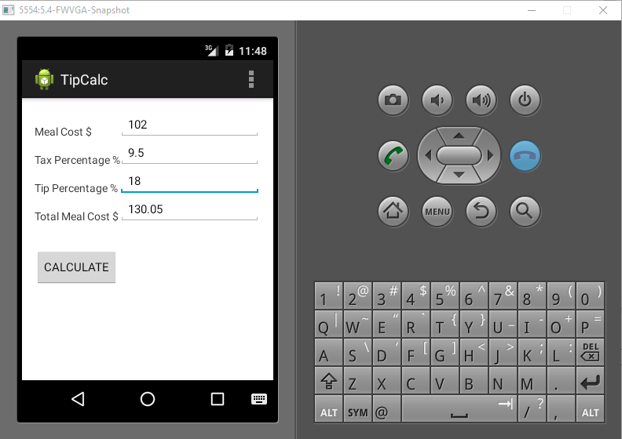

# **ManifestAndroid.xml**

|  |
| --- |
| <?xml version=*"1.0"* encoding=*"utf-8"*?>  <manifest xmlns:android=*"http://schemas.android.com/apk/res/android"*  package=*"com.iit.itm455.hw1.tipCalc"*  android:versionCode=*"1"*  android:versionName=*"1.0"* >  <uses-sdk  android:minSdkVersion=*"8"*  android:targetSdkVersion=*"23"* />  <application  android:allowBackup=*"true"*  android:icon=*"@drawable/ic_launcher"*  android:label=*"@string/app_name"*  android:theme=*"@style/AppTheme"* >  <activity  android:name=*".MainActivity"*  android:label=*"@string/app_name"* >  <intent-filter>  <action android:name=*"android.intent.action.MAIN"* />  <category android:name=*"android.intent.category.LAUNCHER"* />  </intent-filter>  </activity>  </application>  </manifest> |

# **strings.xml**

|  |
| --- |
| <?xml version=*"1.0"* encoding=*"utf-8"*?>  <resources xmlns:android=*"http://schemas.android.com/apk/res/android"*>  <string name=*"app_name"*>TipCalc</string>  <string name=*"action_settings"*>Action Settings</string>  <string name=*"label_meal_cost"*>Meal Cost $</string>  <string name=*"label_tax_percentage"*>Tax Percentage %</string>  <string name=*"label_tip_percentage"*>Tip Percentage %</string>  <string name=*"label_total_meal_cost"*>Total Meal Cost $</string>  </resources> |

# **MainActivity.Class**

|  |
| --- |
| **package** com.iit.itm455.hw1.tipCalc;  **import** android.app.Activity;  **import** android.view.View.OnClickListener;  **import** android.os.Bundle;  **import** android.view.Menu;  **import** android.view.MenuItem;  **import** android.view.View;  **import** android.widget.Button;  **import** android.widget.EditText;  **public** **class** MainActivity **extends** Activity **implements** OnClickListener {  **private** **double** mealCost;  **private** **double** totalCost;  **private** **double** taxPercentage = 0.0;  **private** **double** tipPercentage = 0.0;    **public** **void** calculateTotalCost() {  **if** (**this**.getMealCost() > 0 && **this**.getTaxPercentage() >= 0  && **this**.getTipPercentage() >= 0) {  **double** tax = (**this**.getTaxPercentage() / 100) * **this**.getMealCost();  **double** tip = (**this**.getTipPercentage() / 100) * **this**.getMealCost();  **double** totalCost = tax + tip + **this**.getMealCost();  EditText editTotalCost = (EditText) findViewById(R.id.*editTotalMealCost*);  editTotalCost.setText(String.*format*("%.2f", totalCost));  }  }  @Override  **protected** **void** onCreate(Bundle savedInstanceState) {  **super**.onCreate(savedInstanceState);  setContentView(R.layout.*activity_main*);  Button buttonCalc = (Button) findViewById(R.id.*buttonCalculate*);  buttonCalc.setOnClickListener(**this**);  }  @Override  **public** **boolean** onCreateOptionsMenu(Menu menu) {  getMenuInflater().inflate(R.menu.*main*, menu);  **return** **true**;  }  @Override  **public** **boolean** onOptionsItemSelected(MenuItem item) {  **int** id = item.getItemId();  **if** (id == R.id.*action_settings*) {  **return** **true**;  }  **return** **super**.onOptionsItemSelected(item);  }  **public** **double** getTotalCost() {  **return** totalCost;  }  **public** **void** setTotalCost(**double** totalCost) {  **this**.totalCost = totalCost;  }  **public** **double** getTaxPercentage() {  **return** taxPercentage;  }  **public** **void** setTaxPercentage(**double** taxPercentage) {  **this**.taxPercentage = taxPercentage;  }  **public** **double** getTipPercentage() {  **return** tipPercentage;  }  **public** **void** setTipPercentage(**double** tipPercentage) {  **this**.tipPercentage = tipPercentage;  }  **public** **double** getMealCost() {  **return** mealCost;  }  **public** **void** setMealCost(**double** mealCost) {  **this**.mealCost = mealCost;  }  @Override  **public** **void** onClick(View v) {  EditText editCost = (EditText) findViewById(R.id.*editMealCost*);  EditText editTip = (EditText) findViewById(R.id.*editTipPercentage*);  EditText editTax = (EditText) findViewById(R.id.*editTaxPercentage*);  **double** tip = editTip.getText().length() > 0 ? Double  .*parseDouble*(editTip.getText().toString()) : 0.0;  **double** tax = editTax.getText().length() > 0 ? Double  .*parseDouble*(editTax.getText().toString()) : 0.0;  **if** (editCost.getText().length() > 0) {  **this**.setMealCost(Double.*parseDouble*(editCost.getText().toString()));  **this**.setTipPercentage(tip);  **this**.setTaxPercentage(tax);  **this**.calculateTotalCost();  }  }  } |

# **activity_main.xml**

|  |
| --- |
| <RelativeLayout xmlns:android=*"http://schemas.android.com/apk/res/android"*  xmlns:tools=*"http://schemas.android.com/tools"*  android:layout_width=*"fill_parent"*  android:layout_height=*"match_parent"*  android:paddingBottom=*"@dimen/activity_vertical_margin"*  android:paddingLeft=*"@dimen/activity_horizontal_margin"*  android:paddingRight=*"@dimen/activity_horizontal_margin"*  android:paddingTop=*"@dimen/activity_vertical_margin"*  tools:context=*"com.iit.itm455.hw1.tipCalc.MainActivity"* >  <TextView  android:id=*"@+id/labelMealCost"*  android:layout_width=*"wrap_content"*  android:layout_height=*"wrap_content"*  android:layout_alignBottom=*"@+id/editMealCost"*  android:text=*"@string/label_meal_cost"* >  </TextView>  <EditText  android:id=*"@+id/editMealCost"*  android:layout_width=*"wrap_content"*  android:layout_height=*"wrap_content"*  android:layout_alignParentRight=*"true"*  android:layout_toRightOf=*"@+id/buttonCalculate"*  android:editable=*"true"*  android:enabled=*"true"*  android:inputType=*"numberDecimal"*  android:textSize=*"15sp"* >  </EditText>  <TextView  android:id=*"@+id/labelTaxPercentage"*  android:layout_width=*"wrap_content"*  android:layout_height=*"wrap_content"*  android:layout_alignBottom=*"@+id/editTaxPercentage"*  android:text=*"@string/label_tax_percentage"* >  </TextView>  <EditText  android:id=*"@+id/editTaxPercentage"*  android:layout_width=*"wrap_content"*  android:layout_height=*"wrap_content"*  android:layout_alignLeft=*"@+id/editMealCost"*  android:layout_alignParentRight=*"true"*  android:layout_below=*"@+id/editMealCost"*  android:editable=*"true"*  android:enabled=*"true"*  android:inputType=*"numberDecimal"*  android:text=*"0"*  android:textSize=*"15sp"* >  </EditText>  <TextView  android:id=*"@+id/labelTipPercentage"*  android:layout_width=*"wrap_content"*  android:layout_height=*"wrap_content"*  android:layout_alignBottom=*"@+id/editTipPercentage"*  android:text=*"@string/label_tip_percentage"* >  </TextView>  <EditText  android:id=*"@+id/editTipPercentage"*  android:layout_width=*"wrap_content"*  android:layout_height=*"wrap_content"*  android:layout_alignLeft=*"@+id/editTaxPercentage"*  android:layout_alignParentRight=*"true"*  android:layout_below=*"@+id/editTaxPercentage"*  android:editable=*"true"*  android:enabled=*"true"*  android:inputType=*"numberDecimal"*  android:text=*"0"*  android:textSize=*"15sp"* >  </EditText>  <TextView  android:id=*"@+id/labelTotalMealCost"*  android:layout_width=*"wrap_content"*  android:layout_height=*"wrap_content"*  android:layout_alignBottom=*"@+id/editTotalMealCost"*  android:text=*"@string/label_total_meal_cost"* >  </TextView>  <EditText  android:id=*"@+id/editTotalMealCost"*  android:layout_width=*"wrap_content"*  android:layout_height=*"wrap_content"*  android:layout_alignParentRight=*"true"*  android:layout_below=*"@+id/editTipPercentage"*  android:layout_toRightOf=*"@+id/buttonCalculate"*  android:editable=*"false"*  android:inputType=*"numberDecimal"*  android:textSize=*"15sp"* >  </EditText>  <Button  android:id=*"@+id/buttonCalculate"*  android:layout_width=*"wrap_content"*  android:layout_height=*"wrap_content"*  android:layout_alignLeft=*"@+id/labelTotalMealCost"*  android:layout_below=*"@+id/labelTotalMealCost"*  android:layout_marginTop=*"32dp"*  android:text=*"CALCULATE"*  android:textSize=*"15sp"* />  </RelativeLayout> |