Requirements:

* Interactive multimedia
* Good integration of multimedia elements (text, graphics, navigation, audio & video)
* Navigation controls on every screen
* Design following principles of alignment, proximity, repetition and contrast
* Substantive content
* If you are using HTML/Web authoring tools
* You may specify a specific browser and even the version of the browser
* Make maximum use of HTML 5 elements, especially <video>, <audio> and <img> using SVG
* Optimal HTML 5 support currently is in Chrome and Firefox

Published App Link:

<http://houseknecht.com/budgetCalc/>

Technology:

* Sencha’s ExtJS Framework ~ <http://www.sencha.com/>
* HTML5:
* Embedded YouTube Clips (Video)
* Embedded Shockwave Clips (Audio)
* Graphical Pie Charts
* Local Storage
  + User Input is persisted to the browser’s local storage provider. This means that they can exit the site (close browser). When they return, their input is restored. By using Local Storage, there is no need for a backend database or web service to manage state.
* “Mobile Ready”
  + The app has been developed so that it works in a web browser or on a mobile device. To see this, you can use Chrome’s device testing features.

Wireframes & Functionality:

Get Started Panel

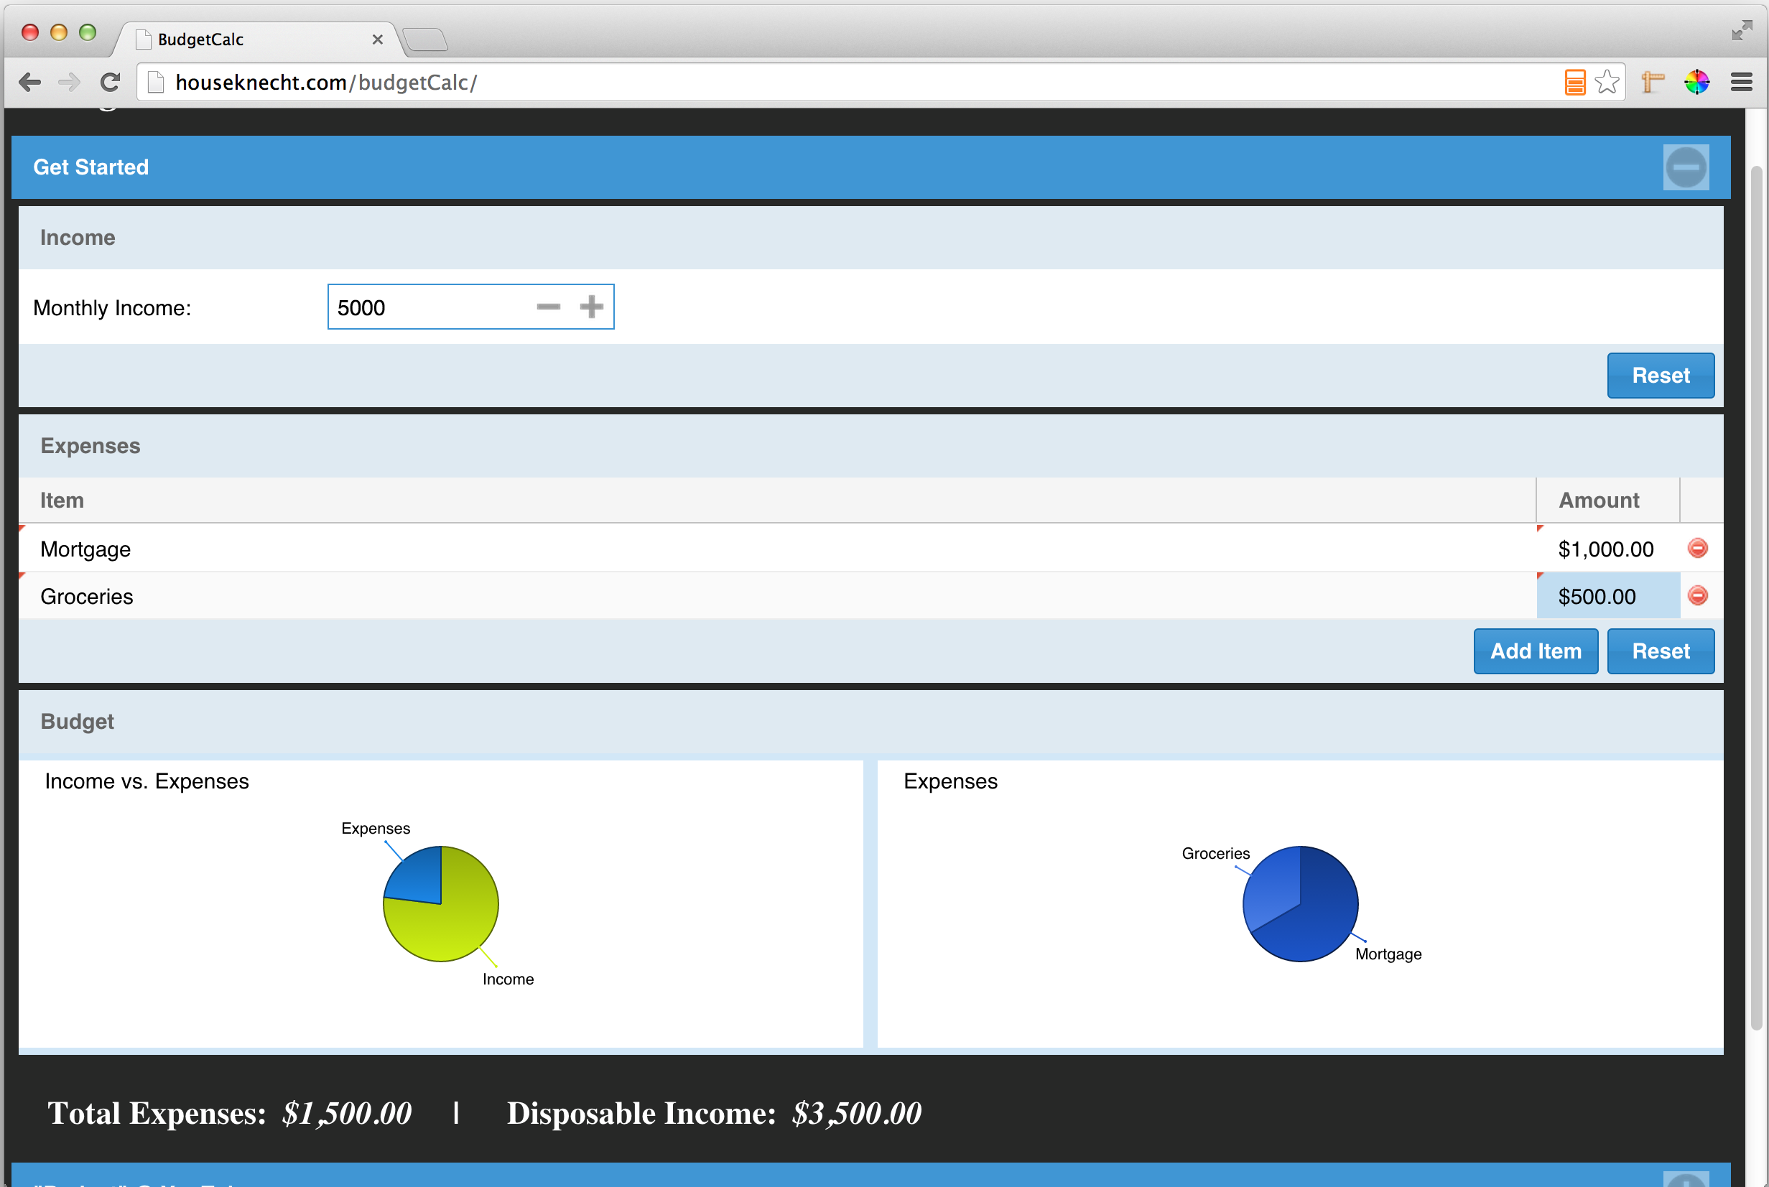

This panel is open by default (startup). This is the real value of the app. This also where persistence comes into play. User’s input is written to the browser’s local storage provider. In addition this tab, showcases the graphical pieces of the app. Specifically, it provides two pie chart graphics. The charts are updated dynamically based on the user’s input. In addition, the graphics support interaction. User’s can rotate the charts or click a specific slice to highlight it.

“Budget” @ YouTube Panel

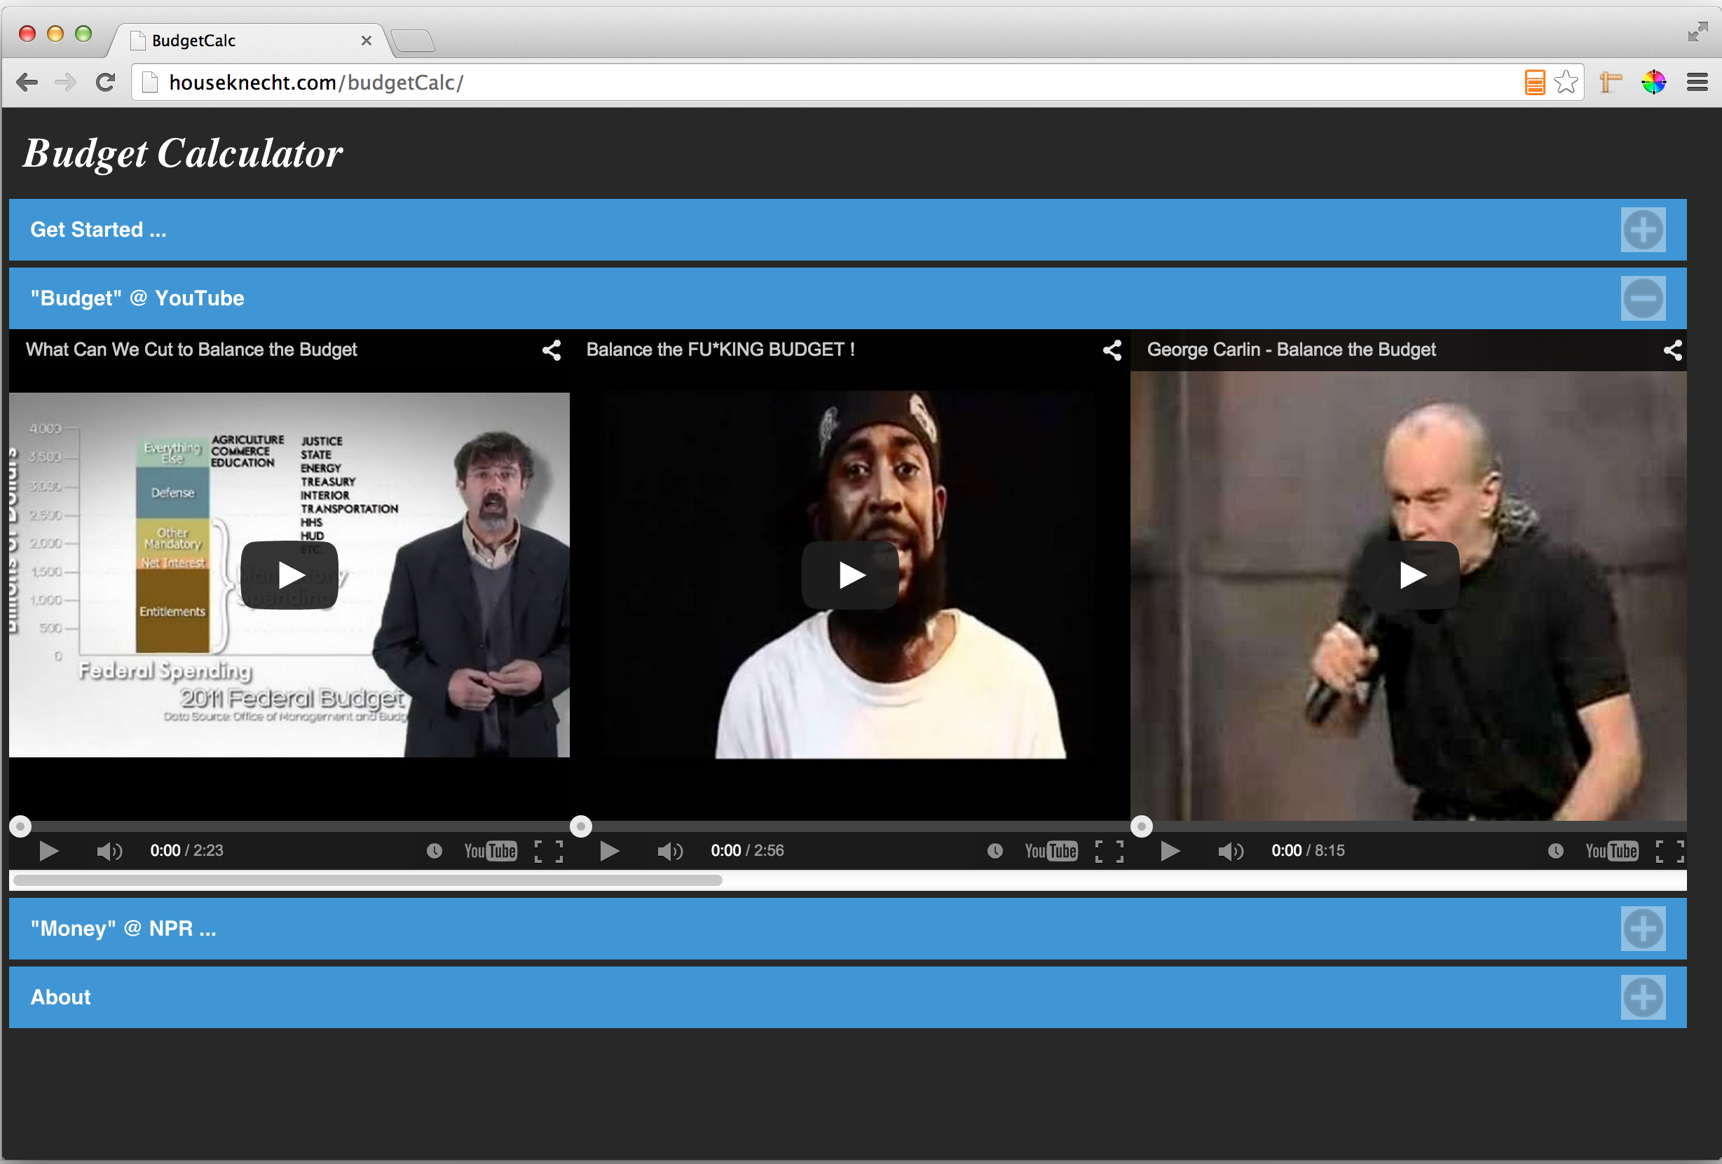

This panel meets the “video” requirement of the project by integrating several YouTube video clips. Each clip is about the topic of “Budget”. From an application perspective, it simply provides the user with some “distraction”—Don’t feel like working on your budget? Then watch a video instead.

“Money” on NPR Panel

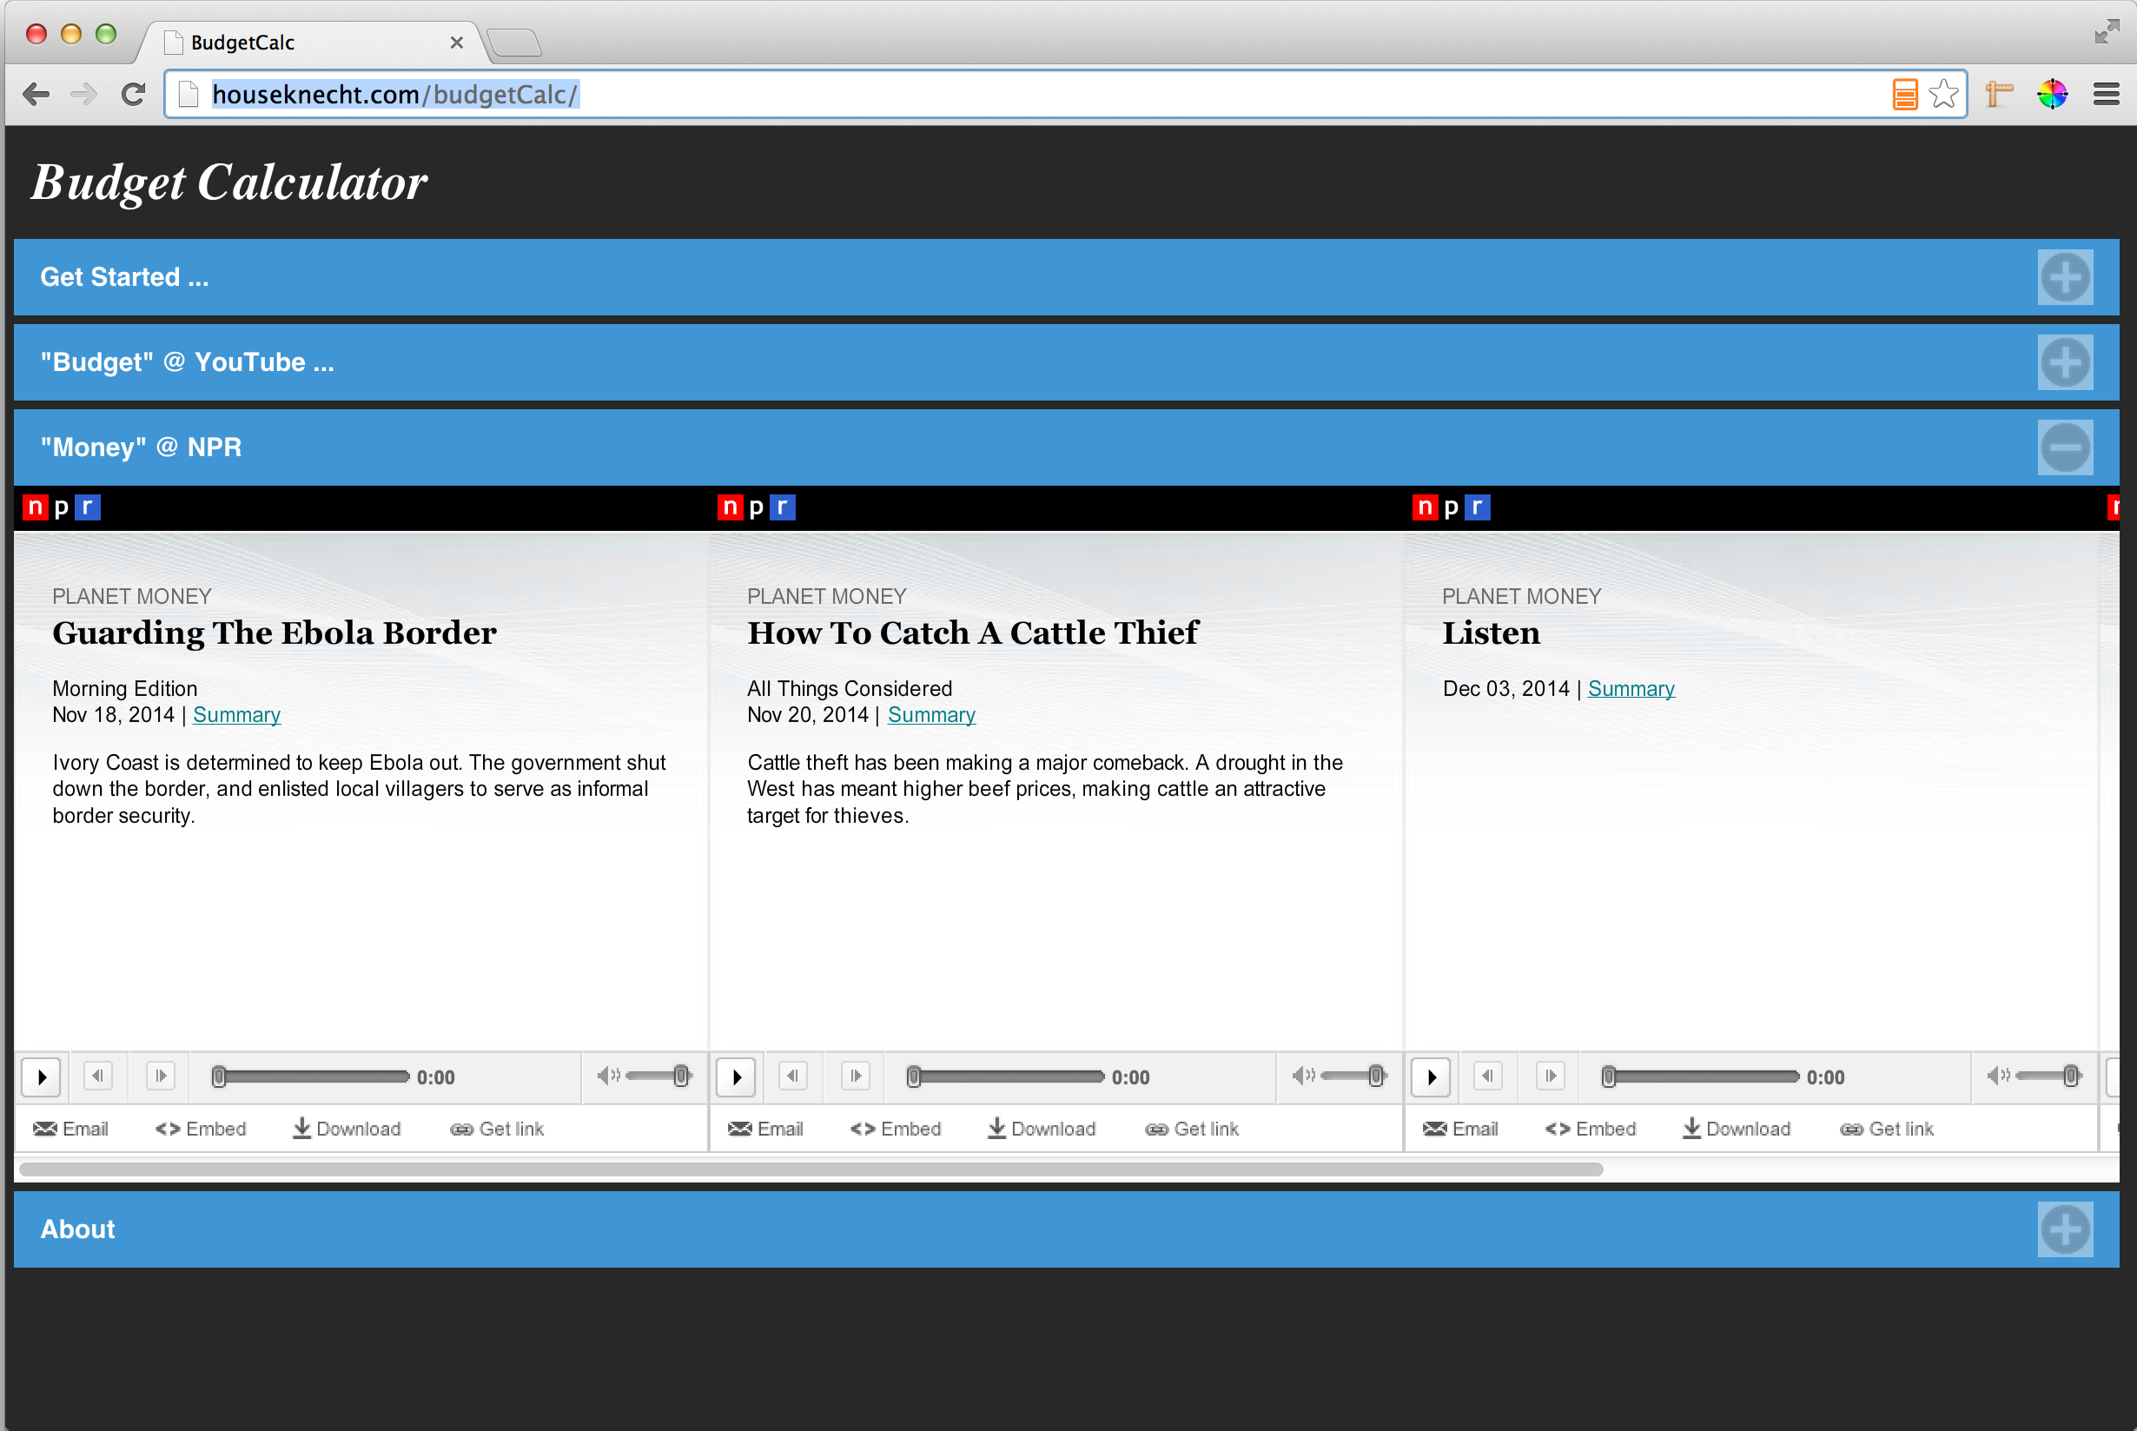

This tab, similar to the YouTube Tab, is meant to provide the user with distraction, and meets the “audio” requirement for the project. It includes embedded shockwave links to several of NPR’s Planet Money Podcast.

About Panel

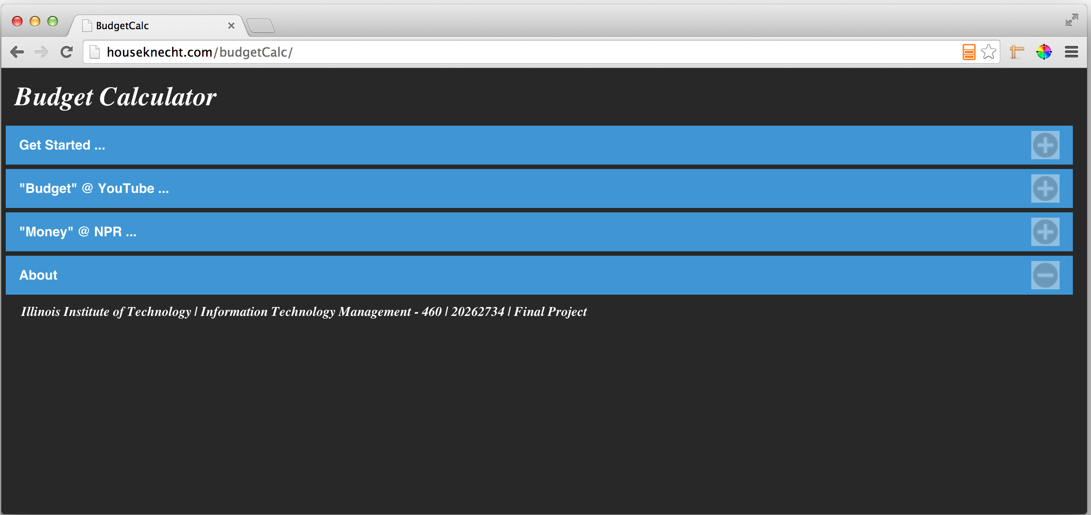

This panel simply describes the author of the app. In this case, it was written as a final project for ITM460.

Element List

* “Budget” related Video clips
* Planet Money Podcast clips

Resource List

* “Budget” related Video clips
  + <https://www.youtube.com/watch?v=asRDOhgN70Q>
  + <https://www.youtube.com/watch?v=SbQuwSlokbM>
  + <https://www.youtube.com/watch?v=wjjPlEW9bRM>
  + <https://www.youtube.com/watch?v=dEvJlzS9C4Q>
  + <https://www.youtube.com/watch?v=oYw3ksQeMD8>
  + <https://www.youtube.com/watch?v=3ugDU2qNcyg>
  + <https://www.youtube.com/watch?v=EW5IdwltaAc>
* “Planet Money Podcast clips
  + <http://www.npr.org/blogs/money/2014/11/18/364144837/guarding-the-ebola-border>
  + <http://www.npr.org/blogs/money/2014/11/20/364984303/how-to-catch-a-cattle-thief>
  + <http://www.npr.org/blogs/money/2014/11/14/363864319/episode-583-cow-noir>
  + <http://www.npr.org/blogs/money/2014/12/05/368723679/episode-587-jubilee>