Brady Messer (wmesser)

Fall 2019

CPSC 4040 HW2

* Solution 1

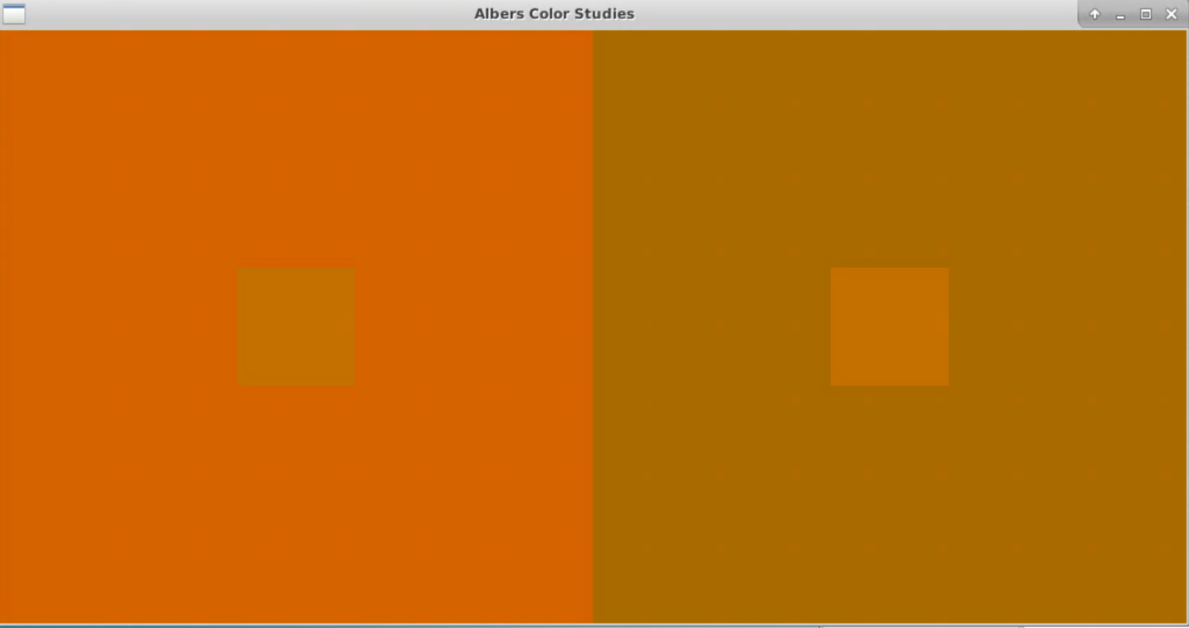

Project

1

199 104 0

161 108 0

184 115 0

0.500000 0.000000

0.100000 0.100000

-1.000000 1.000000

1.000000 1.000000

1.000000 -1.000000

-1.000000 -1.000000

9999 9999

* Solution 2

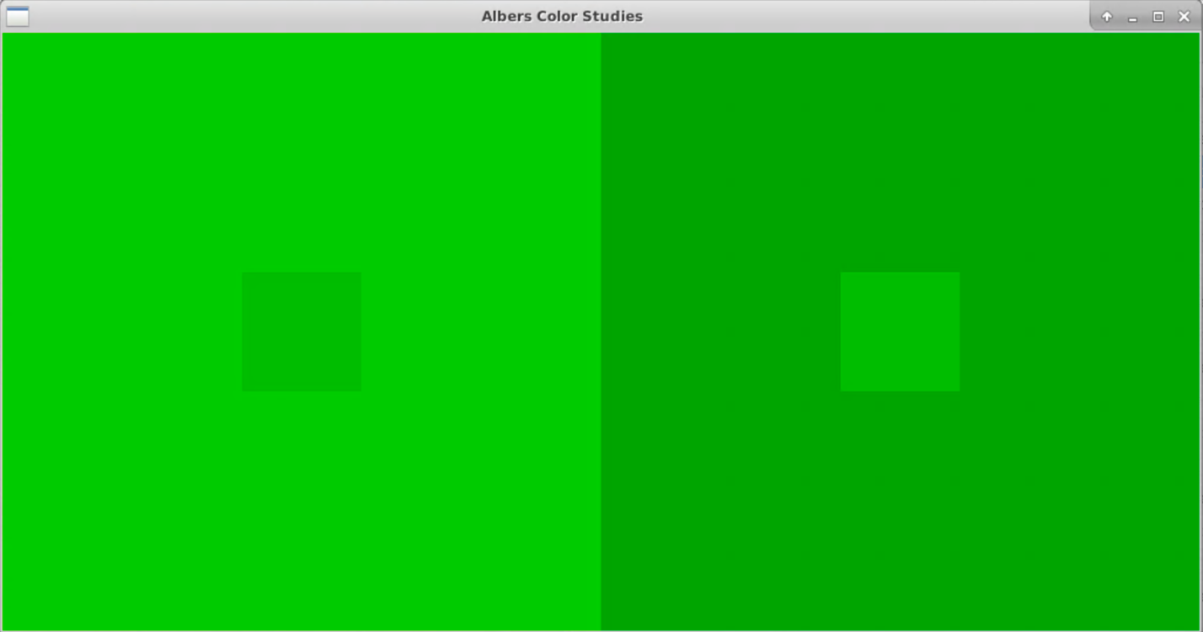

Project

1

64 199 0

0 161 21

46 184 0

0.500000 0.000000

0.100000 0.100000

-1.000000 1.000000

1.000000 1.000000

1.000000 -1.000000

-1.000000 -1.000000

9999 9999