Bhavik Suthar

Brady Messer

CPSC 4770/6770

HW4 Fall 2019

All answers were calculated using the full data sets. See readme for instructions on running with yarn.

1. Averages:

Medians:

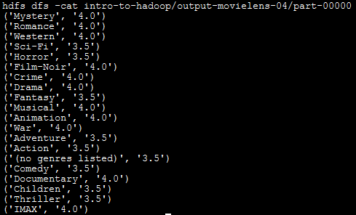

Standard deviations:

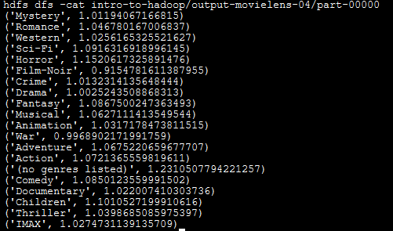

1. The user with the most ratings is user 186590, their most rated category is

Drama, with 8026 ratings in this category. They have 13250 ratings total.

