Matrix Search Help File

Overview:

This program performs sequence similarity searches using predefined nucleotide distribution matrices.

The simulation is broken up into 2 parts:
- Generating matrices: takes nucleotide frequency in various formats and outputs an html file representing the matrix that can be used by the search program
  - fileToMatrix.pl: reads in file with nucleotide frequencies for each position and converts it to the html format used by the search program.
  - fastaToMatrix.pl: reads in a FASTA file with multiple sequences, performs a global alignment on the sequences and generates a matrix for the most conserved region that can be used by the search program (must have the environment variable CLUSTALDIR set to the location of a local ClustalW executable).
  - arrayToMatrix.pl: converts arrays of nucleotide counts (modified by user in Perl script) to an html matrix usable by the search program.
- Searching sequences using predefined matrices
  - matrixSearch.pl: uses an algorithm like the one used by Genomatix’s MatInspector software¹ to pull out matches in a target sequence using matrices created by one of the scripts above. (See Figure 1)

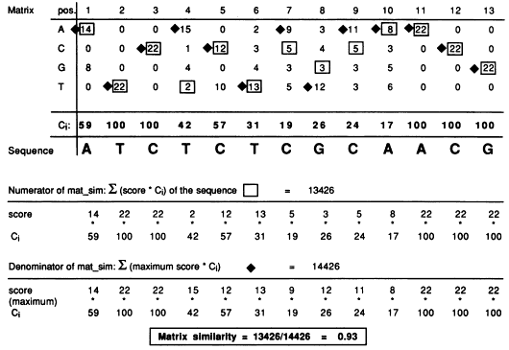
Figure 1. A matrix similarity score is computed by summing the score (matrix count of correct base) times information content C_{i} of each position. Similarly, a core similarity score is computed using the 4 adjacent positions with the highest information content C_{i}. (Quandt K, et. al)

Program Walkthrough:

Step 1. Create matrix:

> perl fileToMatrix.pl input.txt output_matrix.html

This execution takes the input nucleotide file (specification shown below) and writes to the given output file the html format matrix information to be used with the matrixSearch.pl script.

> perl fastaToMatrix.pl inputSeqs.fa output_matrix.html

This execution takes in a FASTA file (containing multiple sequences), aligns them using a local ClustalW program (must have installed ClustalW and set CLUSTALDIR environment variable to the executable path). The resulting search matrix is written to the given output_matrix.html file.

> perl arrayToMatrix.pl output_matrix.html

This execution creates a matrix file from frequency values defined in the script. To edit the values, open the script in an editor, modify frequency arrays, and run the script.

> perl matrixInfo.pl matrix.html

This execution will output information for the given matrix.

Step 2. Search sequence against matrix:

> perl matrixSearch.pl input.fa output.csv
-matrix=lm7.html,lm2.html,lm22.html
-coreSim=1 -matSim=0.8

This execution searches the ‘input.fa’ file sequences for matches to each of the given matrix files (both forward and reverse strands). Multiple matrix files are given by separating filenames by commas without spaces. Here the core similarity is set to 1 and the matrix similarity is set to 0.8. The output is written to ‘output.csv’ as a comma separated value file readable by Excel.

Format Specifications:

fileToMatrix.pl input file:

Input data file should have a 1 line header, followed by any number of rows (one for each position in the matrix). Each row should contain 4 numbers, representing relative frequencies of A, C, G, and T respectively. Example:

A C G T
0.5 0.4 0.0 0.1
0.2 0.6 0.2 0.0
0.5 0.2 0.2 0.1

matrixSearch.pl input file:

The input file is an HTML file containing a table named ‘matrix’ with rows named ‘freqA’, ‘freqC’, ‘freqG’, and ‘freqT’. Each row lists the data for each nucleotide position. C_{i} represents the weight given to each position during the search. Example:

<table name='matrix' border='1'>
<tr name=header>
<td><b>Pos.</b>
<td><b>1</b>
<td><b>2</b>
<td><b>3</b>
<tr name='freqA'>
<td><b>A</b>
<td>0.5
<td>0.2
<td>0.5
<tr name='freqC'>
<td><b>C</b>
<td>0.4
<td>0.6
<td>0.2
<tr name='freqG'>
<td><b>G</b>
<td>0
<td>0.2
<td>0.2
<tr name='freqT'>
<td><b>T</b>
<td>0.1
<td>0
<td>0.1
<trname='ci'>
<td><b>C<sub>i</sub></b></td>
<td>66.0</td>
<td>100.0</td>
<td>66.0</td>
</table>

References

1. Cartharius K, et. al. (2005). MatInspector and beyond: promoter analysis based on transcription factor binding sites. Bioinformatics 21, 2933-42

2. Quandt K, et. al. (1995). MatInd and MatInspector: new fast and versatile tools for detection of consensus matches in nucleotide sequence data. Nucleic Acids Res. 23, 4878-84

