Brady Olsen
bradyo@u.washington.edu
Kaeberlein Lab
Department of Pathology, UW
12 November 2008

PolysomeAnalyzer Guide

Overview:

This program plots polysome gradient data and analyzes peak areas.

Walkthrough:

After launching the PolysomeAnalyzer java program (PolysomeAnalyzer.jar), you will see the main analysis window:

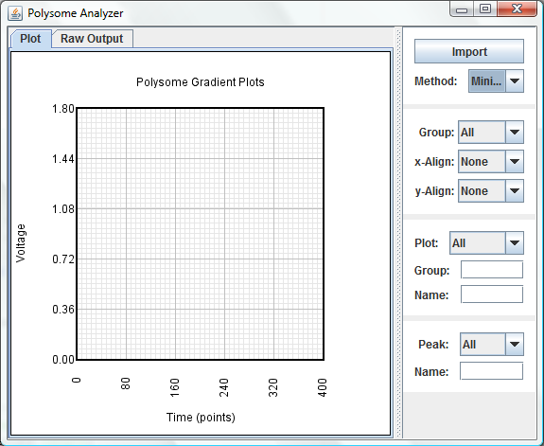
1
2
3
4
6
5

Figure 1. Application overview showing import button (1), group selector (2), plot selector (3), peak selector (4), plot window (5), and output tab (6).

- Loading Data:

Clicking the “Import” button (1) will open a file chooser dialog where you can select an input data file. The input data file you choose must be in a tab-delimited format, where each column represents a single polysome gradient run.

The first row is interpreted as a group name. Gradients with the same group name are able to be visualized in the plot window together and the analysis output will show average peak areas within a group.

The second row is interpreted as the gradient name. It is used to identify individual gradients in the program and to label gradients in the analysis output.

All following rows should be data values. The number of data values in each column does not need to be the same between. Columns that have no values should still be correctly tab-delimited to keep the data lined up with the right gradient. To make things easy, create your data file in a spreadsheet program and export as a tab-delimited file for loading into the analyzer program. An example is given below:

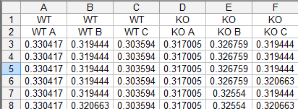

Figure 2. Spreadsheet showing input file format. The first row contains gradient group names, the second row contains individual gradient names, and all following rows contain data values. Export as a tab-delimited file for loading into the analyzer program.

2. Adjusting Areas:

Once the data is loaded into the analyzer program, you should go through each plot and make sure the left and right boundaries, as well as peak areas are correct. Select plots from the drop down menu (3) or by left-clicking on a plot in the chart area (5).

You can zoom in on a region by dragging the left mouse button to box the desired window region. Restore the default window by right-clicking the mouse button (or Ctrl+click for Mac).

When a single plot is selected, the chart window (5) shows the plot’s left, right and baseline boundaries (orange dotted lines), which are used to calculate the normalization area (shown in yellow). These boundaries can be manipulated by dragging the line with the left mouse button.

Peaks can be selected by clicking the blue peak dots in the plot window (5) or by selecting them in the Peak drop down menu (4). Boundaries can similarly be manipulated by dragging with the left mouse button. A new peak can be added by left-clicking on the selected peak at the desired location. The selected peak can be deleted with the “delete” key.

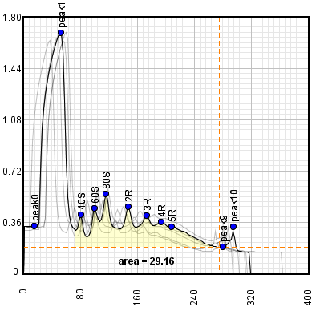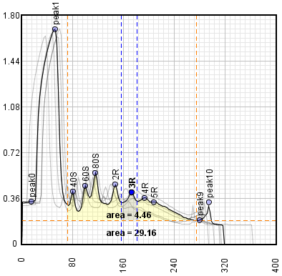

Figure 3. Left: when a single plot is selected, the plot area shows the plot’s left and right boundaries (orange vertical lines), and baseline (horizontal orange line). The area contained within these boundaries is shown in yellow.
Right: when a single peak is selected, the plot area shows the peak’s left and right boundaries (blue vertical lines) and contained area in blue.

3. Getting Analysis Data

After all plot boundaries and peaks have been verified, click the “Raw Output” tab (6) to view calculations for the selected group (or for all gradients if the “All” group is selected).

The first set of data shows peak areas for each plot as well as information about which data point the peak is positioned about (peak x, peak left, peak right).

The second set of data shows the average and standard deviation of equivalently named peaks between each group of plots. This data can be used to do comparisons between groups. Copy and paste the data directly into a spreadsheet program for further analysis.

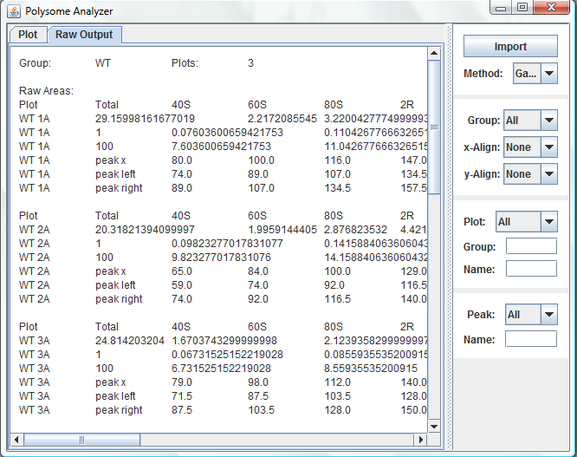

Figure 4. The “Raw Ouput” tab shows calculated values in a tab-delimited format. The text can be pasted into a spreadsheet program for further analysis and presentation.

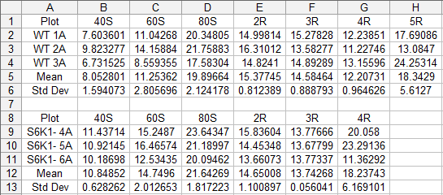

Figure 5. Peak areas between groups obtained from the “Raw Output” tab.

Known Issues:

Gaussian area calculation method is not functional.

The first 7 peaks found within the plot boundaries are named 40S, 60S, 80S, 2R, 3R, 4R, 5R respectively. The last peak found goes out all the way to the baseline boundary and should be considered “>PreviousPeak”.

