CO₂ Flux Decomposition Discrepancy

Issue: When approximating the regression of CO2 flux onto the NPGO in the California Current, there is a large discrepancy between the approximation and the true regression (on the order of 100%).

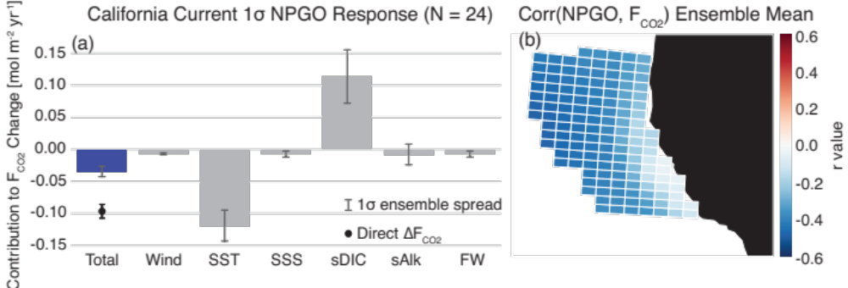

This is unlikely to be due to the regression ΔF itself, as a look at CO2 flux residuals (Y) vs. the NPGO (X) yields a fairly linear relationship.
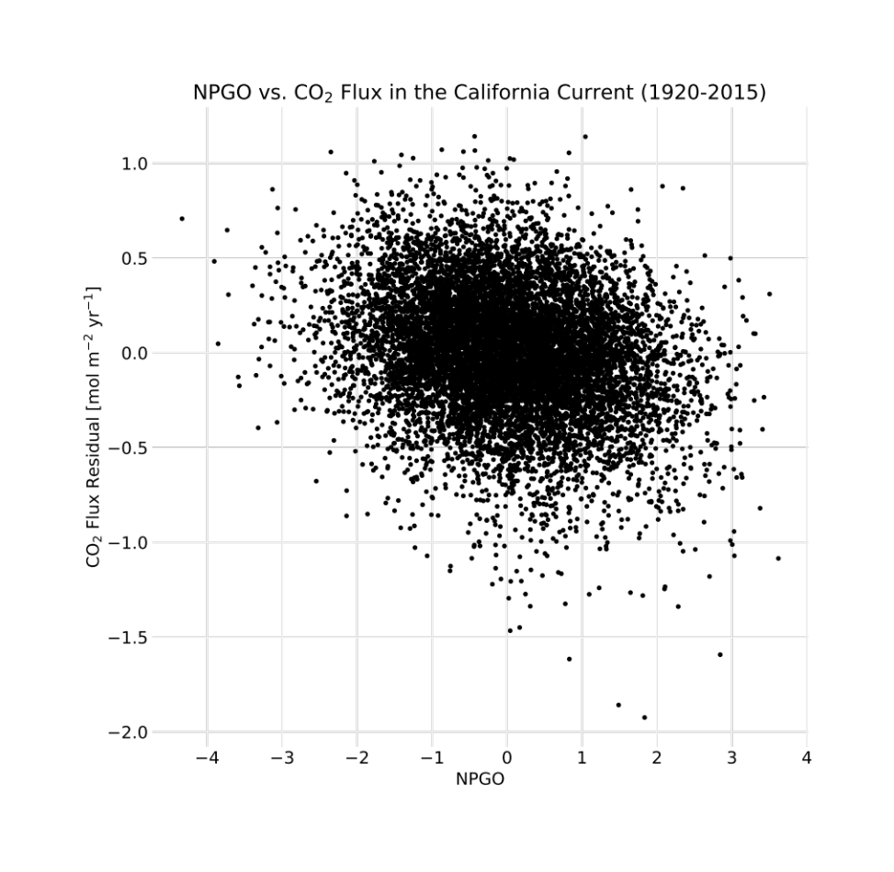

A comparison between the approximation (sum of individual contributions) versus the direct regression at every grid cell reveals that this is a persistent bias across the whole region. In other words, there are not certain sub-regions that drive this bias. This likely suggests that it is the higher-order and cross-derivative terms that lead to this issue.
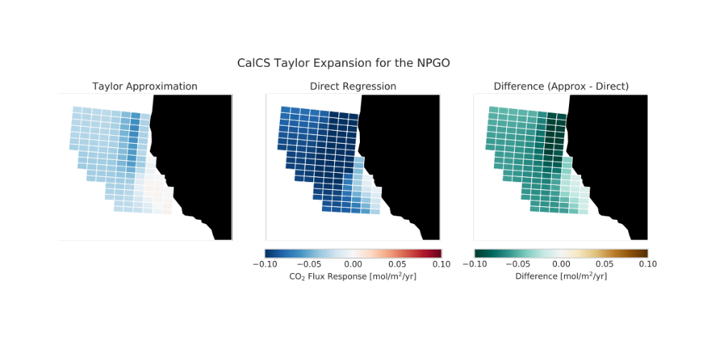

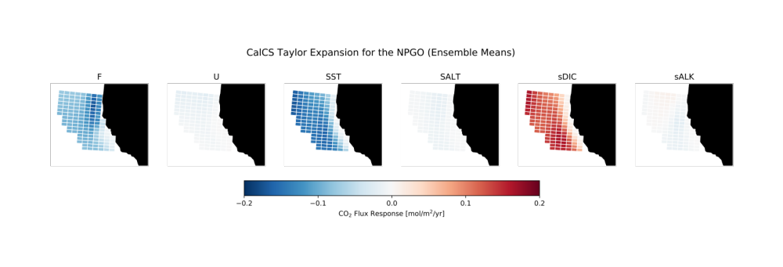
Further evidence is shown by looking at the individual terms and the ensemble spread. It’s pretty uniform across the system.

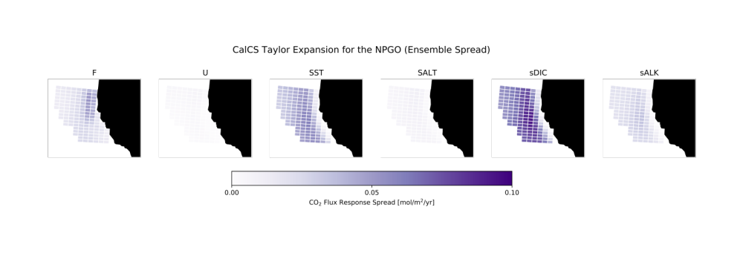

However, the current decomposition utilizes many empirically derived sensitivities that by definition are linear approximations. There are no second derivatives except for in wind speed. Would need to change over to model equations to do this.

Questions:
- Can we just square the linear regression, e.g. ΔU? Or do we need to regress the square of the variable (e.g. Δ(U²))? If the latter, we run into issues of squaring monthly averages.

