**README: Blaise Code for the Online Contraceptive Use History Calendar**

The calendar display described in this paper is a custom control that was developed by Statistics Netherlands as an MVC application using Angular framework (basically it is a plug-in custom package that uses the Blaise API to interact with the Blaise code). The calendar implementation is about 50% Blaise code and 50% MVC, and developing a related or modified version of this application would require the accompanying MVC package. The custom MVC controls need to be combined with the Blaise code, and this is done in the blrd (the Blaise resource database), which can be exported to XML, so this database would be necessary as well. Using the Blaise code provided in this directory requires an annual license for the Blaise software.

Blaise developers can view the bsol, bproj, blrd, Type.incx, blax and bcps files provided in this directory to see the source code and the blrd. All files necessary for the MVC can also be found in this directory. Within the actual Blaise code, the fields "Q4" and "FIELD_Q5" are the two that use the calendar. To view these fields in the layout tab, see ResponseValue= MonthSelector. A Blaise developer can then actually go to the Layout tab, and find this item:

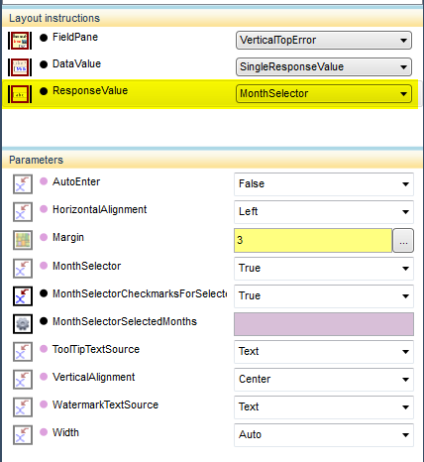

and then right click on it to "Edit Template", which opens up the blrd to that specific template, which looks like this:

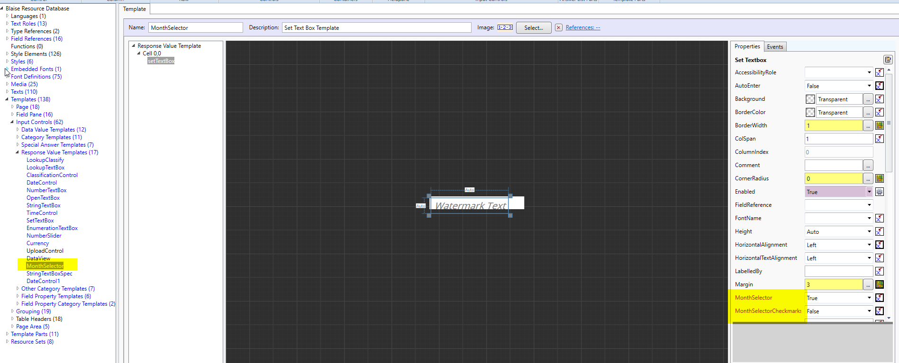

All of the code needed will already be there, and the developer would just need to copy the XML and paste it in their own blrd for whatever instrument they want to use this for.