Senior Design Project Monthly Report for March/2023

***Pothole Detection System***

*Braeden Kurz (Computer Engineering)*

***Faculty advisor: Aline Lopes***

**Current updated system diagram**

**Functions, modules, parts that have been accomplished in the past month.**

As of now, progress was made in compiling a folder containing two types of images: normal and potholes. The normal images are those that capture well maintained roads with little to no damage. These images are compared to the pothole type, which contain images of roads with either severe potholes or large enough cracks.

The folder containing both normal roads and roads with potholes contains 681 images and can be found here:  
<https://www.kaggle.com/datasets/atulyakumar98/pothole-detection-dataset?resource=download>

This dataset was then uploaded to Roboflow, a computer vision solution designed build computer vision applications. Once the dataset was uploaded, these images were annotated to distinguish the object we want to detect, in this case, potholes in the road. The dataset goes through a preprocessing phase by resizing the images to a 416x416 as it is necessary for training on the YOLOv4-Tiny build. Additionally, the brightness of the dataset images were adjusted to be more resillient to lighting and camera changes. Lastly, the dataset was split into three categories for training: 70% training, 20% validation, and 10% testing for the original dataset, including 3x additional images part of the dataset that were augmented, resulting in a total of 1603 images in the dataset.

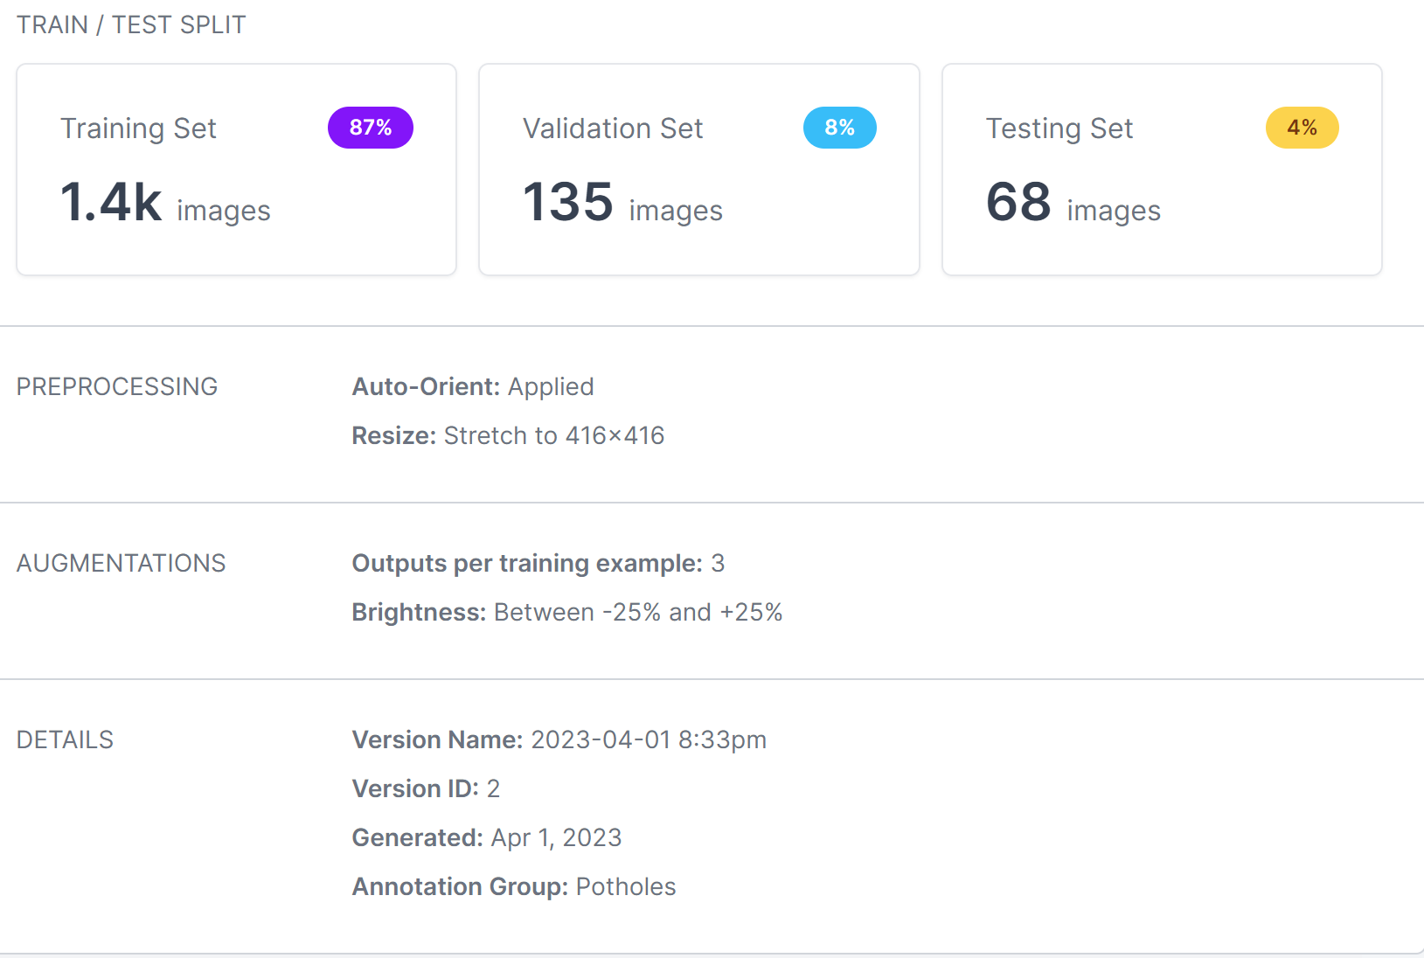

Unfortunately there were issues with training the model. I used Google Colab to implement the YOLOv4-Tiny model to train our dataset. Issue arose when certain folders were not detected and could not finish the operation. I will have to redo the training operation before I can continue on with transferring the trained dataset to the Raspberry Pi 3 Model B+.

The Google Colab YOLOv4-Tiny Notebook:  
<https://colab.research.google.com/drive/1dg0EZd9bN66MGtEHv1N4QkIAtQrGcStY#scrollTo=u2LAciMh4Cut>

The Raspberry Pi 3 Model B+ is loaded with a 128GB SD card containing the Raspbian Bullseye operating system. The operating system is operative on the Raspberry Pi and is running normally. I have ordered the components for the project and am currently waiting for my items to ship to continue further.

*Table of specification & design restrictions*

|  |  |  |
| --- | --- | --- |
| Function module | Specification (use bullets) | Why chooses this specification? |
| Camera Module | * **Input Power:** 1.5V to 3.0V DC * **Peak Current:** 300mA * **Sensor:** OV5647 * **Connection:** 15 cm flat ribbon cable to 15-pin MIPI Camera Serial Interface (CSI) connector * **Lens:** Fixed Focus Lens * **Angle of View:** 54° Horizontal x 41° Vertical * **Field of View:** 2.0 x 1.33m @ 2m * **Resolution:** 5 Megapixels, 2592 x 1944 * **Frame Rates:** 30fps@1080P, 60fps@720P, 90fps@480P * **Fixed Focus:** 1m to Infinity * **Dimensions:** 4.7 inches x 0.2 inches x 0.1 inches * **Weight:** 0.32 ounces * **Operating Temperature:** -30 to+70 °C | * Necessary to operate the camera module * Same as previous * Primarily daytime use * Cable necessary for interfacing on the Raspberry Pi 3 Model B+ * Allows for crisper images to capture. * Images need not be large * The potholes need to be detected at a reasonable distance |
| Raspberry Pi 3 Model B+ Microcontroller | * **Processor:** Broadcom BCM2837B0, Cortex-A53 64-bit SoC @ 1.4GHz * **Memory:** 1GB LPDDR2 SDRAM * **Connectivity:** 2.4GHz and 5GHz IEEE 802.11.b/g/n/ac wireless, LAN, Bluetooth 4.2, BLE, Gigabit Ethernet over USB 2.0 (maximum throughput 300Mbps), 4 × USB 2.0 ports * **Access:** Extended 40-pin GPIO header * **Video & Sound:** 1 × full size HDMI, MIPI DSI display port, MIPI CSI camera port, 4 pole stereo output and composite video port * **Multimedia:** H.264, MPEG-4 decode (1080p30); H.264 encode (1080p30); OpenGL ES 1.1, 2.0 graphics * **SD Card Support:** Micro SD format for loading operating system and data storage * **Input Power:** 5V/2.5A DC via micro USB connector, 5V DC via GPIO header, Power over Ethernet (PoE)–enabled (requires separate PoE HAT) * **Dimensions:** 85 x 56 x 17 millimeters * **Weight:** 7.1 ounces * **Operating Temperature:** 0 to +50 °C | * **Processor:** Necessary for quickly processing signals * **Memory:** Storing the OS * **Connectivity:** Connecting to the internet to send GPS coordinates of detected pothole to cloud * **Access:** **N/A** * **Video & Sound:** Necessary for interfacing with the Raspberry Pi 3 Model B+ to install the OS and camera module * **Multimedia:** Necessary for interfacing the camera module * **SD Card Support:** The SD card contains the OS for operating the Raspberry Pi * **Input Power:** The Raspberry Pi needs this amount of power to function * **Dimensions:** Small and lightweight for easy transportation * **Weight:** Small and lightweight for easy transportation * **Operating Temperature:** Safe operating temperature to avoid damaging the board and harming users |
| GSM Module | * **Input:** 3.3V to 5.0V @ 45.0mA DC * **Data Transmission**   **Protocol:** GSM, TCP/IP, SMS, Bluetooth   * **Operating Temperature**: -40°C to 85°C * **Dimensions:** 30.2mm x 65.0mm * **Weight:** ‎4.6 ounces | * **Input:** Power needed to operate the GSM module * **Data Transmission Protocol:** Uses GSM to transmit data to cloud network. * **Operating Temperature:** Safe operating to avoid damaging the module and harming the user * **Dimensions:** Small and compact to improve portability * **Weigh:** Lightweight to improve portability |
| Battery Pack | * **Input:** 6-AA Batteries * **Output:** ~9.0V DC (~5.0V DC w/ DC-DC Converter) * **Dimensions:** 3.625 inches x 2.25 inches x 0.625 inches * **Weight:** 0.634 ounces | * **Input:** Requires 6-AA batteries to supply Raspberry Pi * **Output:** Need to know how much the output must be reduced to avoid damaging the board. A DC-DC converter is needed to meet power requirements of the Raspberry Pi * **Dimensions:** Bulky and takes up most space * **Weight:** Lightweight to improve portability |
| Cloud Service | * **Input:** Coordinates of identified potholes * **Output:** Visual representation of pothole data * **Power Requirements: N/A** * **Data Transmission Protocol:** WebSocket Protocol * **Measurement Range: N/A** * **Constraints:** Data should be transmitted in intervals of 30 seconds to prevent data congestion. |  |
| Entire prototype | * **Input:** User credentials, video camera recording, battery power supply w/switch (Micro-USB) * **Output:** Data uploading to cloud, alarm notification * **Power Requirements:** 5V, 2.5A DC * **Data Transmission Protocol:** WebSocket Protocol, RS232 and TTL UART, 802.11 b/g/n/ac Wireless LAN * **Pothole Detection Range:** Roughly 10 meters * **Weight:** 9.814 ounces * **Constraints:** There should be enough light to detect the pothole and the vehicle should be moving below 45mph for the system to get a good quality video of the road. | * **Input:** The system * **Output:** The system needs to alert drivers of upcoming potholes and their locations * **Power Requirements:** Need to know how much power the system needs to be supplied * **Data Transmission:** To ensure standard data transmission protocols * **Pothole Detection Range:** Early detection of potholes helps warn users with enough time to react * **Weight:** N/A * **Constraints:** The camera needs enough light and speed to detect incoming potholes |

*Table of necessary standards:*

|  |  |  |  |
| --- | --- | --- | --- |
| Standard | Description | Link or References | Why this standard is employed/necessary? |
| IEEE Standard for Sensor Performance | This standard ensure that sensor performance data is consistent and accurate, which is important for many applications, including industrial process control, environmental monitoring, and medical diagnostics. | https://standards.ieee.org/ieee/2700/6770/ | It helps to ensure that sensors are properly characterized and that their performance is well understood, which can lead to improved system performance and reliability. |
| Standard for Harmonization of Internet of Things (IoT) Devices and Systems | This standard defines a method for data sharing, interoperability, and security of messages over a network, where sensors, actuators and other devices can interoperate, regardless of underlying communication technology. | https://standards.ieee.org/ieee/1451.99/10355/ | The standard defines a communication protocol and data model that allows for the exchange of information between smart transducers in a wireless network, regardless of the manufacturer or communication technology used. |
| IEEE Draft Standard for Automotive System Image Quality | The standard provides a framework for evaluating various aspects of image quality, including resolution, color accuracy, noise, dynamic range, distortion, and more. It also includes guidelines for selecting appropriate test charts and equipment, as well as instructions for conducting tests in different lighting conditions. | https://standards.ieee.org/ieee/2020/6765/ | Mainly used in the automotive industry to ensure that their imaging systems meet the necessary performance requirements for safety and reliability. |
| CC BY 4.0 License | Anyone is free to share, copy, and redistribute a work in any medium or format, and to adapt, remix, transform, and build upon the work for any purpose, even commercially. However, they must give appropriate credit to the original creator(s) and provide a link to the license. | https://creativecommons.org/licenses/by/4.0/legalcode | This license allows others to share, copy, and redistribute a work in any medium or format, and to adapt, remix, transform, and build upon the work for any purpose, even commercially, as long as they give appropriate credit to the original creator(s). This ensures that the original creator(s) receive proper recognition for their work, while also allowing others to benefit from and build upon it. |

**Functions, modules, parts that are in progress**

Pothole Detection: A collection of images containing potholes and normal/well maintained roads were annotated and compiled into a dataset. The images were resized as per the requirements for training on the YOLOv4-Tiny model and augmented by adjusting the brightness to accommodate for changes in the lighting and camera.

Camera Module: Raspberry Pi Camera Module purchased. Raspbian Bullseye installed on Raspberry Pi 3 Model B+.

Alarm System: Piezo buzzers have been purchased.

GPS Function: GPS module has been purchased.

GSM Function: GSM module has been purchased.

Battery Power Supply: DC-DC Buck Converter and 6-1.5V Battery pack has been purchased.

*Challenges (if any):*

* *Dataset creation and annotation process is time consuming.*
* *Currently running into power supply issues with the Raspberry Pi (low power warnings) for testing the device*
* *Google Collab notebook does not contain the proper folders and code for training the dataset.*

*Potential solutions:*

* *Purchasing a 5.0V 2.5A power supply for testing the Raspberry Pi 3 Model B+*
* *Utilize software for automating the annotation process.*
* *Read through the documentation of the Google Collab notebook and update the code*

*Questions (if any):*

* *How do I calculate the necessary power needed to supply this system?*

*Total hardware & budget cost so far:*

|  |  |  |  |  |  |
| --- | --- | --- | --- | --- | --- |
| **Part Description** | **Function** | **Amount Needed /**  **Unit Price** | **Subtotal** | **Purchase Link** | **Datasheet Link** |
| Raspberry Pi 3 Model B+ | Central controller for reading sensor data, alerting the driver and passengers of an upcoming pothole, and uploads the data to a cloud database for future reference and data visualization. | 1/$35.00 | $35.00 | https://www.adafruit.com/product/3775?src=raspberrypi | https://datasheets.raspberrypi.com/rpi3/raspberry-pi-3-b-plus-product-brief.pdf |
| Arducam 5MP Camera Module OV5647 | Camera module for scanning the road and detecting potholes in low-light conditions | 1/$9.99 | $9.99 | https://www.amazon.com/Arducam-Megapixels-Sensor-OV5647-Raspberry/dp/B012V1HEP4?ref_=ast_sto_dp&th=1&psc=1 | https://docs.arducam.com/Raspberry-Pi-Camera/Native-camera/source/OV5647DS.pdf |
| Coolwell Raspberry Pi GSM HAT GSM/GPRS/GNSS/Bluetooth Module | GSM module with GPS support used to send pothole coordinates to the ThingSpeak cloud when a pothole is detected. The module also receives a confirmation message when the data is received by the cloud. | 1/$37.20 | $37.20 | https://www.amazon.com/Coolwell-Raspberry-Bluetooth-Module-Supports/dp/B0BS42WPGQ/ref=sr_1_8?keywords=raspberry+pi+gsm+module&qid=1677371035&sprefix=raspberry+pi+gsm+mo%2Caps%2C323&sr=8-8 | https://www.waveshare.com/w/upload/4/4a/GSM_GPRS_GNSS_HAT_User_Manual_EN.pdf |
| Jumper Wires (4in and 8in pack) | Connecting the modules to their appropriate pins to perform pothole detection and data uploading. | 1/$6.49 | $6.49 | https://www.amazon.com/dp/B01L5ULRUA?ref_=dp_atch_dss_base_image | N/A |
| Cylewet 10Pcs 5V Active Buzzer | Buzzer component for alerting the driver of upcoming pothole | 1/$6.98 | $0.14 | https://www.amazon.com/gp/product/B01N7NHSY6/ref=ewc_pr_img_1?smid=A2O4FZXIRZDLHA&psc=1 | N/A |
| 6-AA 9V Battery Pack | Power supply of the system | 1/$6.99 | $6.99 | https://www.amazon.com/Battery-Holder-Enclosure-Connector-Cable/dp/B01N2INSBR/ref=sr_1_8?crid=1LM4N7NY5TJD2&keywords=6+aa+battery+pack+holder&qid=1679283954&sprefix=aa+battery+pack+holder%2Caps%2C203&sr=8-8 | N/A |
| **Part Description** | **Function** | **Amount Needed /**  **Unit Price** | **Subtotal** | **Purchase Link** | **Datasheet Link** |
| Total: | | $95.81 | | | |

*Employed software/program resources (e.g., open source codes, APIs, etc.)*

|  |  |  |
| --- | --- | --- |
| Function | Key features | Source link/references |
| Raspberry Pi Tensorflow Package | A Raspberry P package necessary for running Tensorflow on the Raspberry Pi | https://github.com/tensorflow/build/tree/master/raspberry_pi_builds |
| Picamera Python Package | Software for interfacing with the Raspberry Pi Camera module | https://github.com/waveform80/picamera/tree/release-1.13 |
| Darkflow Repository | Used to translate the Darknet API to Tensorflow since Darknet is a C++ based framework. | https://github.com/thtrieu/darkflow/ |
| Roboflow Platform | Website for creating | https://docs.roboflow.com/ |
| Kaggle | Creating the dataset for detecting potholes. The dataset is divided into two categories: normal or well maintained roads and road that contain potholes. This division will help the system differentiate between well maintained roads and alert the user for potholes. | https://www.kaggle.com/docs/datasets |