How to Start Dev-C++

Open up Dev-C++ and click <File> / <New> / <Project>

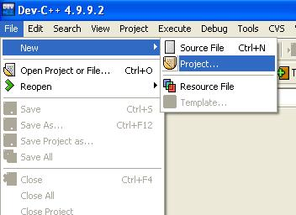

The above step will bring up the following:
Now select the icon <Empty Project> and click <Ok>

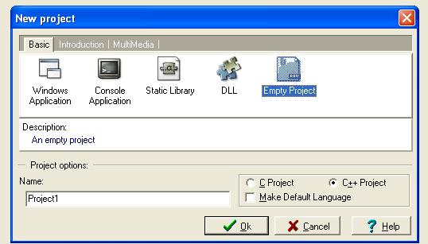

The computer now asks you for a file name and where to save the file.
Then press <Save>

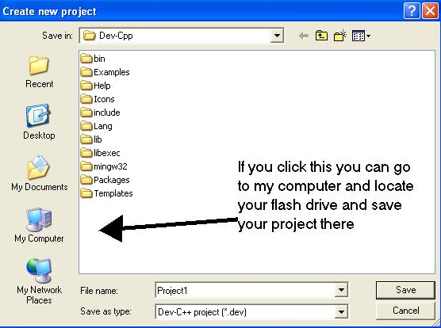

Once the file is saved right-click <Project> / <New File>

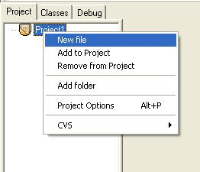

You are now provided with a workspace for your program.
Go ahead and start typing your program.

