How to Start Code::Blocks

Open up Code::Blocks and click <File> / <New> / <Project>

From the list, choose “Console Application”.
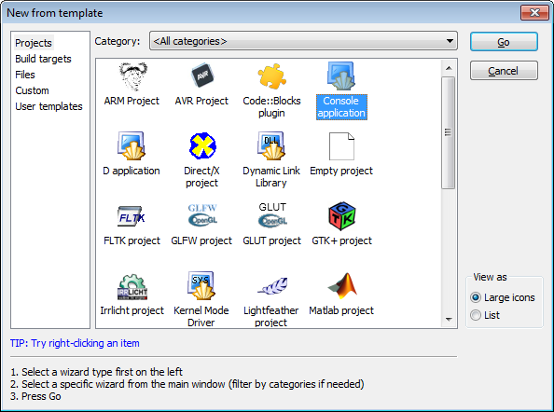

From here, press “Next.”
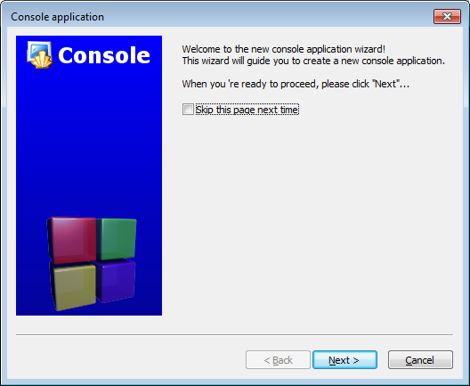

Choose C++ as the language
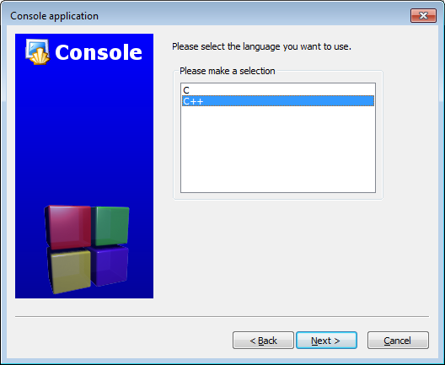
Enter a name for your project and the location at which you want to save it.
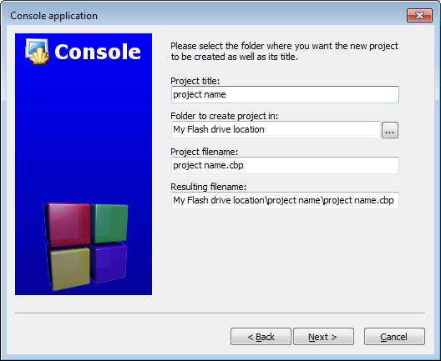
For compiler use “GNU GCC Compiler” and make sure you have the following entered for the debug/release configurations:
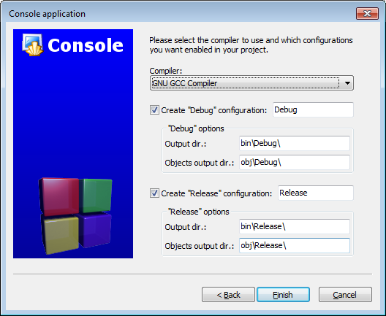
You will now have a “main.cpp” under the “Sources” folder. This is where you can write your program.

