**11/12/2017**

**Head First Design Patterns**

**Project 3 Report**

***Braeden Brettin, Matthew Deremer, and Luke Pace***

**Table of Contents**

Table of Figures 3

Observer Pattern 6

Strategy Pattern 22

References 34

# **Table of Figures**

Figure 1. Subject-Observer Relationship 6

Figure 2. Initial Player Class 7

Figure 3. Initial Subject Class 8

Figure 4. Initial MatchData Class 9

Figure 5. Initial Observer Class 9

Figure 6. Initial PlayerStats Class 10

Figure 7. Initial TeamStats Class 10

Figure 8. Initial Failed Tests 11

Figure 9. Initial Failed Tests 12

Figure 10. Initial Failed Tests 12

Figure 11. Initial Passed Tests 13

Figure 12. Initial Passed Tests 14

Figure 13. Initial Passed Tests 15

Figure 14. Revised Player Class 16

Figure 15. Revised Subject Class 16

Figure 16. Revised MatchData Class 17

Figure 17. Revised MatchData Class 18

Figure 18. Revised Observer Class 18

Figure 19. Revised PlayerStats Class 19

Figure 20. Revised TeamStats Class 20

Figure 21. Passed Tests 21

Figure 22: Strategy Pattern Outline 22

Figure 23: Non-pattern Multiple Method Calculator 24

Figure 24: Non-pattern Multiple Method Calculator 24

Figure 25: Non-pattern Single Method Calculator 25

Figure 26: Non-pattern Single Method Calculator 25

Figure 27: Interface Class 26

Figure 28: AverageByMean Concrete Class 27

Figure 29: AverageByMedian Concrete Class 27

Figure 30: AverageByMode Concrete Class 28

Figure 31: AverageByGeometric Concrete Class 28

Figure 32: AverageByHarmonic Concrete Class 29

Figure 33: Calculator Class 29

Figure 34: Test Suite List 30

Figure 35: Results Close Enough Function 30

Figure 36: Test AverageByMean 31

Figure 37: Test AverageByMedian 31

Figure 38: Test AverageByMode 31

Figure 39: Test AverageByGeometric 32

Figure 40: Test AverageByHarmonic 32

Figure 41: Calculator Passed Test 32

# **Observer Pattern**

The Observer pattern is one of the most widely used patterns in all of software development. Using it, observers can request information from subjects at any time, thereby promoting the idea of loosely-coupled objects. Like a newspaper subscription service, observers can decide if they want to remain subscribed to the subject, the newspaper in this example. Every week, the subject updates the observer with a brand-new newspaper. The Observer pattern is built into the JDK; however, we would like to create our own Observer pattern in our chosen language of C#. Our Observer pattern will have the same functionality as Java’s built -in Observer pattern, allowing observers to be registered and removed from the subject and allowing the subject to notify the observers. In the following project, we will create our own Observer class and interface and Subject class and interface. We will then incorporate them together in a one-to-many relationship to implement the Observer pattern. A general outline of the relationship between the Subject and Observer is shown in Figure 1, below.



Figure 1. Subject-Observer Relationship

In our example, the Subject class will contain data for each player in a soccer match. This data will include number of minutes played, goals, and assists. Every minute of match time, an Observer class will request certain information from the Subject class. The two Observer classes in this project, a statistical analysis for all players and an overview of the current stats for each team, will then be displayed.

To begin, we created a skeleton class for out Subject and Observer interfaces, and we set up a test suite that outlines the various methods and variables that we believe this test will utilize. We will first test the methods contained in the MatchData class, which implements the Subject interface. We first created a Player object, as shown in Figure 2, below, which contains the number of minutes played, goals, and assists for a player.

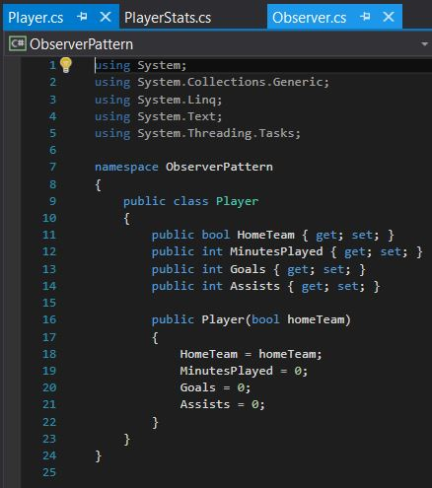

Figure 2. Initial Player Class

The initial Subject interface was as shown in Figure 3, below.

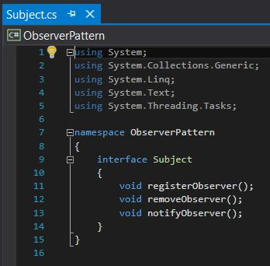

Figure 3. Initial Subject Class

We then created a class that will implement this Subject interface, the MatchData class, as shown in Figure 4, below. This MatchData class contains a list of Player objects, methods for registering, removing, and notifying observers, and a method for returning the list of Player objects.

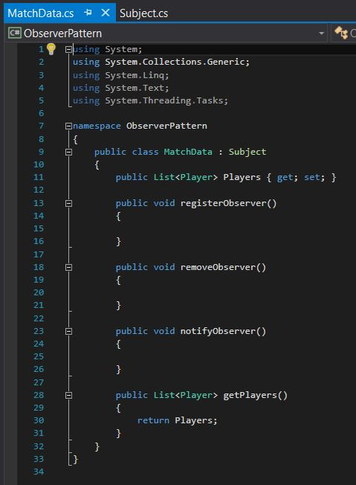

Figure 4. Initial MatchData Class

The initial Observer interface was as shown in Figure 5, below.

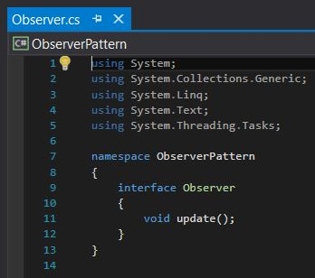

Figure 5. Initial Observer Class

We next created a PlayerStats class that will implement this Observer interface, as shown in Figure 6, below. This class will provide a statistical analysis of Player data, such as the Player with the most minutes played, the top scorer, and the Player with the most assists.

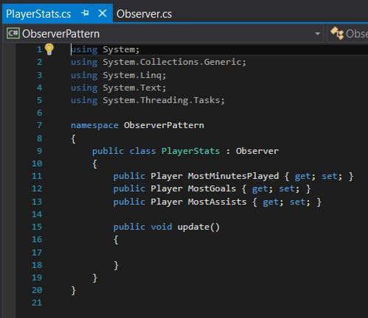

Figure 6. Initial PlayerStats Class

Finally, we created a TeamStats class that will implement the Observer interface, as shown in Figure 7, below. This class will simply display the score of the match.

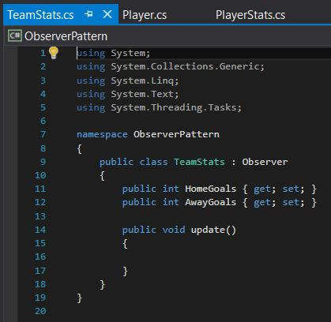

Figure 7. Initial TeamStats Class

With the skeleton structure of these initial classes set up, we created a test suite for each class that implements an interface. These initial tests were set up and run so that they would purposefully fail, as shown in Figures 8 through 10, below.

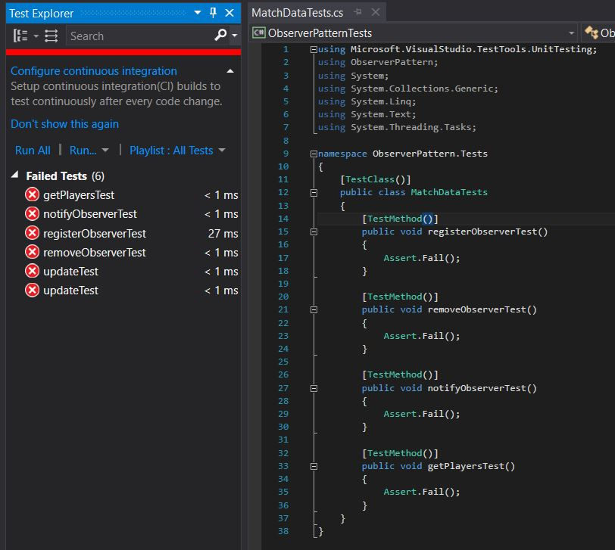

Figure 8. Initial Failed Tests

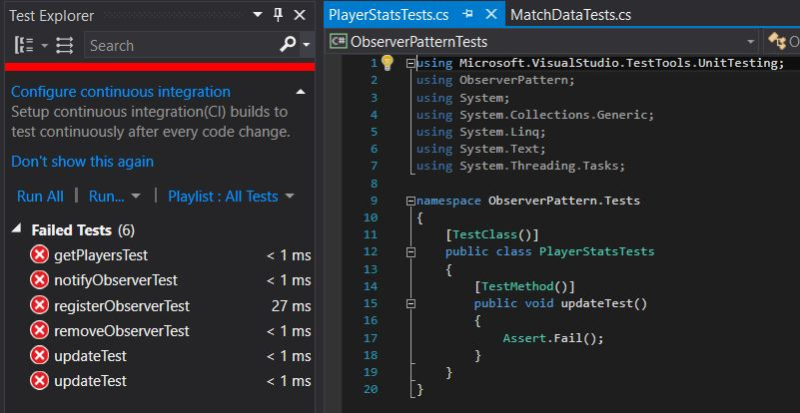

Figure 9. Initial Failed Tests

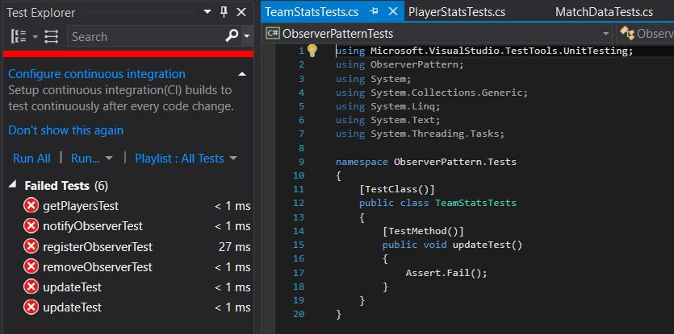

Figure 10. Initial Failed Tests

The next step in test driven development is to add code to our classes being tested so these tests will now pass successfully. After revising the classes being tested, we re-ran the test suite, producing the successful output shown in Figures 11 through 13, below.

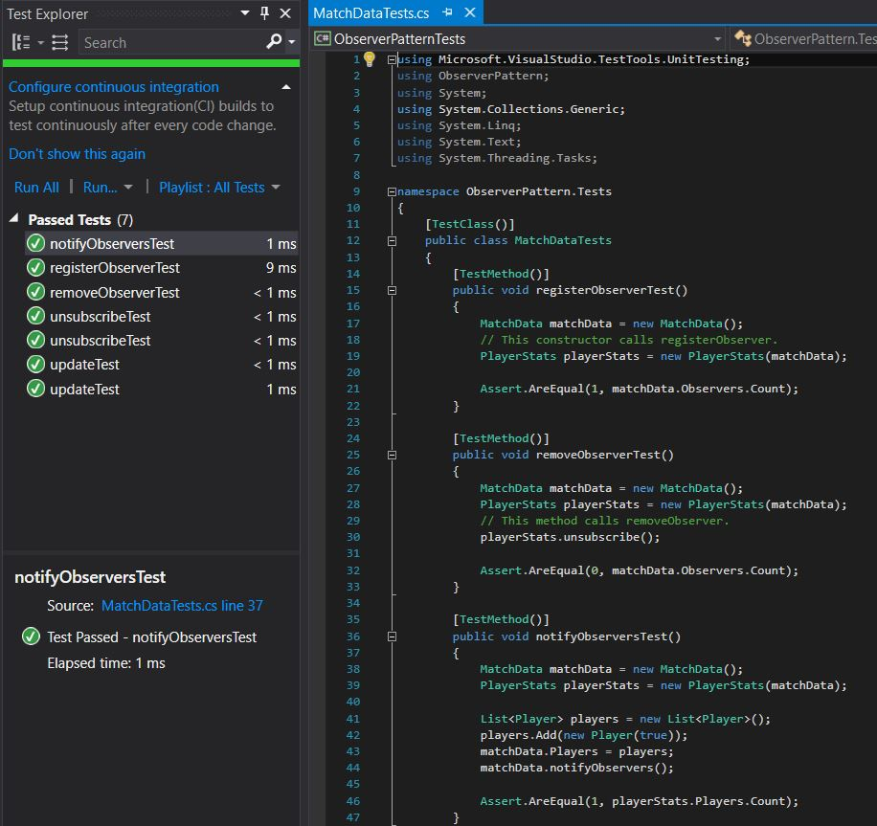

Figure 11. Initial Passed Tests

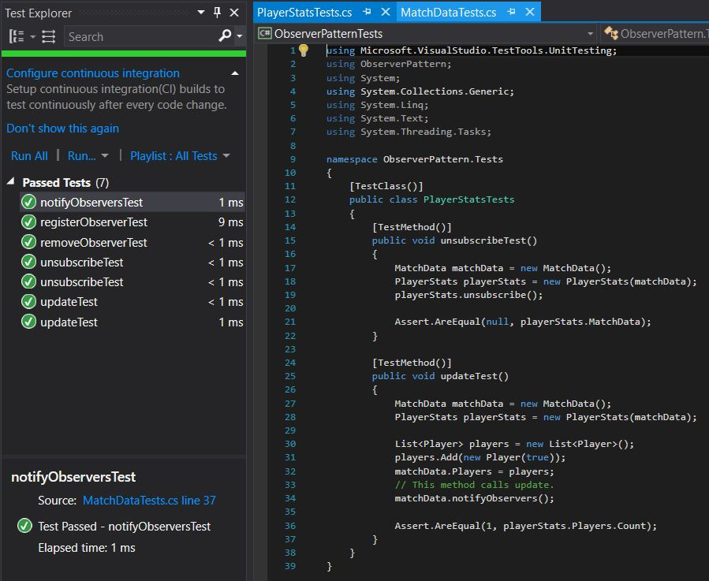

Figure 12. Initial Passed Tests

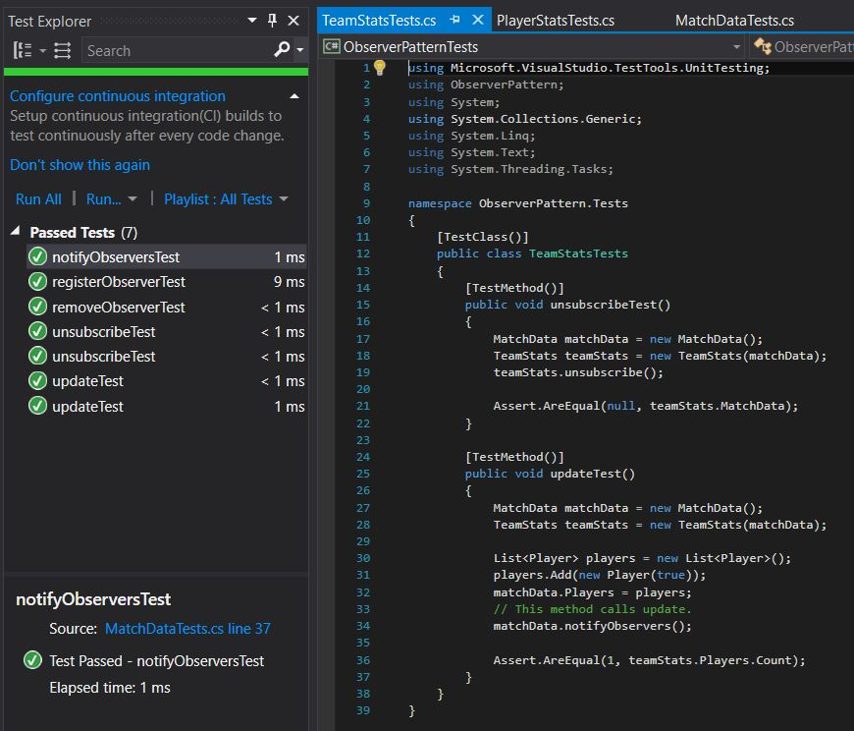

Figure 13. Initial Passed Tests

With these tests now running successfully, we no longer must amend this test suite and can simply re-run it every time we refactor the source code. We now need to add methods for updating the minutes played by each player and recording when a goal is scored and/or an assist is recorded. The classes were amended to include all information needed for our Observers, as shown in Figures 14 through 20 below.

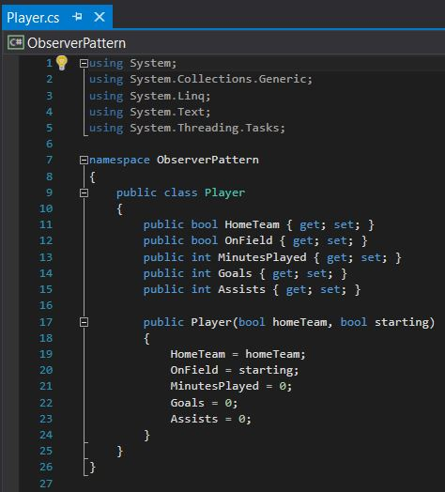

Figure 14. Revised Player Class

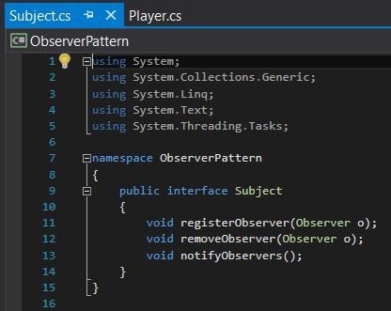

Figure 15. Revised Subject Class

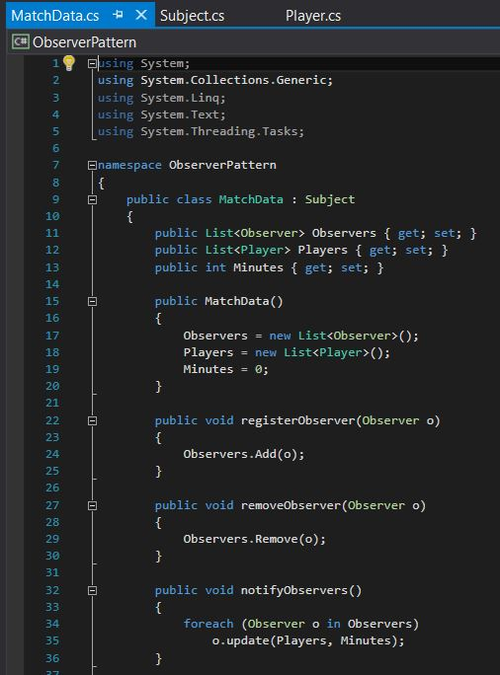

Figure 16. Revised MatchData Class

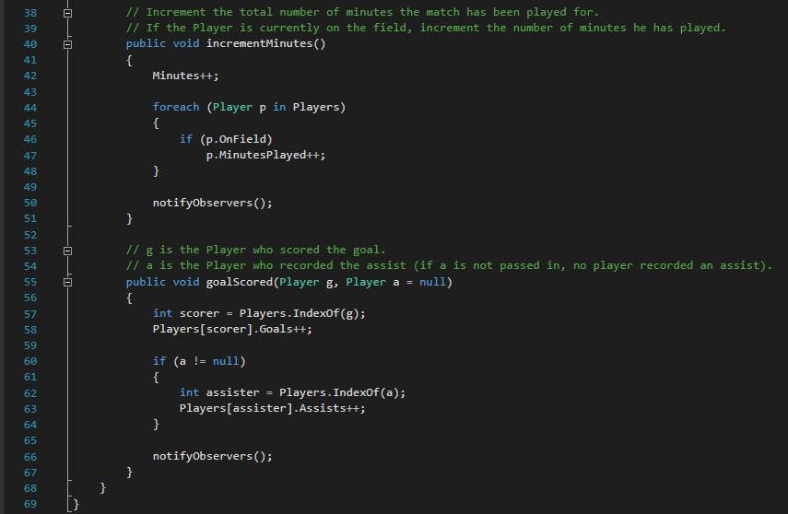

Figure 17. Revised MatchData Class

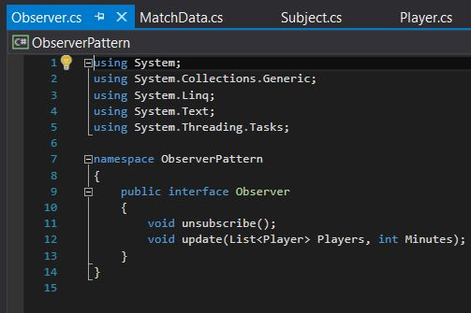

Figure 18. Revised Observer Class

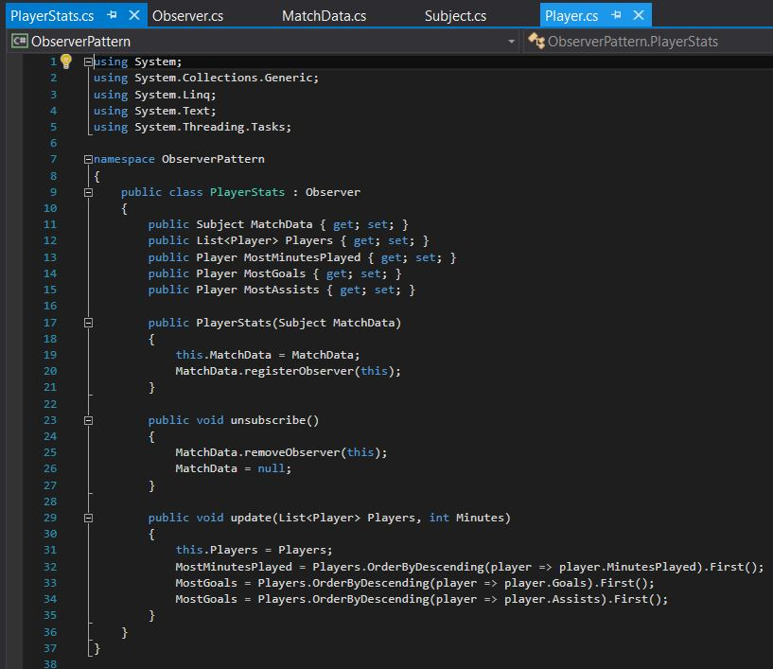

Figure 19. Revised PlayerStats Class

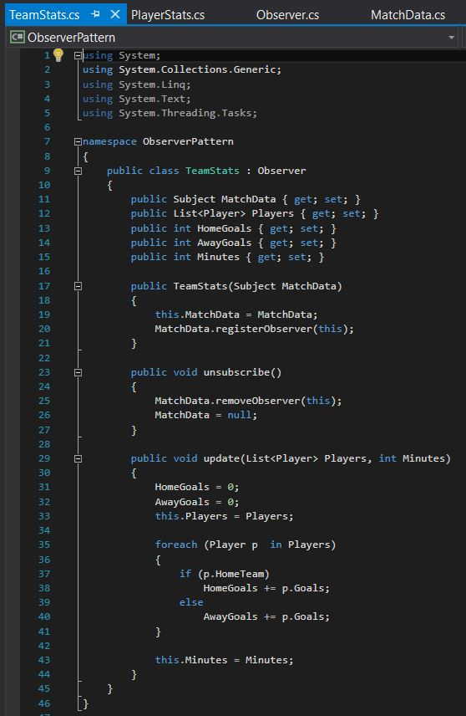

Figure 20. Revised TeamStats Class

To confirm that none of our refactoring affected the functionality of the code, we ran our test suite again, producing the successful output shown in Figure 21, below.

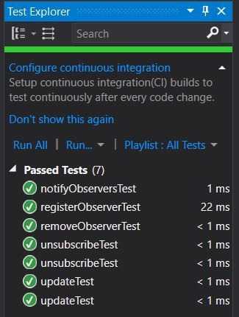

Figure 21. Passed Tests

As seen from this project, the Observer pattern is a widely-used, useful pattern for exchanging data between subjects and observers. It is exceptionally handy in the case of performing a statistical analysis on a sporting event, as shown in this project. Through loosely coupling the subjects and observers, developers can quickly and efficiently pass a wealth of information between multiple classes.

Unfortunately, our Observer pattern requires the subject to notify the Observers with a specific set of information, and the Observer cannot specify which information they would like to receive. In a more in-depth project, we would give the Observer the ability to request specific information from the Subject, reducing the amount of overhead required.

# **Strategy Pattern**

The Strategy Pattern is one of the most fundamental patterns used by developers. The intent of the pattern is to “define a family of algorithms, encapsulate each one, and make them interchangeable. Strategy lets the algorithms vary independently from the clients that use it.” Without the use of the Strategy Pattern, algorithms would be implemented directly within the class that uses it. This makes the class inflexible because the algorithm written in the class is used at compile-time even though it might not be correct for the type of data. Also, since the algorithm would be written directly in the class, it cannot be modified in the future without changing the class and limits the reusability of the class. By using the Strategy Pattern, we can encapsulate the interface in a base class and bury the implementation of different algorithms in derived classes. This is also an example of the open-closed principle which means the interface is open to extension but closed from modification. Figure 22, below, shows the outline of the pattern and how the separation of algorithms from the base class allows for changes to be made to the derived classes without affect the client.

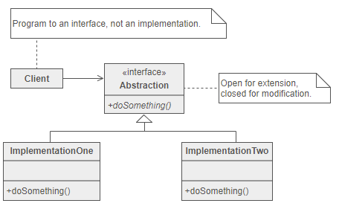

Figure : Strategy Pattern Outline

As with most designs, there are advantages and disadvantages. There are many advantages of the Strategy Pattern including the ability to alter behavior without affecting the client, easily add new algorithms, and avoid the use of series of “switch” and “if-else” statements. There are also drawbacks for the pattern which include the application must be aware of all possible strategies to select the correct one, base classes must expose interface for all required behaviors, and since most applications configure the client with the base class, two objects are created instead of one.

To demonstrate the use of the Strategy Pattern, we have created a Calculator class that needs to calculate the average of a list of numbers using either the mean, median, mode, geometric, or harmonic technique. To show the effectiveness of the pattern, we started by writing multiple methods in a single class which is an alternative to the Strategy Pattern. The non-patterned version can be seen below in Figures 23 and 24.

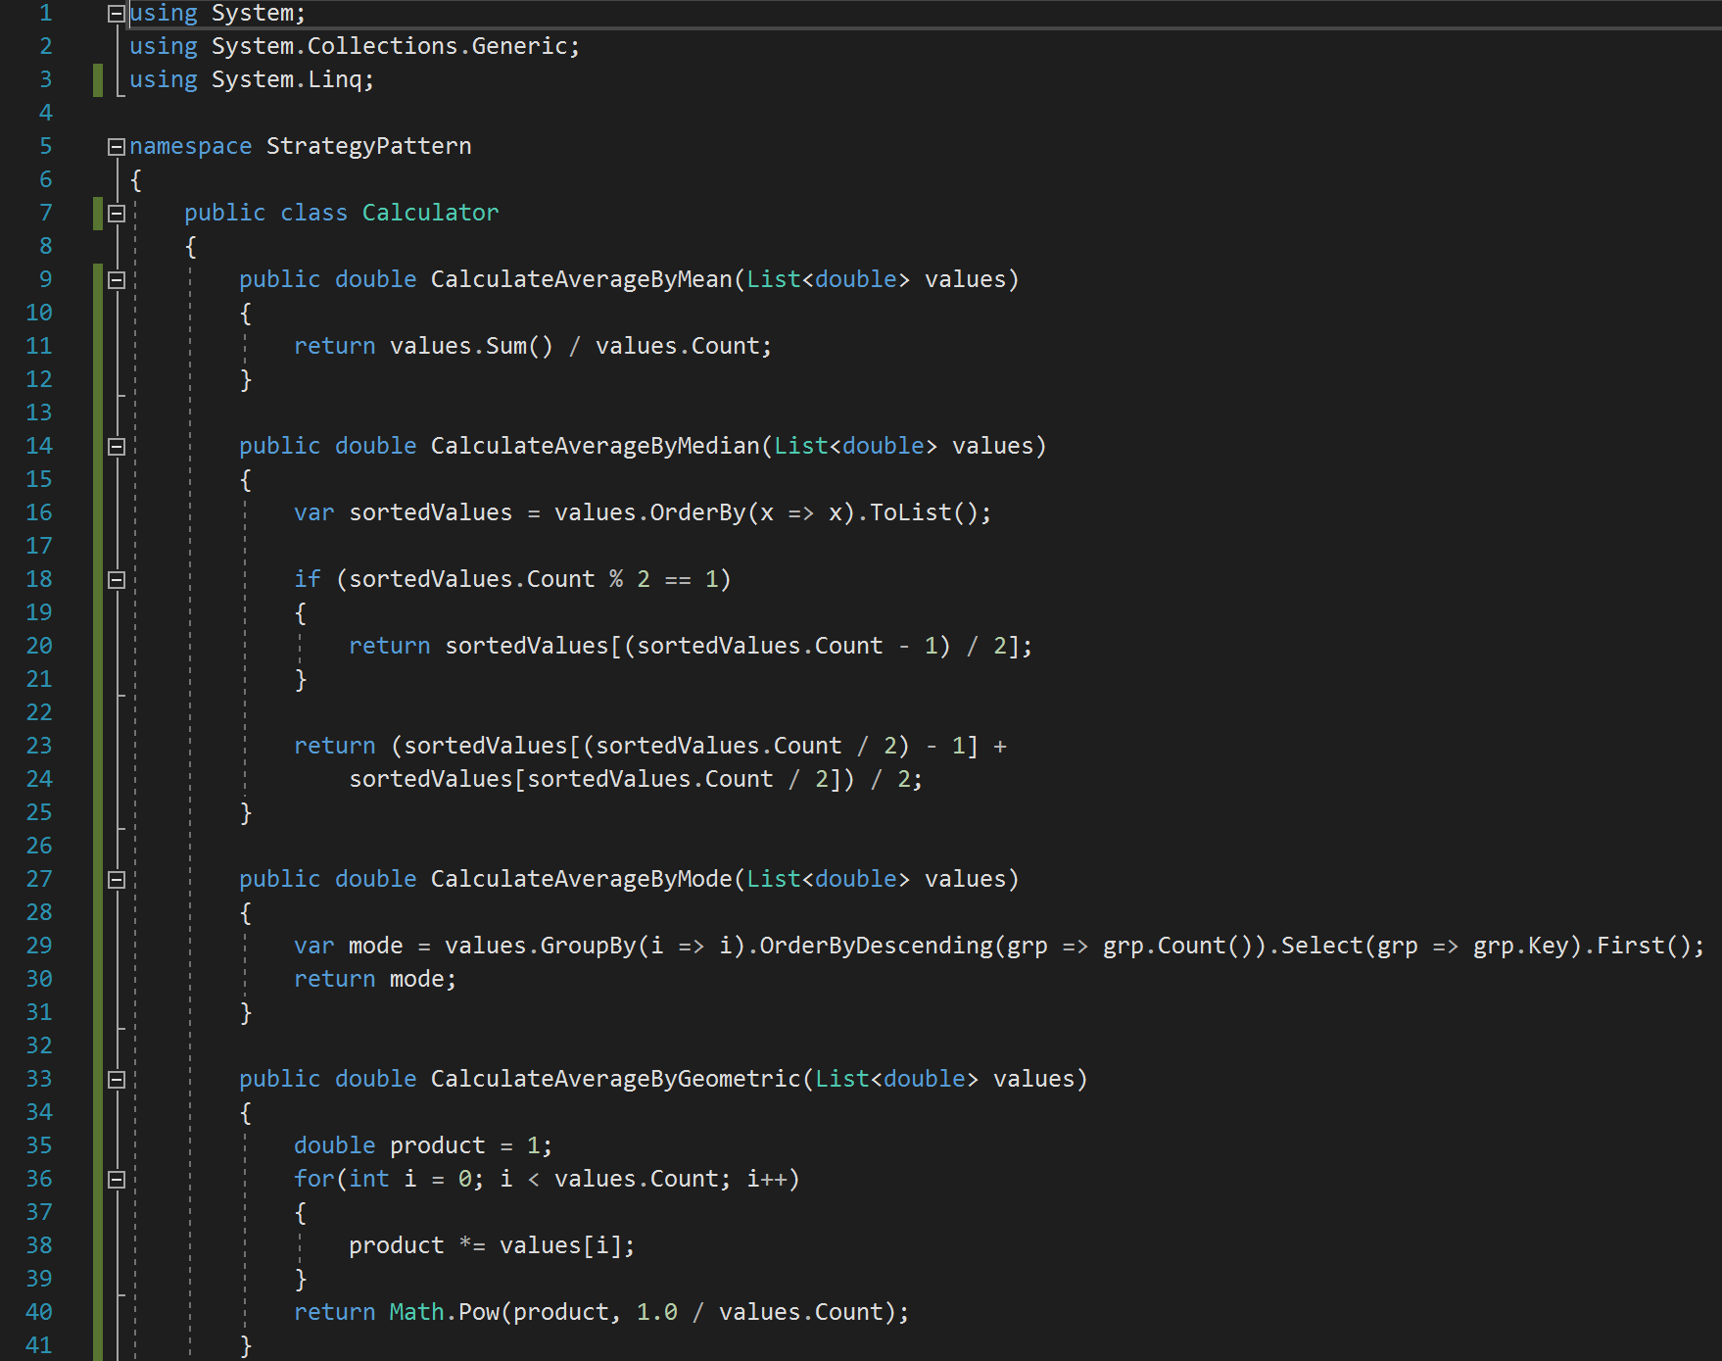

Figure : Non-pattern Multiple Method Calculator

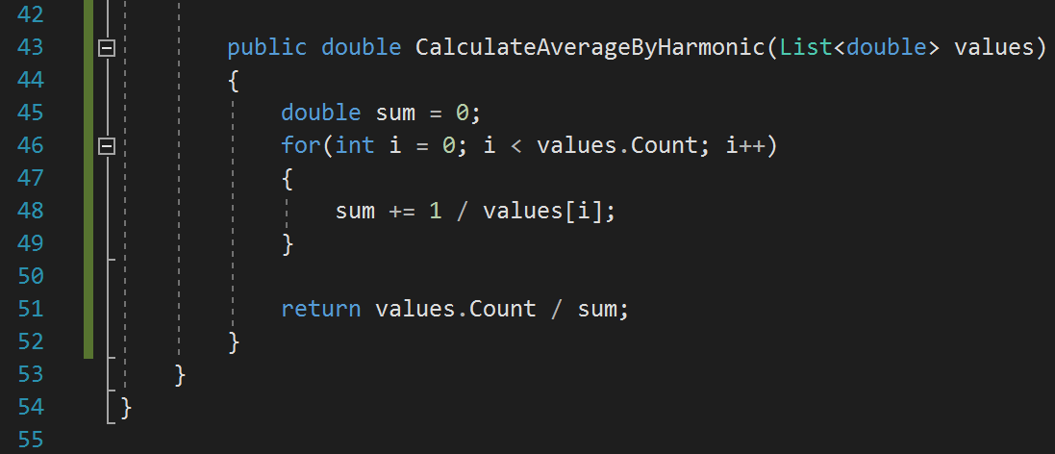

Figure : Non-pattern Multiple Method Calculator

Another alternative to using the Strategy Pattern is to have all the algorithms contained in a single method with switch statements as shown in Figures 25 and 26 below.

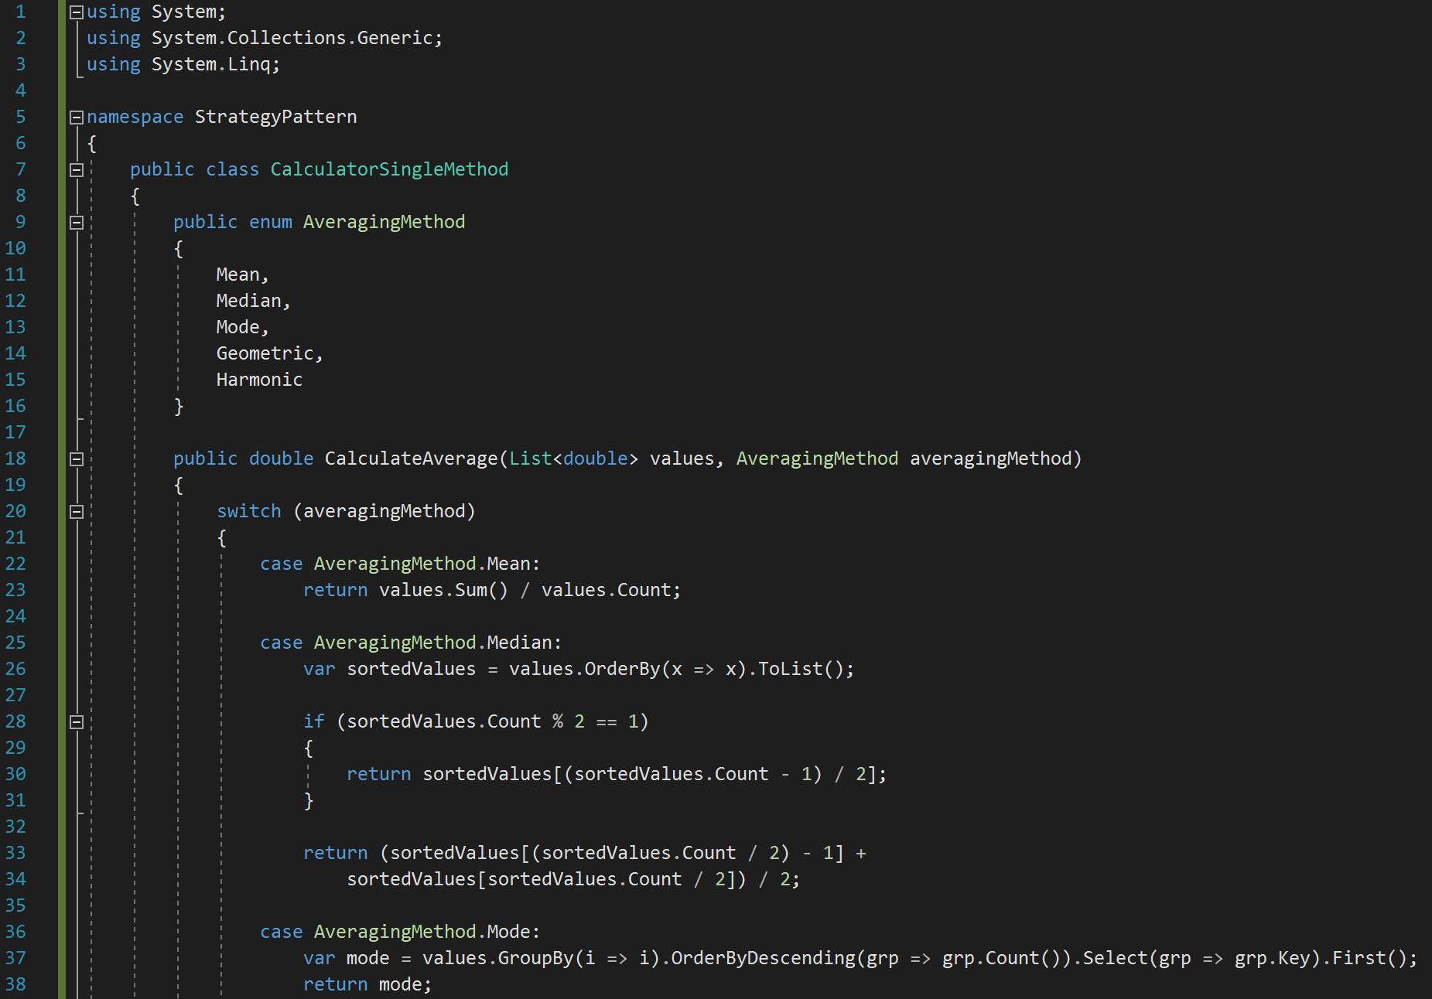

Figure : Non-pattern Single Method Calculator

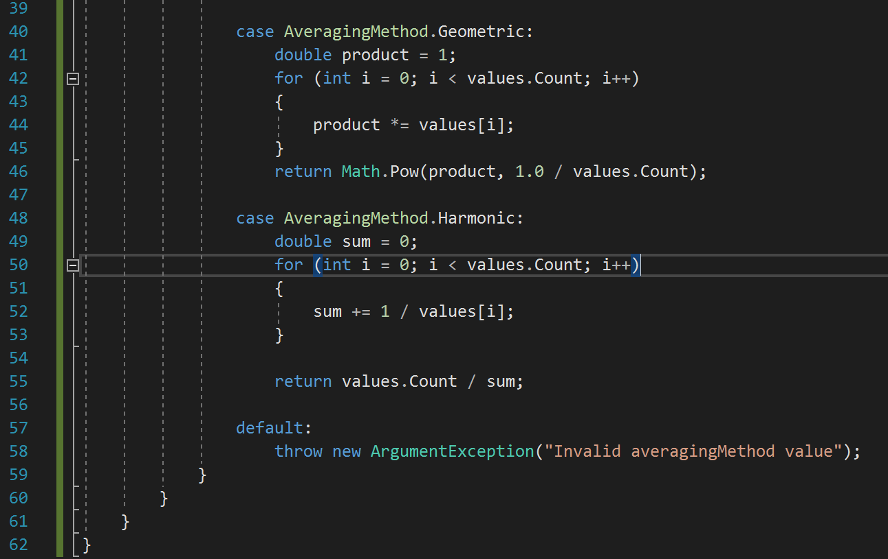

Figure : Non-pattern Single Method Calculator

While the code shown above will work, it is not ideal. The code is long making it hard to read and debug and if any changes want to be made, the class must be rewritten. Now we will implement the class using the Strategy Pattern. The project does become more complex when implementing the project due to the use of multiple files but will be more useful in the future when changes need to be made. We start the implementation of the pattern by creating the interface as shown in Figure 27, below. The interface declares what must exist in each concrete strategy class and the concrete strategy classes implement the interface.

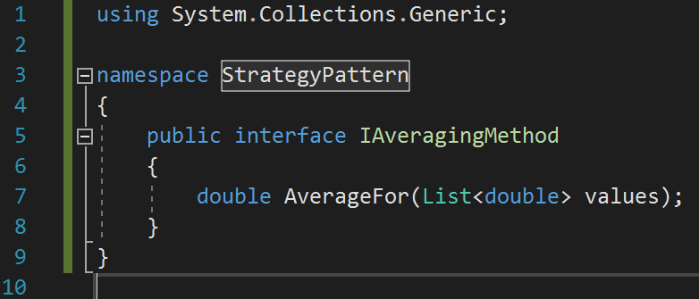

Figure : Interface Class

After writing the interface, each concrete class was written. Each concrete class must include an “AverageFor” function as declared in the interface. The concreate classes are shown below in Figures 28 through 32 in the following order: mean, median, mode, geometric, and harmonic.

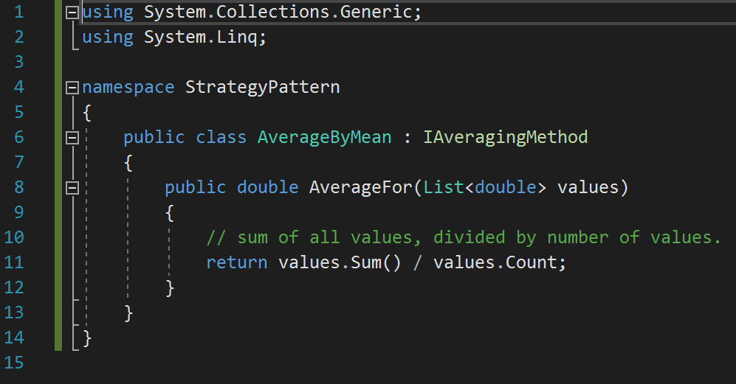

Figure : AverageByMean Concrete Class

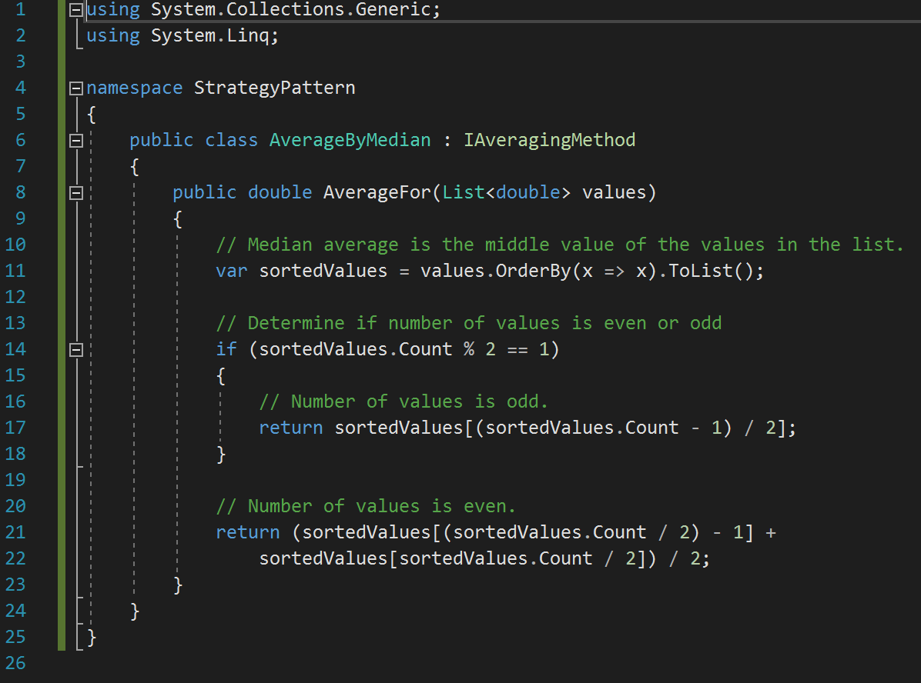

Figure : AverageByMedian Concrete Class

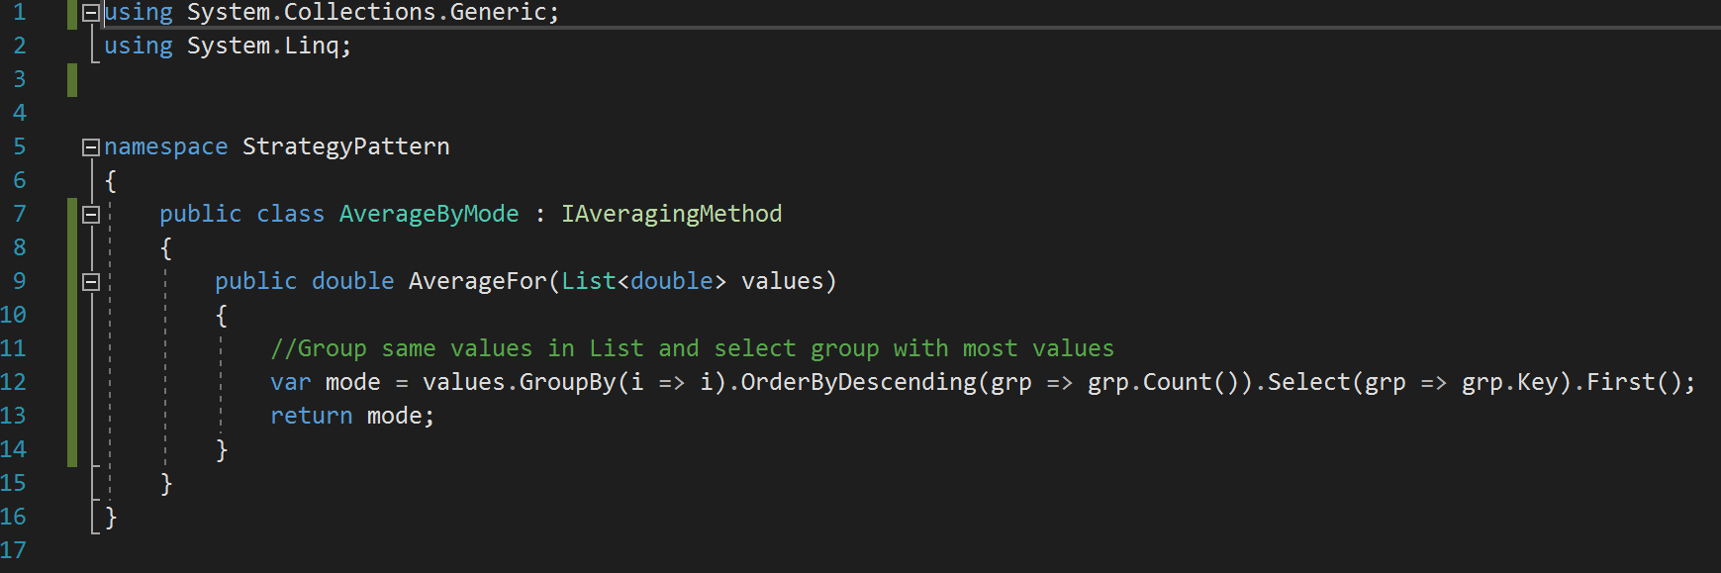

Figure : AverageByMode Concrete Class

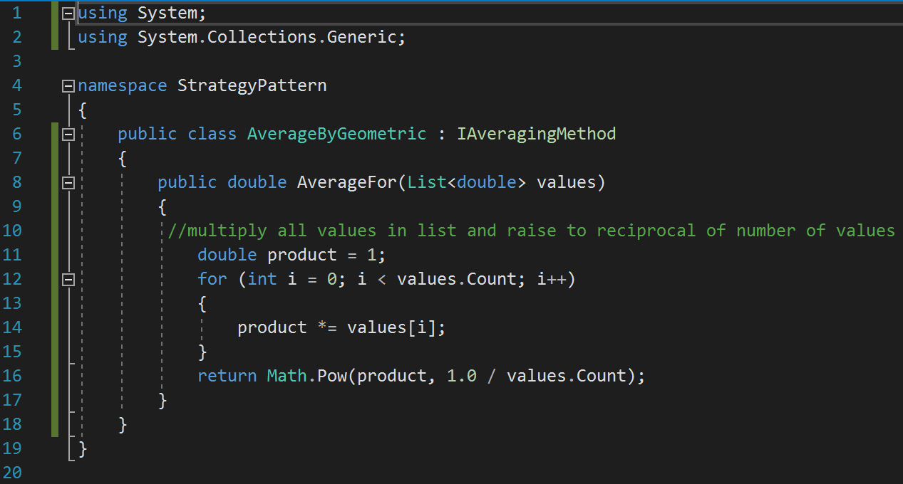

Figure : AverageByGeometric Concrete Class

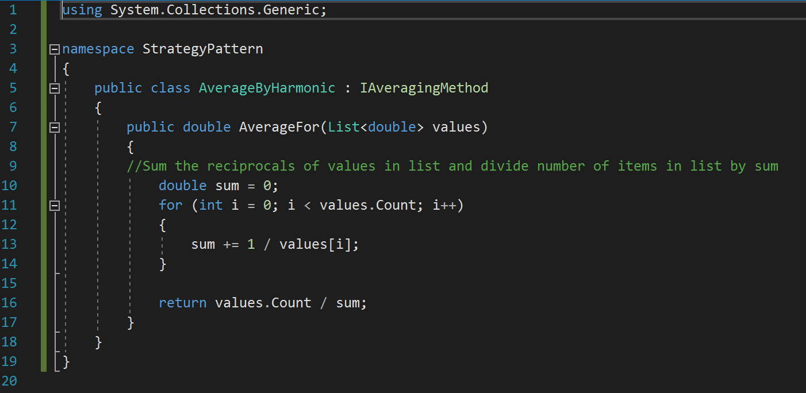

Figure : AverageByHarmonic Concrete Class

After all the concrete classes had been written, we wrote the client class to use the interface class. As shown in Figure 33, below, the function receives a list of numbers and an object of the type of our interface class. This allows us to pass an object that implements the correct concrete class.

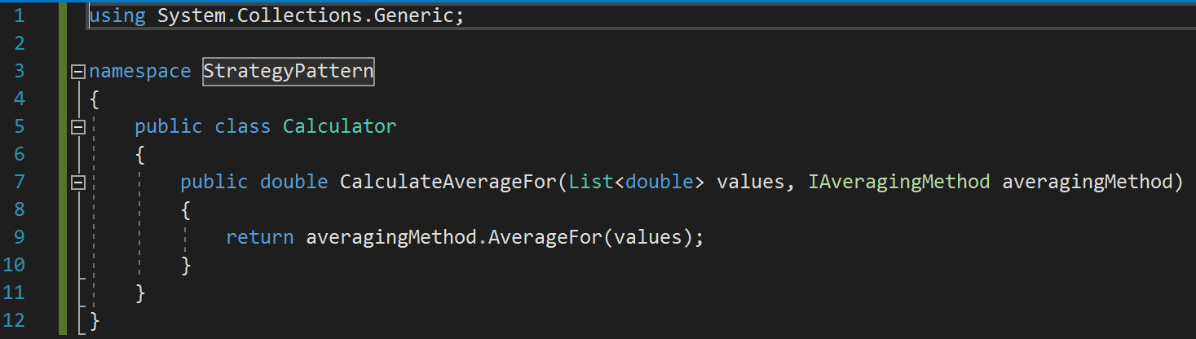

Figure : Calculator Class

The final step in implementing the Strategy Pattern was to test the design. To do this, we create Unit test that would create a Calculator object, call the CalculateAverageFor function for each of the concreate classes, and compare the returned value to expected value. Figure 34, below, shows the setup of the test suite where the list of values that are used in each test is created.

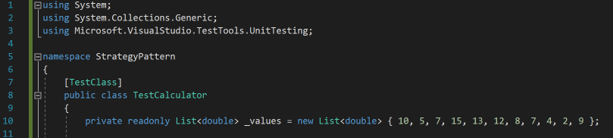

Figure : Test Suite List

Before we could write any test, we need to write a short function to return a bool if the expected value and actual value are within .000001. This function is required because we are using floating point numbers and values may not be an exact match. The function can be seen in Figure 35, below.

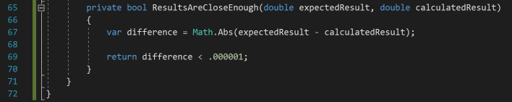

Figure : Results Close Enough Function

We then wrote the test for each concrete class which can be seen in Figures 36 through 40 below. Each test creates a Calculator object, calls the CalculateAverageFor function passing the desired concrete class, and checks if the returned value is close enough to the expected value.

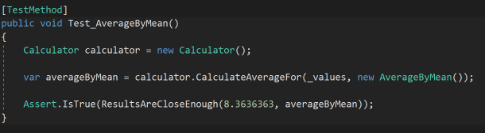

Figure : Test AverageByMean

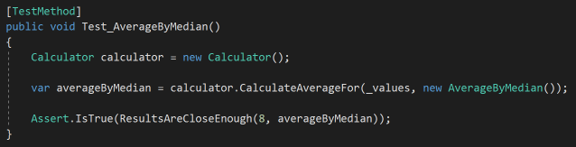

Figure : Test AverageByMedian

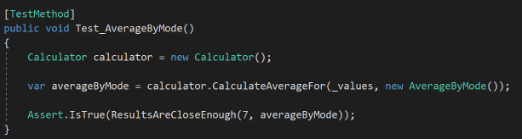

Figure : Test AverageByMode

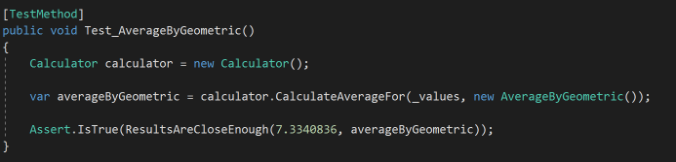

Figure : Test AverageByGeometric

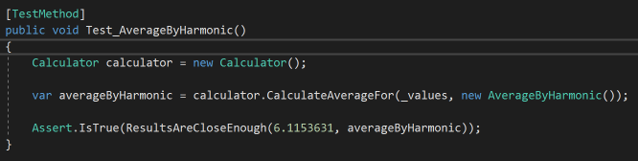

Figure : Test AverageByHarmonic

As shown in Figure 41, below, all test passed proving the Strategy Patten is working correctly.

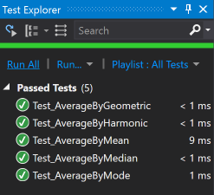

Figure : Calculator Passed Test

As the section of the project has demonstrated, the Strategy Pattern is a useful way to organized projects with more than one way to accomplish a task. The separation of each algorithm in its own class allows for changes to be made to existing algorithms and new algorithms to be add or subtracted without affecting the functionality of the interface or client. This is a better option to the alternative of having all algorithms in one class but different functions or having all algorithms in one class and one function. These alternative methods are okay for smaller projects but in a larger project, having hundreds of lines of code in a single class can be difficult to read and debug.

# **References**

Freeman, E., & Freeman, E. (2005). Head First Design Patterns. O'Reilly.

Wagner, B. (n.d.). Interfaces (C# Programming Guide). Retrieved November 9, 2017, from https://docs.microsoft.com/en-us/dotnet/csharp/programming-guide/interfaces/

Get Max Value in a List of Points. (n.d.). Retrieved November 5, 2017, from https://stackoverflow.com/questions/26593348/get-max-value-in-a-list-of-points

How to: Create and Run a Unit Test. (n.d.). Retrieved November 2, 2017, from <https://msdn.microsoft.com/en-us/library/ms182524(v=vs.90).aspx>

Design Patterns and Refactoring. (n.d.). Retrieved November 16, 2017, from https://sourcemaking.com/design_patterns/strategy