**11/29/2017**

**Head First Design Patterns**

**Project 4 Report**

***Braeden Brettin, Matthew Deremer, and Luke Pace***

**Table of Contents**

Table of Figures 3

Adapter Pattern 4

References 13

# **Table of Figures**

Figure 1. Adapter Design 4

Figure 2. Adapter and Target Design 5

Figure 3. Initial Failed Test 6

Figure 4. Initial Dog Class 7

Figure 5. Initial Beagle Class 7

Figure 6. Initial Wolf Class 7

Figure 7. Initial WildWolf Class 8

Figure 8. WolfAdapter Class 9

Figure 9. Refactored Wolf Class 9

Figure 10. Refactored WildWolf Class 10

Figure 11. Refactored Dog Class 10

Figure 12. Refactored Beagle Class 11

Figure 13. Successful Test 12

# **Adapter Pattern**

The object-oriented notion of an adapter is not too different from that of a real-life adapter. Think back to any trip you may have made to a foreign country. In most other countries, a normal AC plug will not connect to wall outlets. Why is this? It could be due to a difference in required voltage or a difference in socket design. How did you fix the problem? You used an adapter. This adapter adapted your design (the American AC plug) to a client (the wall outlet) without changing either of these components. In much the same way, object-oriented adapters provide functionality to connect an existing system to a client without changing the code of either of these components. Instead, new code is written in the adapter to adapt the two components. This adaptation can be visualized as a jigsaw puzzle, as shown in Figure 1, below.



Figure 1. Adapter Design

The adapter pattern “converts the interface of a class into another interface the clients expect” (Freeman 243). This pattern enables classes to work in tandem that otherwise would not be able to because of incompatible interfaces. This pattern also preserves the decoupling of the adapter and the client. Neither class has any knowledge of the inner workings of the other class, an ideal condition in object-oriented design. The client sees only the Target interface, and all requests get delegated to the Adaptee, as shown in Figure 2, below.



Figure 2. Adapter and Target Design

For the purposes of this project, I will create a Wolf interface that can be adapted to a Dog interface. Considering the close genetic relationship between these two species, these two animals share similar attributes and behaviors. As such, these two interfaces will share similar functions to replicate the real-world behaviors of these two species. The Dog interface contains functions for barking and running, bark() and run(), respectively. The Wolf interface contains functions for howling and running, howl() and run(), respectively. The bark() and howl() functions will differ slightly in the sound that the animal makes. The run() functions in the two classes will differ slightly in the amount of time that the animal runs. We have also created two concrete classes, each implementing either the Dog or Wolf interface.

A test suite was created that outlines the specific functionality we hope to achieve in this project. This test suite was purposefully failed, as shown in Figure 3, below.

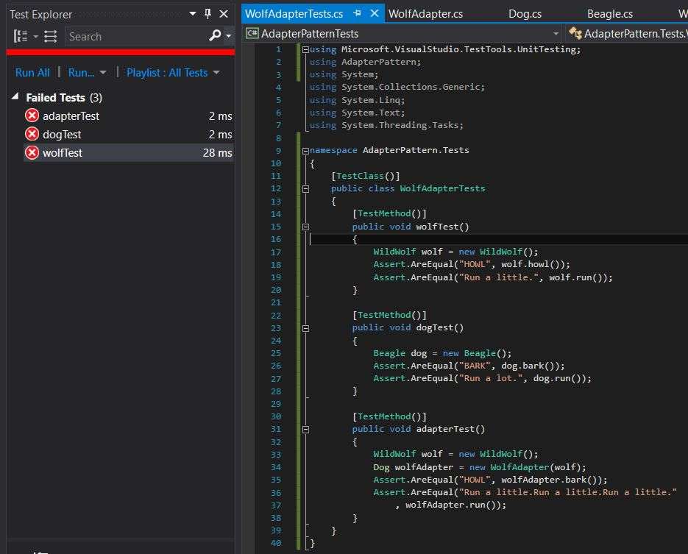

Figure 3. Initial Failed Test

The code in the interfaces and concrete classes at the time of this failed test was as shown in Figures 4 through 7, below.

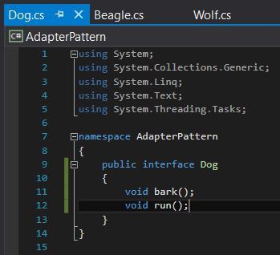

Figure 4. Initial Dog Class

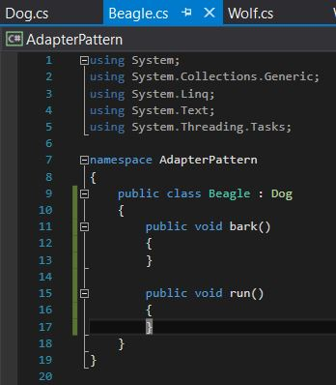

Figure 5. Initial Beagle Class

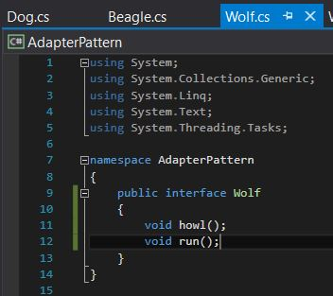

Figure 6. Initial Wolf Class

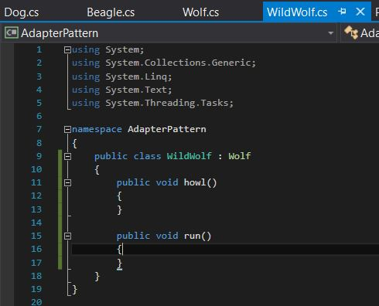

Figure 7. Initial WildWolf Class

Now that these initial classes have been created and the test suite created and outlined, we need to create an adapter for the Wolf interface. How do we go about doing so? We can examine the differences between dogs and wolves to create this adapter. Wolves hunt in packs, so they do not have to run for long periods of time like dogs must. The pack mentality and organization of wolves allows them to conserve energy when hunting. As such, they merely need to run in short spurts. In To to adapt a wolf to a dog, we need to call the wolf’s run() function multiple times to replicate the dog’s run() function, as shown in Figure 8, below.

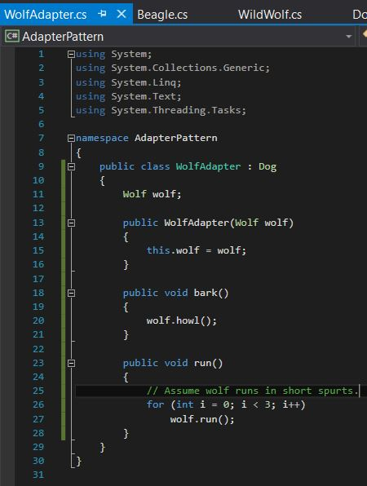

Figure 8. WolfAdapter Class

This adapter now provides the needed functionality to adapt a wolf to a dog and replicate the dog class’s behavior. We now merely need to update the Wolf, WildWolf, Dog, and Beagle classes to return the correct output when their respective functions are called, as shown in Figures 9 through 12, below.

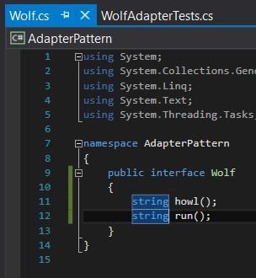

Figure 9. Refactored Wolf Class

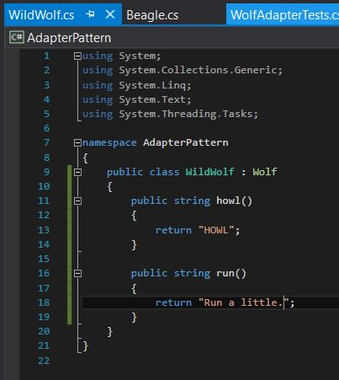

Figure 10. Refactored WildWolf Class

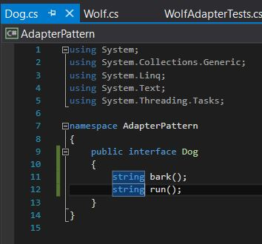

Figure 11. Refactored Dog Class

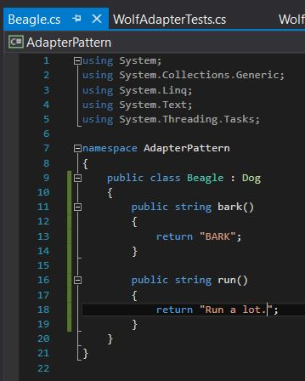

Figure 12. Refactored Beagle Class

With all of these classes refactored, we need to ensure that these changes result in successful tests, preserving the functionality of the project. The test suite was run again, producing the successful output shown in Figure 13, below.

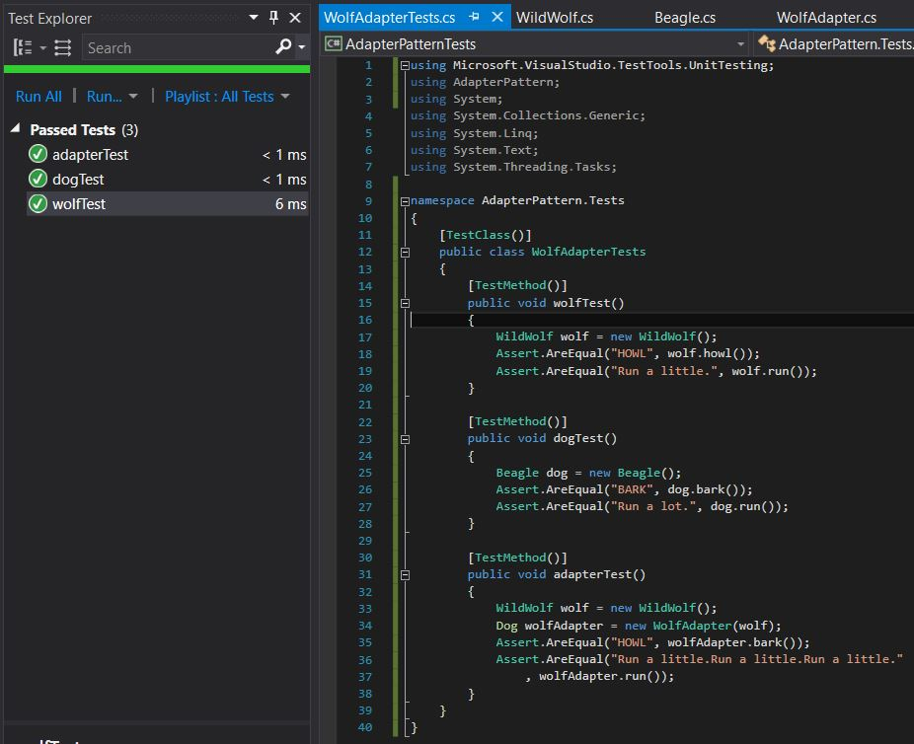

Figure 13. Successful Test

As can be seen from this project, object-oriented adapters can be used to adapt one interface to another without needing to change the code of either interface. The adapter pattern is extremely useful for adapting closely-related classes and has a plethora of real-world applications. When running low on objects of one class, consider using the adapter pattern to adapt this class to another class.

# **Singleton Pattern**

The Singleton Pattern is one of the best-known patterns in software engineering. Essentially, a singleton is a class which only allows a single instance of itself to be created, and usually gives simple access to that instance. Most commonly, singletons don’t allow any parameters to be specified when creating the instance. Although the class design, shown in Figure 14, is very simple, it is still easy to make mistakes during implementation.

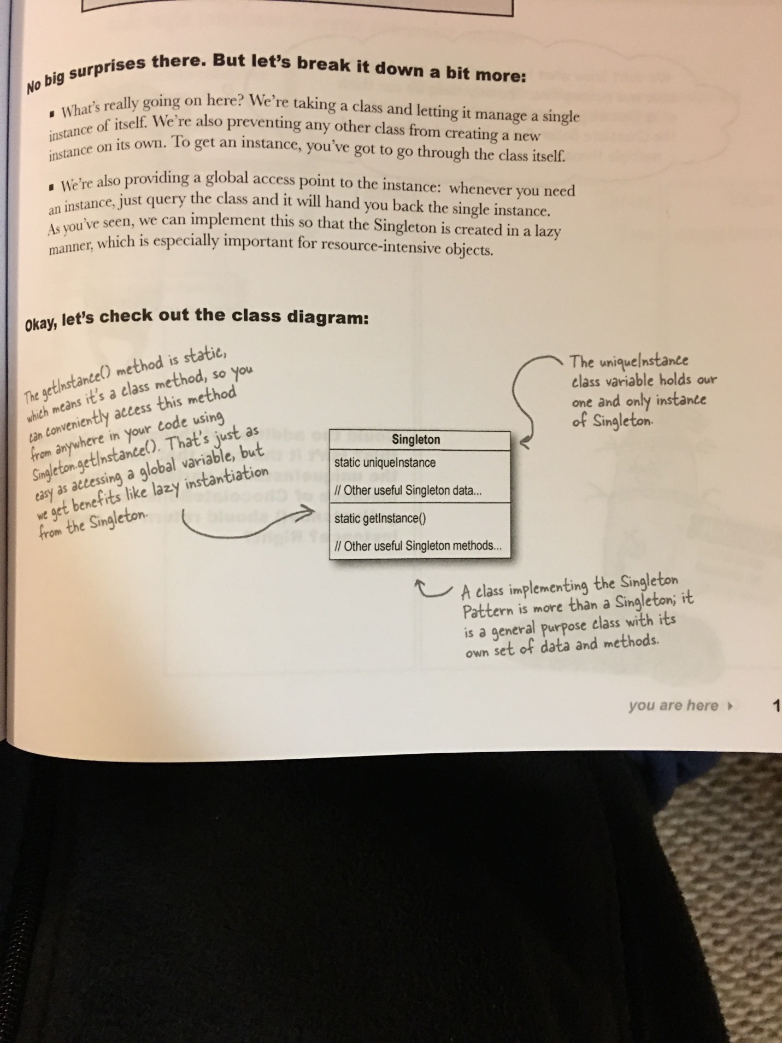

Figure 14. Singleton Pattern Class Diagram

Let’s begin by writing a class for a coffee maker.

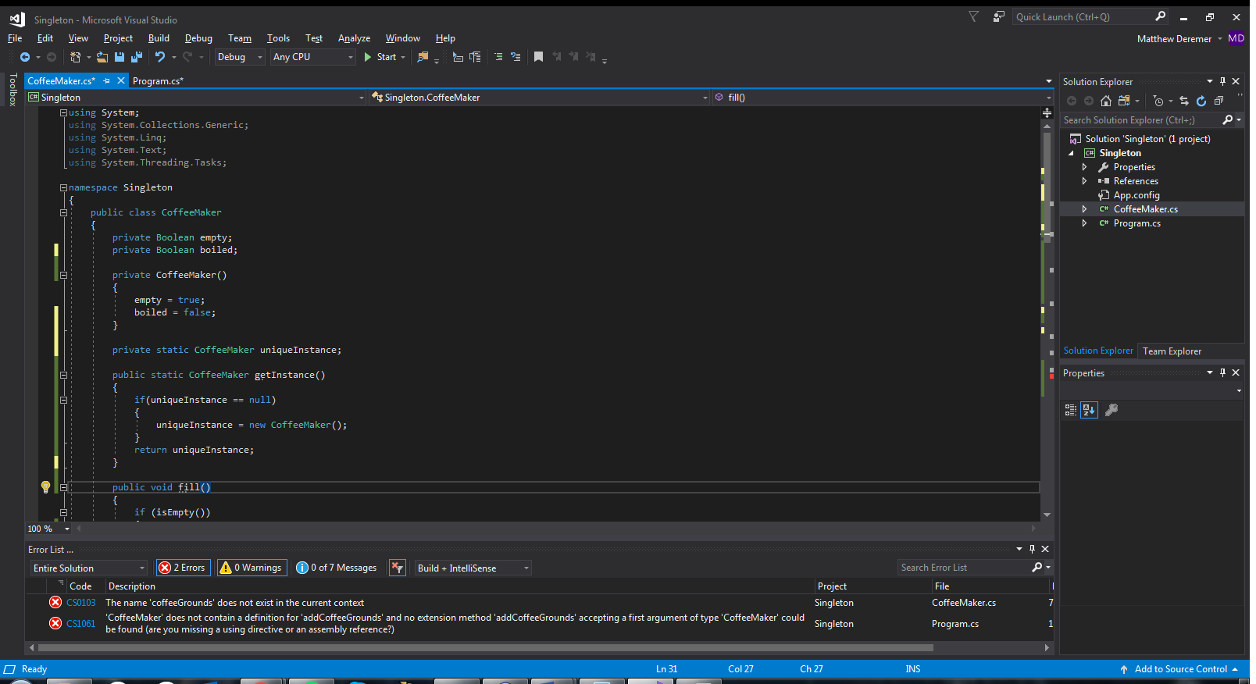

Figure 15. CoffeeMaker Class

As shown above in Figure 15, the CoffeeMaker has two Boolean variables: empty and boiled. When the CoffeeMaker class is first instantiated, it begins as an empty coffee maker with no water. However, this does not ensure that only one CoffeeMaker instance will ever be created. Multiple CoffeeMaker instances can still be generated with a simple code segment: “CoffeeMaker abc = new CoffeeMaker()”. See Figure 16 to see how I modified my code using the Singleton Pattern to work around this problem.

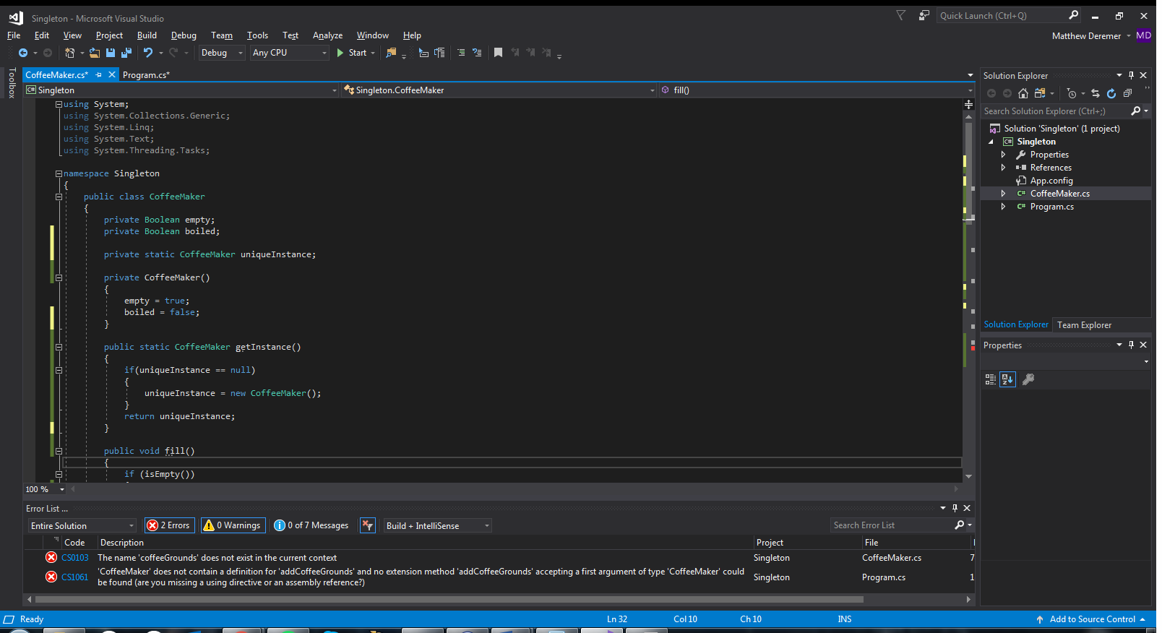

Figure 16. CoffeeMaker Class, Singleton Pattern

While setting up a new CoffeeMaker instance using getInstance, the method returns the original CoffeeMaker instance if one already exists. This ensures that only one instance of CoffeeMaker will be created and used. See Figures 17-19 to see what the class methods do.

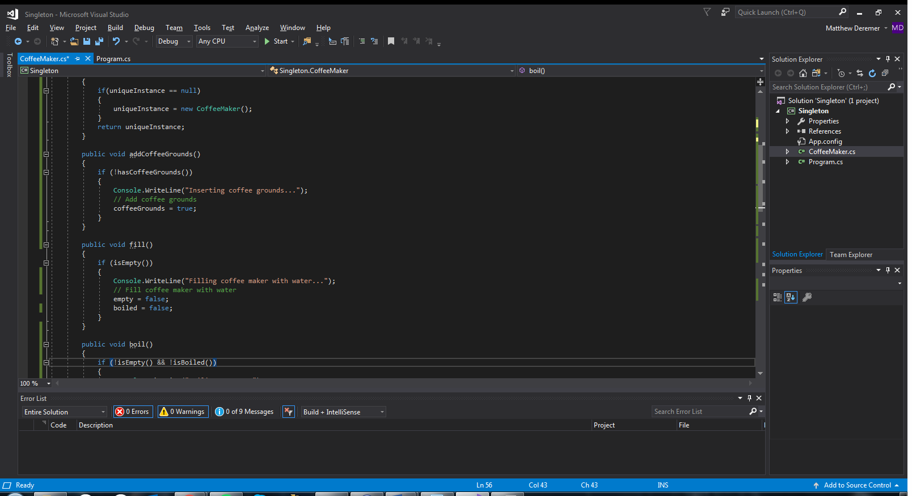

Figure 17. CoffeeMaker Method, Fill

If the CoffeeMaker object does not have water, this method fills the coffee maker with water and sets the empty and boiled variables to false.

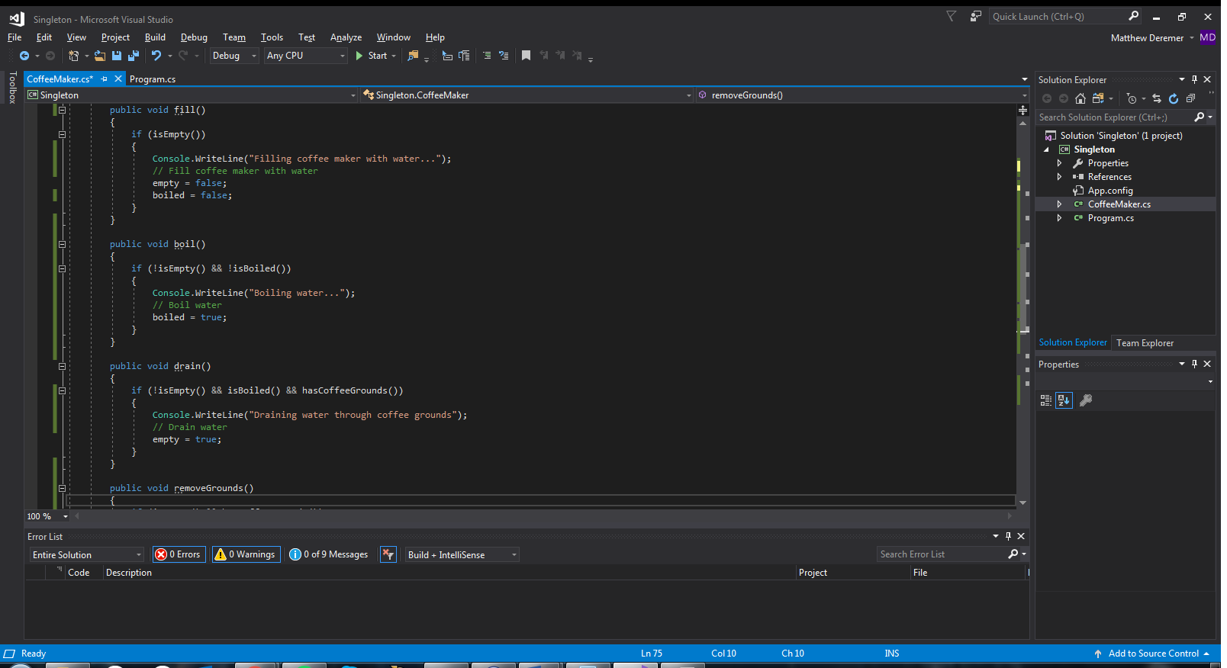

Figure 18. CoffeeMaker Method, Boil

To boil, the CoffeeMaker instance must not be empty and the water must not yet be boiling. This method boils the water and sets the boiled variable to true.

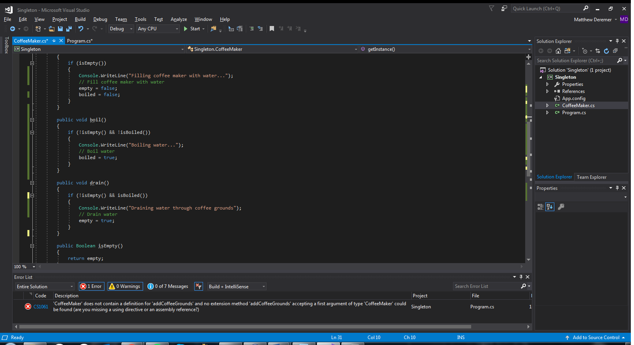

Figure 19. CoffeeMaker Method, Drain

If there is water in the coffee maker and it has boiled, this method drains the water and sets the empty variable to true.

Figure 20 shows the two Boolean methods used in the above methods that simply return their associated Boolean variables.

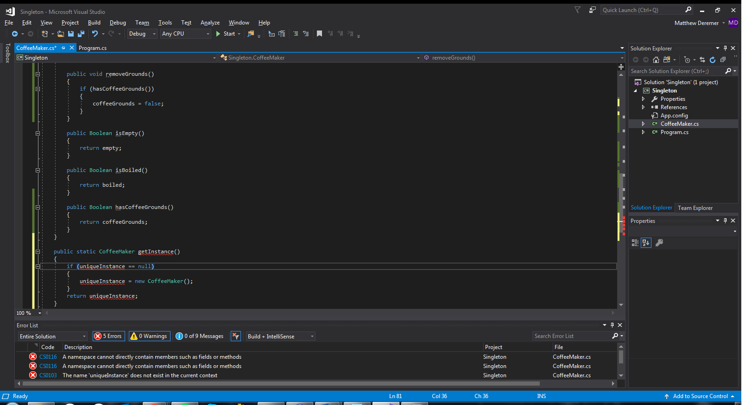

Figure 20. CoffeeMaker, Boolean Methods

Let’s now write a simple client program to utilize the Singleton Pattern. See Figure 21.

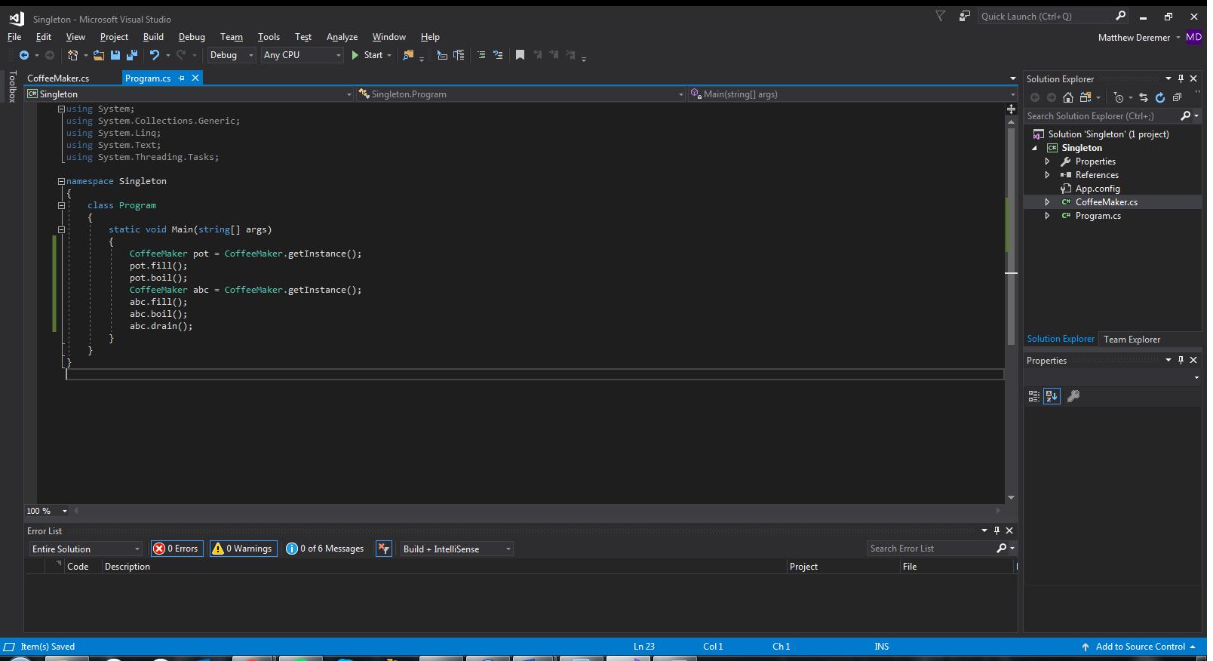

Figure 21. Client Code

The client program generates a CoffeeMaker instance named “pot”. It gets filled with water and then boils. I then show a new CoffeeMaker instance being generated. Since an instance already exists, the getInstance method just returns the original instance that has already been generated and modified. I call the fill and boil methods again on this new instance to show that they won’t actually repeat because of the current state of the CoffeeMaker. See Figure 22 for the output of this program. Notice that the fill and boil methods are not repeated. This is as desired.

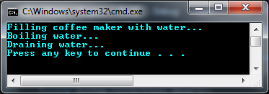

Figure 22. CoffeeMaker Output

Although this pattern works beautifully in the example shown, it has its fair share of problems. One of these problems occurs during multithreading. If two threads are running the code, and an instance has not yet been generated, both threads could be running through the getInstance method with the uniqueInstance variable returning null to both threads. See Figure 23 for reference.



Figure 23. CoffeeMaker, getInstance

Each thread would then generate a new instance, causing two instances to be created. That is exactly what we don’t want with the Singleton Pattern. A simple fix does exist for this! In the CoffeeMaker class, we can have the code create the unique instance when the class is loaded. This guarantees that the instance will be created before any thread accesses the static uniqueInstance variable. The getInstance method can then be reduced to a simple return statement since we will already have an instance. See Figure 24 for the modified code that utilizes this fix.

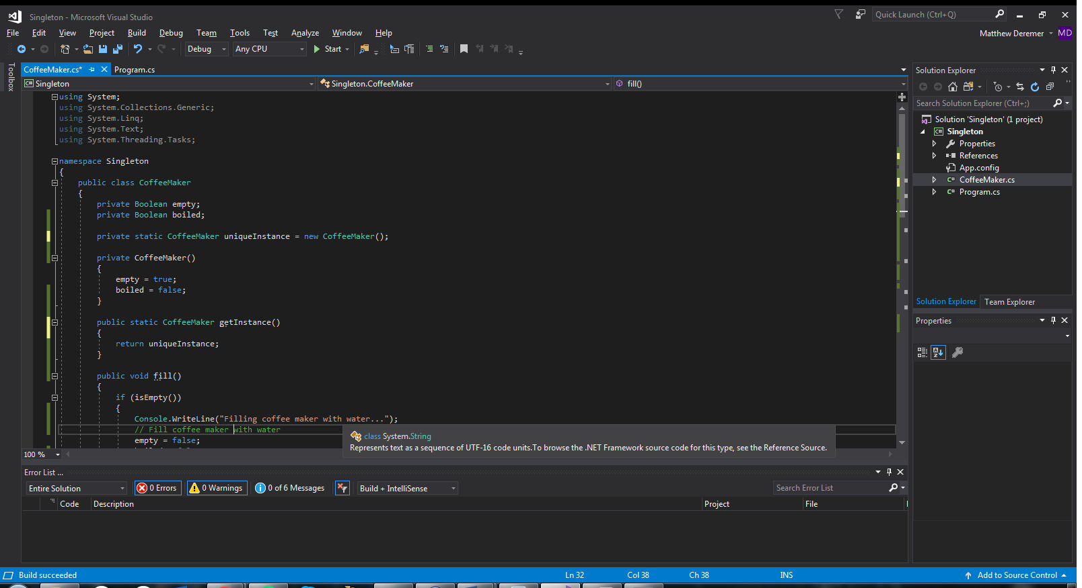

Figure 24. Multithreading Issue, Solution

# **References**

https://docs.microsoft.com/en-us/dotnet/csharp/programming-guide/interfaces/

http://csharpindepth.com/Articles/General/Singleton.aspx