Globalisation’s Stress Test: Geopolitics Is Breaking Liberal Theory, Not Global Trade
Despite the occurrence of the war that took place in the Middle East shaking the economy of the markets, on 8th October the WTO took an initiative to double the world merchandise trade yield from 1.9% to 3.9% (Associated Press 2026). People tend to speculate that globalisation is sinking while on the other side the world trade is gradually growing. But China's temporary halt of the export restrictions on rare earths lapses on 10th November 2026 and the broader US-China truce, just recently extended, ends 10th January 2027 (Al Jazeera 2026).
Both narratives are true on each end, and such tension puts more emphasis on the question. Is current geopolitics challenging liberal theories of globalisation? Well, but not where the majority of commentators look. Globalisation is a fact; the liberal narrative of it is breaking. This is proven by using two indicators: global supply chains and world powers and hegemony.

What Liberal Theory Promises
Hyperglobalists perceive an integrated market undermining the nation-state, and the neoliberal strand is founded on Ricardian comparative advantage: trade, specialise and everyone wins. The “flat world” and the “borderless world” visions that ensued made the numbers look justified. Since 2022, globalisation has stood at a historic point of connectedness and only 4-6% of trade and investment flows in the world have not moved out of the geopolitical opponents in the last ten years (Altman and Bastian, 2026). WTO has recently increased its projections for goods trade made in 2026, from 1.9% to 3.9% (Associated Press, 2026). However, globalisation is not neoliberalism: the first is an empirical fact, the second an ideological initiative. It is the project that faces imitations and not the connections.
Two assumptions which were latent were made heavy-duty, however. To begin with, the trade is a positive-sum exchange that is free of security rivalry, with firms focused on efficiency rather than risk (Neos, 2025). Second, the system is underwritten by a hegemon. Hegemonic stability theory illustrates that preponderant power provides capitals, open markets and institutions; others agree out of their benefit from it (Liang et al., 2025). The drawn assumptions undergo stress-tested by geopolitics, as trade and investment rapidly take geopolitical directions and not necessarily economic routes.

Supply Chains: from Efficiency to Chokepoints
Global value chains turned trade into standardised quality: the exchange at a distance was replaced with deep integration, and GVC-related trade takes up nearly half of all trade in the world (World Bank 2020). The bicycle and iPod examples presented in the module demonstrate the logic, where the design, the parts and assembly processes are distributed among numerous countries. For the Liberals, this is effective specialisation; for the neo-Marxists, working in the world-systems tradition, it is the core capturing surplus value on the smile curve. In any case, companies are now optimised towards cost, speed and value chains had become economics, not geopolitics.
Rare earths put an end to that innocence. China polishes almost 90% of the world's supply (Coface, 2025). Beijing announced in October 2025 that it would no longer export foreign-made products containing Chinese rare earths valued at 0.1% or more of the product before it is approved by China (Coface, 2025). A supplier having control to that extent can leverage it accordingly. The measures were indefinitely suspended after the Busan summit, but in fact, only until 10th November 2026; Beijing issued no extension by mid-October, and European companies continue to grumble about no standardised licensing procedure (Noreika, 2026). Comparative advantage would imply that there is no problem with specialising. In this case, specialisation was leveraged. It has a neo-Marxist twist as well. The reward for joining value chains was to climb the smile curve, but the core also controls who can climb: Washington's 50% subsidiary rule on export controls is one instance and was also suspended for the duration of the truce (Coface, 2025). The broader lesson is that companies valued efficiencies, rather than risk.
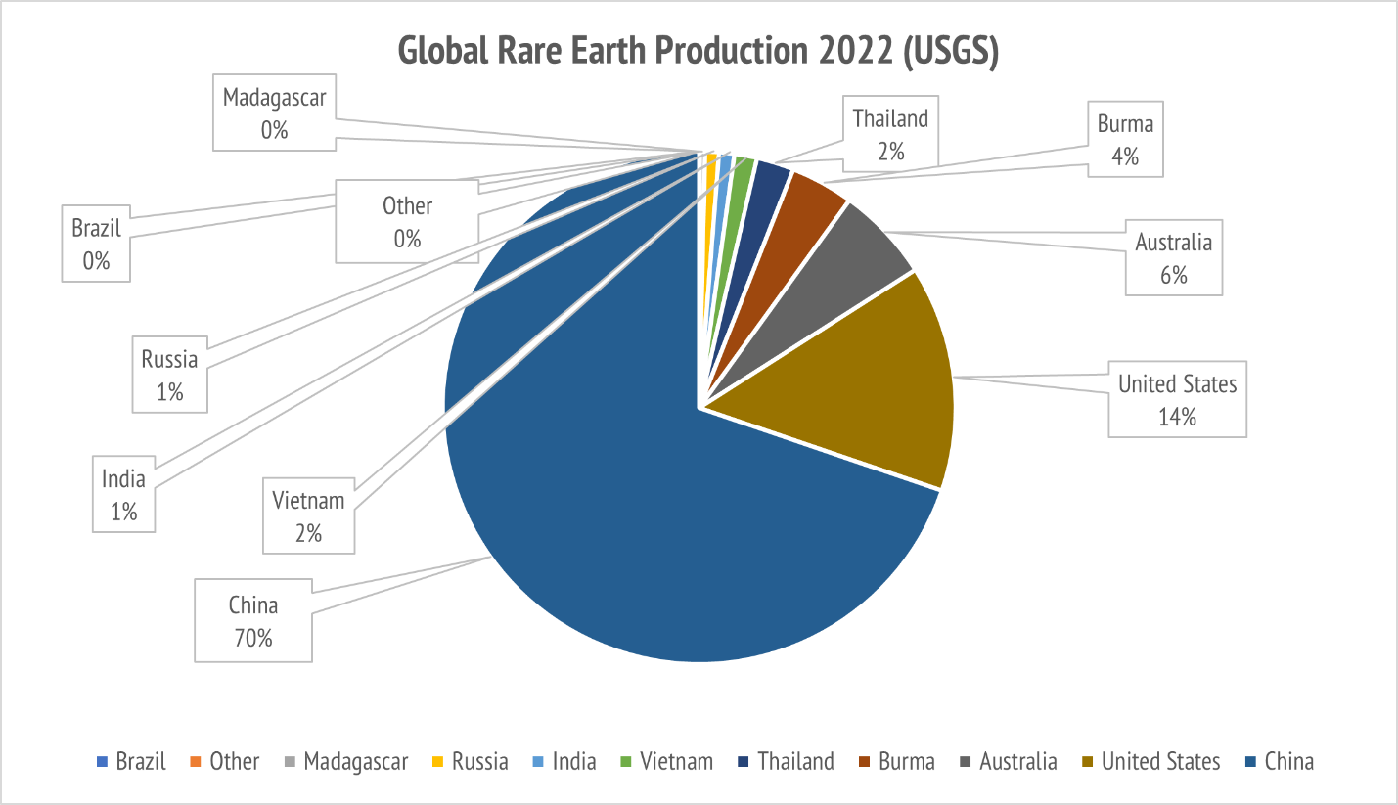
Figure 1: Share of global rare earth mine production by country, 2022 (Livewire Markets, 2023)
However, the overall picture does not point to a deglobalisation narrative (Table 1). The US–China trade route dropped to 2.0% of world trade in 2025, from 2.7% in 2024, and only 4- 6% of world goods trade has been diversified away from geopolitical opponents in 10 years, primarily to India and Vietnam (Altman and Bastian, 2026). Chinese exports to the US dropped about 20%, but its total exports increased 5.5% to $3.77 trillion (WTO, 2026). Supply chains are not being laid off, but rather retrenched.
That embarrasses both camps. The sceptics anticipated regionalisation in North America, Europe and East Asia in the triad; the average distance of goods that are now being made is a record, to the contrary (Altman and Bastian, 2026), and the processes of globalisation and regionalisation are concurrently taking place. Hyperglobalists wanted the states to be reduced to small cogs, but they ended up as gatekeepers. A logistics company commissions the report from DHL and the rerouting through Vietnam might conceal any further Chinese content. Trade and investment become more geopolitical. The fragmentation is partial.
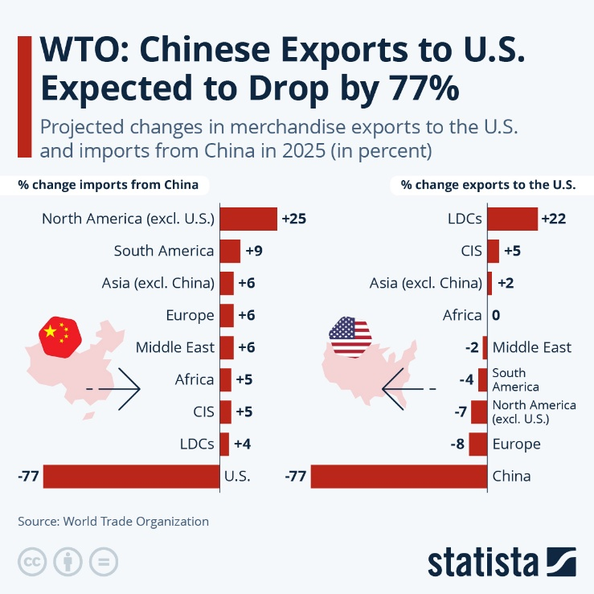
Figure 2: Projected percentage changes in Chinese merchandise imports and exports across regions in 2025. Source: World Trade Organization (WTO), as cited in Fleck (2025).

Table 1: One year, two readings of globalisation, 2025–26
Reading | Indicator | Figure | Source
Fragmentation | US–China share of world trade | 2.7% (2024) to 2.0% (2025) | DHL (2026)
Fragmentation | China’s exports to the US, 2025 | About −20% | WTO (2026)
Fragmentation | China’s share of rare-earth refining | Nearly 90% | Coface (2025)
Resilience | Flows shifted from rivals, past decade | 4–6% | Altman and Bastian (2026)
Resilience | 2026 goods-trade forecast | 3.9% (March: 1.9%) | Associated Press (2026)

Hegemony: Who is Holding up the Rules
Hegemonic power is based on four resources which include control of the markets, capital, raw materials and competitive superiority. The US currently exports approximately $2.18 trillion in goods, which is around $1.6 trillion less than that of China (Statista, 2026), which has been averaging 14.4% of world exports over the last three years (WTO, 2026). The third resource is control of processing provided by China. The battleground is competitive superiority: during the first half of 2026, trade in AI-enabled merchandise like semiconductors and servers increased 67% per annum (Associated Press, 2026), and so now chips, rather than cotton, are the battleground.
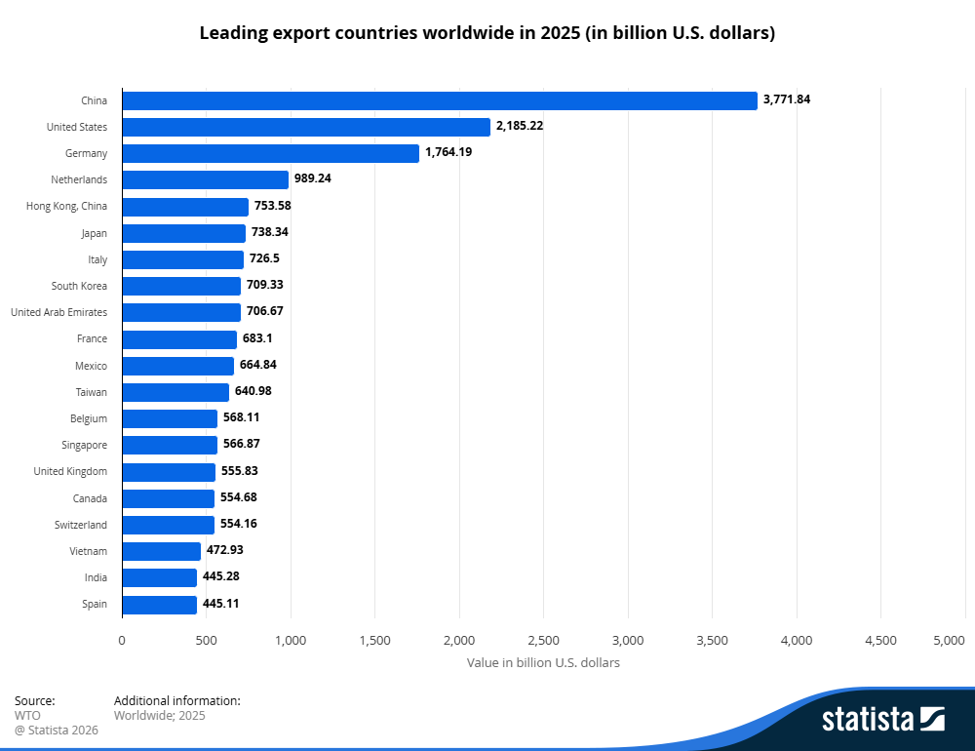
Figure 3: Leading export countries worldwide, 2025 (Statista 2026)
Action is more important than ability. Liberal hegemony is based on consent and internalised norms, and on rules like the most-favoured-nation treatment, which the WTO has acquired through treaties of the nineteenth century. However, the tariffs imposed on Chinese products have reached 36.5%, while China's tariffs on US products are 31% at present (Al Jazeera, 2026). When the hegemon ceases to issue in its own terms, the hegemonic stability theory forecasts instability and realists would dismiss it and say that the international order is the language of the powerful. Some believe that the liberal order was doomed to fail as power collapsed; others think its crisis is domestic and that its institutions are flexible.
These statistics lean in favour of the institutionalist assertion that institutions long outlive their guarantor: trade by rules continues to provide growth in the absence of an enforcing hegemon. Nor has a Pax Sinica come. The China export success is that of a surplus economy rather than one of last resort: the volumes rose by 9.2% while the values rose by only 5.5% (WTO, 2026), the actions of a surplus economy, not a market of last resort. This is better suited to a multi-order world whereby there are multiple regional powers, as opposed to a hegemon. Resilience is also small-scale: AI-enabled goods grew first-half trade by 47%, and the outlook for any service was reduced (Associated Press, 2026). The massive expansion of chips and servers does not represent a healthy rules-based system.

Verdict: Revise, do not Discard
So, who was right? Hyperglobalists were wrong about the state: the governments did not reduce to small cogs; they adopted the role of gatekeepers. Sceptics were correct in their approach regarding the state and incorrect in regard to regionalisation, as goods are travelling further than ever. Transformationalists are best off, since globalisation cannot be killed or remain the same, but rewired. Fragmentation is a reality and is geographical or geopolitical, but weak and non-aligned “connector” countries continue to hold together the two rival blocks. Even the US move of parting with China is largely diversionary rather than a retreat.
Liberal theory must be fixed and not put to rest. It was not its strength to think of interdependence in a power-neutral manner. The curve is different in the case of rare earths, and it is the same reality applied in the financial and information networks America dominates. Specialisation was designed to leverage everyone to a richer level and most importantly giving more power to the one controlling the chokepoint. Comparative Advantage must be measured in a security-priced manner, balancing the risk of dependency and the benefit of efficiency. Globalisation is not dying. Its liberal justification is.

References
Al Jazeera (2026) ‘“Hostile, but hooked”: what’s behind the US–China trade truce extension?’, Al Jazeera, 24 September. Available at: https://www.aljazeera.com/economy/2026/9/24/hostile-but-hooked-whats-behind-the-us-china-trade-truce-extension (Accessed: 25 October 2026).
Altman, S.A. and Bastian, C.R. (2026) DHL Global Connectedness Report 2026. Bonn: DHL Group and New York University Stern School of Business. Available at: https://www.dhl.com/global-en/microsites/core/global-connectedness/report.html (Accessed: 25 October 2026).
Associated Press (2026) ‘WTO raises merchandise trade growth forecast to 3.9% as AI boom offsets hit from Middle East’, U.S. News & World Report, 8 October. Available at: https://www.usnews.com/news/business/articles/2026-10-08/wto-raises-merchandise-trade-growth-forecast-to-3-9-as-ai-boom-offsets-hit-from-middle-east (Accessed: 25 October 2026).
Coface (2025) US–China trade agreement: a tactical truce, not a strategic shift. Available at: https://www.coface.com.sg/content/download/87938/file/PR%20-%20Coface%20-%20US-China%20trade%20agreement%20a%20tactical%20truce,%20not%20strategic%20shift%20-%20SG.pdf (Accessed: 25 October 2026).
DHL (2026) Globalization holds firm at a record level, while the U.S. and China continue to decouple: DHL Global Connectedness Report 2026. Press release, 12 March. Available at: https://www.dhl.com/fr-en/home/press/press-archive/2026/global-connectedness-report-2026.html (Accessed: 25 October 2026).
Fleck, A. (2025) ‘WTO: Chinese Exports to U.S. Expected to Drop by 77%’, Statista, 17 April. Available at: https://www.statista.com/chart/34324/projected-changes-in-merchandise-exports-to-the-us-and-imports-from-china/ (Accessed: 25 October 2026).
Liang, Y., Li, J., Aroles, J., & Granter, E. (2025). Content creation within the algorithmic environment: A systematic review. Work, Employment and Society, 39(4). https://doi.org/10.1177/09500170251325784 (Accessed: 25 October 2026).
Livewire Markets (2023) ‘Which country is the largest exporter of unseparated rare earth concentrates to China?’, Livewire Markets, 13 April. Available at: https://www.livewiremarkets.com/wires/which-country-is-the-largest-exporter-of-unseparated-rare-earth-concentrates-to-china (Accessed: 25 October 2026).
Neos, N. (2025) When trade turns strategic: lessons from fourteen trade wars for US–China strategic competition. SSRN Working Paper 5805382. Available at: https://dx.doi.org/10.2139/ssrn.5805382 (Accessed: 25 October 2026).
Noreika, A. (2026) ‘China’s rare-earth export pause: what ends on 10 November’, Technology.org, 19 October. Available at: https://www.technology.org/2026/10/19/china-rare-earth-export-pause-november-10/ (Accessed: 25 October 2026).
Statista (2026) Leading export countries worldwide in 2025 (in billion U.S. dollars) . Available at: https://www.statista.com/statistics/264623/leading-export-countries-worldwide/ (Accessed: 25 October 2026).
World Bank (2020) World Development Report 2020: trading for development in the age of global value chains. Washington, DC: World Bank. Available at: https://www.worldbank.org/en/publication/wdr2020 (Accessed: 25 October 2026).
World Trade Organization (WTO) (2026) Global trade outlook and statistics, March 2026. Geneva: WTO. Available at: https://www.wto.org/english/res_e/booksp_e/gtos0326_e.pdf (Accessed: 25 October 2026).

