Contraseptive Technology Update (CTU)



Asuhan Persalinan Normal (APN)

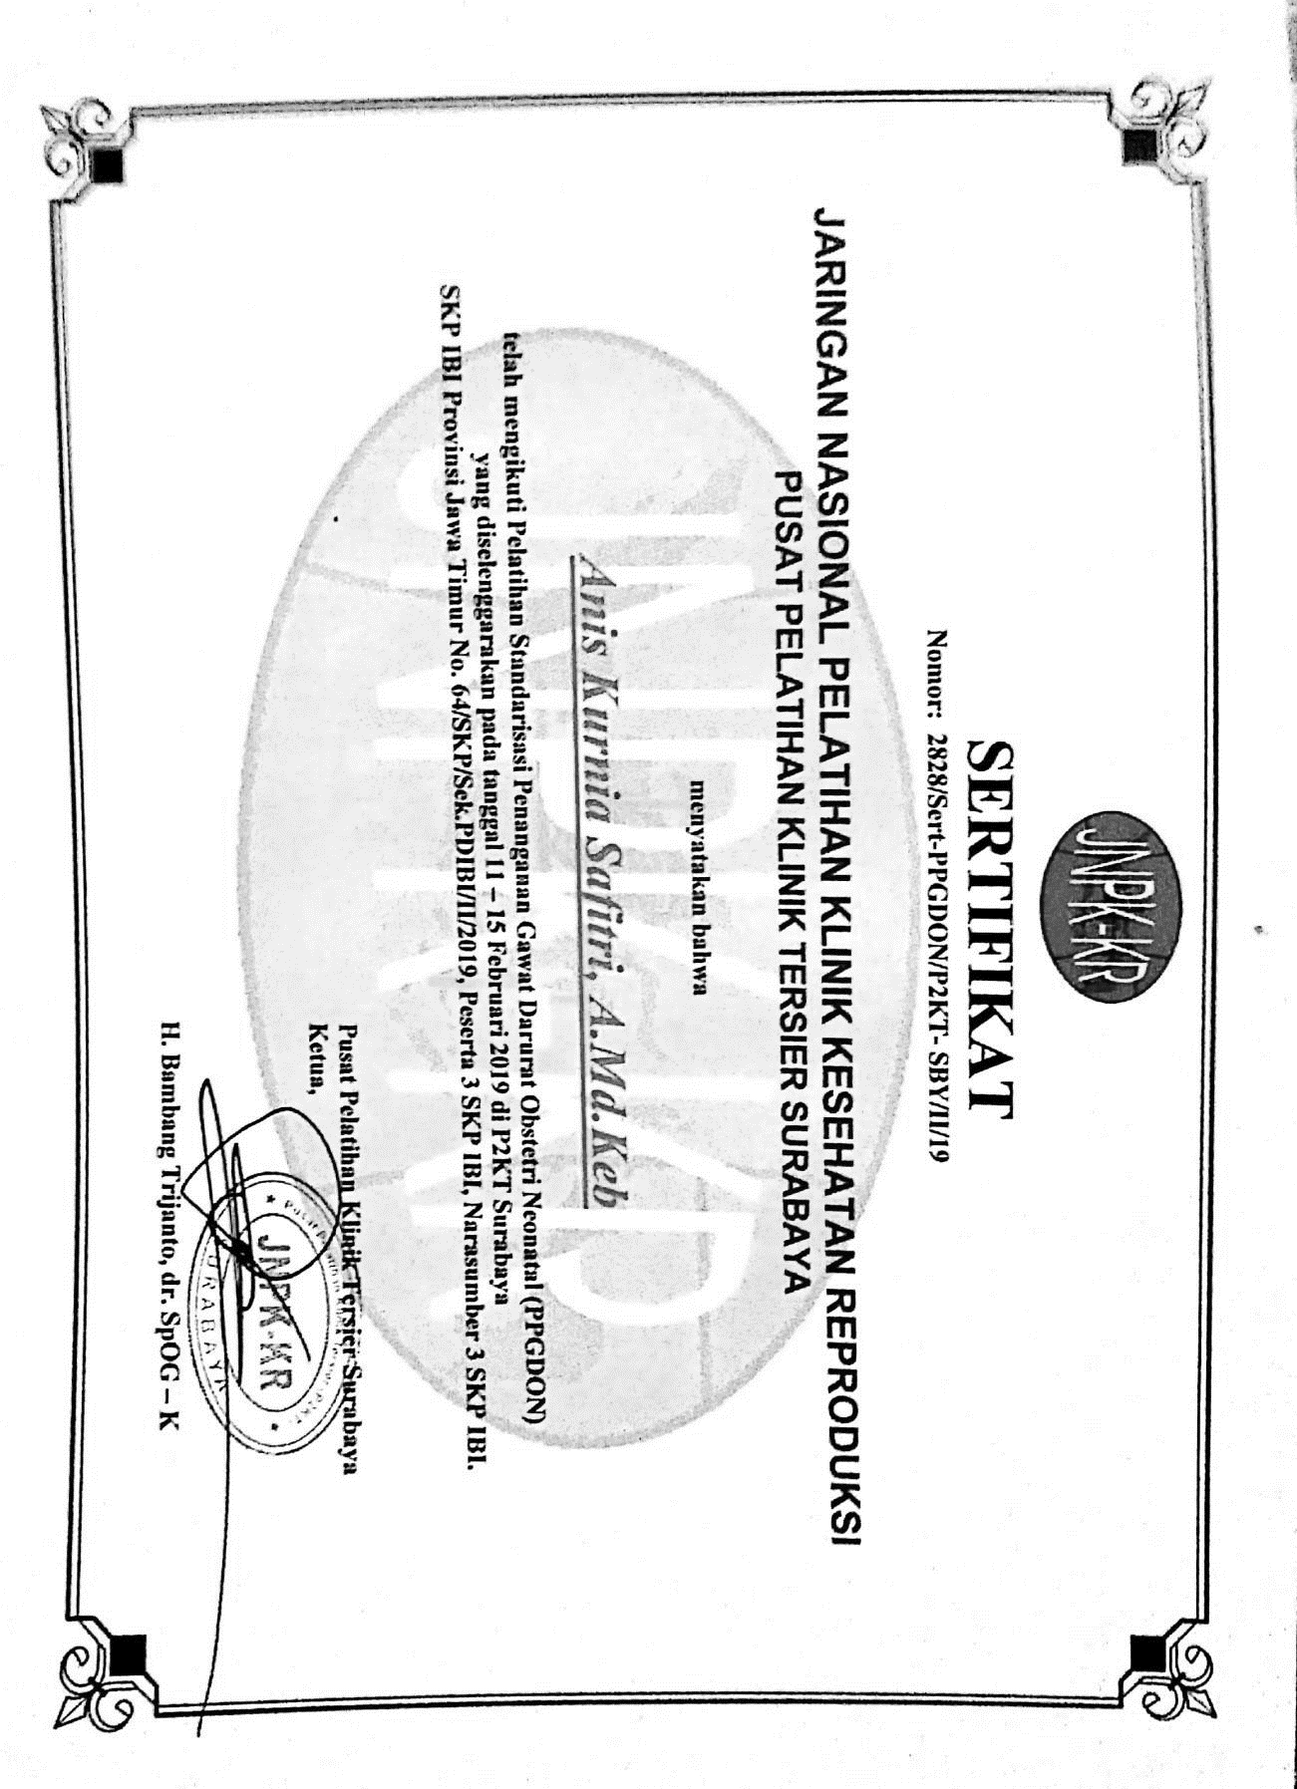
Pelatihan Standarisasi Penanganan Gawat Darurat Obstetri Neonatal (PPGDON)

