****Quantitative mapping from DESS using a Horos plugin****

The group has developed and maintained image viewer plugins to do the DESS fitting. This is often more convenient than using Matlab, and some people don’t have Matlab installed. This only works on a Mac. The plugin was initially developed for the OsiriX image viewer, but as OsiriX got harder to use for free, some OsiriX users forked off a code version to maintain the free functionality, calling it Horos.

The plugin has gone through several versions, first for OsiriX and then for Horos. The current version, for Horos, isn’t completed yet but it does do T2 and ADC mapping from DESS scans.

Make sure you have Horos installed. You can get it for free here:

<https://www.horosproject.org/>

**1. Installing the plugin:**

Download “DESSmaps.osirixplugin” to your computer. The icon should look like this:

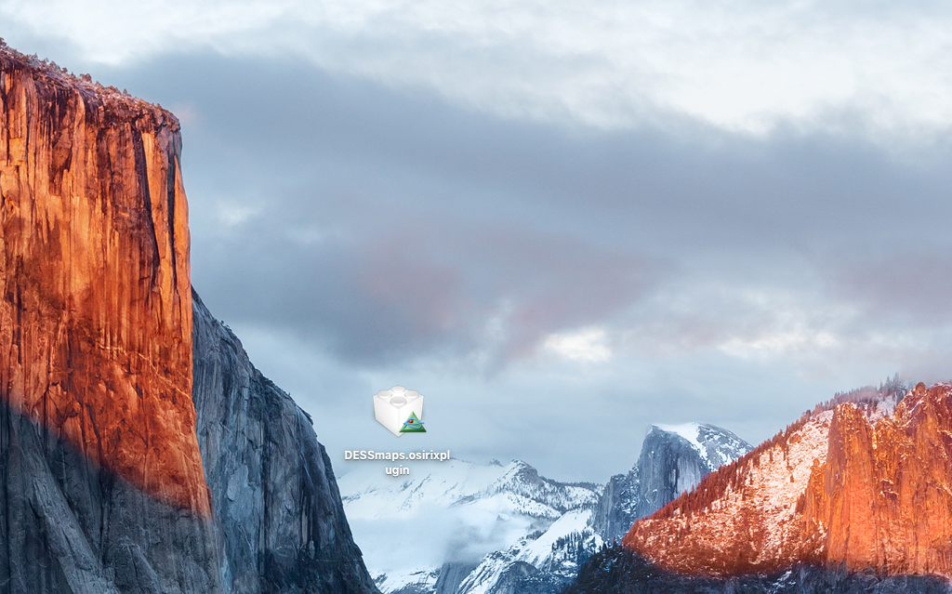

Double-click the icon. You will see a message like this:

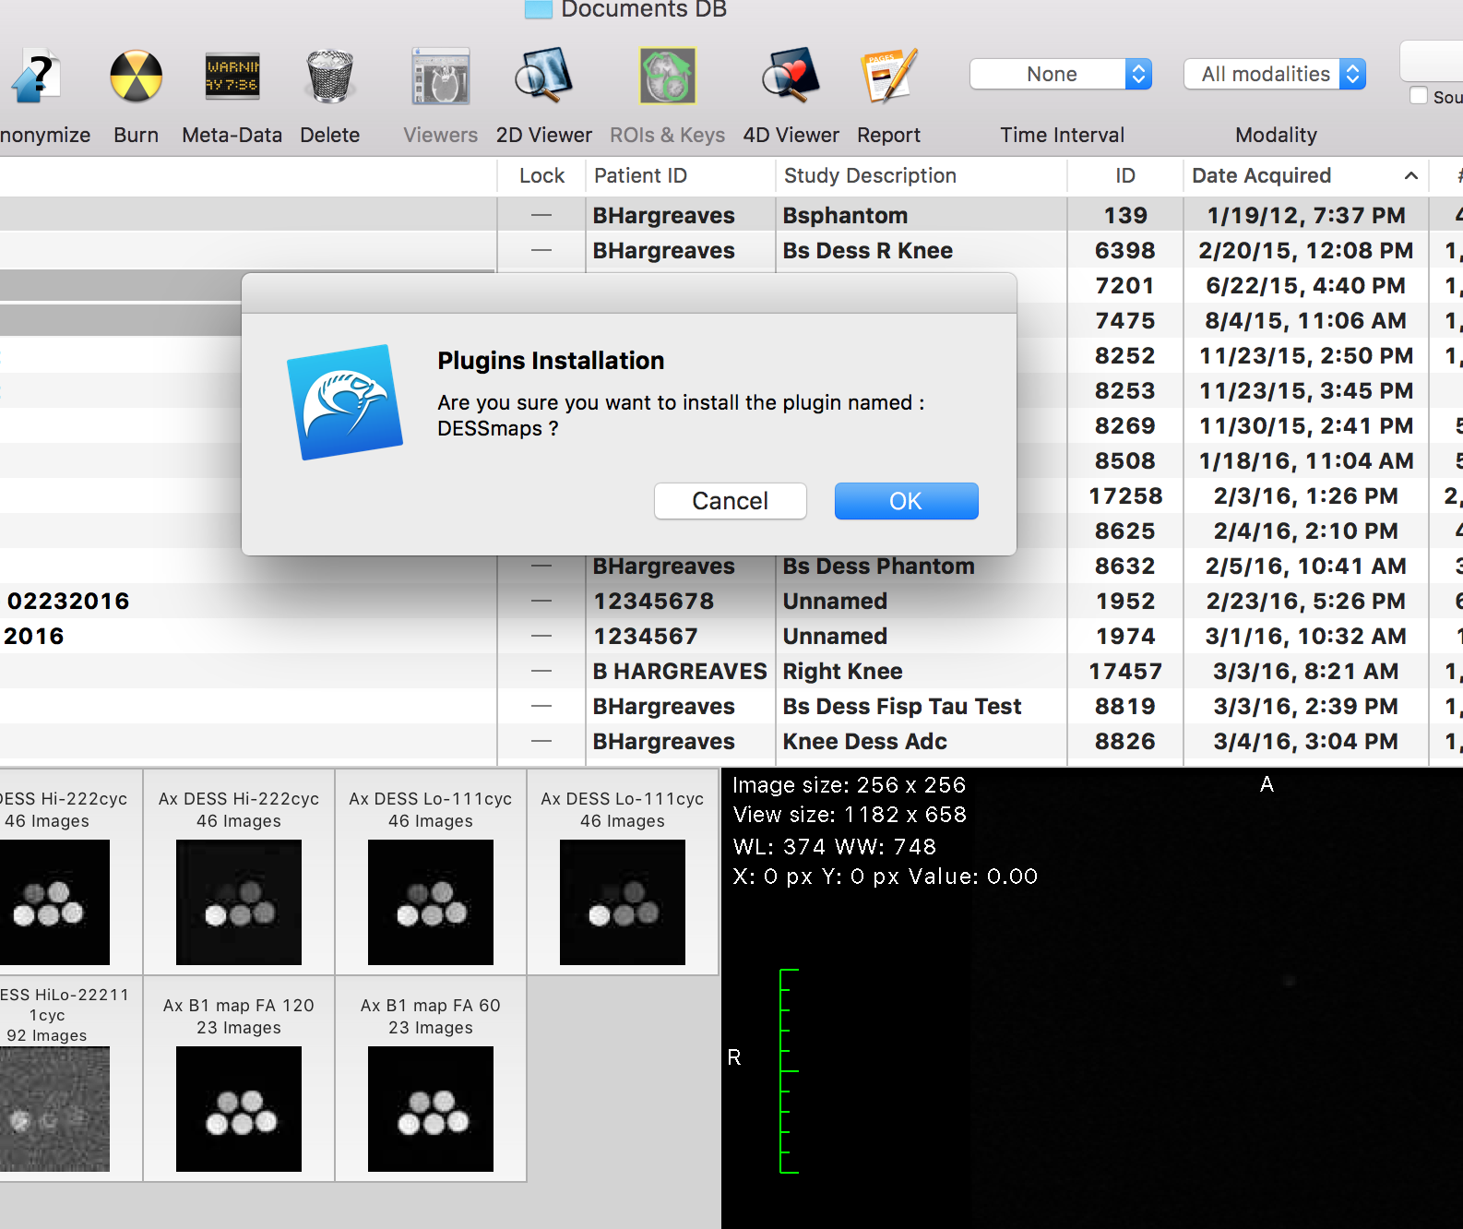

Click OK, and type in your computer’s password when prompted. Shut down and restart Horos.

**2. Opening the plugin:**

Horos should display the two echoes from a DESS scan as two separate lines in the database.

**2a.** If you only performed one DESS scan (with low diffusion weighting) and want to produce a T2 map:

In the Horos database, select the two echoes in the database and click the 4D viewer (the 4D viewer can also be selected by right-clicking the selection and selecting “Open images in 4D”):

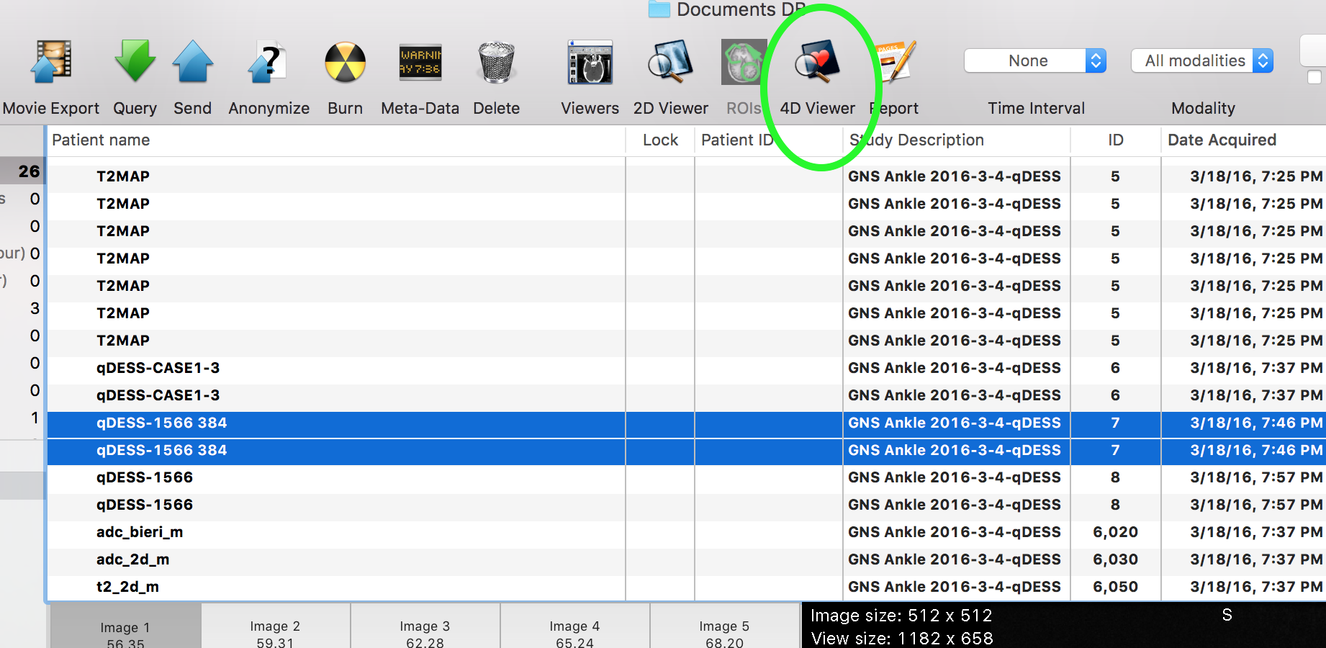

**2b.** If you ran two separate DESS scans (one with high diffusion weighting and one with low diffusion weighting) and want to produce T2 and ADC maps, select all four echoes in the database and open in 4D viewer:

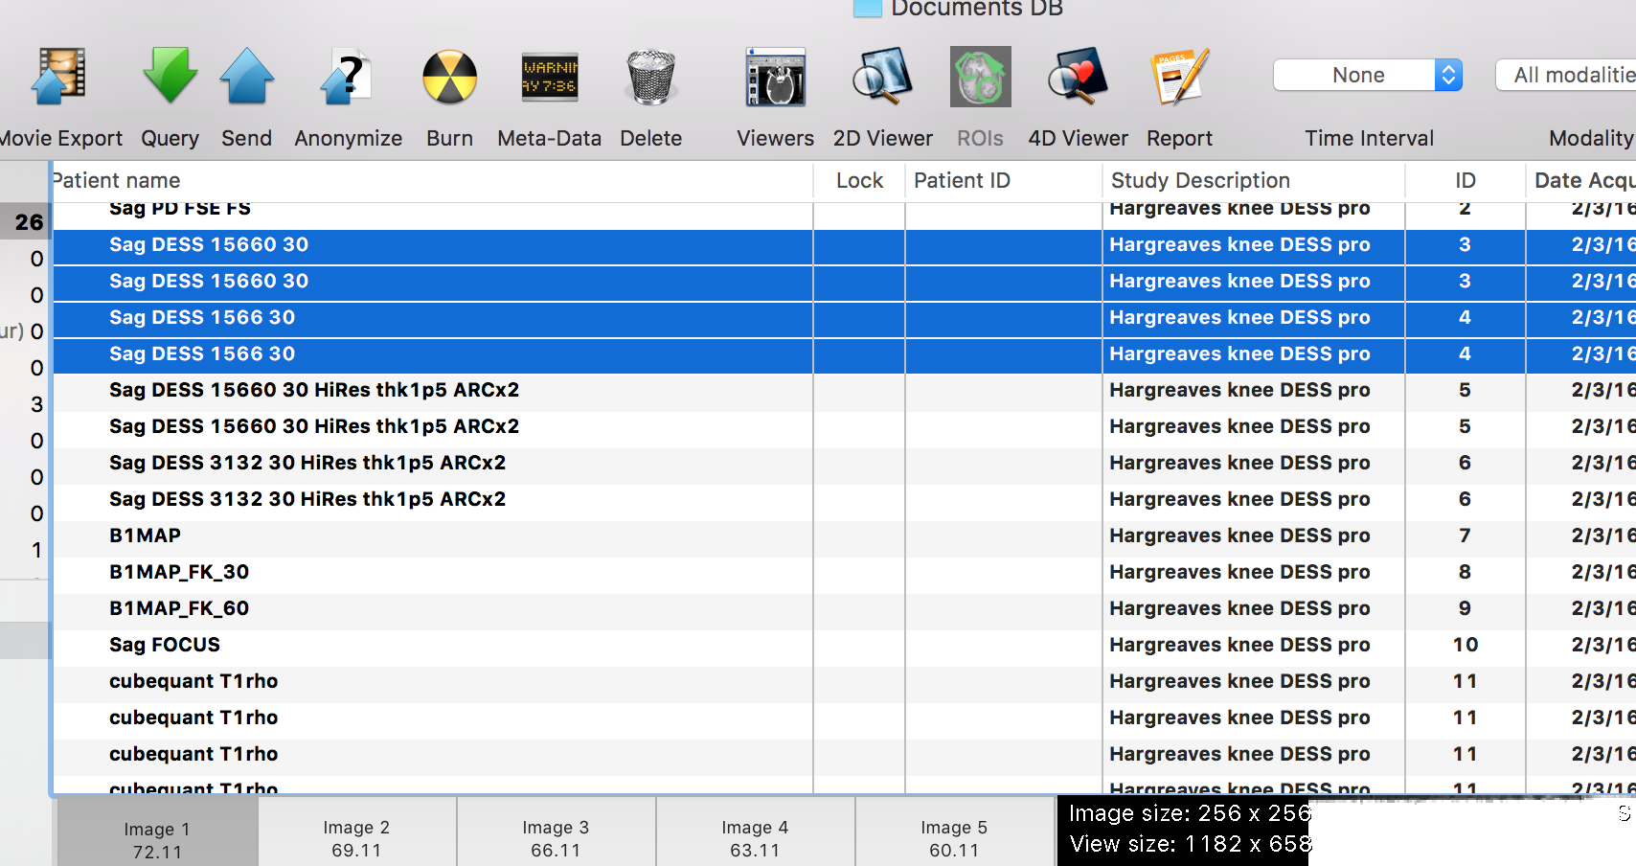

**2c.** If you ran a two-phase DESS scan, where the scan with high and low diffusion weighting are run at once, and you want to compute T2 and ADC maps, it should show up as two lines in the database. Select them and open in 4D viewer:

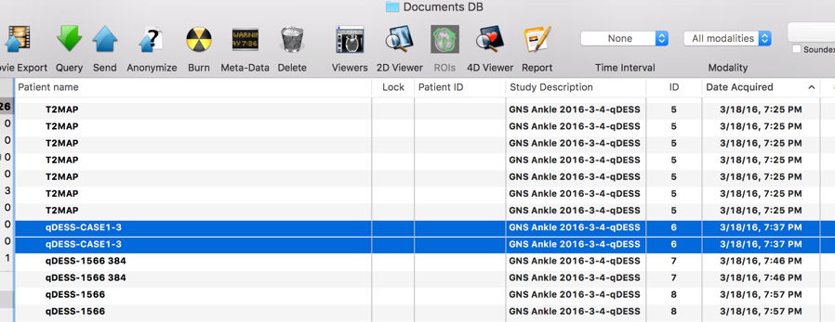

**3. Running the plugin:**

In the 4D viewer, go to plugins, image filters, and select DESSmaps:

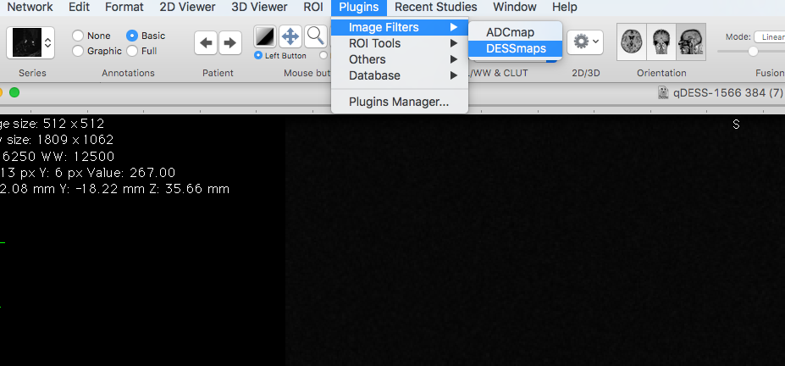

You should see a window pop up that looks like this:

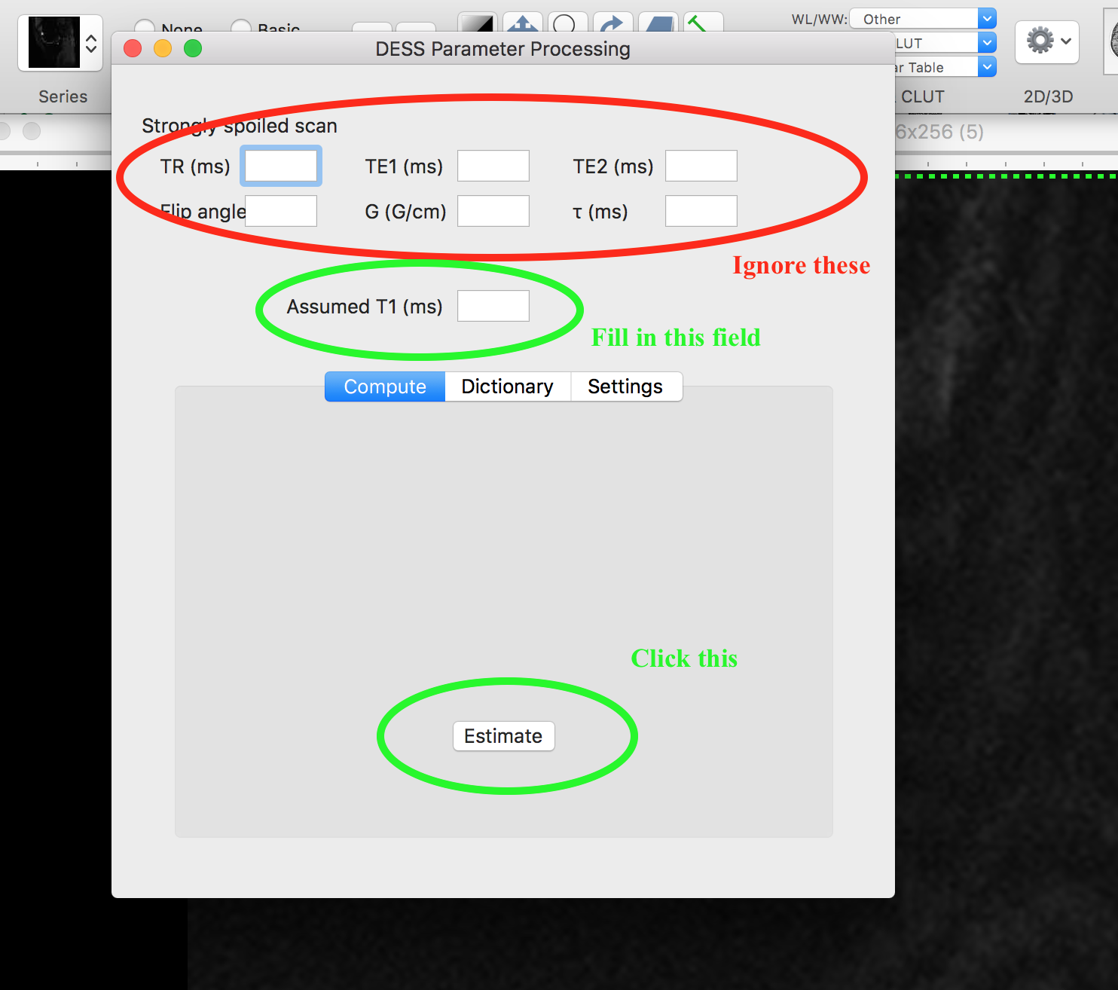

Fill in a T1 estimate for the tissue (1200 ms is typical for cartilage at 3T, for example – this does not need to be very accurate). Click the “Estimate” button. Ignore the other text fields and the tabs – these are not yet functional.

If you ran the plugin with high and low diffusion weighted scan (either separate as in 2b or combined as in 2c) you should see a T2 map and and ADC map pop up. The T2 is in ms. The ADC is in μm2/s.

If you ran the plugin with just one scan (with low diffusion weighting), then you should only get a T2 map (this will be much faster).

Please note that the only ADC mapping method currently supported in the plugin assumes that the only parameters changing between the “High” and “Low” DESS scans is the gradient area. TR, TE, and flip angle should stay the same.