THE STATE OF THE GRID
2026
A State-by-State Analysis of America's Renewable Energy Transition by Aditya Brahmachary
MOXVER 2026 High School Internship
Data Sources: U.S. Energy Information Administration (EIA-923, SEDS)

Project Overview
Four-phase analysis of the U.S. clean energy transition, state by state.
This project analyzes 25 years of EIA net generation data across all 50 states and Washington, D.C. to answer four questions: How has each state's renewable energy share changed over time? When did renewables overtake coal? When might each state reach a full wind + solar transition? And how do states compare against one another?
Phase I Discovery: Extracted and cleaned EIA generation data for Coal, Natural Gas, Wind, and Solar across all 51 states.
Phase II Trends: Calculated renewable energy percentage by year and identified each state's Pivot Year when renewables first exceeded coal.
Phase III Forecasting: Applied linear regression to project each state's Intersection Year the year wind + solar could reach 100% of generation.
Phase IV Reporting: Built a composite Grade (A–F) per state and an interactive Tableau dashboard for exploring the results.

Phase I: Data Extraction & Cleaning
Raw EIA generation data, melted, parsed, and reshaped into an analysis-ready table.
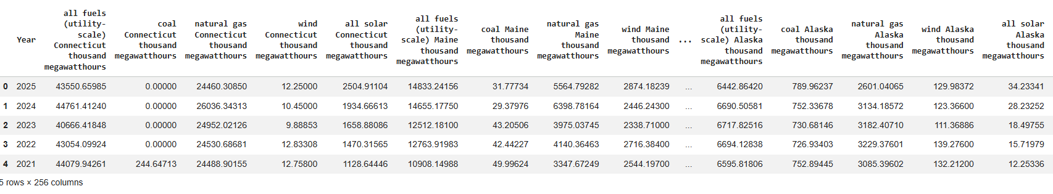
Raw EIA export: annual net generation (thousand MWh) by state and fuel type.
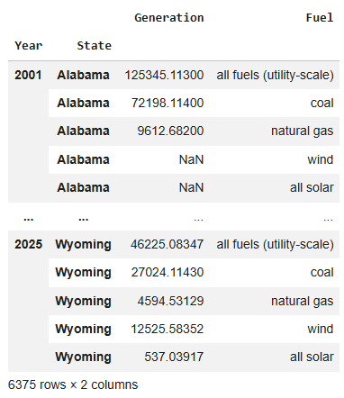
Cleaned dataframe (‘final_df`): Multi-index with clear Year & State details about its Generation and Fuel type.

Phase II: Renewable Trends
Renewable share (wind + solar) tracked over time for every state.
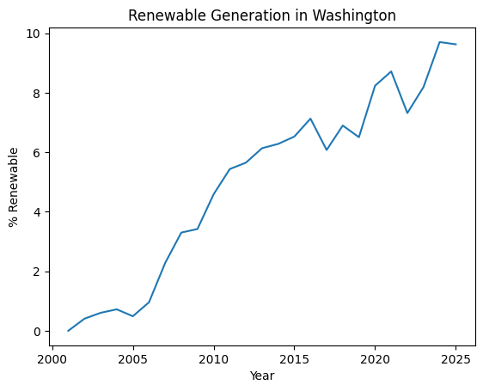
Example: Washington's renewable share over time is low despite a famously clean grid, since its clean energy is almost entirely hydropower, not wind or solar.
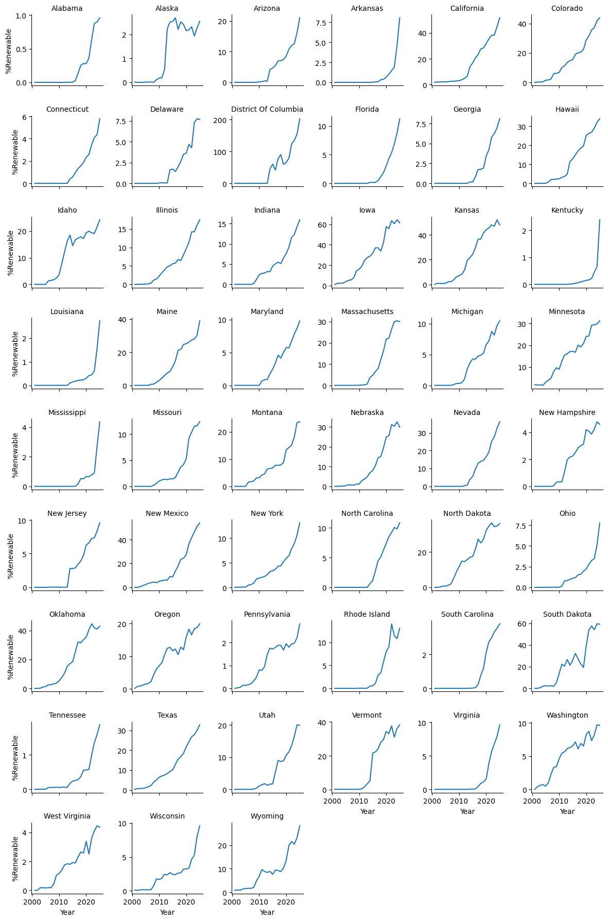
Renewable share (%) trend, 2001–2025, faceted across all 51 states/jurisdictions.
Phase II: The Pivot Year
The first year renewables (wind + solar) generation exceeded coal generation, per state.
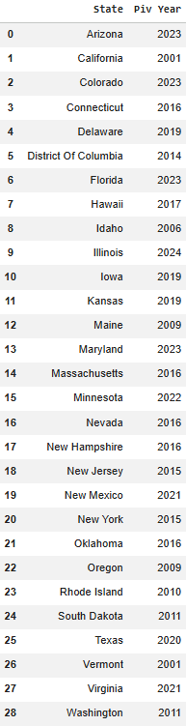
Pivot Year by state. 22 states have not yet crossed this threshold as of the latest data available.
Key finding: 22 states concentrated in the Midwest, South, and Appalachia still generate more electricity from coal than from wind and solar combined.

Phase III: Forecasting the Transition
Linear regression projects each state's wind + solar Intersection Year.
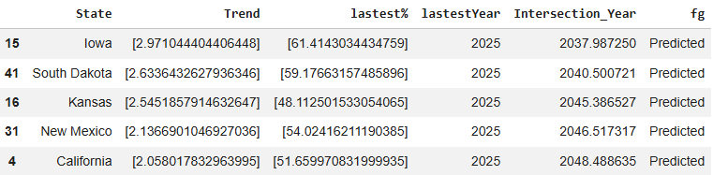
Top 5 soonest projected wind+solar Net-Zero: Iowa, South Dakota, Kansas, New Mexico, California.
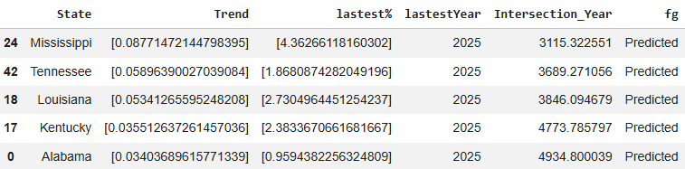
Bottom 5 furthest projected wind+solar Net-Zero: model projections beyond a realistic 2100 should be taken with a grain of salt and this is simply because of the linear regression and how its defined as a constant growth.

Phase IV: The State Report Card
Composite scoring of renewable adoption speed and current renewable share.
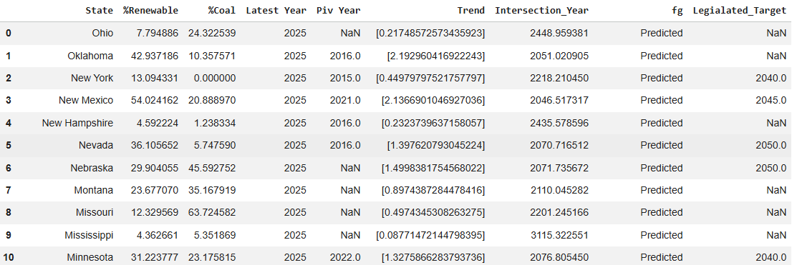
Composite score = 50% current renewable adoption + 50% adoption speed (trend), normalized 0–1 across all states.
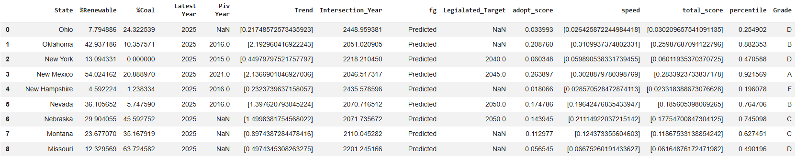
The Grade given is a comparison between other states and its percentile in renewable energy.

The Interactive Dashboard
Built in Tableau click any state to explore its grade, trend, and fuel mix.
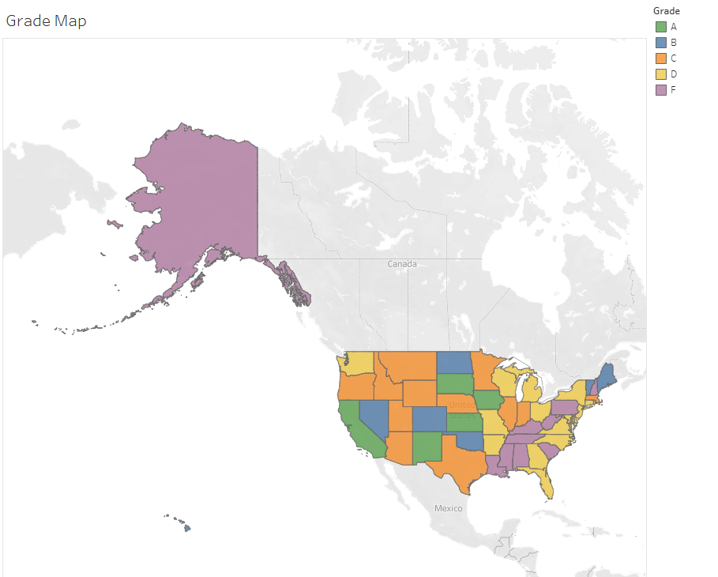
Grade Map: each state colored A (green) through F (purple) by composite transition score.

Fuel Comparison: 2014 vs. 2024
Each state's generation mix, compared across a decade: Coal, Natural Gas, Wind, Solar, and Other (hydro, nuclear, biomass).
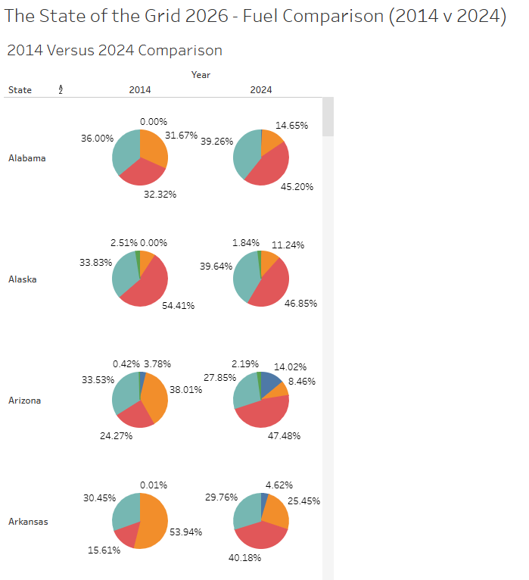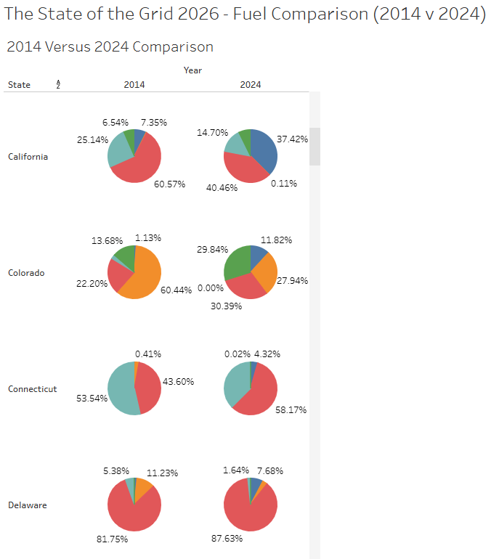
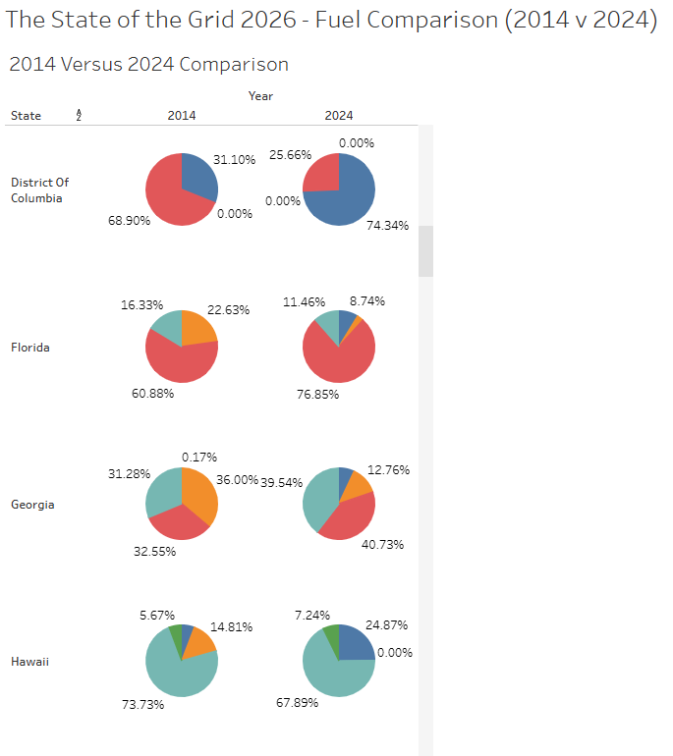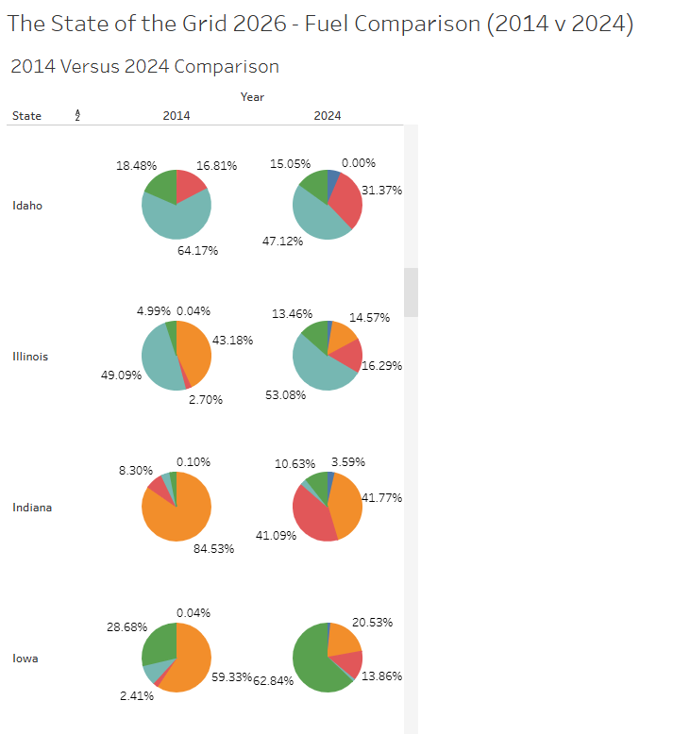
Selected states, alphabetical — full 51-state view available in the Tableau dashboard.

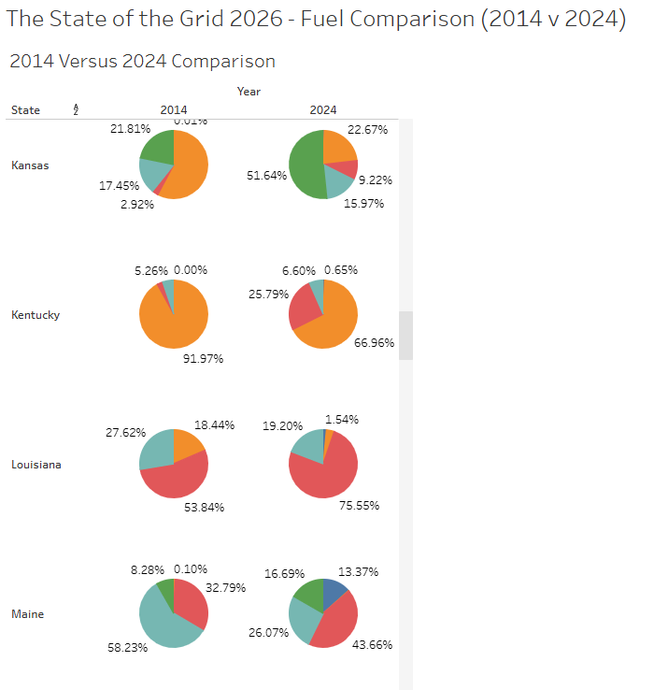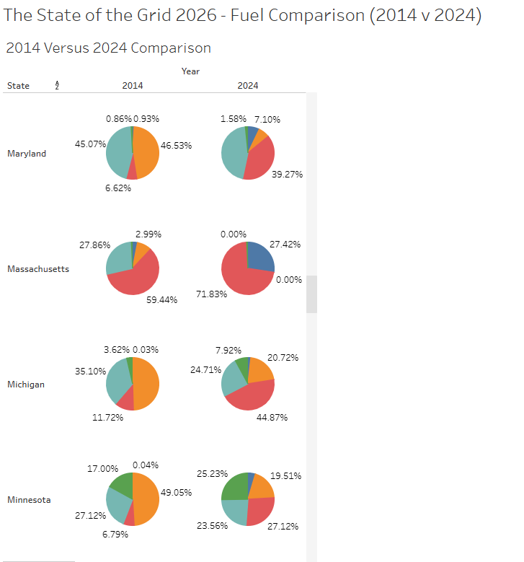
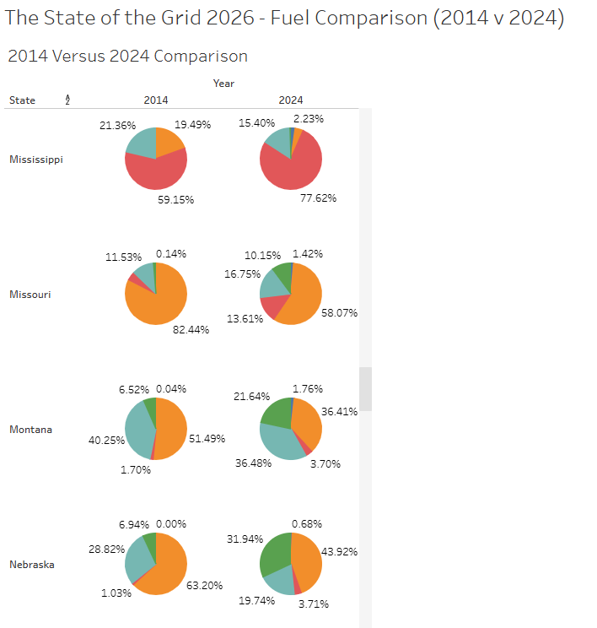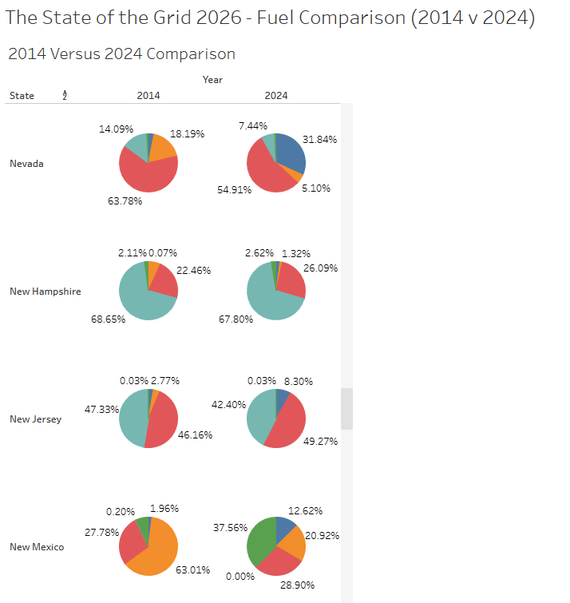

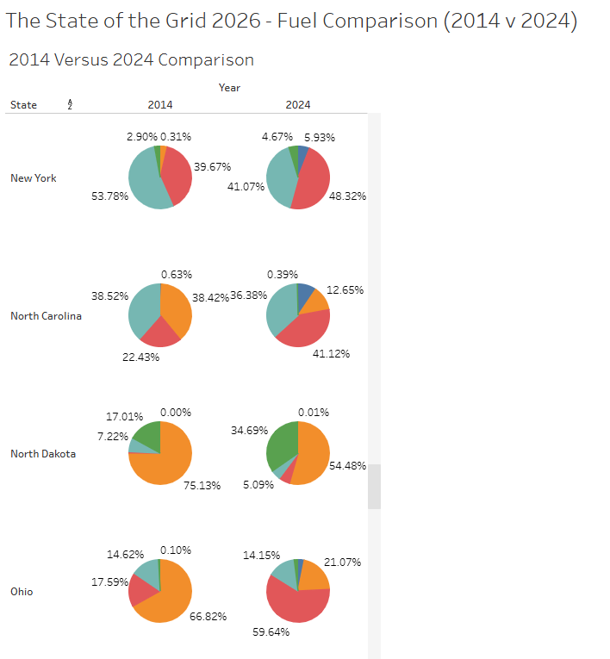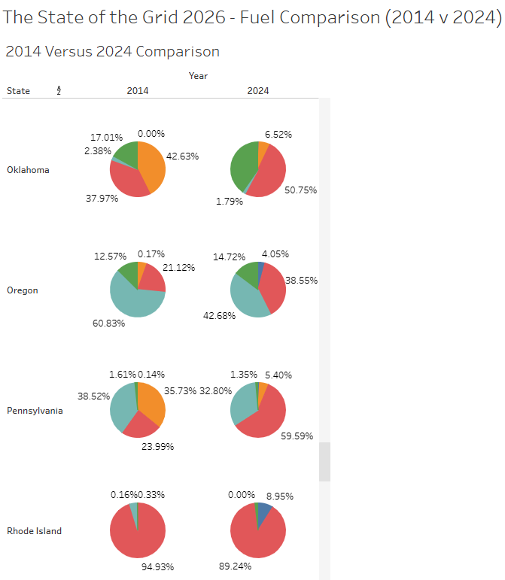
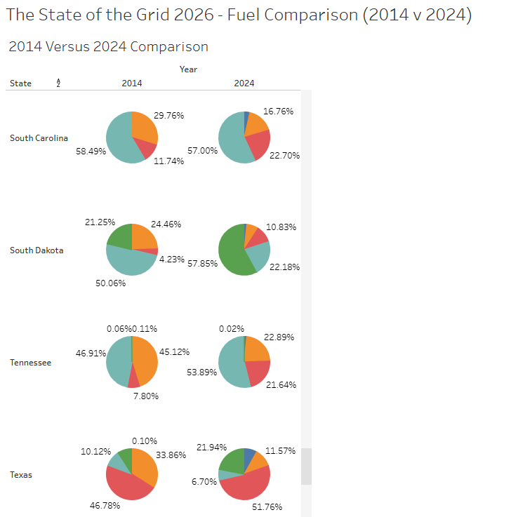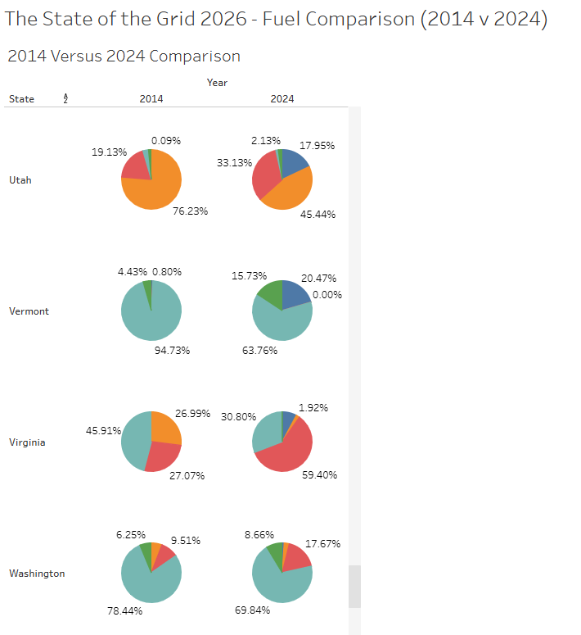

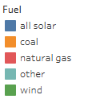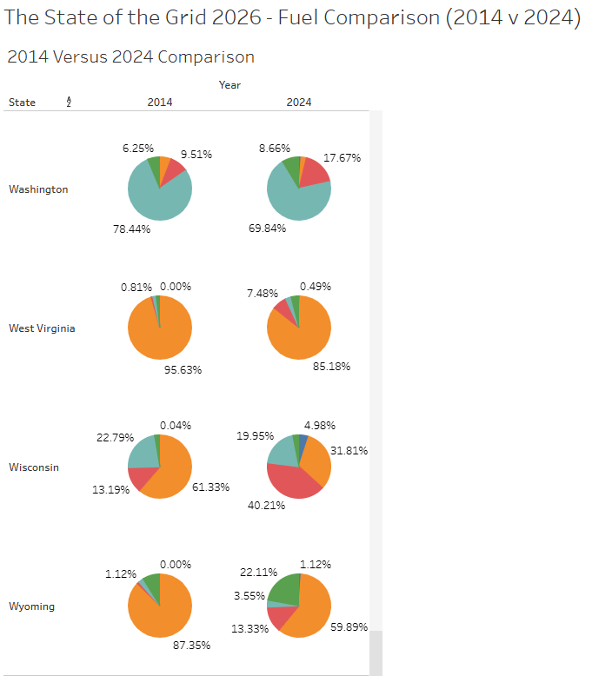
Washington, West Virginia, Wisconsin, Wyoming — note Washington's hydro-dominant "Other" slice.

Key Insights & Limitations
1. Iowa, South Dakota, and Kansas lead the nation in wind+solar adoption speed and share consistently with independently verified EIA generation data.
2. 22 states still generate more electricity from coal than from wind + solar combined, with no crossover date under current data.
3. This analysis defines "renewable" as wind + solar only. States like Washington and Vermont rank poorly despite very clean grids, because their clean energy comes from hydropower, a source outside this project's scope.
4. Linear regression assumes constant growth continues indefinitely. Real-world events (example: Iowa's recent wind permitting slowdown) can make near-term projections optimistic; all forecasts beyond 2100 were treated as unreliable.
5. Grades are assigned on a curve, relative to other states in this dataset not against an absolute national standard.

Citations
Dataset: Data Sources: U.S. Energy Information Administration (EIA-923, SEDS)
Libraries: Pandas, Numpy, Matplotlib, Seaborn, Sklearn
External References: Renewable Energy Data, Analysis, and Decisions: A Guide for Practitioners & ChatGPT (for Python syntax structure reference)

