**Section B**

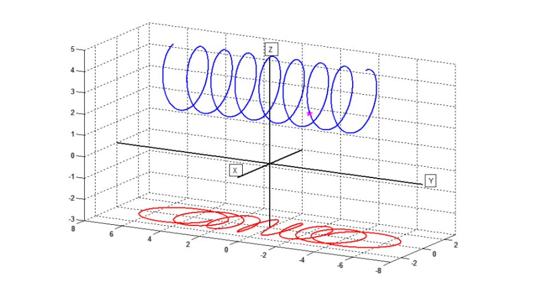

1. The projection of the star is marked on the image plane as a pink star.
2. First, we have that:

$$a\left(0\right)=\left(0,0,5\right),$$

$$a\left(-8π\right)=\left(0, -\frac{8π}{5}, 5\right)$$

$$Z_{min}=2, Z_{max}=5$$

We can see that this trace is created by a circle which is continuously moved along the y axis, so the x and z coordinates will be some variation of cos and sin of some expression.

We have $$a\left(-8π\right)=\left(0, -\frac{8π}{5}, 5\right)$$

And so we know that when s = $-8π$, then x = 0.

We also know that when s = 0, then, x = 0. In order to get 8 full circles in the span of 16 $π$*,* we have to have the expression cos(s $)$ and in order to adjust for the starting and 0 points, we add $\frac{π}{2}$ to the angle, leaving us with cos(s+ $\frac{π}{2})$. The final adjustment is for the radius which is 1.5 (we have $Z_{min}=2, Z_{max}=5), and so$ we get:  
**x = 1.5cos(s+ $\frac{π}{2}).$**

Y changes constantly and ranges from $-\frac{8π}{5} to \frac{8π}{5},$ so we get:

**y = $\frac{s}{5}.$**

The definition of z comes similarly to x; the only difference is that the circle radius is at a distance of 3.5 from the XY plane, because $Z_{min}=2, Z_{max}=5,$ and so we get:

**z = 3.5 +1.5sin(s+ $\frac{π}{2}).$**

1. ϐ(s) is the perspective projection of α(s), so for every point p we will define its projected point $p_{i}=\left(\frac{p_{x}*f}{p_{z}}, \frac{p_{y}*f}{p_{z}}\right),$ so we substitute the terms and get:

$$p_{i}=\left(\frac{6cos⁡(s+\frac{π}{2})}{3.5+1.5sin⁡(s+\frac{π}{2})},\frac{3s}{3.5+1.5sin⁡(s+\frac{π}{2})}\right)$$