Getting started with github and git?



Git is not Github

I **. What is Git?**  
  
**Version Control System**  
Lets say you have a project you want to work on.   
Now you have **2 primary motives.**  
**(a)**To write some code  
(**b)**To take up the project as a team , meaning that more than  one people are going to be responsible for writing the code.

II. How to use git with github ?

1. Install git and create a github account

The first two things you'll want to do are: install git and create a free GitHub account.

***sudo apt-get install git (ubuntu)***

***sudo yum install git (redhat)***

1. login to your github account

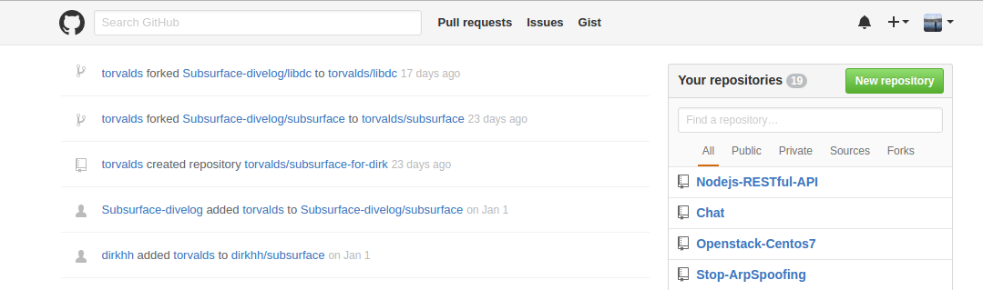

3. Create a new repository by typing New Repository

Choose a name for your repository and write a short repository description in the Description field.

You can initialize your project with a readme file and a license

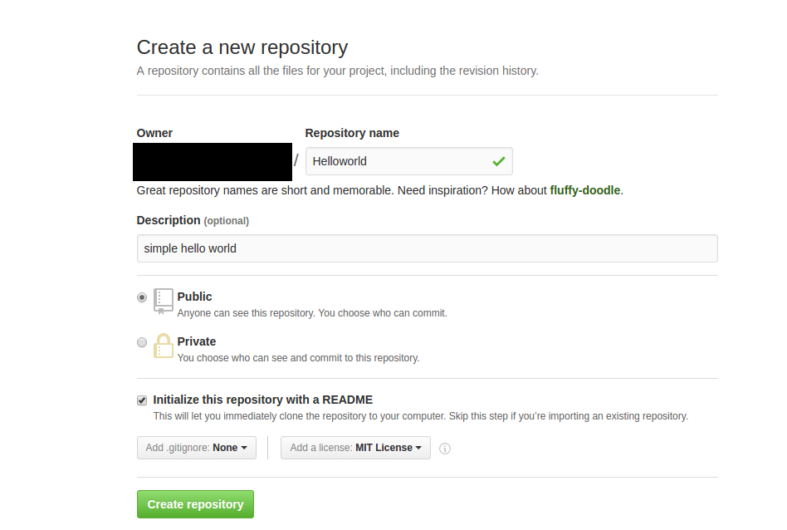

Hit : Create repository

4.Copy repository link

hit Clone or download

then Copy to Clipboard

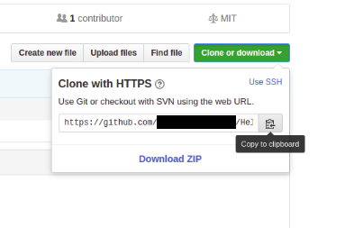

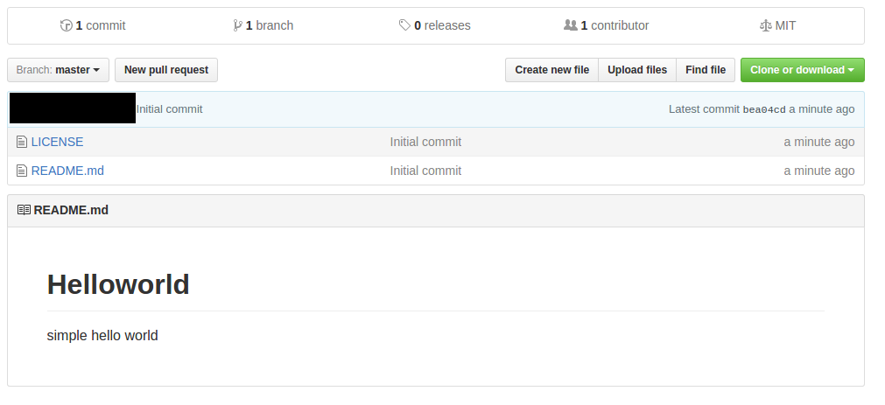

5. Now open your terminal :

and verify that git is installed by typing

***git - -version***

in my case the output of this command is :

***git version 1.9.1***

**6. Cloning repository to your local disk**

to clone the repository to your disk you have to issue the command :

***git clone <paste clipboard content>***

example:

***git clone*** [***https://github.com/JhonDoe/Helloworld.git***](https://github.com/JhonDoe/Helloworld.git)

this command will copy the content of the repository Helloworld to the current directory.

Now verify that the repository is cloned by typing ls

you can notice that a new folder named Helloworld was created

***cd Helloword;ls***

in my case the command above printed :

LICENSE README.md

If you didn’t initialized your repository neither with a README file nor a LICENSE the command above will not print anything

now let us modify this repository by adding some files :

for example let us create a file simple.js and add this line to it :

console.log('hello world')

now we will upload our work to the repository reopen the terminal and go to the Helloworld folder :

1. cd peth/to/Helloworld

2. git add –-all

3. git commit -m “adding simple.js file”

4. git push

then git will prompt for your username and your password then it will update your guthub repository :

Counting objects: 4, done.

Delta compression using up to 4 threads.

Compressing objects: 100% (2/2), done.

Writing objects: 100% (3/3), 341 bytes | 0 bytes/s, done.

Total 3 (delta 0), reused 0 (delta 0)

To https://github.com/xxxxxxxxxx/Helloworld.git

bea04cd..9c1f1b4 master -> master