Lab01 – Containerize an application

In this exercise, you will practice building a container image from an existing `Dockerfile`. Then you will run the container from the image, and interact with it.

- Inspect the `Dockerfile` (./app/Dockerfile) in the `app` directory.
The `Dockerfile` builds a nodejs-based application. All files necessary to run the application are available in the same directory. The `Dockerfile` exposes port 3000.

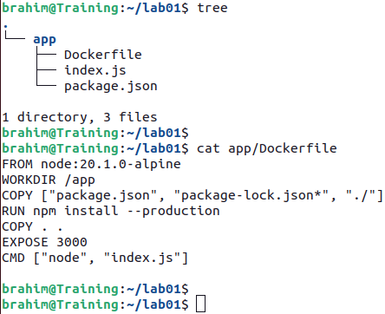

- Build the container image from the `Dockerfile` with the tag `nodejs-hello-world:1.0.0`.
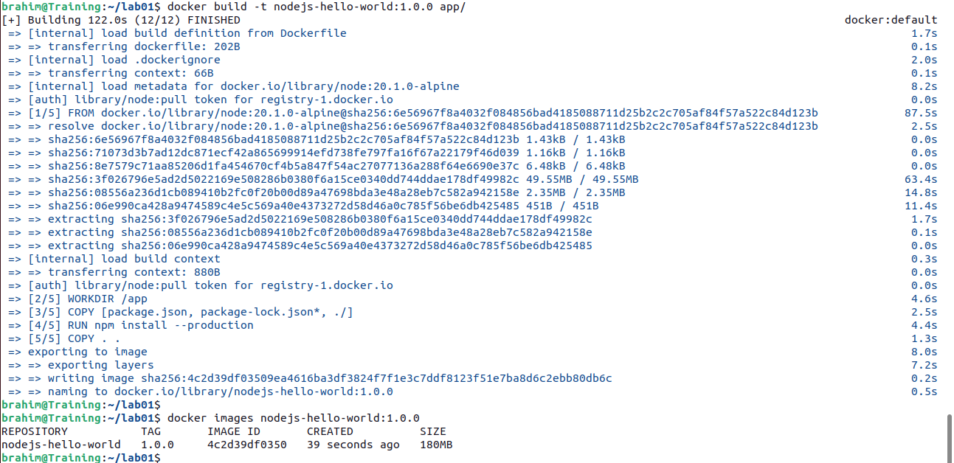

- Run a container with the container image. Make the application available on port 80.
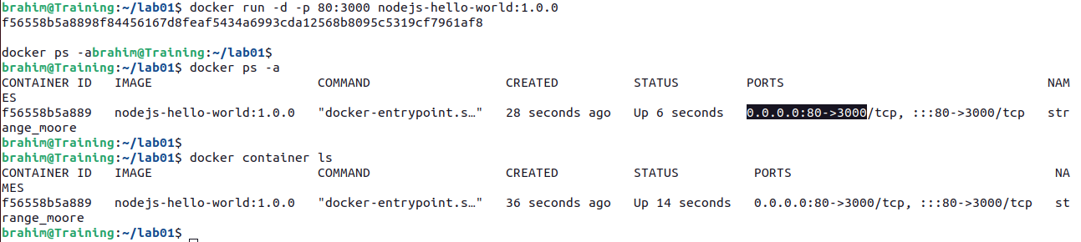

- Use your browser or Execute a `curl` or `wget` command against the application's endpoint.
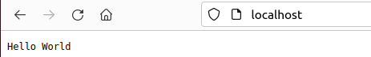

- Retrieve the container logs.
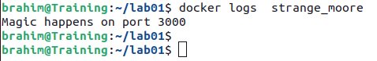

- Save the container image to the file `nodejs-hello-world-1.0.0.tar`.
