Lab06 – Labels and annotations

In this exercise, you will exercise assigning labels and annotations to a set of Pods. Moreover, you will use `kubectl` to query for Pods based on different requirements.

- Create three different Pods with the names `frontend`, `backend` and `database` that use the image `nginx`. Declare labels for those Pods as follows:
  - `frontend`: `env=prod`, `team=shiny`
  - `backend`: `env=prod`, `team=legacy`, `app=v1.2.4`
  - `database`: `env=prod`, `team=storage`

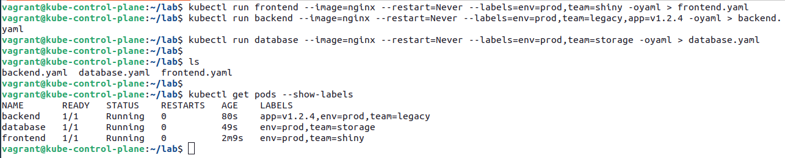
- Edit the existing Pods with the `edit` command and add the annotations as follows:
  - `frontend`: `contact=John Doe`, `commit=2d3mg3`
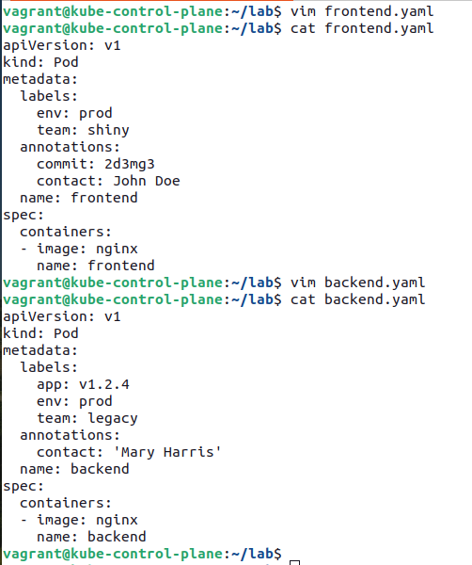
  - `backend`: `contact=Mary Harris`

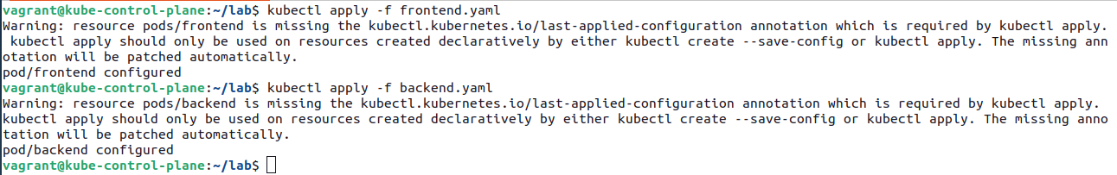

- Use label selectors on the command line to query for all production Pods that belong to the teams `shiny` and `legacy`.

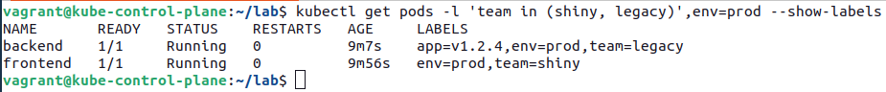

- Remove the label `env` from the `backend` Pod and rerun the selection.
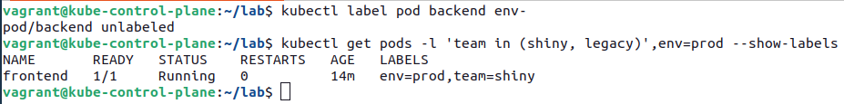

- Render the surrounding 3 lines of YAML of all Pods that have annotations

