Lab07 – Deployment

Rolling Update Deployment
In this exercise, you will create a Deployment with multiple replicas. After inspecting the Deployment, you will update its Pod template. Furthermore, you will use the rollout history to roll back to a previous revision.

- Create a Deployment named `nginx` with 3 replicas. The Pods should use the `nginx:1.23.0` image and the name `nginx`. The Deployment uses the label `tier=backend`. The Pod template should use the label `app=v1`.

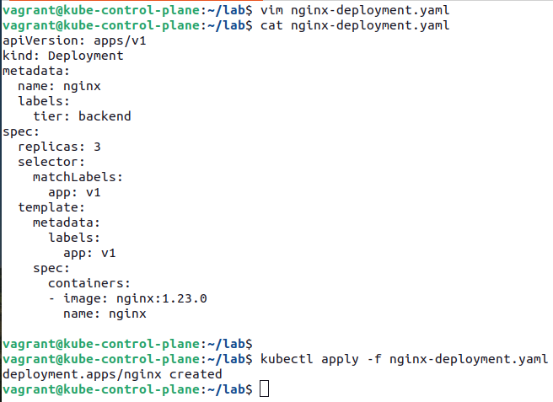

- List the Deployment and ensure that the correct number of replicas is running.
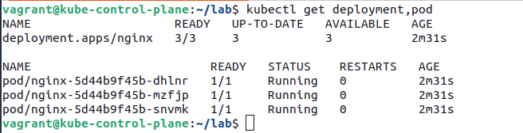

- Update the image to `nginx:1.23.4`.

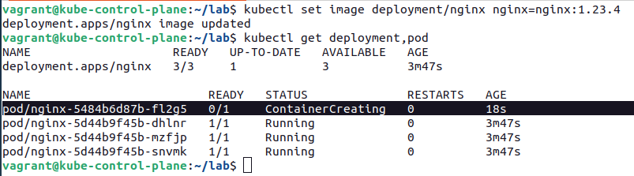

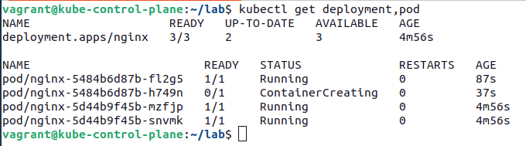

- Verify that the change has been rolled out to all replicas.

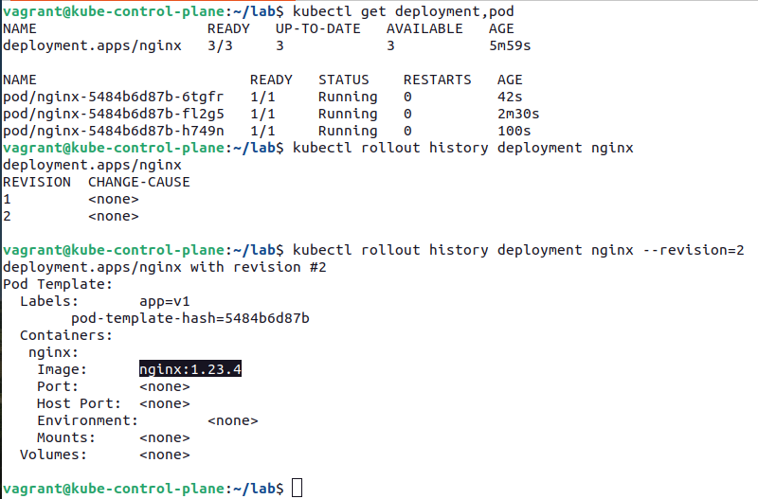

- Assign the change cause "Pick up patch version" to the revision.

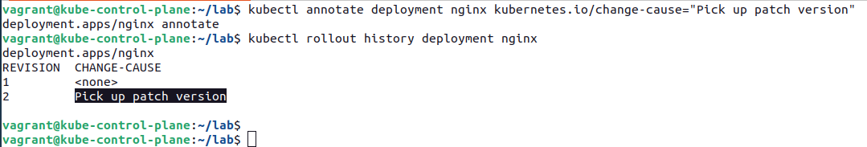

- Scale the Deployment to 5 replicas.

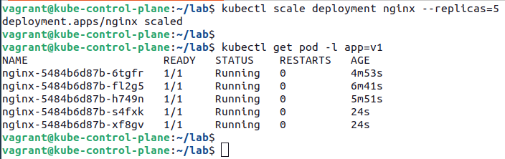

- Have a look at the Deployment rollout history.
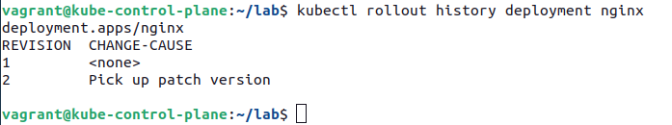

- Revert the Deployment to revision 1.
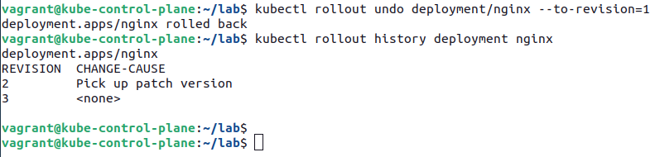

- Ensure that the Pods use the image `nginx:1.23.0`.

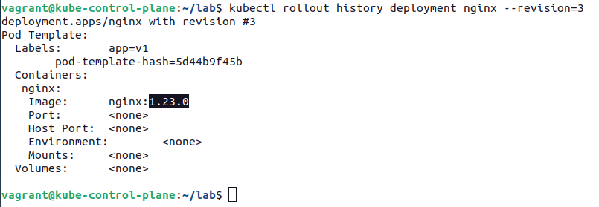

Blue/Green Deployment
In this exercise, you will set up a blue-green Deployment scenario. You'll first create the initial (blue) Deployment and expose it will a Service. Later, you will create a second (green) Deployment and switch over traffic.

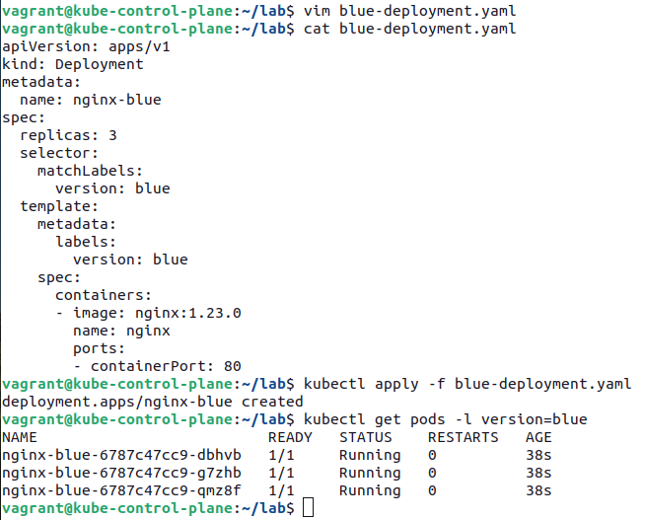
- Create a Deployment named `nginx-blue` with 3 replicas. The Pod template of the Deployment should use container image `nginx:1.23.0` and assign the label `version=blue`.

- Expose the Deployment with a Service of type `ClusterIP` named `nginx`. Map the incoming and outgoing port to 80. Select the Pod with label `version=blue`.

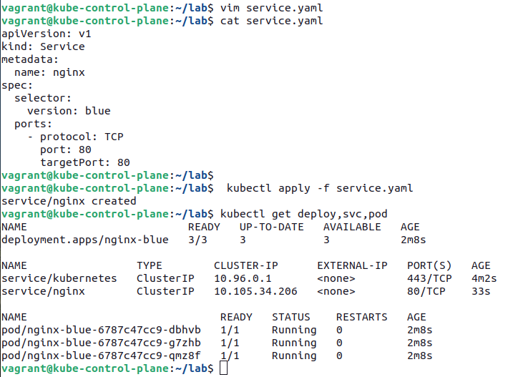

- Run a temporary Pod with the container image `alpine/curl:3.14` to make a call against the Service using `curl`.
- Create a second Deployment named `nginx-green` with 3 replicas. The Pod template of the Deployment should use container image `nginx:1.23.4` and assign the label `version=green`.

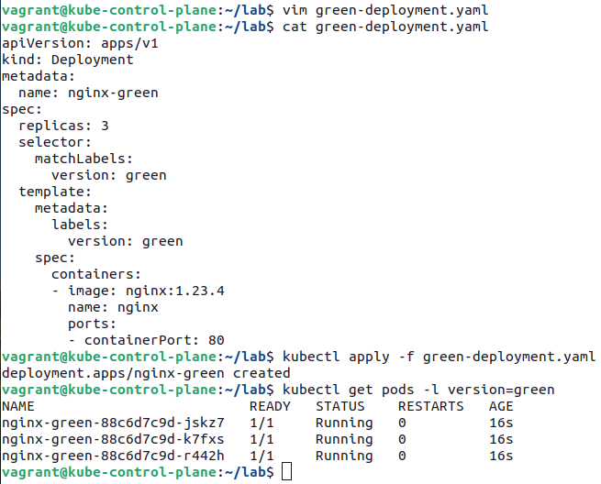

- Change the Service's label selection so that traffic will be routed to the Pods controlled by the Deployment `nginx-green`.

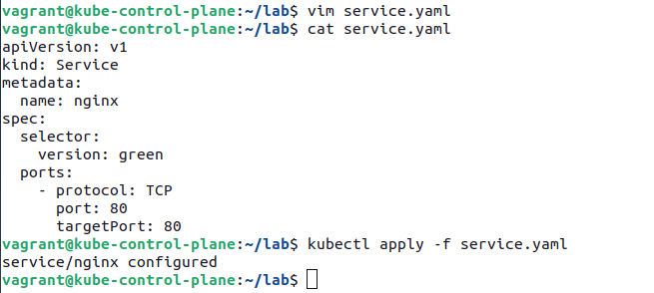

- Delete the Deployment named `nginx-blue`.
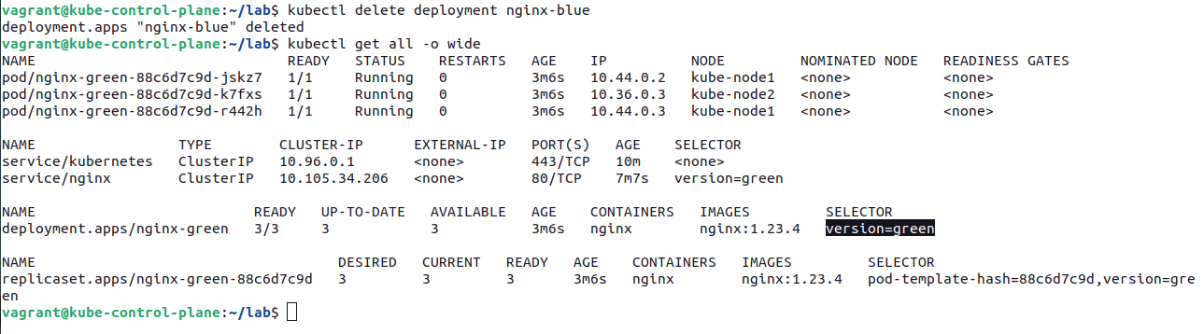

- Run a temporary Pod with the container image `alpine/curl:3.14` to make a call against the Service.

