Lab08 – HPA

- Install the metrics server to actual resource metrics. You can find [installation instructions](https://github.com/kubernetes-sigs/metrics-server#installation) on the project's GitHub page.

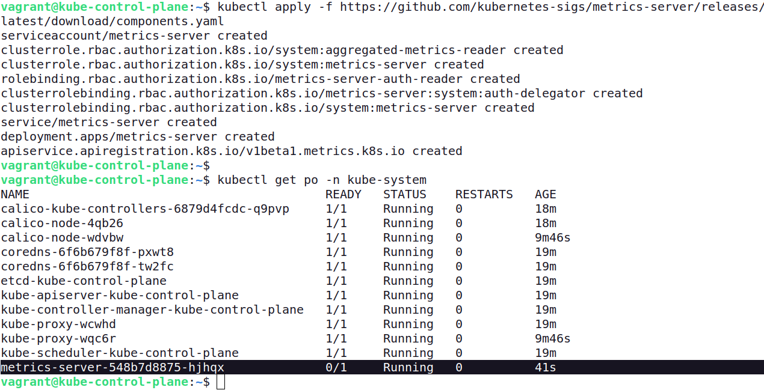

- Create a Deployment named `nginx:1.23.4` with 1 replica. The Pod template of the Deployment should use container image `nginx:1.23.4`, set the CPU resource request to 0.5, and the memory resource request/limit to 500Mi.
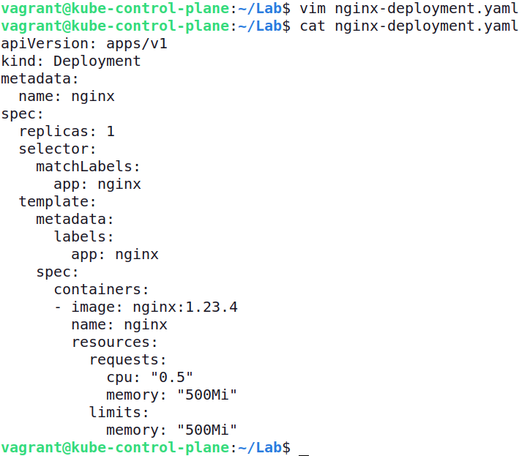

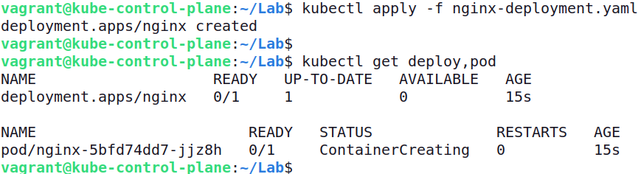

- Create a HorizontalPodAutoscaler for the Deployment named `nginx-hpa` that scales to minium of 3 and a maximum of 8 replicas. Scaling should happen based on an average CPU utilization of 75%, and an average memory utilization of 60%.

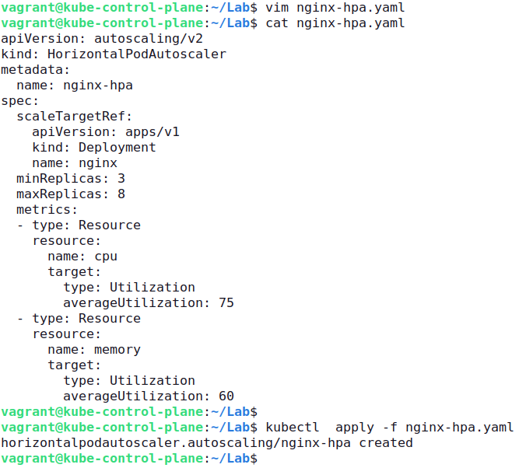

- Inspect the HorizontalPodAutoscaler object and identify the currently-utilized resources. How many replicas do you expect to exist?
