Lab09 – blue/green deployment

- Create a Deployment named `nginx-blue` with 3 replicas. The Pod template of the Deployment should use container image `nginx:1.23.0` and assign the label `version=blue`.
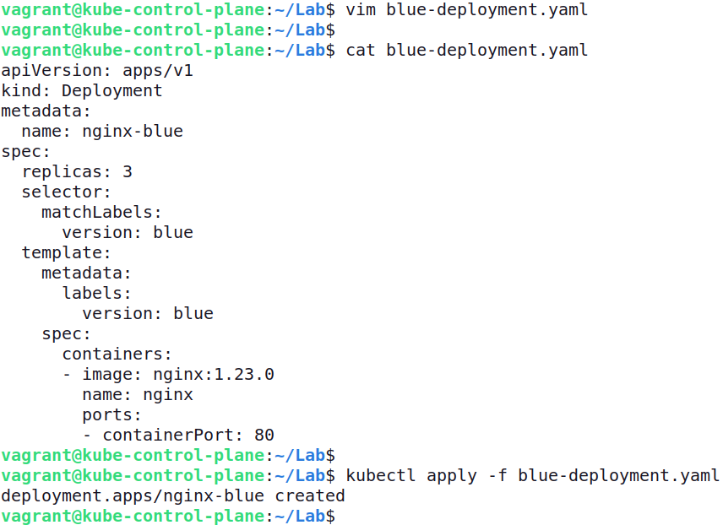

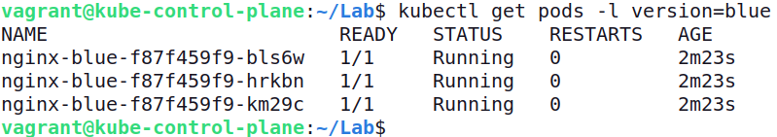

- Expose the Deployment with a Service of type `ClusterIP` named `nginx`. Map the incoming and outgoing port to 80. Select the Pod with label `version=blue`.

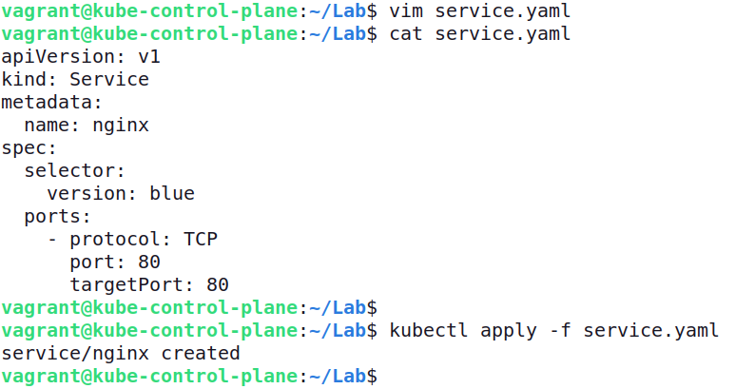

- Run a temporary Pod with the container image `alpine/curl:8.5.0` to make a call against the Service using `curl`. The returned headers will include the nginx server version.

- Create a second Deployment named `nginx-green` with 3 replicas. The Pod template of the Deployment should use container image `nginx:1.23.4` and assign the label `version=green`.

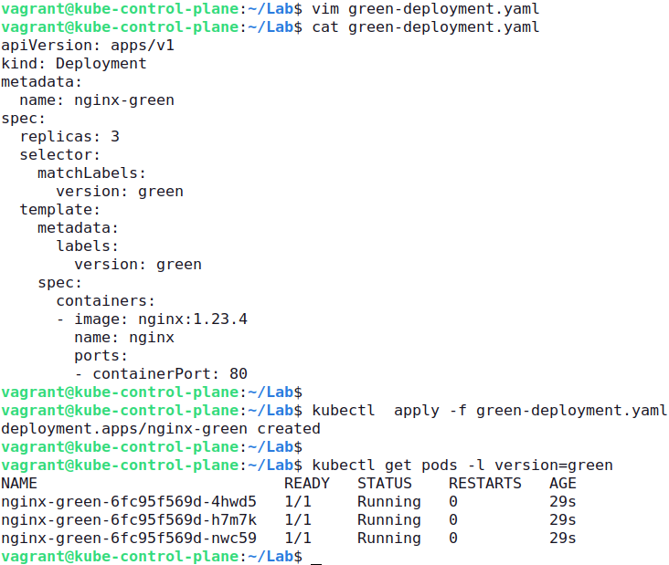

- Change the Service's label selection so that traffic will be routed to the Pods controlled by the Deployment `nginx-green`.

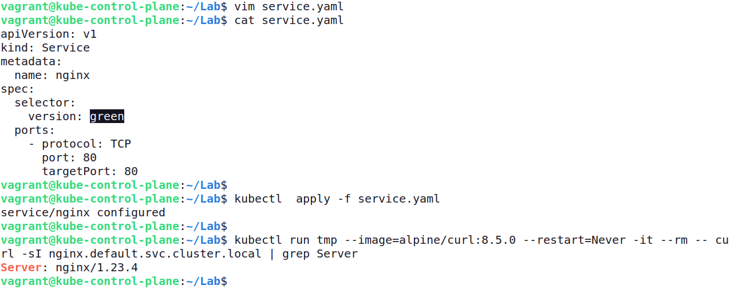

- Delete the Deployment named `nginx-blue`. Run a temporary Pod with the container image `alpine/curl:8.5.0` to make a call against the Service.

