Lab10 – Helm

Helm consume chart
In this exercise, you use Helm to install Kubernetes objects needed for the open source monitoring solution Prometheus (https://prometheus.io/). The easiest way to install Prometheus on top of Kubernetes is with the help of the prometheus-operator (https://prometheus-operator.dev/) Helm chart.

- The Prometheus Helm charts reside in the artifact repository (https://prometheus-community.github.io/helm-charts). Add the repository to the list of known repositories accessible by Helm with the name `prometheus-community`.

- Update to the latest information about charts from the respective chart repository.
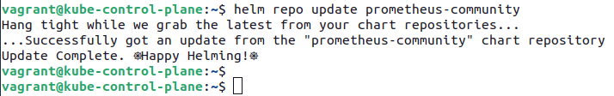

- Run the Helm command for listing available Helm charts and their versions. Identify the latest chart version for `kube-prometheus-stack`.

- Install the the chart `kube-prometheus-stack`.

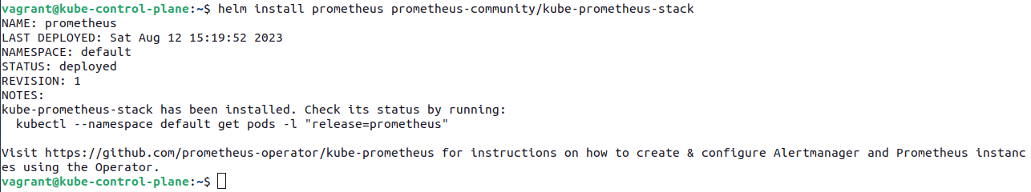
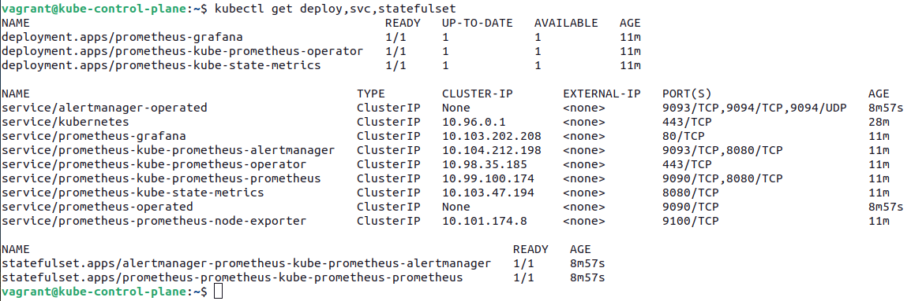
- List the installed Helm chart.

- List the Service named `prometheus-operated` created by the Helm chart. The object resides in the `default` namespace. This Service exposes the Prometheus dashboard on port 9090.
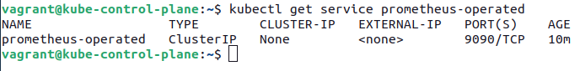

- Use the kubectl `port-forward` command to forward the local port 8080 to the port 9090 of the Service.

- Open a browser and bring up the Prometheus dashboard.
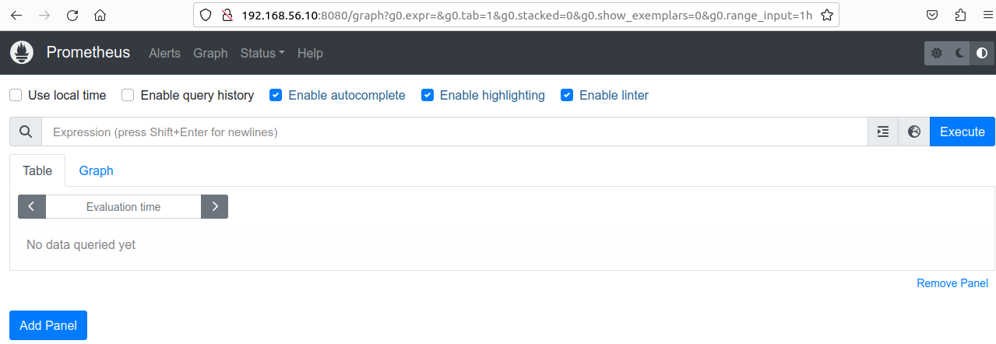

- Stop port forwarding and uninstall the Helm chart.
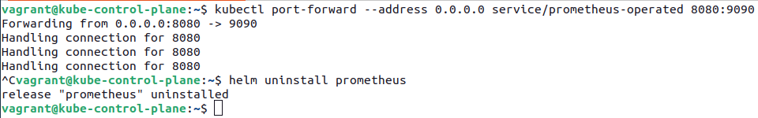

Helm build chart
In this exercise, you will practice the implementation, packaging, and installation of a configurable custom Helm chart.

- Create a new chart file named `Chart.yaml`. Define all mandatory attributes including the chart's API version, the name, and the version. Add the following key-value pairs: `API version: 1.0.0`, `Name: web-app`, and `Version: 2.5.4`.

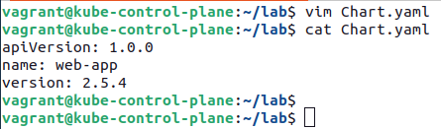

- Create a new values file named `values.yaml`. It should contain the following key-value pairs: `service_port: 80`, and `container_port: 3000`.
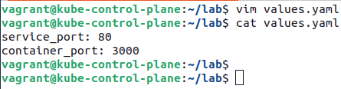

- Create the template file `web-app-pod-template.yaml`. The YAML manifest defines a Pod named `hello-world` with the image `brahimhamdi/nodejs-hello-world:1.0.0`. The container port uses the placeholder `container_port` from the `values.yaml` file.

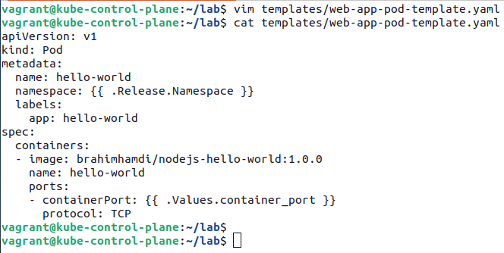

- Create the template file `web-app-service-template.yaml`. The YAML manifest defines a Service named `web-app-service` of type `ClusterIP`. The target port should use the placeholder `container_port` from the `values.yaml` file, the port should use the placeholder `service_port` from the `values.yaml` file.

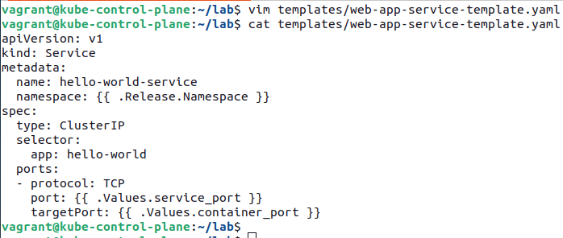

- Bundle the template files into a chart archive file by running the correct Helm command. What's the name of the file produced?
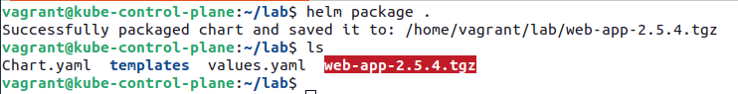

- Install the chart with the name `hello-world` to the namespace `app-stack` using the appropriate Helm command. Override the value of `service_port` with the value `9090`.
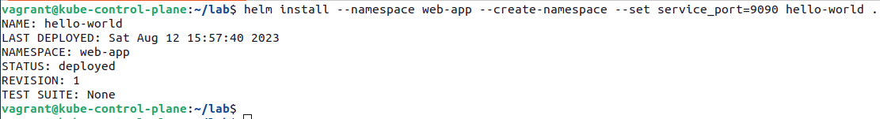

- Find the installed objects provided by the chart.
