Lab12 – Troubleshooting Pod

In this exercise, you will practice your troubleshooting skills by inspecting a misconfigured Pod.

- Create a new Pod from the YAML manifest in the file `pod.yaml` (./pod.yaml). Check the Pod's status. Do you see any issue?
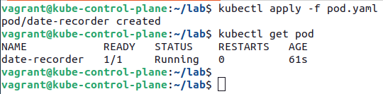

- Render the logs of the running container and identify an issue.

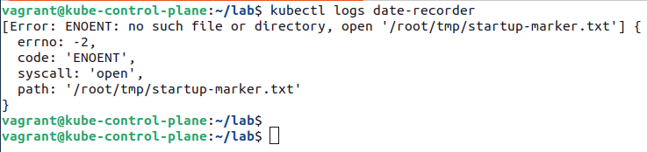

- Shell into the container. Can you verify the issue based on the rendered log message?
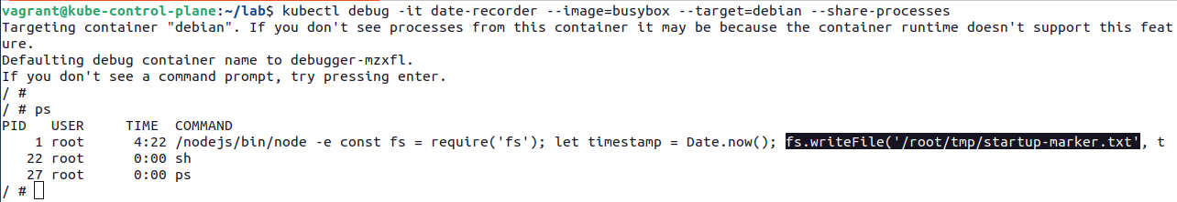

Apparently, the directory we want to write to does indeed not exist.

- Suggest solutions that can fix the root cause of the issue.
We'll likely want to change the command running the original container to point to directory that does exist upon container start. Alternatively, it may make sense to mount an ephemeral Volume to provide the directory.

