Lab13 – Custom Resource Definition

- Create a CRD resource named `backup.example.com` with the following specification :
    - Group: `example.com`
    - Version: `v1`
    - Kind: `Backup`
    - Singular: `backup`
    - Plural: `backups`
    - Properties of type `string`: `cronExpression`, `podName`, `path`

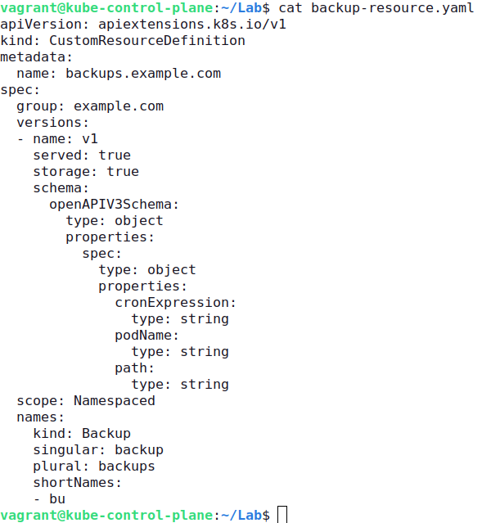

- Retrieve the details for the `Backup` custom resource created in the previous step.
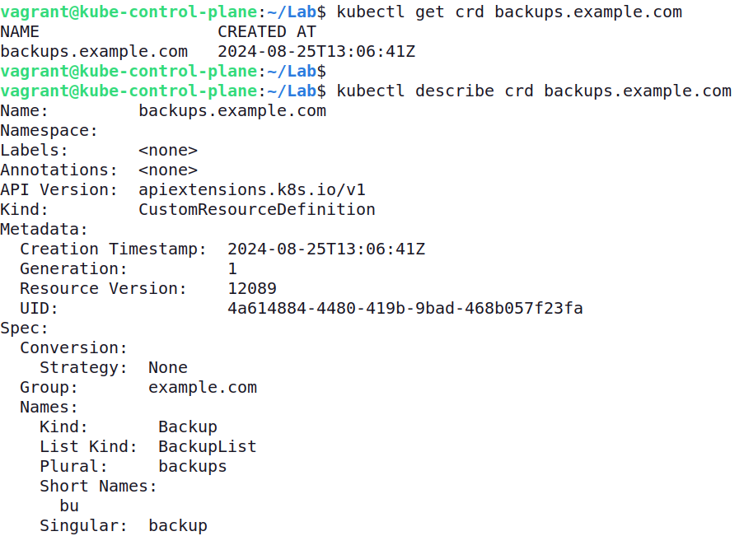

- Create a custom object named `nginx-backup` for the CRD. Provide the following property values:
    - `cronExpression`: `0 0 * * *`
    - `podName`: `nginx`
    - `path`: `/usr/local/nginx`

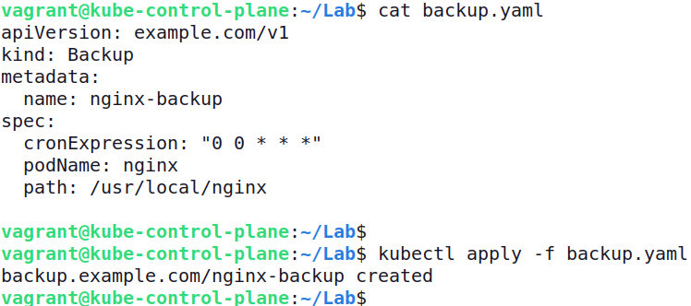

- Retrieve the details for the `nginx-backup` object created in the previous step.

