Lab16 – Config Data

In this exercise, you will first create a ConfigMap from a YAML configuration file as a source. Later, you'll create a Pod, consume the ConfigMap as Volume and inspect the key-value pairs as files. Also you will first create a Secret from literal values. Next, you'll create a Pod and consume the Secret as environment variables. Finally, you'll print out its values from within the container.

ConfigMap
- Inspect the YAML configuration file named `application.yaml`
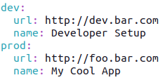

- Create a new ConfigMap named `app-config` from that file.
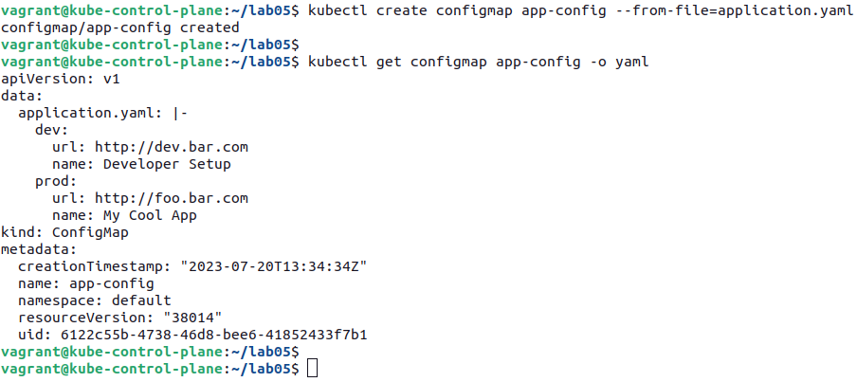

- Create a Pod named `backend` that consumes the ConfigMap as Volume at the mount path `/etc/config`. The container runs the image `nginx:1.23.4-alpine`.

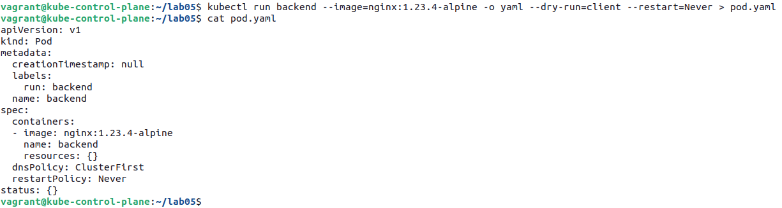

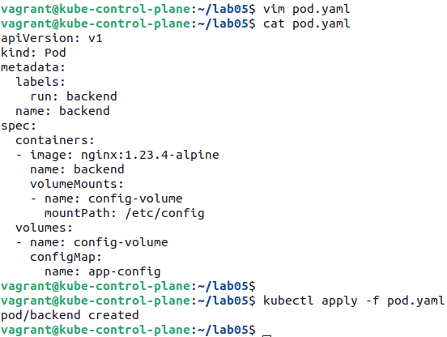

- Shell into the Pod and inspect the file at the mounted Volume path. You must find the file `application.yaml` with the expected YAML content.
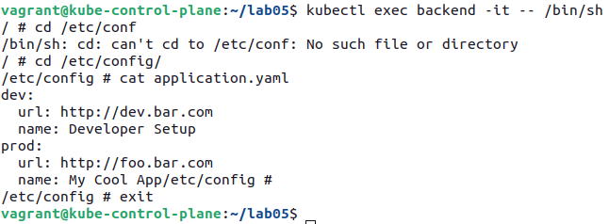

Secret
- Create a new Secret named `db-credentials` with the key/value pair `db-password=passwd`.
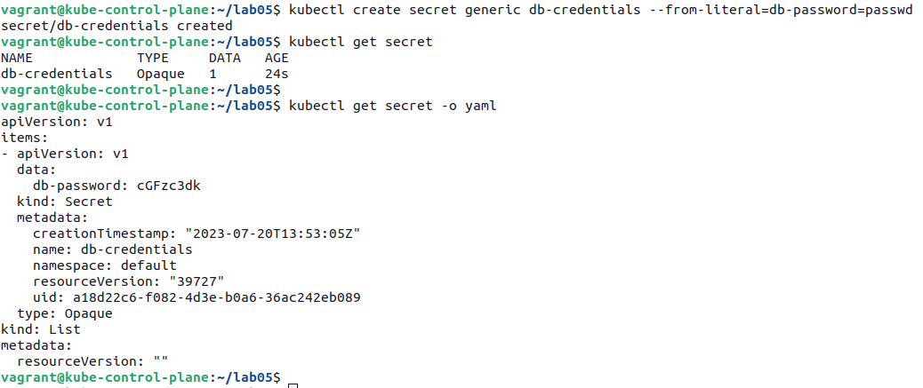

- Create a Pod named `backend` that uses the Secret as environment variable named `DB_PASSWORD` and runs the container with the image `nginx:1.23.4-alpine`.
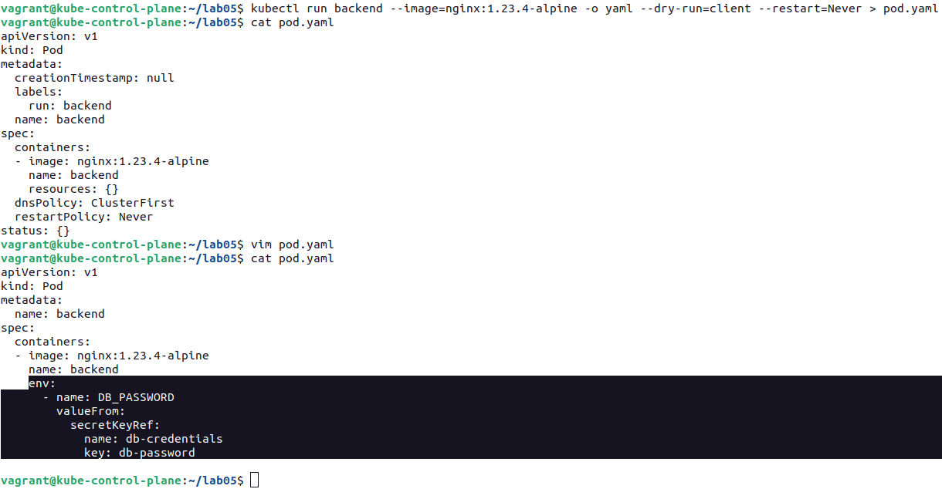

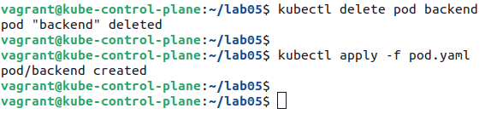

- Shell into the Pod and print out the created environment variables. You should find `DB_PASSWORD` variable.

