Lab17 – Security Context

In this exercise, you will create a Pod that defines a security context with different options.

- Define a Pod named `busybox-security-context` that
  - uses the image `busybox:1.28` for a single container running the command `sh -c sleep 1h`.

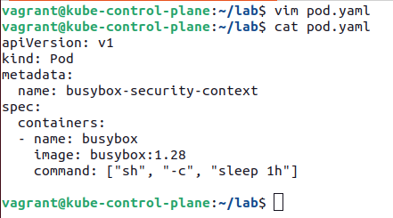

- Add an ephemeral Volume of type `emptyDir`. Mount the Volume to the container at `/data/test`.
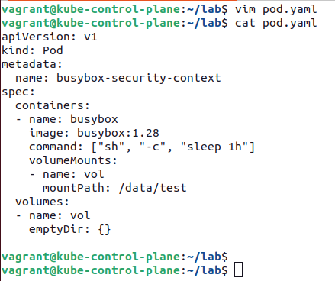

- Define a security context that runs the container with user ID 1000, with group ID 3000, and the file system group ID 2000. Ensure that the container should not allow privilege escalation.

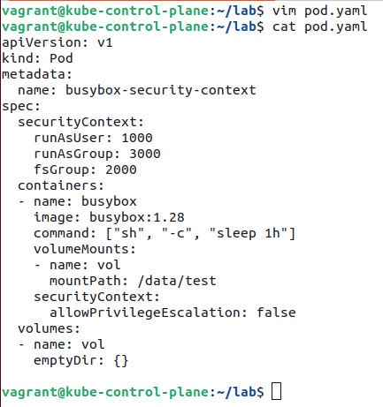

- Create the Pod object and ensure that it transitions into the "Running" status.
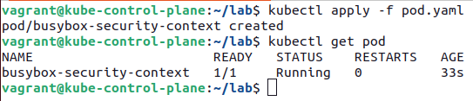

- Open a shell to the running container and create a new file named `logs.txt` in the directory `/data/test`. What's the file's user ID and group ID?

