Lab18 – Service types

In this exercise, you will create a Deployment and expose a container port for its Pods. You will demonstrate the differences between the service types ClusterIP and NodePort.

- Create a Service named `myapp` of type `ClusterIP` that exposes port 80 and maps to the target port 80.
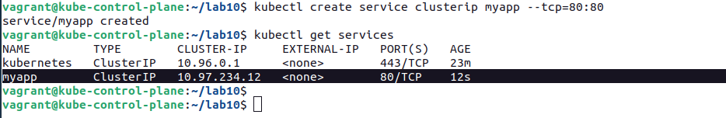

- Create a Deployment named `myapp` that creates 1 replica running the image `nginx:1.23.4-alpine`. Expose the container port 80.
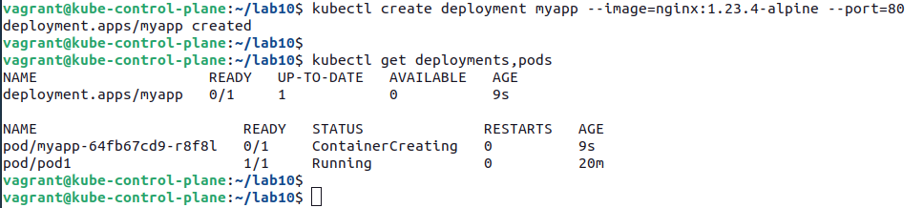

- Scale the Deployment to 2 replicas.

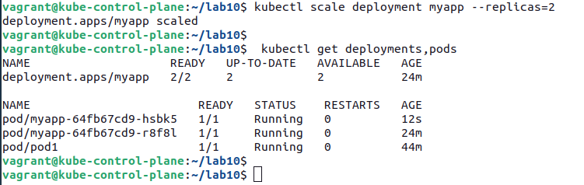

- Create a temporary Pod using the image `busybox` and run a `wget` command against the IP of the service.
Determine the cluster IP and the port for the Service. In this case, it's `10.97.234.12:80`. Alternatively, you can use the DNS name `myapp`. Use the information with the `wget` command.
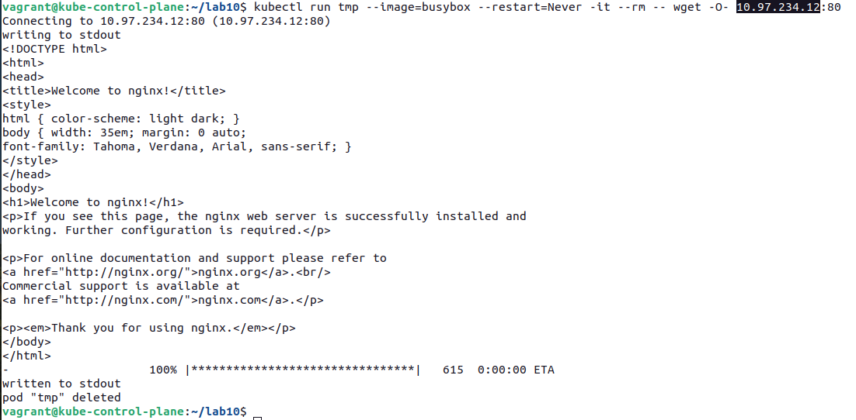

- Change the service type so that the Pods can be reached from outside of the cluster. You muast turn the type of the service into `NodePort` to expose it outside of the cluster. Now, the service should expose a port in the 30000 range.
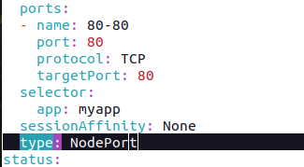

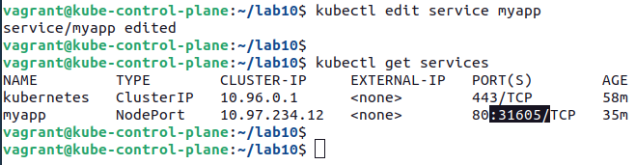

- Run a browser or `wget` command against the service from outside of the cluster.

