Lab19 – Defining and using an Ingress

In this exercise, you will create an Ingress with rules that routes traffic to 2 Services.

Ingress Controller setup
The Kubernetes documentation (https://kubernetes.io/docs/concepts/services-networking/ingress-controllers/) lists a wide range of Ingress Controller implementations.
- Use command bellow to implement an ingress controller.
kubectl apply -f https://raw.githubusercontent.com/kubernetes/ingress-nginx/controller-v1.10.0/deploy/static/provider/cloud/deploy.yaml

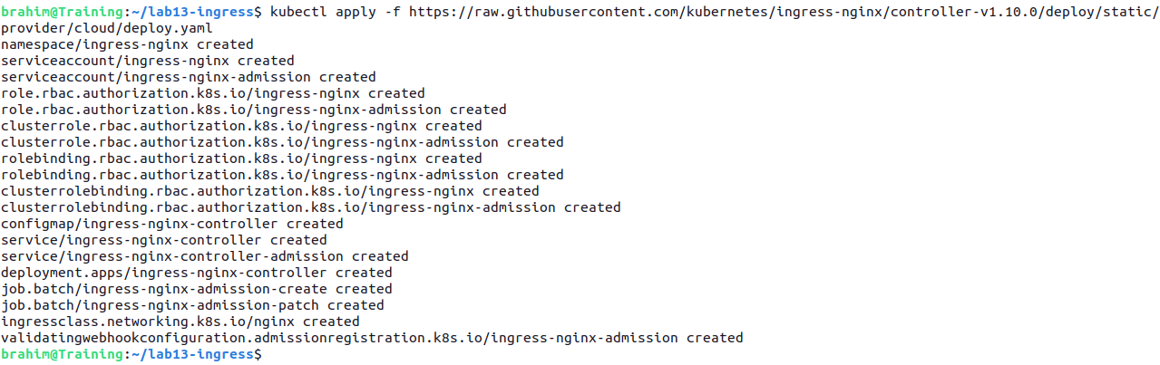

- The Ingress controller will run as a Pod in the `ingress-nginx` namespace. Make sure that the Pod `ingress-nginx-controller-...` transitions into the "Running" status.

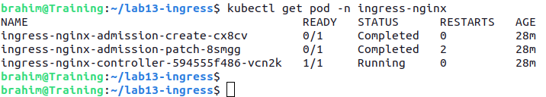

Using Ingress
- Create create two pods that output a slightly different response :
    - apple-app : execute image hashicorp/http-echo, print apple
    - banana-app : execute image hashicorp/http-echo, print banana

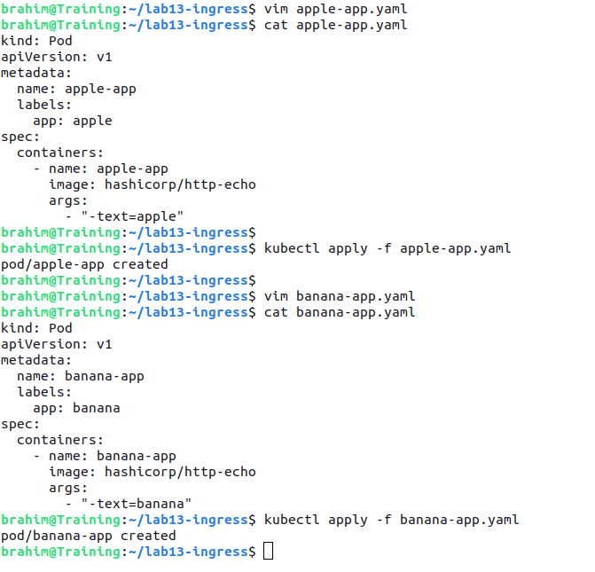

- Expose the pods with a Services named `apple` and `banana` of type `NodePort`. The Services routes trafic, respectively, to the Pods `apple-app` and `banana-app`.

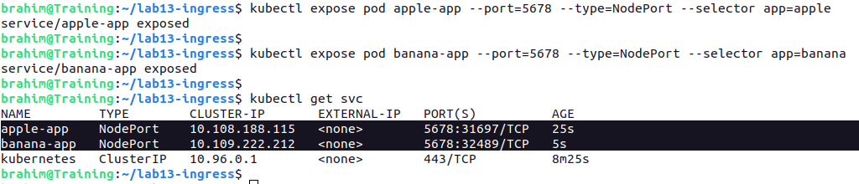
- Make a request to the endpoints of the applications to test services.

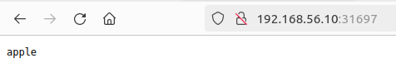

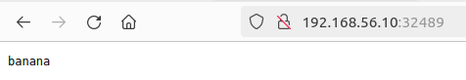

- Create an Ingress that exposes the paths `/apple` and `/banana` for the host `fruit.exposed.com`. The traffic should be routed to the Services created earlier.

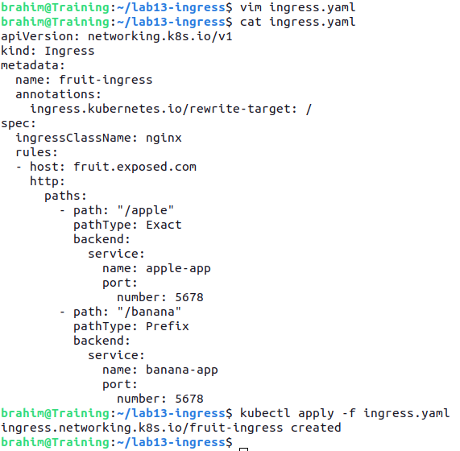

- List the Ingress object. The value for the IP address will populate after waiting for a little while. You may have to run the command multiple times.
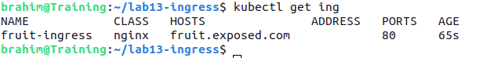

- Add an entry in `/etc/hosts` that maps the virtual node IP address to the host `fruit.exposed.com`.

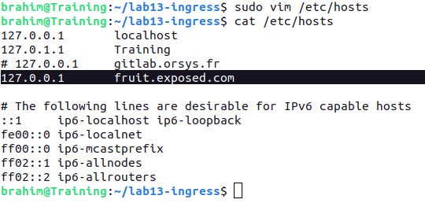

- Now, forward a local port to the ingress controller with this command :
kubectl port-forward --namespace=ingress-nginx service/ingress-nginx-controller 8080:80

- Test access to app using curl or your browser
