Lab20 – Troubleshooting an issue with Network Policy

In this exercise, you will create a network policy allowing the web-app to query its database. The application stack consists of a web application implemented using node.js, and a MySQL database. The web application connects to the database upon requesting its endpoint. Web application and MySQL database run in a Pod. Both Pods have been exposed by a Service. The Service for the web application Pod is of type `NodePort`. The Service for the MySQL database is of type `ClusterIP`. By default, all ingress and egress traffic is not allowed in this namespace.

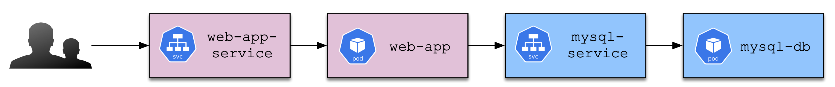

- Create a new namespace named `network`. Within the namespace, setup the configuration `kubectl -n network apply -f setup.yaml`.

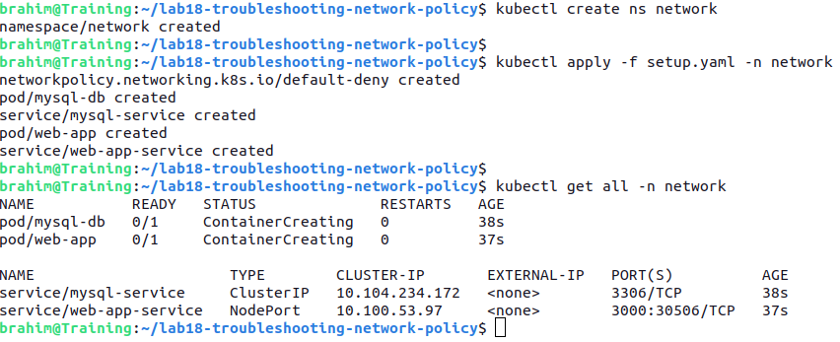

- The Pod running web application exposes the container port 3000. From your machine, use your browser or execute `curl` or `wget` to access the application through the Service endpoint from outside of the cluster. A successful response should render `Successfully connected to database!`, a failure response should render `Failed to connect to database: <error message>`.

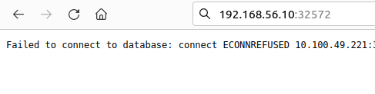

- Add a new NetworkPolicy allowing web-app to connect to mysql-db only on port 3306.

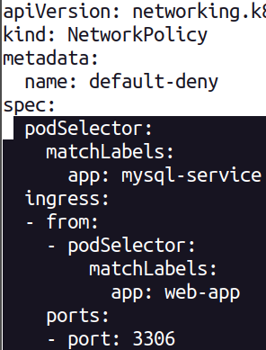

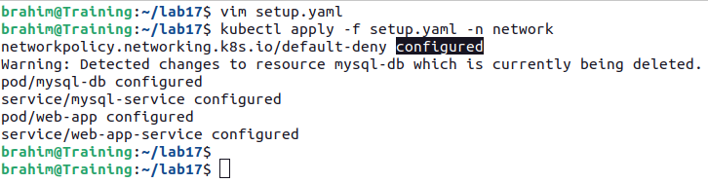

- Use your browser or `curl` or `wget` command should now render the message `Successfully connected to database!`.
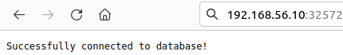

- Delete the namespace `network`.

