Lab02 – Creating a Pod and inspecting it

In this exercise, you will practice the creation of a new Pod in a namespace. Once created, you will inspect it, shell into it and run some operations inside of the container.

- Create the namespace `ckad-prep`.
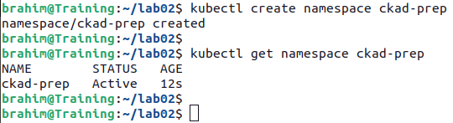

- In the namespace `ckad-prep`, create a new Pod named `mypod` with the image `nginx:2.3.5`. Expose the port 80.
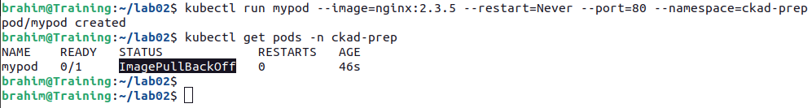

- Identify the issue with creating the container. Write down the root cause of issue in a file named `pod-error.txt`.
The list of events of the Pod can give you a deeper insight.

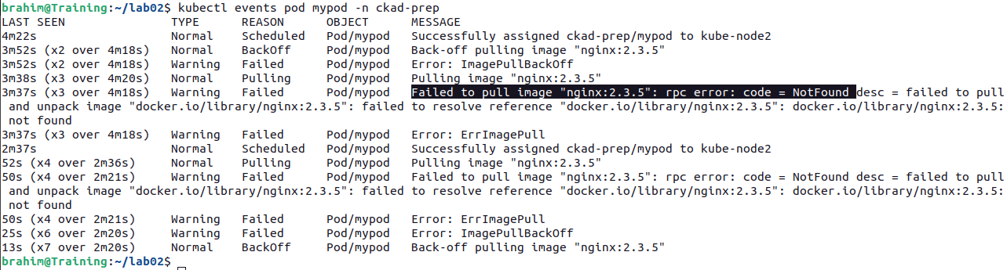

- Change the image of the Pod to `nginx:1.15.12`, and then list the Pod and ensure that the container is running.
Go ahead and edit the existing Pod. Alternatively, you could also just use the `kubectl set image pod mypod mypod=nginx --namespace=ckad-prep` command.
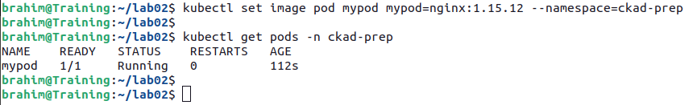

- Log into the container and run the `ls` command. Write down the output. Log out of the container.
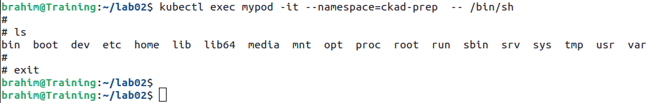

- Retrieve the IP address of the Pod `mypod`.

- Run a temporary Pod in the namespace `ckad-prep` using the image `busybox`, shell into it and run a `wget` command against the `nginx` Pod using port 80.
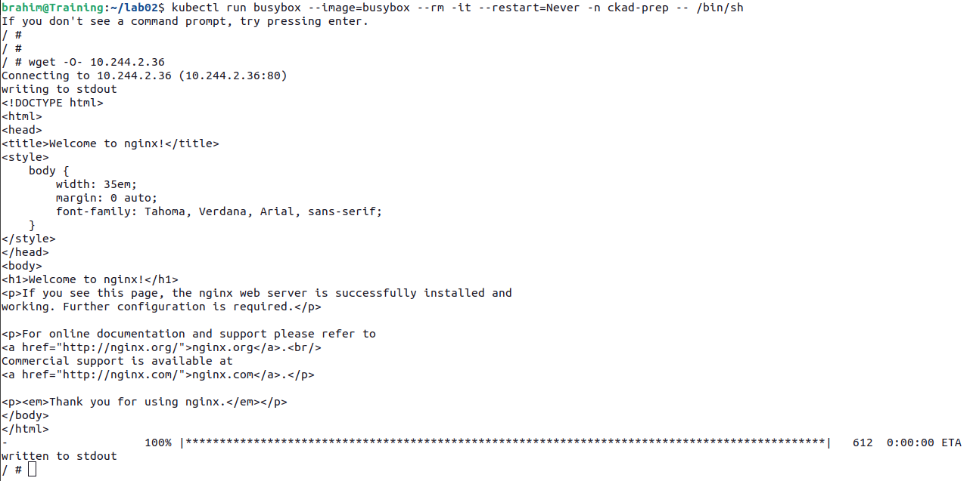

- Render the logs of Pod `mypod`.
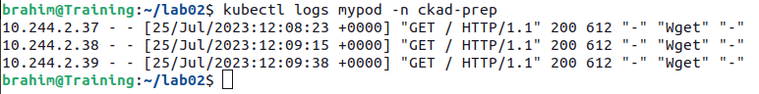

- Delete the Pod and the namespace.
