Lab05 – Creating a Persistent Volume

In this exercise, you will create a PersistentVolume, connect it to a PersistentVolumeClaim and mount the claim to a specific path of a Pod.

- Create a PersistentVolume named `pv`, access mode `ReadWriteMany`, 512Mi of storage capacity and the host path `/data/config`.
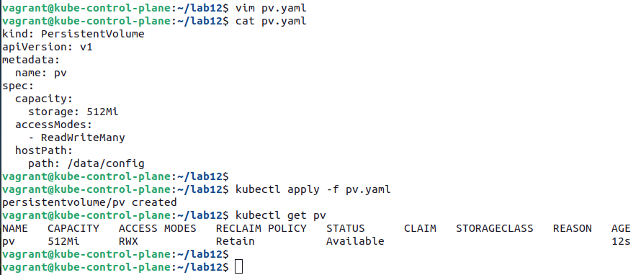

- Create a PersistentVolumeClaim named `pvc`. The claim should request 256Mi and use an empty string value for the storage class. Ensure that the PersistentVolumeClaim is properly bound after its creation.
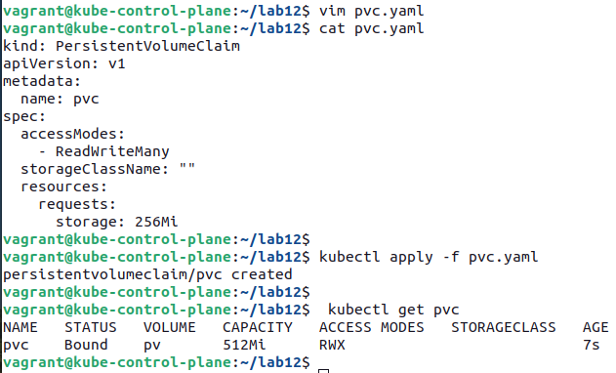

- Mount the PersistentVolumeClaim from a new Pod named `app` with the path `/var/app/config`. The Pod uses the image `nginx:1.21.6`.
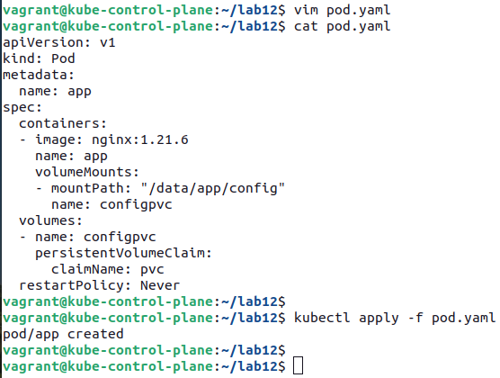

- Open an interactive shell to the Pod and create a file in the directory `/var/app/config`.

