Lab06 – Multi-Container Pods

Init Container
Kubernetes runs an init container before the main container. In this lab, the init container retrieves configuration files from a remote location and makes it available to the application running in the main container. The configuration files are shared through a volume mounted by both containers. The running application consumes the configuration files and can render its values.

- Create a new Pod in a YAML file named `business-app.yaml`. The Pod should define two containers, one init container and one main application container. Name the init container `configurer` and the main container `web`. The init container uses the image `busybox`, the main container uses the image `brahimhamdi/nodejs-read-config:1.0.0`. Expose the main container on port 8080.
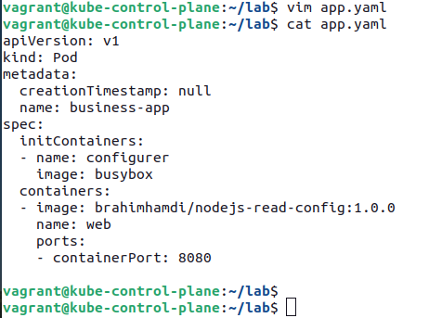

- Edit the YAML file by adding a new volume of type `emptyDir` that is mounted at `/usr/shared/app` for both containers.

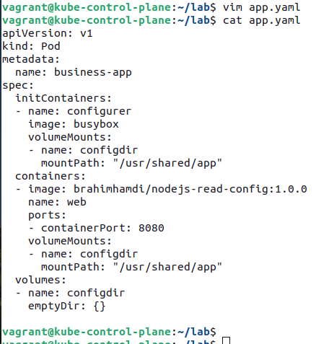

- Edit the YAML file by providing the command for the init container. The init container should run a `wget` command for downloading the file `https://raw.githubusercontent.com/brahimhamdi/ckad-lab/master/labs/lab6/config.json` into the directory `/usr/shared/app`.
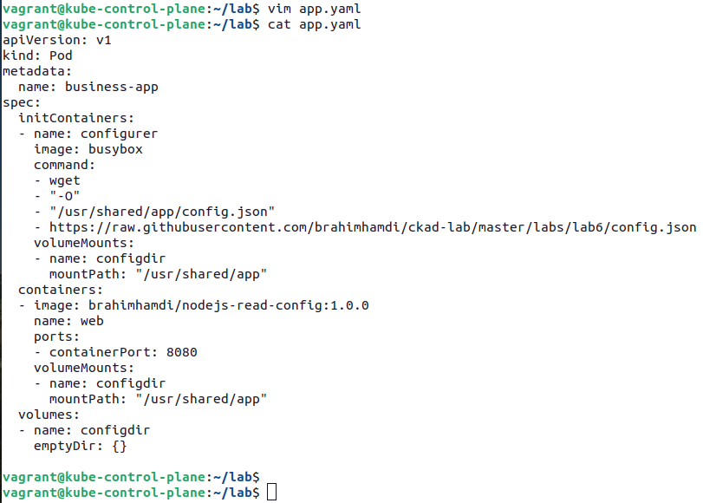

- Create the Pod from the YAML file. Once the application is running, shell into the container. The mounted volume path contains the downloaded configuration file. The `curl` command renders the values from the configuration file.
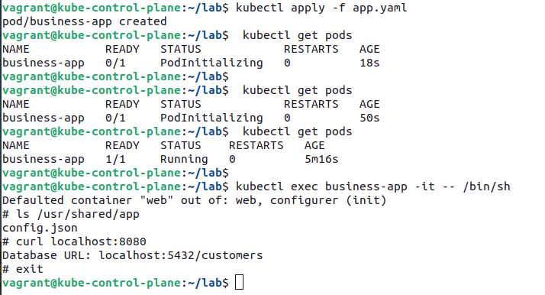

Adapter pattern
The adapter pattern helps with providing a simplified, homogenized view of an application running within a container. For example, we could stand up another container that unifies the log output of the application container. As a result, other monitoring tools can rely on a standardized view of the log output without having to transform it into an expected format.

- Create a new Pod in a YAML file named `adapter.yaml`. The Pod declares two containers. The container `app` uses the image `busybox` and runs the command `while true; do echo "$(date) | $(du -sh ~)" >> /var/logs/diskspace.txt; sleep 5; done;`. The adapter container `transformer` uses the image `busybox` and runs the command `sleep 20; while true; do while read LINE; do echo "$LINE" | cut -f2 -d"|" >> $(date +%Y-%m-%d-%H-%M-%S)-transformed.txt; done < /var/logs/diskspace.txt; sleep 20; done;` to strip the log output off the date for later consumption by a monitoring tool. Be aware that the logic does not handle corner cases (e.g. automatically deleting old entries) and would look different in production systems.
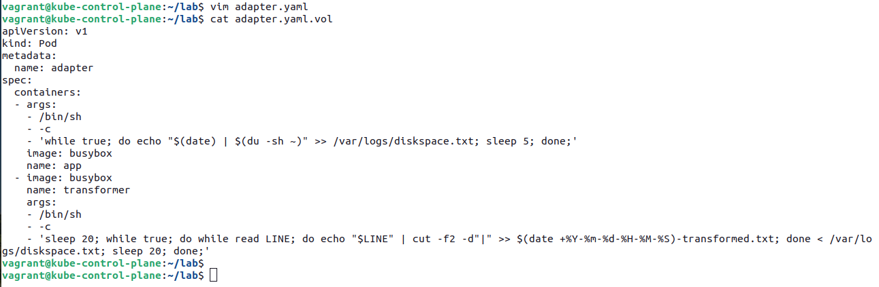

- Before creating the Pod, define an `emptyDir` volume. Mount the volume in both containers with the path `/var/logs`.

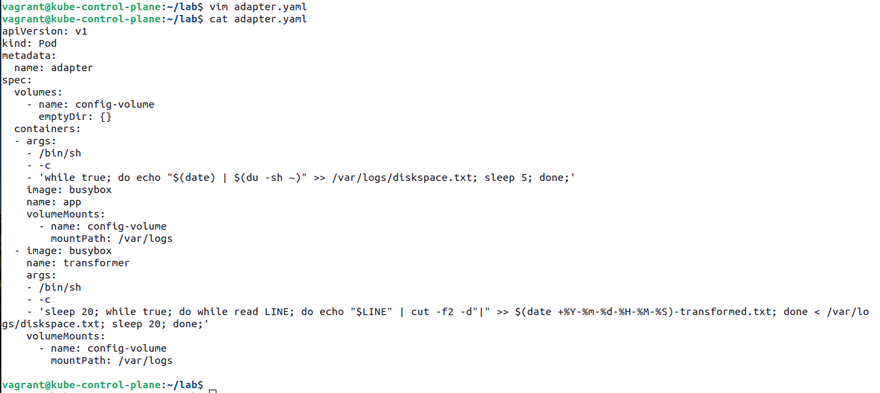

- Create the Pod, log into the container `transformer`. The current directory should continuously write a new file every 20 seconds.
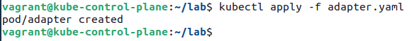

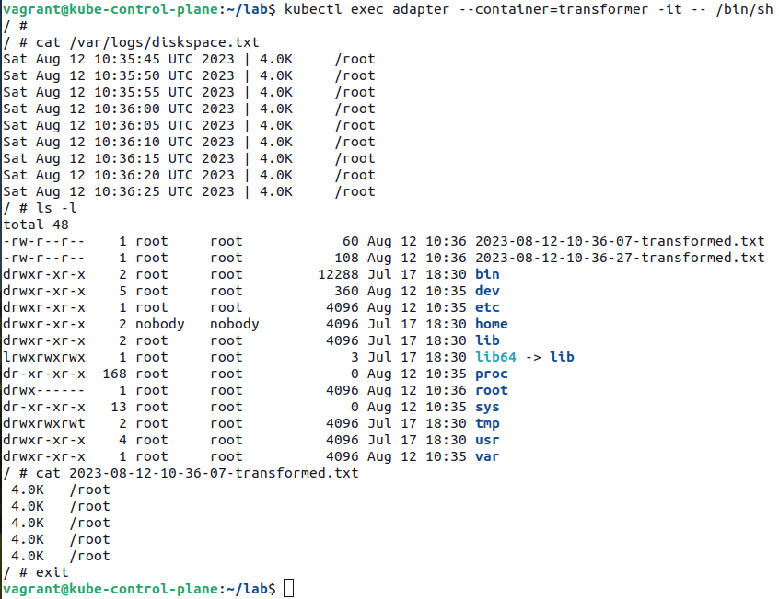

Ambassador Pattern
In this example, you'll be asked to implement rate-limiting functionality for HTTP(S) calls to an external service. For example, the requirements for the rate limiter could say that an application can only make a maximum of five calls every 15 minutes. Instead of strongly coupling the rate-limiting logic to the application code, it will be provided by an ambassador container.
The image `brahimhamdi/nodejs-business-app:1.0.0` represents a Node.js-based application that makes a call to localhost on port 8081. The ambassador container represented by the image `brahimhamdi/nodejs-ambassador:1.0.0` running on port 8081 will take on making the HTTP call to the external service while at the same time enforcing rate limiting.

- Create a YAML manifest for a Pod with the name `rate-limiter` in the namespace `ext-access`. Store the definition in the file named `rate-limiter.yaml`. The main application container named `business-app` should use the image `brahimhamdi/nodejs-business-app:1.0.0` and expose the container port 8080.

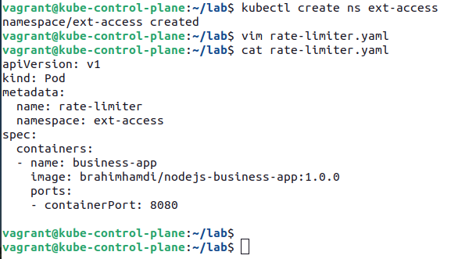

- Modify the YAML manifest by adding the ambassador container named `ambassador`. The ambassador container uses the image `brahimhamdi/nodejs-ambassador:1.0.0` and exposes the container port 8081.

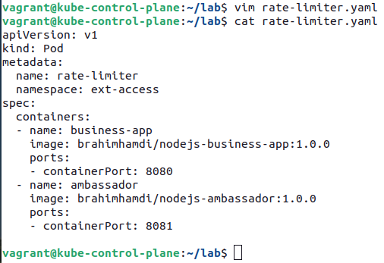

- Test the rate-limiting functionality. First, create the Pod, shell into the `business-app` container that runs the business application, and execute a series of `curl` commands that target `localhost:8081`, the end point of the `ambassador` container. The first five calls will be allowed to the external service. On the sixth call, you’ll receive an error message, as the rate limit has been reached within the given time frame.



